COVER PAGE



City of Albany
Local Planning Scheme No. 2

Amendment No. 3

Summary of Amendment Details
Standard Amendment, Rezoning Land from ‘Rural Smallholdings’, ‘Light Industry’ and ‘Local Road’ to ‘Urban Development’ to Facilitate Precinct Structure Plan Operation

FORM 2A

Planning and Development Act 2005
RESOLUTION TO PREPARE AMENDMENT
TO LOCAL PLANNING SCHEME

City of Albany Local Planning Scheme No. 2
Amendment No. 3
Resolved that the Local Government pursuant to section 75 of the Planning and Development Act 2005, amend the above Local Planning Scheme by:
- Rezone Lots 895 and 1209 Woolstores Place, Mount Melville, Lot 1104 on Deposited Plan 165964, Lots 1156 and 1157 on Deposited Plan 171141 from ‘Light Industry’ to ‘Urban Development’;
- Rezone Lot 50 on Deposited Plan 426285, Lot 141 Woolstores Place, Mount Elphinstone, Lot 44 on Deposited Plan 171141 and Pin 583843 from ‘Rural Smallholdings’ to ‘Urban Development’;
- Rezone a 3,787m² portion of Lot 530 on Deposited Plan 408474 and Lot 529 Deposited Plan 408473 from ‘Local Road’ (Woolstores Place) to ‘Urban Development’, as notated on the Scheme Map;
- Rezone Lot 1350 on Deposited Plan 184224 from ‘Drainage/Waterway’ reserve to ‘Urban Development’;
- Delete RU8 from Schedule 3, Table 10.
- Add row 69 to Schedule 7, Table 17, as follows:
No. | Description of Affected Lands | Standards
69 | Lots 895 and 1209 Woolstores Place, Mount Melville  Lot 141 Woolstores Place, Mount Elphinstone  Lot 50 Woolstores Place, Mount Elphinstone  Lot 1104 on Deposited Plan 165964  Lots 44, 1156 and 1157 on Deposited Plan 171141  Lot 1350 on Deposited Plan 184224  A portion of Lot 530 on Deposited Plan 408474  Lot 529 on Deposited Plan 408473  Lot 501 on Deposited Plan 409116  Pin 583843 | - All development shall be constructed with a minimum finished floor level height of 2.5m AHD.
- Delete Special Control Area 15 – Princess Royal Harbour Inundation Area from the amendment area, as specified within the Scheme Map.

The amendment is standard under the provisions of the Planning and Development (Local Planning Schemes) Regulations 2015 for the following reason(s):
- The Amendment is consistent with the City of Albany Local Planning Strategy.

Dated this 22 day of October 2024

_____________________
(Chief Executive Officer)

EXECUTIVE SUMMARY
Rowe Group acts on behalf of Rural Logistics (WA) Pty Ltd (‘Client’), the main landowner of the Woolstores Precinct. The Precinct comprises privately held lots and lots and road reserves owned by the Crown, State of Western Australia and/or vested with the City of Albany (‘City’) for its care and management (‘subject land’ or ‘amendment area’).
We have been instructed by our Client to request an amendment to the City of Albany Local Planning Scheme No. 2 seeking to transfer the subject land from the ‘Rural Smallholdings’ and ‘Light Industry’ zone, and ‘Local Road’ reserve to the ‘Urban Development’ zone. The proposal ultimately seeks to facilitate the operation of the Albany Woolstores Precinct Structure Plan (‘PSP’ or ‘structure plan’) over the subject land.
The PSP was formally accepted by the City for assessment in August 2023, with public consultation concluding in October 2023. At its meeting in February 2024, the City’s Council resolved to support the PSP and submit it to the DPLH for final assessment. The DPLH are currently considering the PSP and aims to have it finalised in the last half of the 2024 calendar year. The DPLH has advised that the proposed amendment should be initiated by Council, considered by the Environmental Protection Authority and approved by the Minister for Planning for the purpose of consultation prior, to the determination of the PSP. In this regard, this amendment request is being made in accordance with Section 75 of the Planning and Development Act 2005 to facilitate subdivision and development over the subject land, as guided by the draft structure plan.
The purpose of this report is to provide the DPLH and the Western Australian Planning Commission (‘WAPC’) with the necessary information to support the proposed rezoning of the subject land and amendment to the scheme text. This report represents the accumulation of technical reporting from this scheme amendment request and the structure plan proposal.
As demonstrated in the balance of this report and the attached technical appendices, the proposed scheme amendment request represents a reasonable and appropriate planning outcome for the subject land for the following reasons:
- The proposed amendment is to facilitate the implementation of the Albany Woolstores PSP over the subject land and allow for the structure plan to be considered by the Western Australian Planning Commission;
- The proposed amendment is consistent with the regional and local strategic planning frameworks to facilitate a mixed use development with a tourism focus;
- The proposed scheme amendment request together with the PSP provides an opportunity for the existing zoning restrictions for the past use of the site, being ‘Restricted Use 8’, and the broader area, being ‘Special Control Area 15 – Princess Royal Harbour Inundation Area’, to be removed and allow for a more efficient and suitable use of the subject land based on the site specific circumstances and management regime outlined in the PSP; and
- The planning and development process will in time provide the trigger for the provisions of the structure plan to be normalised into the City of Albany Local Planning Scheme No. 2 consistent with orderly and proper planning.

INTRODUCTION
Rowe Group acts on behalf of the main landowner within the Woolstores Precinct (Rural Logistics (WA) Pty Ltd). The Precinct comprises privately held lots and lots and road reserves owned by the Crown, State of Western Australia and/or vested with the City of Albany for its care and management (‘subject land’ or ‘amendment area’).
We have been instructed by the landowner to request an Amendment to the City of Albany Local Planning Scheme No. 2. The proposal seeks to transfer the subject land to the ‘Urban Development’ zone to facilitate the operation of a structure plan.
This request is being made in accordance with Section 75 of the Planning and Development Act 2005 to facilitate development over the subject land, as guided by the draft Albany Woolstores Precinct Structure Plan (‘PSP’). The PSP is currently under final assessment by the Department of Planning, Lands and Heritage (‘DPLH’).
The purpose of this report is to provide the DPLH and the Western Australian Planning Commission (‘WAPC’) with the necessary information to support the proposed rezoning of the subject land.
In preparing this report, we have engaged a project team of specialist consultants to provide technical input. The consultant team is listed in Table 1 below.
Discipline | Consultant
Town Planning | Rowe Group
Environment | Strategen-JBS&G
Table 1: Project Team

SITE CONTEXT
  - Location
The subject land is located in the municipality of the City of Albany (‘City’), approximately 1.7 kilometres west of the Albany town centre and within the Great Southern Region of Western Australia. Albany is a regional city and is surrounded by key regional towns including Denmark, Mount Barker, Jerramungup, and Bremer Bay.
Refer Figure 1 – Regional Location.
The subject land is situated in suburbs of Mount Elphinstone and Mount Melville and is bound by the Albany Ring Road to the north and east, the southern railway line to the west, and the Princess Royal Harbour to the south.
The railway line is a key freight route between Albany and Northam, primarily for grain. The Albany Ring Road is an 11.5 kilometre freight route which extends south from Menang Drive and the Albany Highway intersection, running parallel to Link Road and connecting to Princess Royal Drive. This in turn provides access to the localities of Robinson, Torndirrup, Little Grove and beyond.
The surrounding land is characterised by rural smallholdings and residential to the west, industrial to the north and Mount Melville to the east.
Refer Figure 2 – Local Context.
  - Surrounding Land uses
The subject land is generally bound by Princess Royal Drive which provides access to existing recreational and suburban residential development to the north and east of the amendment area.
Explain Albany Ring Road as this has replaced Frenchman Bay Road as a boundary to the north.
Frenchman Bay Road provides access to rural properties of various sizes and coastal land identified for future development via a structure plan.
Land to the north of the subject land is serviced by Lower Denmark Road (via Frenchman Bay Road) and Hanrahan Road (via Frenchman Bay Road and Princess Royal Drive) which provides access to large areas of land utilised for industrial development. The subject land is significantly isolated from the primary industrial area due to the existing and future road configuration north of the amendment area.

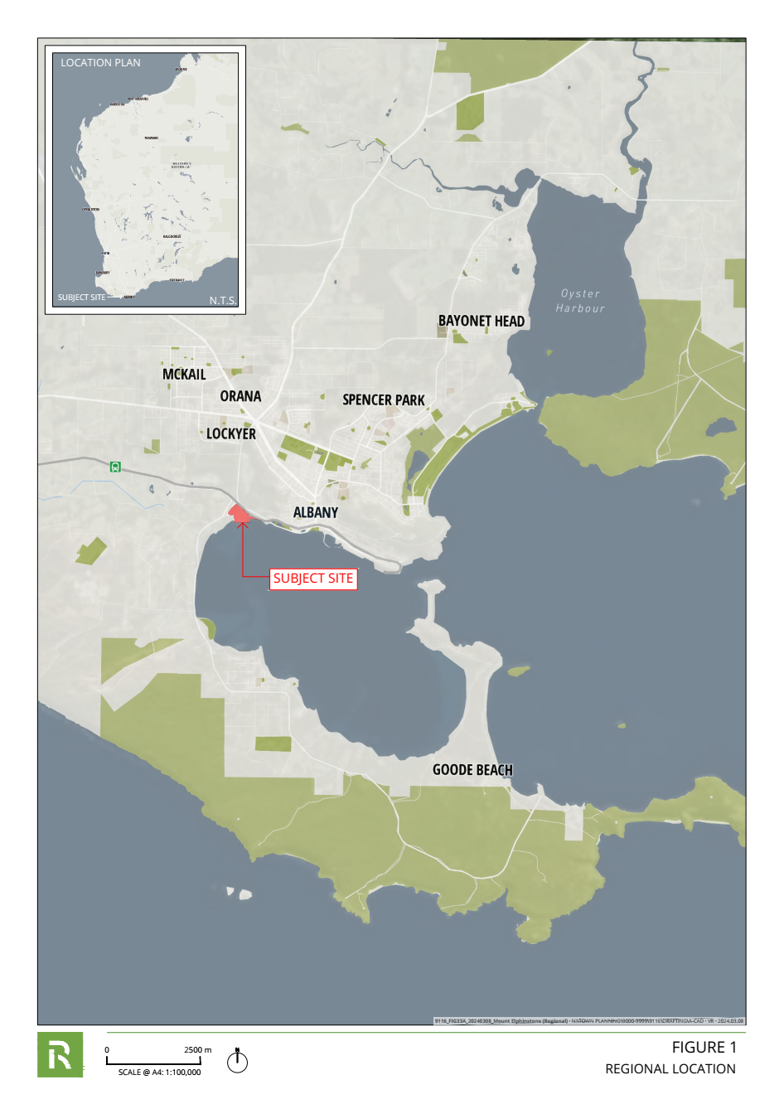
Figure 1
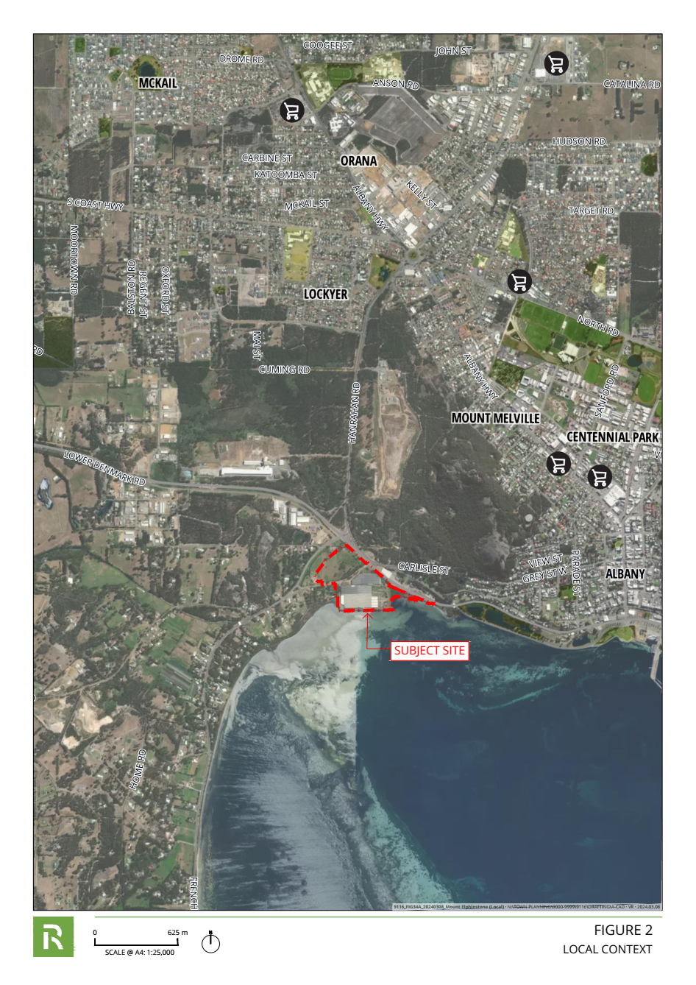
Figure 2
  - Site Area and Ownership
The subject land comprises various lots and road reserves. The lots and road reserves that form the amendment area are summarised below in Table 2 below.
Lot | Plan | Vol/Folio | Address | Area - ha | Landowner
895 | DP161301 | 445/ 169A | 34 Woolstores Place, Mount Melville | 4.054 | Rural Logistics (WA) Pty Ltd
1104 | DP165964 | 445/ 169A | 34 Woolstores Place, Mount Melville | 2.001 | Rural Logistics (WA) Pty Ltd
1209 | DP173935 | 445/ 169A | 34 Woolstores Place, Mount Melville | 3.359 | Rural Logistics (WA) Pty Ltd
1156 | DP171141 | 480/62A | No Street Address Available | 0.202 | Rural Logistics Pty (WA) Ltd
1157 | DP171141 | 123/109A | No Street Address Available | 2.253 | Rural Logistics (WA) Pty Ltd
530 | DP408474 | LR3172/668 | Woolstores Place – road reserve | 1.090 | State of Western Australia
1350 | DP184224 | LR3009/754 | No Street Address Available | 0.432 | State of Western Australia
44 | DP171141 | LR3008/848 | No Street Address Available | 0.303 | State of Western Australia
PIN 583843 | No details | No details | No street Address Available | 0.110 | Crown Land
402 | DP413330 | No Details | No Street Address Available | 1.9202 | State of Western Australia
141 | DP027076 | LR1133/829 | 23 Woolstores Places, Mount Elphinstone | 0.2025 | Rural Logistics (WA) Pty Ltd
50 | DP426285 | 4054/644 | No Street Address Available | 1.988 | Rural Logistics (WA) Pty Ltd
529 | DP408473 | LR3172/ 667 | Woolstores Place – road reserve | 0.3787 | State of Western Australia
501 | DP409116 | LR3168/234 | Road reserve | 0.1934 | State of Western Australia
Table 2: Land Ownership Table
Refer Figure 3 – Site Plan.

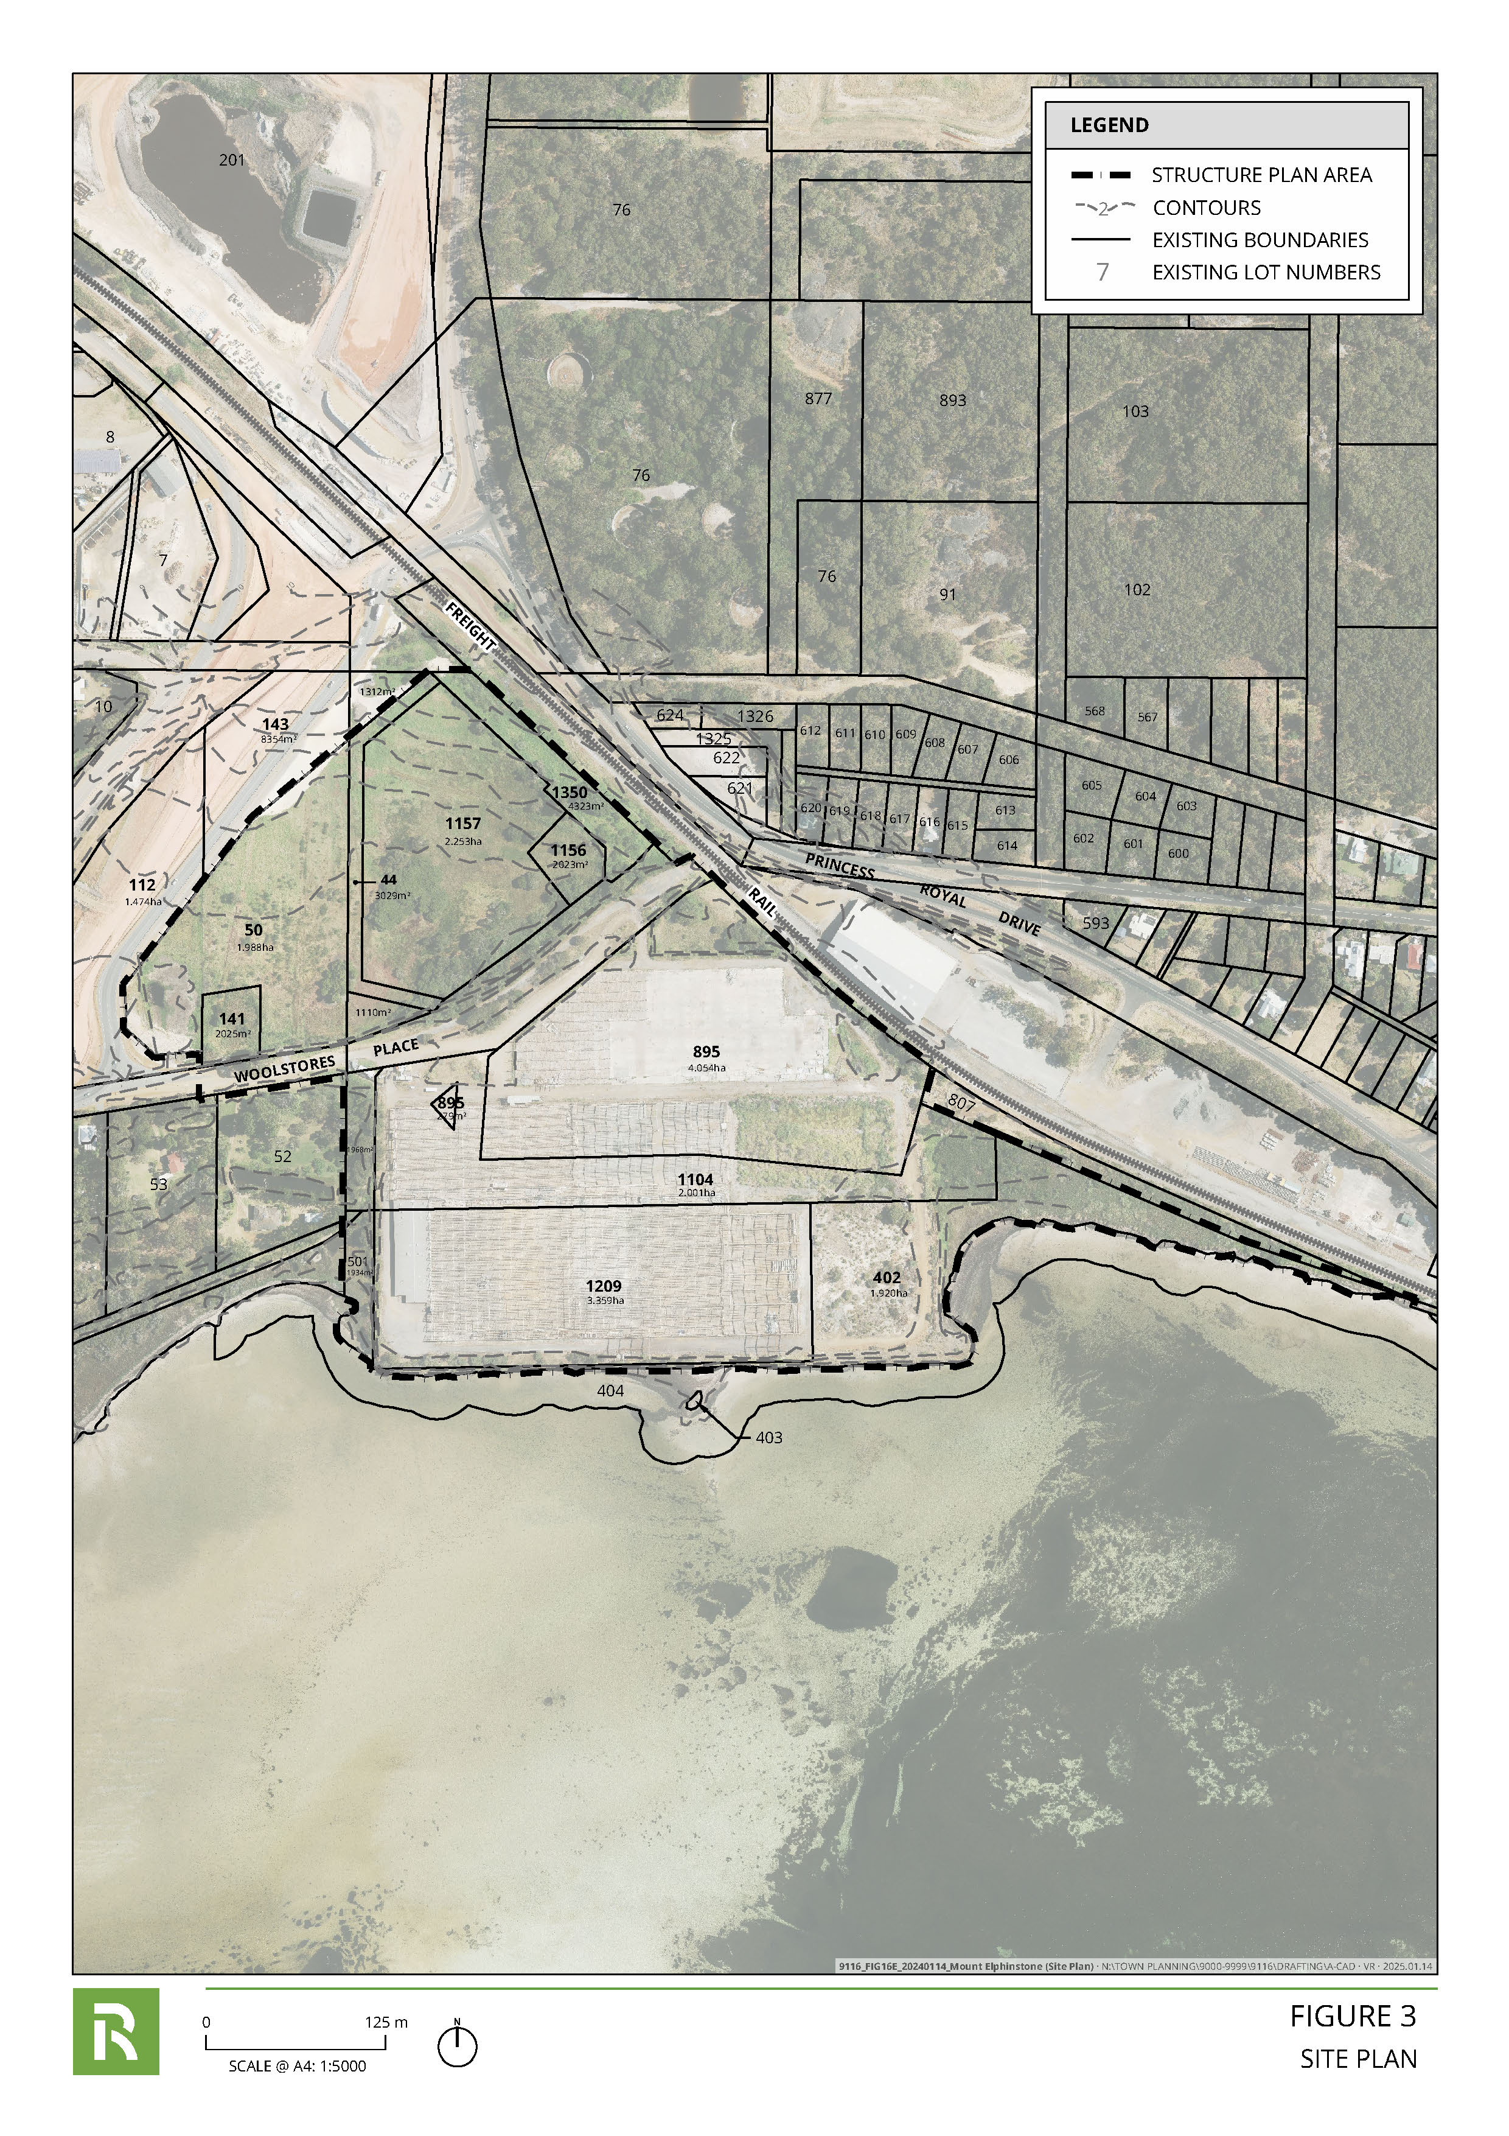
Site plan
  - Site Conditions
The following section provides a summary of the environmental site conditions of the subject land as outlined in the Environmental Assessment Report (‘EAR’) prepared by JBS&G in support of the structure plan. This EAR has since been updated to reflect the findings of an Ecological Assessment and Ecological Survey.
  - TYPOGRAPHY
The subject land is relatively flat to slightly undulating, with elevations ranging from 10 metres Australian Height Datum (‘AHD’) to 2 metres AHD toward the south. The elevation is steepest toward the northmost portion of the subject land.
  - Geomorphology and Soils
The subject land is located in the Albany-Fraser Orogen Nornalup Complex Range Formation, the geological unit of which the site is based comprises Mesoproterozoic granite and pegmatite. This geological unit is described by Geoscience Australia (2008) as follows:
- Mg 74405: Granite, metagranite, Equigranular to porphyritic granite; leucocratic granite; biotite granite with potassium feldspar phenocrysts in places; foliated adamellite; mixed granitic rocks; dioritic rocks.
The subject land is located within the Torbay soil systems, specifically within the Owingup soil subsystem. The Owingup subsystem is described by the Department of Primary Industries and Regional Development (‘DPIRD’) (2019) as follows:
- 42TbOW: Plains with swamps, lunettes, and dunes. Yellow solonetzic soils, organic loams, and diatomaceous earth; Wattle-Paperbark thickets, Teatree heath and reeds. Podzols on dunes; Banksia-Sheoak woodland.
The geomorphology and soil(s) that the subject land is comprised of contribute to the narrow, swampy coastal plain that makes up the southern portion of the Albany Sandplain hydrological zone. The soils are described by DPIRD (2019) as being relatively non-saline, pale-deep sands that generally support sedgelands and paperbark thickets.
Acid Sulfate Soils (‘ASS’) are naturally occurring, iron sulphide-rich soils, sediments, or organic substrates, formed under inundated/waterlogged conditions. when exposed to oxygen, these sulphides can oxidise and release sulfuric acid and heavy metals. This process can occur due to drainage, dewatering or excavation.
The ASS risk mapping available from the Australian Soil Resource Information System (‘ASRIS’) (2013) and the Department of Water and Environmental Regulation (‘DWER’) (2017). The land is classed as having a ‘High Probability of Occurrence’ (ASRIS 2013) and/or ‘High to Moderate risk’ (DWER 2017) of ASS occurring within 3 metres of the natural soil surface that could be disturbed by land development activities.
Accordingly, the Environmental Assessment Report (‘EAR’) completed by JBS&G recommends that should dewatering/soil draining or soil disturbance of more than 100 m³ be anticipated during subdivision and development of the land, then an ASS investigation should be completed to assess the nature and extent of ASS at the site. Should ASS be identified, and its disturbance unavoidable during site construction/development, an ASS management plan should be prepared and implemented during the site development.
  - Hydrology
Groundwater
Regional hydrological mapping indicates that the subject land is underlain by the Bremer West Superficial Aquifer. Groundwater quality in the broader area is fresh to saline, with approximate total dissolved solid concentrations being between 100 to 100,000 mg/L.
Given the subject land's proximity to the coast, groundwater levels range from approximately 7.5 metres below ground level (‘mbgl’) to less than 1 mbgl, with surface expressions of groundwater presenting themselves throughout the southern portion of the subject land. No groundwater licences currently exist within the subject land.
Surface Water
The subject land is situated within the Princess Royal Harbour hydrological catchment and sub-catchment of the Albany Coast Basin. There are no perennial waterways onsite; however, surface expressions of groundwater present themselves on a seasonal basis. No significant, Nationally Important (Directory) and/or Ramsar-listed wetlands are present within the subject land. Surface water drainage networks drain run through the land (from the north) via a main open channel into three catchments.
The subject land is not within a mapped 100 Year ARI Floodplain Area; however, given its proximity to the foreshore flat of the Royal Princess Harbour, it is subject to inundation. Early site sampling from the Hydrology Consultant has indicated that groundwater nutrient levels are elevated for the site, possibly contributed from surrounding and historical land uses.
  - Contamination
A list of contaminated sites from a search of the DWER contaminated sites database identified seven (7) registered contaminated sites within a 1 kilometre radius of the subject land, all listed as ‘Remediated for Restricted Use’. The majority of the contamination issues with these sites are related to historical usage of:
- Lead products;
- Fertilisers;
- Acidic groundwater and pollutant transport; and
- Increased levels of iron, zinc, and copper in groundwater beyond environmental standards (ANZECC).
A Preliminary Site Investigation (‘PSI’) comprising a desktop assessment and field inspection has been undertaken by JBS&G to assess the nature of current and/or historical potentially contaminating activities that may have previously occurred within the subject land or on adjacent properties, which is intended to guide the requirement for a further site assessment (Detailed Site Investigation) at later stages of the subdivision implementation process.
Potential sources of contamination within the subject land that were identified in the PSI include, but may not be limited to, the following:
- The historical industrial land use(s) of the site;
- Asbestos contamination associated with the former site structures or illegal dumping/fly tipping activities (southeast portion of the subject land);
- Potential uncontrolled fill associated with the reclaimed land; and
- Potential migration of contaminated groundwater from up-gradient properties.
Based on the PSI conclusions, the following recommendations were made:
- Further assessment or management/remediation of the potentially impacted soils and groundwater should be considered to assess the potential risks to future site receptors. It is noted that an intrusive sampling program should be considered to characterise impacts associated with the APECs identified.
- It was recommended that JBS&G provide a scope for a Sampling Analysis and Quality Plan (‘SAQP’) and subsequent Detailed Site Investigation (‘DSI’) in order to characterise the nature, extent and risk of potential contamination onsite (site derived and offsite migration).
JBS&G has since prepared a SAQP reflecting the findings of the PSI to support a DSI which will be prepared to support future subdivision and development of the subject land. The outcomes of the SAQP are summarised below:
- Asbestos Investigations – The commercial/industrial structures which have recently been demolished are known to have included asbestos containing materials (‘ACM’). However, there is considered a low potential for demolition to have resulted in the contamination of soils at the site with asbestos based on the controlled manner in which asbestos removal and subsequent demolition occurred. It is also possible that asbestos may be present in underground structures at the site, including pipes, infrastructure conduits, footings, and slabs which have not yet been identified. In the absence of any evidence of the existence of such structures, it is suggested that if they are identified in the future (during development activities), they are managed as unexpected finds.
There is an area in the eastern portion of the subject land where fill material is observed to have been placed. Multiple PACM fragments were also observed across this area, and it is considered likely that these are (at least in part) associated with the demolition of a historical building in the area.
Furthermore, a review of historical aerial photographs has identified that the southern portion of the subject land is reclaimed land. The fill utilised to create the current site levels is of unknown origin.
Based on the presence of uncontrolled fill, investigations will be required to extend to below the depth of imported fill materials where virgin/natural soils are present, which is anticipated to be 1.5 m bgl to 2 m bgl.
- Groundwater Investigations – The potentially contaminating activities conducted at the subject land historically also have the potential to have resulted in groundwater contamination. As such, it is proposed to complete a groundwater investigation to assess the quality of groundwater beneath the subject land. The installation of six groundwater monitoring wells is proposed.
- Acid Suflate Soils – Given the proposed redevelopment of the subject land, it is likely that ground disturbance events above occur. This will trigger the requirements for ASS investigation. ASS investigation will be required at both the northern rural residential lots, and the commercial/ industrial lots. The maximum depth of disturbance identified based on the provided plans is 4.3 m bgl. The guidelines require that investigation is undertaken to at least 1 m in excess of the maximum depth of disturbance. Therefore, it is proposed that soil bores for the purposes of characterising ASS are advanced to 6 m bgl, as a conservative measure.
Refer Attachment 1 – Preliminary Site Investigation, Attachment 2 - PSI and Attachment 3 – Sampling and Analysis Quality Plan.
  - Flora and Vegetation
JBS&G’s EAR confirmed the subject land is mainly comprised of cleared (or ‘parkland cleared’) paddocks, access roads, fences, and other man-made structures. As such, the majority of vegetation present is anticipated to be ‘Completely Degraded’.
The vegetation surrounding the former buildings and the southern and eastern coastal portion of the subject land did not form part of the vegetation survey by Southern Ecology (2020).
In order to support the preparation and lodgement of the PSP with the City of Albany, a preliminary ecological assessment was completed by JBS&G to:
- confirm the presence/absence of the coastal samphire threatened ecological community identified in the desktop; and
- clarify the likelihood of occurrence of other key flora and vegetation values identified within the desktop assessment.
The preliminary ecological assessment was undertaken on 15 December 2022 by an Associate Ecologist with over 15 years of experience conducting ecological assessment in the South-west bioregion. A site walkover was carried out to visually inspect key features of the site, with a focus on identifying requirements for further ecological survey and any vegetation potentially representative of the Subtropical and Temperate Coastal Saltmarsh ecological community.
Saltmarsh vegetation aligning with key criteria of the Subtropical and Temperate Coastal Saltmarsh TEC/PEC was observed adjacent to, but outside of, the subject land.
No areas of vegetation clearly identifiable as saltmarsh or considered likely to represent the Subtropical and Temperate Coastal Saltmarsh TEC/PEC were observed within the subject land during the inspection visit.
One small area of low-lying vegetation in the eastern-most portion of the subject land, adjacent to the rail corridor and north-east of existing lot 402, exhibited superficial signs of periodic inundation and some lesser-defined features characteristic of saltmarsh vegetation and as such has some potential to constitute the TEC/PEC or an ecotone thereof.
Other areas of vegetation within the subject land were not found to overtly exhibit any key characteristic of the Subtropical and Temperate Coastal Saltmarsh TEC/PEC, or any other listed ecological community reported from the desktop study. No Threatened flora or fauna species identified from the EAR as having likely potential to occur were observed during the preliminary site walk-over. Further ecological survey in line with Government recommended methodologies (DBCA 2021; DSEWPaC 2013; EPA 2016; EPA2020) was identified to be required in order to confirm presence or absence of these ecological features on the subject land.
In response to this recommendation, an Ecological Survey has been undertaken. This has informed an updated EAR attached to this report, which confirms ecological matters on-site and measures to be implemented via future development of the site.
A brief summary is articulated below as it relates to Flora and Vegetation:
Observation: Saltmarsh vegetation aligning with key criteria of the Subtropical and Temperate Coastal Saltmarsh TEC was observed adjacent to and also within the site, with 0.48 ha of intact native vegetation on the eastern end of the site. This TEC is at risk from anthropogenic changes in sea level, with steep embankments preventing saltmarsh from retreating landward as sea levels rise. Other risks to the patch include weed invasion, ASS, stormwater drainage, reinforcement of embankments for development and pedestrian traffic.
Proposed Management: Potential impacts to Flora and Vegetation resulting from the development of the site are likely to be limited in nature due to the degraded condition of the vegetation, and the existing infrastructure that currently exists on the site.
The seawall proposed as part of the CHRMAP work being undertaken may have potential impacts on flora and vegetation. Potential impacts to the TEC resulting from seawall upgrades and drainage will require management.
An appropriate tree retention strategy and management plan will need to be determined and approved by the City of Albany.
It is noted that the area within the site is proposed to be public open space in response to draft modifications from the City of Albany. While not part of this amendment, this would likely aid with addressing the proposed management regime together with a managed response to the hybrid protection methodology identified in MP Roger’s CHRMAP.
Refer Attachment 4 – Environmental Assessment Report, Attachment 5 – Ecological Assessment and Attachment 6 – Ecological Survey.
  - Fauna and Habitat
As with flora and vegetation, proposed management measures to be implemented via future development has been informed by an Ecological Survey, with an updated EAR prepared to articulate proposed management measures as follows:
Observation: Six fauna habitats were identified within the site. Most of these were highly modified but still retained some value to fauna as evidenced by fauna observed during the field survey. The most significant fauna habitat identified within the site was Western Ringtail Possum habitat (Drainage Line and Damplands 1). This occupied 8.35 % (1.4 ha) of the site.
Proposed Management: Proposed management measures can be determined in consultation with relevant agencies. It is likely a trapping and relocation program may be recommended to mitigate impacts to the Western Ringtail Possum and Quenda.

  - Physical Infrastructure and Services
  - Stormwater and Flood Management
JBS&G’s EAR identified several existing stormwater drainage features within the subject land. These features are evident from both the City of Albany’s Stormwater Mapping Database, the Water Corporation’s ‘Esinet’ Asset Register and from the site Feature Survey.
There is an existing stormwater discharge point to Princess Royal Harbour located in the southwestern corner of the subject land between existing Lots 55 and 54.
Based on the available stormwater network information, stormwater from catchments to the north-west, north and north-east flow through the subject land and discharges to Princess Royal Harbour.
A portion of the existing open channel drain within Woolstores Place is currently a Water Corporation asset. Initial advice from the Water Corporation is that the portion of this open drain within Woolstores Place can be closed, replaced with a pipe system and transferred to the control of the City of Albany.
It is noted that the subject site is impacted by the construction of stormwater drainage infrastructure associated with the Albany Ring Road project. Through liaison with Main Roads Western Australia, the subject land’s detailed stormwater design shall integrate with the Albany Ring Road design to ensure a coordinated design outcome.
In this regard, Hyd2o was commissioned to prepare a Local Water Management Strategy (‘LWMS’) to support the PSP (which can be provided upon request). The document provides a comprehensive overall assessment of the existing water management system of the area and how it will be modified and integrated with the new development to improve water sensitive urban design outcomes as a result of the proposed land use change. Understanding key hydrological considerations has informed the development of this LWMS for the subject land.
  - Wastewater Reticulation
There are no existing Water Corporation wastewater reticulation assets within or surrounding the site. The Water Corporation’s long-term planning for the proposed development is to discharge to the existing Water Corporation network within Newton Street, approximately 1.8 kilometres to the north-west, via a Type 10 wastewater pumping station (‘WWPS’) located within the development and a DN100 pressure main. Internal sewers will be a combination of DN225 and DN150.
The WWPS should be located at a minimum distance of 30 metres from buildings to the centre of WWPS as per standard Water Corporation requirements outlined in Design Standard 51.
  - Water Reticulation
The following existing Water Corporation water reticulation assets surround the site:
- a DN150 AC main located within Princess Royal Drive and Lower Denmark Road to the north-east of the development;
- a DN58 AC main located within Frenchman Bay Road and Ware Road to the north of the development; and
- a DN200 AC main, DN300 steel main and DN525 steel main located within Woolstores Place within the development (existing Woolstores Place road reserve).
Water Corporation have not advised of specific water servicing requirements as part of this servicing report however it is understood that the existing water network has sufficient capacity to service the subject land.
  - Gas Reticulation
ATCO Gas does not operate a reticulated gas network within the subject land. As such, no gas is currently available for the proposed development and would need to be extended at the developer’s cost from Grey Street West and Festing Street, which are approximately 850 metres east of the subject land.
  - Power
An analysis of Western Power’s DFIS system has been conducted to determine the existing power supply configuration surrounding the development. The existing Western Power network surrounding the site consists of the following:
- HV overhead line on the North Eastern side of proposed Lot 1157. This HV line is located within the future road reserve and is likely to be abandoned after completion of the proposed subdivision;
- HV overhead line originating from the Northern side of Princess Royal Drive and continuing in a Westerly direction along Woolstores Place into Frenchman Bay Road. It is likely that Western Power will require that this overhead line be replaced with underground HV cabling.
The Western Power Network Capacity Mapping Tool indicates that the forecasted remaining capacity for this area for 2023 is in the order of 5-10MVA. This figure indicates that capacity is available at the zone substation.
  - Telecommunications
The proposed development will require a fibre ready pit and conduit network to be installed at the developer’s cost. The pit and conduit will be designed in accordance with NBN standards and will be installed in the telecommunications alignment within the internal road reserves. Once installed and inspected, ownership of the pit and conduit network will be transferred to NBN.
The nearest existing NBN network is located within the road reserve in Frenchman’s Bay Road. Based on the proposed development, it is likely that the connection will initially originate from existing pits along Frenchman’s Bay Road.
Refer Attachment 6 – Engineering Servicing Report.

LOCAL PLANNING CONTEXT
  - State & Regional Planning Context
  - Great Southern Regional Planning and Infrastructure Framework
The Great Southern Regional Planning and Infrastructure Framework was adopted in 2015 to provide strategic regional context and guide future land use planning and infrastructure investment in the Great Southern region.
The vision provides a clear statement of the values and aspirations that will guide development in the future:
A future that promotes economic development and diversification; offers an attractive lifestyle and improved quality of life to a growing multicultural population and recognises the important links between economic activity, ecosystem functions and the region’s outstanding nature conservation, biodiversity and heritage values.
In this regard, the purpose of the proposed amendment is to operationalise the PSP being considered for the subject land. This PSP is proposed to promote redevelopment of the subject land to facilitate economic development, including tourism development based on the region’s natural and heritage values. Therefore, the proposed amendment is entirely consistent with the Great Southern Regional Planning and Infrastructure Framework

  - Lower Great Southern Strategy
The Lower Great Southern Strategy was adopted by the WAPC in 2016 to guide land use planning and provide strategic direction for the subregion over the next 20 years. The Lower Great Southern Strategy states the following vision for the subregion:
In the year 2035, the Lower Great Southern is a productive, innovative and successful area for intensive primary production and downstream processing. It is an attractive business, lifestyle and tourism destination with quality cultural, built and natural landscapes. It is recognised as a centre of excellence in natural resource management and provides a diverse range of health and wellbeing, higher education, training and employment opportunities. It is equipped to respond to local and global challenges and has supportive, vibrant, accessible and safe communities that embrace their Indigenous and historic heritage.
Specific actions to meet with the need to maximise opportunities for development and growth of a sustainable tourism industry include zoning land for identified strategic tourism sites in local planning strategies to protect them for that purpose and to ensure local planning strategies respond to changing needs of the tourism sector and take advantage of emerging markets.
Key planning issues for Albany, relevant to the proposed LPS 2 amendment, include:
- Identifying opportunities for urban infill development;
- Fostering tourism development in key tourist areas;
- Guiding development of the Albany Waterfront;
- Accommodating predicted increases in the proportion of aged people in the community and meeting their associated care and health needs;
- Developing cultural and recreation facilities to cater for future growth;
- Achieving a balance between conservation and urban development and protecting Albany’s natural assets; and
- Managing risks associated with seal level rise and climate change on existing and proposed infrastructure and coastal development areas.
These issues have each been considered by preparation and endorsement of the City of Albany Local Planning Strategy (the ‘Strategy). It is considered that the proposed LPS 2 amendment offers the opportunity and capacity to provide urban infill development, to foster tourism development and responsible waterfront development, while managing risk associated with climate change (sea level rise). These factors are all considered by the PSP, which this amendment is designed to operationalise.
STATE PLANNING POLICIES
  - State Planning Policy 2.6 – Coastal Planning
State Planning Policy 2.6 – Coastal Planning (‘SPP 2.6’) provides for the long-term sustainability of Western Australia’s coast and is relevant to those local governments that contain coastal areas. The purpose of the policy is to provide guidance for decision making within the coastal zone including managing development and land use change, establishment of foreshore reserves and protecting, conserving and enhancing coastal values.
In this regard, we note that M P Rogers & Associates Pty Ltd has prepared a Coastal Hazard Risk Management and Adaptation Plan (‘CHRMAP’) for the PSP which will guide any future development of the subject land.
This will act as a specific tool for the subject land in lieu of broad provisions within LPS 2 for ‘Special Control Area 15 - Princess Royal Harbour Inundation Area’ (‘SCA’). This results in the need to remove the application of ‘Special Control Area 15’ as it relates to the subject land to ensure the CHRMAP prepared specifically for the PSP area can be implemented.
  - State Planning Policy 3.0 – Urban Growth and Settlement
State Planning Policy 3.0 – Urban Growth and Settlement (‘SPP 3.0’) is a broad sector policy that sets out the principles and considerations which apply to planning for urban growth and settlement in Western Australia. The purpose of the policy is to facilitate sustainable patterns of urban growth and settlement by setting out the requirements of sustainable settlements and communities and the broad policy for accommodating growth and change.
SPP 3.0 outlines general measures to create sustainable communities, plan liveable neighbourhoods, coordinate services and infrastructure, manage rural-residential growth and plan for aboriginal communities. These general measures should be considered in conjunction with issue-specific urban growth and settlement state planning policies which supplement SPP 3.0.
In this regard, the proposed amendment, and by extension, the PSP, is consistent and/or supports the following objectives of SPP 3.0:
- To build on existing communities with established local and regional economies, concentrate investment in the improvement of services and infrastructure and enhance the quality of life in those communities.
- To manage the growth and development of urban areas in response to the social and economic needs of the community and in recognition or relevant climatic, environmental, heritage and community values and constraints.
- To promote the development of a sustainable and liveable neighbourhood form which reduces energy, water and travel demand whilst ensuring safe and convenient access to employment and services by all modes, provides choice and affordability of housing and creates an identifiable sense of place for each community.
  - State Planning Policy 3.6 – Infrastructure Contributions
State Planning Policy 3.6 – Infrastructure Contributions (‘SPP 3.6’) sets out the principles and requirements that apply to the establishment and collection of infrastructure contributions in new and established areas. The policy establishes objectives to coordinate the efficient and effective delivery of infrastructure to support population growth and development; provide clarity on the acceptable methods of collecting and coordinating contributions for infrastructure and provide the framework for a transparent, equitable, and accountable system for apportioning, collecting and spending contributions.
Given the scale, ownership and extent of the subject land, as well as regional traffic being unable to traverse through the subject land, arrangements for developer contributions are not considered applicable in this instance and infrastructure can be considered through subdivision applications. The PSP outlines consideration for these matters.
  - State Planning Policy 3.7 – Planning in Bushfire Prone Areas
State Planning Policy 3.7 – Planning in Bushfire Prone Areas (’SPP 3.7’) provides a framework in which to implement effective, risk-based land use planning and development outcomes to preserve life and reduce the impact of bushfire on property and infrastructure. The policy emphasises the need to identify and consider bushfire risks in decision-making at all stages of the planning and development process whilst achieving an appropriate balance between bushfire risk management measures, biodiversity conservation and environmental protection.
The policy applies to all land which has been designated as bushfire prone by the Fire and Emergency Services Commissioner as well as areas that may have not yet been designated as bushfire prone but is proposed to be developed in a way that introduces a bushfire hazard.
In this regard, we note that a Bushfire Management Plan (‘BMP’) has been submitted with the PSP. Based on this, the preparation of a Bushfire Hazard Level assessment in support of the proposed rezoning is considered to be not applicable in this instance as the PSP, being a more detailed planning instrument, is currently being assessed.
We note that any future subdivision or development application over the subject land may require additional bushfire reporting in support of the individual application.
  - State Planning Policy 5.4 – Road and Rail Noise
State Planning Policy 5.4 – Road and Rail Noise (‘SPP 5.4’) provides guidance for the performance-based approach for managing and mitigating transport noise associated with road and rail operations. This policy applies where noise sensitive land uses are located within a specified distance of a transport corridor, new or major road or rail upgrades are proposed or where works propose an increase in rail capacity resulting in increased noise. The policy also sets out specific exemptions for where the policy requirements do not apply.
SPP 5.4 supports noise impacts being addressed as early as possible in the planning process to avoid land use conflict and achieve better land use planning outcomes. Considerations for decision-makers include ensuring that the community is protected from unreasonable levels of transport noise, whilst also ensuring the future operations of transport corridors.
In accordance with SPP 5.4, we note that a Transport Noise Assessment and associated Noise Contour Maps have been submitted as part of the PSP, which provides consideration towards the following matters:
- Identification of appropriate compatible land-use zoning that is commensurate with the function of the transport corridor;
- Design solutions that utilise street and lot configuration to screen and/or buffer noise;
- Consideration of density and built form outcomes that will help alleviate and/or manage noise;
- Outlining the need for additional noise mitigation measures through quiet house requirements in accordance with the guidelines, to be implemented via Part 1; and
- Consideration of appropriate future planning provisions to ensure more detailed planning is undertaken at the subdivision and development stage.
In this regard, the preparation of a Transport Noise Assessment in support of the proposed rezoning is considered to be not applicable given that the proposal is in accordance with the PSP.
We note that any future subdivision or development application over the subject land may require additional acoustic reporting in support of the individual application.
  - State Planning Policy 7.0 – Design of the Built Environment
State Planning Policy 7.0 – Design of the Built Environment (‘SPP 7.0’) is a broad sector policy relevant to all local governments. The policy sets out the objectives, measures, principles and processes that apply to the design and assessment of built environment proposals through the planning system. It is intended to apply to activity precinct plans, structure plans, local development plans, subdivision, development and public works.
SPP 7.0 contains ten (10) design principles which set out specific considerations for decision makers when considering the above proposals. These include, context and character, landscape quality, built form and scale, functionality and build quality, sustainability; amenity, legibility, safety, community and aesthetics.
In this regard, we note that each of the design principles contained within SPP 7.0 has been considered within the vision and design intent for the PSP.
  - State Planning Policy 7.3 – Residential Design Codes
Volume 1 and 2 of State Planning Policy 7.3 – Residential Design Codes (‘SPP 7.3’) provide design elements for single, grouped and multiple dwellings based on the designated residential density coding under the planning framework.
In this regard, the proposed PSP includes the designation of residential density codes between R50 and R160. We note that the PSP includes provisions relating to building height, plot ratio and building setbacks.
The remaining elements as it applies to residential development within the structure plan area will be deferred to the provisions of SPP 7.3.
In this way, the proposed amendment does not need to apply SPP 7.3 directly.
LOCAL PLANNING STRATEGY
  - City of Albany Local Planning Strategy
The City of Albany Local Planning Strategy was endorsed by the WAPC in 2019 to guide settlement growth and land use planning for Albany and its surrounds over a 10 to 15 year period and provides a rationale for zoning, land use and development controls in the City’s Local Planning Scheme.
The Strategy will guide the City’s progress towards its vision to be Western Australia’s most sought after and unique regional city to work, live and visit. It provides strategic direction which, over the long term, is aiming to deliver a more compact city where residents will live closer to local shops, services and employment with easy access to public transport and greater ability to walk or cycle.
The subject land is identified by the Strategy as ‘Investigation Area 2 – Woolstores’. The Strategy states that investigation areas are identified to acknowledge that additional research needs to be undertaken to determine appropriate strategic and statutory planning responses. More specifically, Investigation Area 2 includes a strategic direction to facilitate the preparation of a structure plan that shows how the site can be redeveloped.
- The Strategy also outlines that structure planning adjacent to the Albany Ring Road, such as the subject land, is to ensure the identification of measures to minimise impacts between the ring road, heavy fright routes and adjacent land uses occurs, such as the following:
- Application of land use and development controls for adjacent properties based on the recommendations of the Albany Heavy Freight Access Study (2003);
- Provision of adequate separation between incompatible or sensitive land uses and the ring road, particularly urban residential development;
- Application of road planning standards to minimise potential road user conflict;
- Noise and visual impact mitigation measures; and
- Minimise impacts on environmental values.
In this regard, the proposed amendment will facilitate the implementation of the PSP to, in turn, provide a positive response to the strategic direction of the Strategy.
LOCAL PLANNING POLICIES
  - Local Planning Policy – Significant Tourist Accommodation Sites
In accordance with the recommendation of the Tourist Accommodation Planning Strategy, Local Planning Policy – Significant Tourist Accommodation Sites classifies the amendment area as a “Prime Tourism” site.
The Policy helps to maintain the site’s role as a key tourist accommodation site by encouraging tourist, residential and non-residential uses. The Policy recommends:
- Hotel, tourist resort and residential land uses being developed; and
- Redevelopment be guided by a structure planning process.
In this regard, we note that the proposed amendment facilitates the implementation of the PSP to enable redevelopment of the subject land in accordance with the broad objectives of this policy.
  - Local Planning Policy – Woolstores Redevelopment Site
The main objectives of Local Planning Policy – Woolstores Redevelopment Site is to create an innovative and comprehensively planned urban development in close proximity to the town centre, while also accounting for noise and vibration associated with rail infrastructure and provision of public access to the waterfront. The Policy includes a number of broad development standards that aim to enable redevelopment that can respond to the objectives identified above.
In this regard, we note that the PSP will effectively replace this policy once approved, with the purpose of this amendment to facilitate the implementation of the PSP.

PROPOSAL
PRE-LODGEMENT ENGAGEMENT
As part of the process of preparing this report, preliminary comments on the amendment text and the context of this amendment request were sought from the Department of Planning, Land and Heritage (‘DPLH’)) and City of Albany.
The preliminary comments received from the DPLH concluded the need to simplify the proposed amendment text as it would only enable the PSP to be operational.
At a later stage and once development has substantially taken place over the subject land, the PSP can be normalised within LPS 2, with appropriate primary controls to be added to the LPS 2 text.
This has resulted in the amendment text proposed in this request.
PROPOSED SCHEME AMENDMENT
This Scheme Amendment request proposes to rezone the subject land to the ‘Urban Development’ zone under LPS 2 and assign site specific provisions (in Schedule 7, Table 17 – Site Specific Provisions) to the amendment area. The proposed rezonings include:
- Rezone Lots 895 and 1209 Woolstores Place, Mount Melville, Lot 1104 on Deposited Plan 165964, Lots 1156 and 1157 on Deposited Plan 171141 from ‘Light Industry’ to ‘Urban Development’;
- Rezone Lot 50 on Deposited Plan 426285, Lot 141 Woolstores Place, Mount Elphinstone, Lot 44 on Deposited Plan 171141 and Pin 583843 from ‘Rural Smallholdings’ to ‘Urban Development’;
- Rezone a 3,787m² portion of Lot 530 on Deposited Plan 408474 and Lot 529 Deposited Plan 408473 from ‘Local Road’ (Woolstores Place) to ‘Urban Development’, as notated on the Scheme Map; and
- Rezone Lot 1350 on Deposited Plan 184224 from ‘Drainage/Waterway’ reserve to ‘Urban Development’.
In proposing an ‘Urban Development’ zone, the following other amendments are proposed to support this outcome and the wider implementation of the PSP over the subject land:
- Delete RU8 from Schedule 3, Table 10.
- Add row 69 to Schedule 7, Table 17, as follows:
  - All development shall be constructed with a minimum finished floor level height of 2.5m AHD.
- Delete Special Control Area 15 – Princess Royal Harbour Inundation Area from the amendment area, as specified within the Scheme Map.
This request is being made in accordance with Section 75 of the Planning and Development Act 2005 to facilitate the implementation of the PSP over the subject land. In due course, and once substantial progression and redevelopment of the PSP area has occurred, a separate amendment to LPS 2 can be undertaken to ‘normalise’ the primary controls of the PSP into the scheme text.
Refer Figure 5 – Proposed City of Albany Local Planning Scheme No. 2 Zoning.

Figure 5
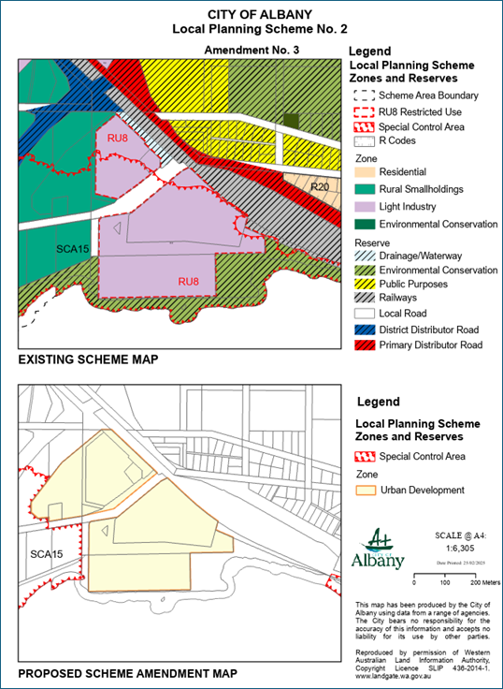

PLANNING JUSTIFICATION
  - Albany Woolstores Precinct Structure Plan
As noted, the proposed amendment is to facilitate the implementation of the PSP over the subject land. The PSP is required to be delivered by a strategic goal of the Strategy.
The PSP Area is divided into two (2) precincts, the Woolstores Precinct and the Commercial/Retail Precinct.
The intent for the Woolstores Precinct is to create a prime visitor destination with a lively blend of entertainment, cultural, commercial, retail and residential uses within a waterfront environment.
The Commercial/Retail Precinct has effective access to Woolstores Place and the wider Albany Ring Road infrastructure, which also provides a clear boundary or frame to the Precinct, along with the freight rail to the east. The Commercial/Retail Precinct is to be an employment generator at a neighbourhood scale, with high quality medium to large format commercial development taking advantage of access to the abovementioned roads, while providing a safe and inviting urban environment for pedestrians and workers fronting onto Woolstores Place.
The PSP includes a number of primary controls to guide redevelopment outcomes, inclusive building height, setbacks, plot ratio and other relevant development standards.
A number of documents are required to be delivered at future planning stages to support realisation of the vision and intent of the PSP.
The PSP was formally accepted by the City for assessment in August 2023, with public consultation concluding in October 2023. At its meeting in February 2024, the City’s Council resolved to support the PSP and submit it to the DPLH for final assessment. This resolution included a number of recommended modifications to the PSP, for consideration by DPLH.
DPLH are currently considering the PSP and aim to have it considered by the Statutory Planning Committee in the last half of the 2024 calendar year.
The DPLH has advised that the proposed amendment should be initiated by Council, considered by the Environmental Protection Agency and approved by the Minister for Planning for the purpose of consultation prior, to approval of the PSP.

  - Proposal Opportunities and Constraints
During the preparation of this scheme amendment report and precinct structure plan for the subject land, various opportunities and constraints were identified for this proposal. Of relevance to the proposed scheme amendment, the following opportunities and constraints are summarised below.
  - Key Opportunities and constraints
- Provision of Appropriate Land Uses – The proposed rezoning of the subject land to an ‘Urban Development’ zone will enable the implementation of the PSP. The PSP has been prepared based on the strategic direction of the City to facilitate a mixed use development, with a focus on tourism land uses at the subject land. In providing site specific planning via the PSP, the amendment request has an opportunity to remove the current ‘Restricted Use 8’ zoning and facilitate future land uses that are consistent with the City’s strategic direction.
- Inundation and Erosion – A CHRMAP was prepared to support the PSP. This found that the existing assets, both proposed and existing, are likely to be at Low risk within the planning timeframe with the exception of a small portion of land located the north side of Woolstores Place, which is expected to be at a Medium risk level in 2122. An assessment for coastal erosion indicates that this land is at Low risk within the 100 year planning timeframe, however land south of Woolstores Place is likely to be at medium risk of impact in the 25 year planning timeframe, at least where the land abuts the water. While the existing SCA provisions for the harbour included within LPS 2 relate to the subject land, these provisions are broad in nature and do not account for the specific results and recommendations of the CHRMAP that supports the PSP. This results in the need to remove the application of the SCA as it relates to the subject land to ensure the CHRMAP prepared specifically for the PSP area can be implemented.
- Ecological considerations – While the vegetation within the subject land is largely degraded, the remnant foreshore vegetation to the east includes the Subtropical and Temperate Coastal Saltmarsh TEC. This has resulted in the need for management measures to be articulated as highlighted earlier in this report.
- Contamination - The PSI completed at the site has identified the following areas of potential environmental concern:
- Asbestos contamination associated with the former site structures or illegal dumping/fly tipping activities.
- Potential uncontrolled fill associated with the reclaimed land that the Woolstores warehouses were built on.
- Historical industrial land use of the site.
- Migration of potentially contaminated groundwater from up-gradient properties.
As confirmed by JBS&G, a DSI should be undertaken support future stages of development to investigate the identified areas of potential environmental concern, to assess the potential risk to current and future site receptors.
- Acid Sulfate Soils (‘ASS’) - Soils within the subject land are considered to have a ‘High to Moderate risk’ of ASS occurrence within 3 metres of the natural soil surface. Should soil disturbance of more than 100 m³ be anticipated during the development of the subject land, then an ASS investigation should be completed to assess the nature and extent of ASS.

CONCLUSION
This scheme amendment request seeks to rezone the subject land from ‘Rural Smallholdings’, ‘Light Industry’ and ‘Local Road’ reserve to the ‘Urban Development’ zone under the City of Albany Local Planning Scheme No. 2.
This request is being made in accordance with Section 75 of the Planning and Development Act 2005 to facilitate the implementation of the Albany Woolstores PSP over the subject land.
In light of the preceding sections of this report and enclosed technical reports, the following provides a summary of key considerations that demonstrate this request represents a reasonable and appropriate planning outcome for the subject land:
- The proposed amendment is to facilitate the implementation of the Albany Woolstores PSP over the subject land and allow for the structure plan to be considered by the Western Australian Planning Commission;
- The proposed amendment is consistent with the regional and local strategic planning frameworks to facilitate a mixed use development with a tourism focus;
- The proposed scheme amendment request together with the PSP provides an opportunity for the existing zoning restrictions for the past use of the site, being ‘Restricted Use 8’, and the broader area, being ‘Special Control Area 15 – Princess Royal Harbour Inundation Area’, to be removed and allow for a more efficient and suitable use of the subject land based on the site specific circumstances and management regime outlined in the PSP; and
- The planning and development process will in time provide the trigger for the provisions of the structure plan to be normalised into the City of Albany Local Planning Scheme No. 2 consistent with orderly and proper planning.
In this regard, we respectfully request that the City of Albany initiates the proposed amendment to the City of Albany Local Planning Scheme No. 2.

Planning and Development Act 2005
RESOLUTION TO AMEND LOCAL PLANNING SCHEME

City of Albany Local Planning Scheme No. 2
Amendment No. 3

Resolved that the Local Government pursuant to section 75 of the Planning and Development Act 2005, amend the above Local Planning Scheme by:

- Rezone Lots 895 and 1209 Woolstores Place, Mount Melville, Lot 1104 on Deposited Plan 165964, Lots 1156 and 1157 on Deposited Plan 171141 from ‘Light Industry’ to ‘Urban Development’;
- Rezone Lot 50 on Deposited Plan 426285, Lot 141 Woolstores Place, Mount Elphinstone, Lot 44 on Deposited Plan 171141 and Pin 583843 from ‘Rural Smallholdings’ to ‘Urban Development’;
- Rezone a 3,787m² portion of Lot 530 on Deposited Plan 408474 and Lot 529 Deposited Plan 408473 from ‘Local Road’ (Woolstores Place) to ‘Urban Development’, as notated on the Scheme Map;
- Rezone Lot 1350 on Deposited Plan 184224 from ‘Drainage/Waterway’ reserve to ‘Urban Development’;
- Delete RU8 from Schedule 3, Table 10.
- Add row 69 to Schedule 7, Table 17, as follows:
No. | Description of Affected Lands | Standards
69 | Lots 895 and 1209 Woolstores Place, Mount Melville  Lot 141 Woolstores Place, Mount Elphinstone  Lot 50 Woolstores Place, Mount Elphinstone  Lot 1104 on Deposited Plan 165964  Lots 44, 1156 and 1157 on Deposited Plan 171141  Lot 1350 on Deposited Plan 184224  A portion of Lot 530 on Deposited Plan 408474  Lot 529 on Deposited Plan 408473  Lot 501 on Deposited Plan 409116  Pin 583843 | - All development shall be constructed with a minimum finished floor level height of 2.5m AHD.
- Delete Special Control Area 15 – Princess Royal Harbour Inundation Area from the amendment area, as specified within the Scheme Map.

AMENDMENT MAP

FORM 6A
COUNCIL RESOLUTION TO PREPARE AND ADVERTISE
This standard Amendment was advertised by resolution of the Council of the City of Albany at the Ordinary Meeting of the Council held on the 22 day of October 2024.
..........................................................
MAYOR/SHIRE PRESIDENT
..............................................................
CHIEF EXECUTIVE OFFICER
COUNCIL FINAL RECOMMENDATION
This Amendment is recommended for support by resolution of the City of Albany at the Ordinary Meeting of the Council held on the day of 2024 and the Common Seal of the City of Albany was hereunto affixed by the authority of a resolution of the Council in the presence of:
..........................................................
MAYOR/SHIRE PRESIDENT
.............................................................
CHIEF EXECUTIVE OFFICER
WAPC ENDORSEMENT (r.63)
........................................................
DELEGATED UNDER S.16 OF
THE P&D ACT 2005
DATE...............................................
APPROVAL GRANTED
.........................................................
MINISTER FOR PLANNING
DATE.................................................

