CITY OF ALBANY

Local Planning Scheme No. 2

Updated to include AMD ? GG ??/??/20??



Prepared by the
Department of Planning, Lands and Heritage
Original Town Planning Scheme Gazettal
Date?

Disclaimer

This is a copy of the Local Planning Scheme produced from an electronic version of the Scheme held and maintained by the Department of Planning, Lands and Heritage. Whilst all care has been taken to accurately portray the current Scheme provisions, no responsibility shall be taken for any omissions or errors in this documentation.
Consultation with the respective local government authority should be made to view a legal version of the Scheme.
Please advise the Department of Planning, Lands and Heritage of any errors or omissions in this document.
Department of Planning, Lands and Heritage  Gordon Stephenson House  140 William Street  Perth WA 6000  Locked Bag 2506  Perth WA 6001 | website: www.dplh.wa.gov.au  email: info@dplh.wa.gov.au  tel: 08 6551 9000  fax: 08 6551 9001  National Relay Service: 13 36 77  infoline: 1800 626 477

LOCAL PLANNING SCHEME NO. 2

Prepared by the City of Albany
Original Local Planning Scheme Gazettal

DISCLAIMER

This is a copy of the Local Planning Scheme produced from an electronic version of the Scheme held and maintained by the City of Albany. Whilst all care has been taken to accurately portray the current Scheme provisions, no responsibility shall be taken for any omissions or errors in this documentation.

Consultation with the City of Albany should be made to view a legal version of the Scheme.

Please advise the City of Albany of any errors or omissions in this document.

City of Albany  102 North Road, Yakamia WA 6330  PO Box 484, Albany WA 6331 | Website: www.albany.wa.gov.au  Email: staff@albany.wa.gov.au  Tel: 08 6820 3000  Fax: 08 6820 3942

CITY OF ALBANY LPS 2 - TEXT AMENDMENTS

AMDT NO | GAZETTAL  DATE | UPDATED |  | DETAILS
 |  | WHEN | BY
New Scheme | ?? | ?? | ?? | New Scheme
 | ?? | ?? | ?? | ??

Preamble

The City of Albany under the powers conferred by the Planning and Development Act 2005 makes the following Local Planning Scheme No. 2 in accordance with the purposes of the Act.
The Local Planning Scheme of the City of Albany consists of this Scheme Text and accompanying Scheme Map (sheets 1 to 35). The Scheme divides the local government district into zones to identify areas for particular land uses and identifies land reserved for public purposes. Most importantly, the Scheme controls the types of land uses and development allowed in different reserves and zones.
The Scheme Text and Map should be read in conjunction with the Local Planning Strategy, which is the overarching planning instrument of the City’s Local Planning Framework. The Local Planning Strategy sets out the long-term planning directions for the local government, applies State and regional planning policies and provides the rationale for the zones and other provisions of the Scheme. In addition to the Local Planning Strategy, the Local Planning Framework provides for local planning policies which set out the general policies of the local government on matters within the Scheme.
The separately gazetted deemed provisions for local planning schemes are prescribed under Schedule 2 of the Planning and Development (Local Planning Schemes) Regulations 2015 and have automatic statutory effect as part of the Scheme. In addition to the provisions set out in the Scheme Text, the following lists the parts of the deemed provisions included as part of the Scheme:
Part 1 - Preliminary: | Sets out the meaning of general terms used throughout the Scheme Text.
Part 2 - Local planning framework: | Sets out the relationship of the Scheme to other planning instrument of the Local Planning Framework (e.g. Local Planning Strategy and local planning policies).
Part 3 - Heritage protection: | Sets out the suite of heritage protection measures (e.g. establishment of a Heritage List, designation of Heritage Areas, entering into of Heritage Agreements with landowners, requirements for a Heritage Assessment and the giving of Heritage Conservation Notices).
Part 4 - Structure plans: | Sets out the requirements, effect and procedure for preparing, implementing and amending Structure Plans adopted by the Western Australian Planning Commission (Commission).
Part 5 - Nil
Part 6 - Local development plans: | Sets out the requirements, effect and procedure for preparing, implementing and amending Local Development Plans adopted by the local government.
Part 7 - Requirement for development approval: | Sets out the requirement for development approval and the types and nature of development for which development approval is not required.
Part 8 - Applications for development approval: | Sets out the form of application and accompanying material required for development approval, and the procedure for advertising applications.
Part 9 - Procedure for dealing with applications for development approval: | Sets out the procedure for consultation with other authorities and the matters to be considered by the local the government when dealing with and determining applications for development approval.
Part 10A – Bushfire risk management | Sets out procedure for dealing with development in bushfire prone areas.
Part 10B — Exemptions from planning requirements for state of emergency | Sets out procedure in the instance of a state emergency.
Part 10 - Enforcement and administration: | Sets out the powers of the local government for the purposes of implementing the Scheme, the procedure for delegating those powers and other miscellaneous matters.  Part 10B - Exemptions from planning requirements for state of emergency
Part 11 - Forms referred to in this Scheme: | Application for Development Approval;  Additional Information for Development Approval for Advertisements;  Notice of Public Advertisement of Planning Proposal; and  Notice of Determination on Application for Development Approval.

TABLE OF CONTENTS
Part 1 – Preliminary 7
1. Citation 7
2. Commencement 7
3. Scheme revoked 7
4. Notes do not form part of Scheme 7
5. Responsibility for Scheme 7
6. Scheme area 7
7. Contents of Scheme 7
8. Purposes of Scheme 7
9. Aims of Scheme 8
10. Relationship with local laws 8
11. Relationship with other local planning schemes 8
12. Relationship with region planning Scheme 8
Part 2 – Reserves 9
13. Regional Reserves 9
14. Local Reserves 9
Table 1. Reserve Objectives 9
15. Additional uses for Local Reserves 11
Part 3 – Zones and Use of Land 12
16. Zones 12
Table 2. Zone Objectives 12
17. Zoning Table 17
Table 3. Zoning Table 18
18. Interpreting zoning table 27
19. Additional uses 28
20. Restricted uses 28
21. Special use zones 28
22. Non-conforming uses 29
23. Changes to non-conforming use 29
24. Register of non-conforming uses 29
Part 4 – General Development Requirements 31
25. R-Codes 31
26. Modification of R-Codes 31
Table 4. Outbuildings Specifications – Where the R-Codes apply 33
27. State Planning Policy 3.6 to be read as part of Scheme 35
28. Modification of State Planning Policy 3.6 35
29. Other State planning policies to be read as part of Scheme 35
Table 5. State planning policies to be read as part of Scheme 35
30. Modification of State planning policies 35
31. Environmental Conditions 35
32. Additional Site and Development Requirements 35
33. Additional Site and Development Requirements for areas covered by Structure Plan or Local Development Plan. 36
34. Variations to site and development requirements 36
35. Restrictive Covenants 36
Part 5 – Special Control Areas 38
36. SPECIAL CONTROL AREAS 38
Part 6 – Terms referred to in Scheme 39
37. Terms used 39
38. Land use terms used 40
Schedules 51
Schedule A –Supplemental provisions to the deemed provisions 52
Table 6. Supplemental provisions for works 52
Table 7. Supplemental provisions for use of land 54
Schedule 1 - Specified additional uses for land in local reserves in Scheme area 55
Table 8. Specified additional uses for land in local reserves in Scheme area 55
Schedule 2 - Specified additional uses for zoned land in Scheme area 62
Table 9. Additional Use Provisions 62
Schedule 3 - Restricted uses for land in Scheme area 78
Table 10. Restricted Use Provisions 78
Schedule 4 – Special use zones in Scheme area 89
Table 11. Special Use Provisions 89
Schedule 5 – Additional requirements that apply to specific zones in Scheme area 108
Table 12. Additional requirements that apply to specific zones in Scheme area 108
Schedule 6 – General development standards that apply to land in the Scheme area 168
Table 13. General development standards that apply to land in the Scheme area 168
Table 14. Parking Requirements 190
Table 15. Construction Standards for Car Parking Bays 197
Schedule 7 - Additional requirements that apply to land covered by structure plan, or local development plan. 198
Table 16. Additional requirements that apply to land covered by structure plan, or local development plan 198
Table 17. Max Lettable Areas – Neighbourhood Centre Zone 206
Schedule 8 - Special control areas in Scheme Area 207
Table 18. Special control areas in Scheme Area 207
Schedule 9 – Signage for which development approval not required 230
Table 19. Signage for which development approval not required 230
Schedule 10 – Policy, Precinct, Local Structure & Local Development Plan Areas 234
Figure 1.Homestead Lot Policy Area 234
Figure 2.Middleton Beach Activity Centre Precinct Plan 235
Figure 3.Albany Motorsports Precinct Plan 235
Figure 4.Lot 600-615 La Perouse Rd and Karrakatta Rd, Goode Beach 236
Figure 5. Lots 1-6 Oyster Hts, Lots 50, 905 and 9000, Oyster Hts, Lots 121-131 Maddison Way, Bayonet Head. 236
Figure 6.Lots on Endeavour Way, Radiata Drive, Maritime Av and Parmelia Way, McKail 237
Figure 7.Warrenup Place, Warrenup 237
Figure 8.Deloraine Drive, Warrenup 238
Figure 9.Menegola Drive, Warrenup 238
Figure 10.Kemal Court, Warrenup 239
Figure 11.Coyanarup Place, Warrenup 239
Figure 12.Moortown Road, Gledhow 240
Figure 13.Morilla Road, Lower King 240
Figure 14.Rufus Street, Milpara 241
Figure 15.Lots 650-658, La Perouse Court, Goode Beach 241
Figure 16.Gladville Road, McKail 242
Figure 17.Nanarup/Kula Roads, Lower King 242
Figure 18.Willyung Road, Willyung 243
Figure 19.Greenwood Dr, Willyung 243
Figure 20.Lots-Pony Club Rd, Willyung 244
Figure 21.Lots – Nevile Rise, Willyung 244
Figure 22.Lots-Kelty View, Willyung 245
Figure 23.Hayne Road, Goode Beach 245
Figure 24.Bylund Way, McKail 246
Figure 25.Norwood Road, Lower King 246
Figure 26.Henry Street, Warrenup 247
Figure 27.Lot 11 Nanarup Road, Kalgan 247
Figure 28.Lots – Kalgonak Lane 248
Figure 29.Lots – Sandalwood Road 248
Figure 30.Lots - Hazzard Road, Millbrook 249
Figure 31.Lots – Mead Rd, Kalgan 249
Figure 32.Lots – McBride Road, Goode Beach 250
Figure 33.Lots - Gull Rock Road (West), Kalgan 250
Figure 34.Lots – Valley Pond Hts 251
Figure 35.Lots - Gull Rock Road (East), Kalgan 251
Figure 36.Lots – Shoal Bay Rtt 252
Figure 37.Lots - Rowney Road, Robinson 252
Figure 38.Lots - Viscount Hts, Kalgan 253
Figure 39.Lots - Pinaster Road, Willyung 253
Figure 40.Lots – Peet Rise, Kronkup 254
Figure 41.Lots – Forsyth Glde 254
Figure 42.Lots – Robinson Road 255
Figure 43.Lots – Pearson Place 255
Figure 44.Lots – Greatrex Road 256
Figure 45.Lots - Bon Accord Road, Lower King 256
Figure 46.Lots - Lowanna Drive, Marbelup 257
Figure 47.Lots – Lancaster Road 257
Figure 48.Lots - Link Road/Ajana Drive, Marbelup 258
Figure 49.Lots - Laithwood Crt, Marbelup 258
Figure 50.Lots - Manni Road, Robinson 259
Figure 51.Lots – Racecourse Road 259
Figure 52.Lots - Migo Place, Kronkup 260
Figure 53.Lots – Koolbardi Court 260
Figure 54.Lots - Forest Court, Kronkup 261
Figure 55.Lots – Bottlebrush Road 261
Figure 56.Lot - Henderson Road 262
Figure 57.Lot 9000-Lancaster Rd 262
Figure 58.Lots - Link Rd, Marbelup 263
Figure 59.Lots – Redgum Trail 263
Figure 60.Lots - Shelley Beach Road 264
Figure 61.Lot – 202 Sandalwood Road 264
Figure 62.Lots – Home Road 265
Figure 63.Lots – Beaudon Road 265
Figure 64.Lot 50 Chester Pass Road 266
Figure 65.Lots - Symers Street, Little Grove 266
Figure 66.Lot – 114 Frenchman Bay Road 267
Figure 67.Lots - Hortin Rd, Kronkup 267
Figure 68.Lots – 1 & 973 Nanarup Road 268
Figure 69.Lot – 2 Gunn Road 268
Figure 70.Lots 105-106 Nanarup Road 269
Figure 71.Lots - Eden Rd, Nullaki 269
Figure 72.Lots – Rainbows End, Little Grove 270
Figure 73.Lots 20-23 Torbay Road 270
Figure 74.Lot - 10 Chester Pass Road and portion of Lot 521 Mercer Road, Walmsley 271
Figure 75.Lots –Chester Pass Road, Pendeen Road, Copal Road and Mallard Road, Willyung 271
Figure 76.Lots – Cnr. Down Road and Albany Highway, Drome. 272
Figure 77.Local Structure Plan & Local Development Plan Areas 272
Adoption 280

Part 1 – Preliminary
- Citation
This local planning scheme is the City of Albany Local Planning Scheme No. 2.
- Commencement
Under section 87(4) of the Act, this local planning scheme comes into operation on the day on which it is published in the Gazette.
- Scheme revoked
The following Scheme is revoked:
City of Albany Local Planning Scheme No.1, Gazettal date 28 April 2014.
- Notes do not form part of Scheme
Notes, and instructions printed in italics, do not form part of this Scheme.
- Responsibility for Scheme
The City of Albany is the local government responsible for the enforcement and implementation of this Scheme and the execution of any works required to be executed under this Scheme.
- Scheme area
The Scheme applies to the Scheme area which covers the entire local government district of the City of Albany, as shown on the Scheme Map.
- Contents of Scheme
- In addition to the provisions set out in this document (the scheme text), this Scheme includes the following —
- the deemed provisions, (set out in the Planning and Development (Local Planning Schemes) Regulations 2015 Schedule 2) including any supplemental deemed provisions outlined in Table 6 and Table 7 of Schedule A of the scheme text;
- the Scheme Map;
- the following plans, maps, diagrams, illustrations or materials —
- Supplemental Provisions contained in Schedule A of this Scheme;
- Schedule 1-14 of this Scheme;
- Plans – Policy Plan, Precinct Plans, Local Structure Plans and Local Development Plans.
- The Scheme is to be read in conjunction with the Albany Local Planning Strategy for the Scheme area.
- Purposes of Scheme
The purposes of this Scheme are to:
- set out the local government’s planning aims and intentions for the Scheme area; and
- set aside land as local reserves for public purposes; and
- zone land within the Scheme area for the purposes defined in this Scheme; and
- control and guide development including processes for the preparation of structure plans and local development plans; and
- set out procedures for the assessment and determination of development applications; and
- set out procedures for contributions to be made for the costs of providing infrastructure in connection with development through development contribution plans; and
- make provision for the administration and enforcement of this Scheme; and
- address other matters referred to in Schedule 7 of the Act.
- Aims of Scheme
The aims of this Scheme are:
- Define by zoning and reservation of land use and the types of development permitted on land to assist in guiding decisions of investors, public authorities, residents and business people.
- Regulate public and private development, the use of land and the carrying out of works in order to achieve a high quality of life for residents.
- Promote the conservation and management of the natural environment and the sustainable management of all-natural resources including water, land, minerals and basic raw materials to prevent land degradation.
- Promote a hierarchy of commercial activity within a framework which consolidates central area functions, promotes strong neighbourhood centres and rehabilitates and revitalises existing premises.
- Define a framework of controls and buffer areas for land uses such as the port, airport, speedway, major extractive industries, infrastructure facilities and other similar activities to ensure the designated land use is not compromised by the development of noise-sensitive developments such as residential housing or create potential nuisance claims (noise, odour, chemicals).
- Protect and conserve Albany’s unique cultural heritage. Promote awareness of Aboriginal and historic heritage, including the conservation and protection of historic buildings, areas, precincts and places of archaeological significance. .
- Set aside adequate land to accommodate the employment and industrial needs of residents within the scheme area.
- Relationship with local laws
Where a provision of the Scheme is inconsistent with a Local Law, the provision of the Scheme prevails to the extent of the inconsistency.
- Relationship with other local planning schemes
There are no other Schemes of the City of Albany which apply to the Scheme area.
- Relationship with region planning Scheme
There are no region planning schemes which apply to the Scheme area.

Part 2 – Reserves
- Regional Reserves
There are no regional reserves in the scheme area.
- Local Reserves
- In this clause —
- Department of Main Roads means the department principally assisting in the administration of the Main Roads Act 1930;
- Western Australian Road Hierarchy means the document of that name available on the website maintained by the Department of Main Roads.
- Local reserves are shown on the Scheme Map according to the legend on the Scheme Map.
- The objectives of each local reserve are as follows –

Reserve Objectives
Reserve Name | Objectives
Public Open Space | - To set aside areas for public open space, particularly those established under the Planning and Development Act 2005 s. 152.  - To provide for a range of active and passive recreation uses such as recreation buildings and courts and associated car parking and drainage.
Environmental conservation | - To identify areas with biodiversity and conservation value, and to protect those areas from development and subdivision.  - To identify and protect areas of biodiversity conservation significance within National Parks and State and other conservation reserves.
Foreshore | - To set aside areas for foreshore reserve abutting a body of water or water course  - To provide for the protection of natural values and processes, a range of active and passive recreational uses, cultural and community activities, activities promoting community education of the environment and/or uses that are compatible with and/ or support the amenity of the reservation.
Civic and Community | - To provide for a range of community facilities which are compatible with surrounding development.  - To provide for public facilities such as halls, theatres, art galleries, educational, health and social care facilities, accommodation for the aged, and other services by organisations involved in activities for community benefit.
Social Care Facilities | - Civic and Community which specifically provide for a range of essential social care facilities.
Cultural Facilities | - Civic and Community which specifically provide for a range of essential cultural facilities.
Public Purposes | - To provide for a range of essential physical and community infrastructure.
Medical Services | - Public Purposes which specifically provide for a range of essential medical services.
Infrastructure Services | - Public Purposes which specifically provide for a range of essential infrastructure services.
Education | - Public Purposes which specifically provide for a range of essential education services.
Emergency Services | - Public Purposes which specifically provide for a range of essential emergency services.
Heritage | - Public Purposes which specifically provide for a range of heritage purposes.
Government Services | - Public Purposes which specifically provide for a range of government services.
Recreational | - Public Purposes which specifically provide for a range of public recreational facilities.
Cemetery | - To set aside land required for a cemetery.
Car Park | - To set aside land required for a car park.
Drainage / Waterway | - To set aside land required for significant waterways and drainage.
Railways | - To set aside land required for passenger rail and rail freight services.
Primary Distributor Road | - To set aside land required for a primary distributor road being a road classified as a Regional Distributor or Primary Distributor under the Western Australian Road Hierarchy.
District Distributor Road | - To set aside land required for a district distributor road being a road classified as a Distributor A or Distributor B under the Western Australian Road Hierarchy.
Local Road | - To set aside land required for a local road being a road classified as an Access Road under the Western Australian Road Hierarchy.
Special Purpose Reserve | - To set aside land for a special purpose  - Purposes that do not comfortably fit in any other reserve classification.
- Additional uses for Local Reserves
- Table 8 of Schedule 1 sets out —
- classes of use for specified land located in local reserves that are additional to classes of use determined in accordance with the objectives of the reserve; and
- the conditions that apply to that additional use
- Despite anything contained in clause 14, land that is specified in the Table to subclause (1) may be used for the additional class of use set out in respect of that land subject to the conditions that apply to that use.

Part 3 – Zones and Use of Land
- Zones
- Zones are shown on the Scheme Map according to the legend on the Scheme Map.
- The objectives of each zone are as follows —

Zone Objectives
Zone name | Objectives
Residential | - To provide for a range of housing and a choice of residential densities to meet the needs of the community.  - To facilitate and encourage high quality design, built form and streetscapes throughout residential areas.  - To provide for a range of non-residential uses, which are compatible with and complementary to residential development.  - Maintain the character and amenity of established residential areas and ensure that new development, including alterations and additions, is sympathetic with the character and amenity of those areas.  - To protect, conserve and enhance places of cultural heritage significance that represent Albany’s unique historic values.
Urban Development | - To provide an intention of future land use and a basis for more detailed structure planning in accordance with the provisions of this Scheme.  - To provide for a range of residential densities to encourage a variety of residential accommodation.  - To provide for the progressive and planned development of future urban areas for residential purposes and for commercial and other uses normally associated with residential development.  - To protect land required for future residential development from non-compatible subdivision or development.
Rural | - To provide for the maintenance or enhancement of specific local rural character.  - To protect broad acre agricultural activities such as cropping and grazing and intensive uses such as horticulture as primary uses, with other rural pursuits and rural industries as secondary uses in circumstances where they demonstrate compatibility with the primary use.  - To maintain and enhance the environmental qualities of the landscape, vegetation, soils and water bodies, to protect sensitive areas especially the natural valley and watercourse systems from damage.  - To provide for the operation and development of existing, future and potential rural land uses by limiting the introduction of sensitive land uses in the Rural zone.  - To provide for a range of non-rural land uses where they have demonstrated benefit and are compatible with surrounding rural uses.  - To protect, conserve and enhance places of cultural heritage significance that represent Albany’s unique historic values.
Priority Agriculture | - To identify land of State, regional or local significance for food production purposes.  - To retain priority agricultural land for agricultural purposes.  - To limit the introduction of sensitive land uses which may compromise existing, future and potential agricultural production.  - To protect, conserve and enhance places of cultural heritage significance that represent Albany’s unique historic values.
Rural Enterprise | - To provide for light industrial and ancillary residential development on one lot.  - To provide for lot sizes in the range of 1 ha to 4 ha.  - To carefully design rural enterprise estates to provide a reasonable standard of amenity without limiting light industrial land uses.  - To notify prospective purchasers of potential amenity impacts from light industrial land uses.
Rural Residential | - To provide for lot sizes in the range of 1 ha to 4 ha.  - To provide opportunities for a range of limited rural and related ancillary pursuits on rural-residential lots where those activities will be consistent with the amenity of the locality and the conservation and landscape attributes of the land.  - To set aside areas for the retention of vegetation and landform or other features which distinguish the land.  - To protect, conserve and enhance places of cultural heritage significance that represent Albany’s unique historic values.
Rural Smallholdings | - To provide for lot sizes in the range of 4 ha to 40 ha.  - To provide for a limited range of rural land uses where those activities will be consistent with the amenity of the locality and the conservation and landscape attributes of the land.  - To set aside areas for the retention of vegetation and landform or other features which distinguish the land.
Rural Townsite Zone | - To provide for a range of land uses that would typically be found in a small country town.
Environmental Conservation | - To identify land set aside for environmental conservation purposes.  - To provide for the preservation, maintenance, restoration or sustainable use of the natural environment.  - To provide for residential uses adjoining significant environmentally sensitive areas such as coastal or conservation areas where there is a demonstrated commitment to protecting, enhancing and rehabilitating the flora, fauna and landscape qualities of the particular site.  - To protect, conserve and enhance places of cultural heritage significance that represent Albany’s unique historic values.
Light Industry | - To provide for a range of industrial uses and service industries generally compatible with urban areas, that cannot be located in commercial zones.  - To ensure that where any development adjoins zoned or developed residential properties, the development is suitably set back, screened or otherwise treated so as not to detract from the residential amenity.
General Industry | - To provide for a broad range of industrial, service and storage activities which, by the nature of their operations, should be isolated from residential and other sensitive land uses.  - To accommodate industry that would not otherwise comply with the performance standards of light industry.  - Seek to manage impacts such as noise, dust and odour within the zone.
Industrial Development | - To designate land for future industrial development.  - To provide a basis for future detailed planning in accordance with the structure planning provisions of this Scheme.
Strategic Industry | - To designate industrial sites of State or regional significance.  - To protect, conserve and enhance places of cultural heritage significance that represent Albany’s unique historic values.
Commercial | - To provide for a range of shops, offices, restaurants/cafés and other commercial outlets in defined townsites or activity centres.  - To ensure that development is not detrimental to the amenity of adjoining owners or streetscape in the locality.
Neighbourhood Centre | - To provide services for the immediate neighbourhoods, that are easily accessible, which do not adversely impact on adjoining residential areas.  - To provide for neighbourhood and/or local centres to focus on the main daily household shopping and community needs.  - To encourage high quality, pedestrian-friendly, street-orientated development.  - To provide a focus for medium density housing.  - To ensure the design and landscaping of development provides a high standard of safety, convenience and amenity and contributes towards a sense of place and community.
Mixed Use | - To provide for a wide variety of active uses on street level which are compatible with residential and other non-active uses on upper levels.  - To allow for the development of a mix of varied but compatible land uses such as housing, offices, showrooms, amusement centres, eating establishments and appropriate industrial activities which do not generate nuisances detrimental to the amenity of the district or to the health, welfare and safety of its residents.  - To protect, conserve and enhance places of cultural heritage significance that represent Albany’s unique historic values.
Service Commercial | - To accommodate commercial activities which, because of the nature of the business, require good vehicular access and/or large sites.  - To provide for a range of wholesale sales, showrooms, trade and services which, by reason of their scale, character, operational or land requirements, are not generally appropriate in, or cannot conveniently or economically be accommodated in, the central area, shops and offices or industrial zones.
Regional Centre | - To provide a range of services and uses to cater for both the local and regional community, including but not limited to specialty shopping, restaurants/cafes and entertainment.  - To ensure that there is provision to transition between the uses in the regional centre and the surrounding residential areas to ensure that the impacts from the operation of the regional centre are minimised.  - To provide a broad range of employment opportunities to encourage diversity and self-sufficiency within the Centre.  - To encourage high quality, pedestrian-friendly, street-orientated development that responds to and enhances the key elements of the Regional Centre, to develop areas for public interaction and support the provision of public transport.  - To ensure the provision of residential opportunities within the Regional Centre including high density housing and tourist accommodation that supports the role of the regional centre and meets the needs to the community.  - To protect, conserve and enhance places of cultural heritage significance that represent Albany’s unique historic values.
Tourism | - To promote and provide for tourism opportunities.  - To provide for a variety of holiday accommodation styles and associated uses, including retail and service facilities where those facilities are provided in support of the tourist accommodation and are of an appropriate scale where they will not impact detrimentally on the surrounding or wider area.  - To allow limited residential uses where appropriate.  - To encourage the location of tourist facilities so that they may benefit from existing road services, physical service infrastructure, other tourist attractions, natural features and urban facilities.
Special Use Zone | - To facilitate special categories of land uses which do not sit comfortably within any other zone.  - To enable the Council to impose specific conditions associated with the special use.
Private Community Purposes | - To provide sites for privately owned and operated recreation, institutions and places of worship.  - To integrate private recreation areas with public recreation areas wherever possible.  - To separate potentially noisy engine sports from incompatible uses.  - To provide for a range of privately owned community facilities, and uses that are incidental and ancillary to the provision of those facilities, which are compatible with surrounding development.  - To ensure that the standard of development is in keeping with surrounding development and protects the amenity of the area.
Cultural and Natural Resource | - To support the preservation of Aboriginal heritage and culturally significant areas.  - To provide for the conservation of landscape and environmental areas and values.  - To provide for economic development that balances cultural and conservation values.

- Zoning Table
The zoning table for this Scheme is as follows -

Zoning Table
Land Use | Residential | Urban Development | Rural | Priority Agriculture | Rural Enterprise | Rural Residential | Rural Smallholdings | Rural Townsite Zone | Environmental Conservation | Light Industry | General Industry | Industrial Development | Strategic Industry | Commercial | Neighbourhood Centre | Mixed Use | Service Commercial | Regional Centre | Tourism | Private Community Purposes | Cultural and Natural Resource | Special Use
Abattoir | X | X | A | A | X | X | X | X | X | X | A | X | X | X | X | X | X | X | X | X | X | Land use permissibility in accordance with clause 21 and Table 11 of Schedule 4.  Land use permissibility in accordance with  clause 21 and Table 11 of Schedule 4.  Land use permissibility in accordance with clause 21 and Table 11 of Schedule 4.  Land use permissibility in accordance with clause 21 and Table 11 of Schedule 4.  Land use permissibility in accordance with clause 21 and Table 11 of Schedule 4.  Land use permissibility in accordance with clause 21 and Table 11 of Schedule 4.  Land use permissibility in accordance with clause 21 and Table 11 of Schedule 4.  Land use permissibility in accordance with clause 21 and Table 11 of Schedule 4.
Agriculture – Extensive | X | D | P | P | P | X | D | X | X | X | X | A | P | X | X | X | X | X | X | X | P
Agriculture – Intensive | X | X | D | D | D | X | A | X | X | X | X | A | D | X | X | X | X | X | X | X | D
Amusement Parlour | X | X | X | X | X | X | X | X | X | X | X | X | X | D | D | X | X | D | X | X | X
Ancillary Dwelling | D | D | D | D | D | D | D | D | D | X | X | X | X | X | X | D | X | D | X | X | D
Animal Establishment | X | X | D | D | D | X | D | X | X | X | X | A | A | X | X | X | X | X | X | X | A
Animal Husbandry – Intensive | X | X | D | D | D | X | X | X | X | X | X | A | A | X | X | X | X | X | X | X | A
Art Gallery | X | A | A | A | A | X | A | D | X | P | P | D | X | P | P | P | X | P | D | P | A
Bed and Breakfast | A | A | D | D | D | X | A | D | A | X | X | X | X | X | X | A | X | A | X | X | D
Betting Agency | X | X | X | X | X | X | X | X | X | X | X | X | X | X | A | X | X | P | X | X | X | Land use permissibility in accordance with  clause 21 and Table 11 of Schedule 4.  Land use permissibility in accordance with  clause 21 and Table 11 of Schedule 4.  Land use permissibility in accordance with clause 21 and Table 11 of Schedule 4.  Land use permissibility in accordance with clause 21 and Table 11 of Schedule 4.  Land use permissibility in accordance with clause 21 and Table 11 of Schedule 4.  Land use permissibility in accordance with clause 21 and Table 11 of Schedule 4.  Land use permissibility in accordance with clause 21 and Table 11 of Schedule 4.  Land use permissibility in accordance with clause 21 and Table 11 of Schedule 4.
Brewery | X | X | A | A | A | X | D | A | X | D | D | D | X | D | A | D | X | D | X | X | X
Bulky Goods Showroom | X | X | X | X | X | X | X | X | X | X | X | X | X | P | A | X | D | D | X | X | X
Caravan Park | X | X | I | I | X | X | X | A | X | X | X | X | X | X | X | X | X | X | A | X | A
Caretaker’s Dwelling | X | X | I | I | X | X | X | X | X | I | I | I | X | X | X | X | X | X | I | X | I
Car Park | X | X | X | X | X | X | X | X | X | D | D | X | X | D | P | D | D | D | X | X | I
Child Care Premises | A | X | X | X | X | X | X | A | X | X | X | X | X | A | D | A | X | A | X | X | A
Cinema/Theatre | X | X | X | X | X | X | X | X | X | X | X | X | X | X | D | X | X | P | X | X | X
Civic Use | A | X | D | X | D | X | A | D | X | D | P | A | X | A | D | D | A | D | A | X | X
Club Premises | X | X | D | X | D | X | A | A | X | D | X | X | X | A | A | A | D | D | X | P | X
Commercial Vehicle Parking | X | X | A | X | D | X | A | A | X | D | D | D | D | X | X | X | D | X | X | X | X
Community Purpose | D | X | D | X | X | X | D | A | X | D | X | X | X | D | D | P | D | P | A | D | X
Consulting Rooms | A | X | X | X | X | X | X | D | X | X | X | X | X | P | P | P | X | P | X | X | X | Land use permissibility in accordance with  clause 21 and Table 11 of Schedule 4.  Land use permissibility in accordance with  clause 21 and Table 11 of Schedule 4.  Land use permissibility in accordance with clause 21 and Table 11 of Schedule 4.  Land use permissibility in accordance with clause 21 and Table 11 of Schedule 4.  Land use permissibility in accordance with clause 21 and Table 11 of Schedule 4.  Land use permissibility in accordance with clause 21 and Table 11 of Schedule 4.  Land use permissibility in accordance with clause 21 and Table 11 of Schedule 4.  Land use permissibility in accordance with clause 21 and Table 11 of Schedule 4.
Convenience Store | X | X | X | X | X | X | X | D | X | X | X | X | X | A | P | D | X | A | I | X | X
Corrective Institution | X | X | A | X | X | X | X | X | X | X | X | X | X | X | X | X | X | X | X | X | X
Display Home | P | X | X | X | X | X | X | X | X | X | X | X | X | X | X | X | X | X | X | X | X
Dry Cleaning Premises | X | X | X | X | X | X | X | X | X | D | D | X | X | D | P | A | A | D | X | X | X
Educational Establishment | A | X | A | X | D | X | X | A | X | A | X | X | X | D | X | A | X | P | X | D | D
Exhibition Centre | X | X | A | A | X | X | X | A | X | X | X | D | X | A | D | A | A | P | A | D | X
Family Day Care | D | X | D | X | X | X | A | A | X | X | X | X | X | X | X | A | X | X | X | X | X
Fast Food Outlet/Lunch Bar | X | X | X | X | X | X | X | X | X | D | X | X | X | D | D | X | X | A | X | X | X
Fuel Depot | X | X | X | X | D | X | X | X | X | X | D | A | D | X | X | X | X | X | X | X | X
Funeral Parlour | X | X | X | X | X | X | X | X | X | D | D | X | X | A | X | A | A | A | X | X | X
Garden Centre | X | X | D | X | X | X | A | A | X | P | P | A | X | D | D | X | P | X | X | D | D | Land use permissibility in accordance with clause 21 and Table 11 of Schedule 4.  Land use permissibility in accordance with  clause 21 and Table 11 of Schedule 4.  Land use permissibility in accordance with clause 21 and Table 11 of Schedule 4.  Land use permissibility in accordance with clause 21 and Table 11 of Schedule 4.  Land use permissibility in accordance with clause 21 and Table 11 of Schedule 4.  Land use permissibility in accordance with clause 21 and Table 11 of Schedule 4.  Land use permissibility in accordance with clause 21 and Table 11 of Schedule 4.  Land use permissibility in accordance with clause 21 and Table 11 of Schedule 4.
Grouped Dwelling | D | X | A | A | X | X | X | X | X | X | X | X | X | X | X | D | X | D | X | X | D
Holiday Accommodation | D | X | X | X | X | X | X | X | X | X | X | X | X | A | X | A | X | D | X | X | X
Holiday House | D | A | A | X | X | X | D | D | X | X | X | X | X | X | X | A | X | D | X | X | P
Home Business | A | A | D | D | D | D | A | A | D | X | X | X | X | X | X | A | X | A | X | X | D
Home Occupation | D | D | D | D | D | D | D | D | D | X | X | X | X | X | X | D | X | A | X | X | P
Home Office | I | I | I | I | I | I | I | I | I | X | X | X | X | X | X | I | X | I | X | X | I
Home Store | X | X | X | X | X | X | X | A | X | X | X | X | X | X | X | D | X | A | X | X | X
Hospital | X | X | X | X | X | X | X | X | X | X | X | X | X | D | X | A | X | D | X | X | X
Hotel | X | X | X | X | X | X | X | X | X | X | X | X | X | X | X | X | X | D | A | X | X
Independent Living Complex | D | X | X | X | X | X | X | X | X | X | X | X | X | X | X | X | X | X | X | X | X
Industry | X | X | X | X | X | X | X | A | X | X | P | A | D | D | X | X | X | X | X | X | X
Industry – Cottage | A | A | P | X | D | D | D | D | D | P | X | X | X | X | X | P | X | A | X | D | D | Land use permissibility in accordance with  clause 21 and Table 11 of Schedule 4.  Land use permissibility in accordance with  clause 21 and Table 11 of Schedule 4.  Land use permissibility in accordance with clause 21 and Table 11 of Schedule 4.  Land use permissibility in accordance with clause 21 and Table 11 of Schedule 4.  Land use permissibility in accordance with clause 21 and Table 11 of Schedule 4.  Land use permissibility in accordance with clause 21 and Table 11 of Schedule 4.  Land use permissibility in accordance with clause 21 and Table 11 of Schedule 4.  Land use permissibility in accordance with clause 21 and Table 11 of Schedule 4.
Industry – Extractive | X | X | A | A | X | X | X | X | X | X | X | A | D | X | X | X | X | X | X | X | D
Industry - Light | X | X | X | X | D | X | X | A | X | P | P | A | D | D | X | A | D | X | X | X | X
Industry – Primary Production | X | X | A | A | D | X | A | A | X | X | X | A | D | X | X | X | X | X | X | X | X
Industry - Rural | X | X | D | D | D | X | D | A | X | X | D | X | X | X | X | X | X | X | X | X | X
Liquor Store - Large | X | X | X | X | X | X | X | X | X | X | X | X | X | D | A | A | A | A | X | X | X
Liquor Store - Small | X | X | X | X | X | X | X | A | X | X | X | X | X | D | D | A | X | D | X | X | X
Marina | X | X | X | X | X | X | X | X | X | X | X | D | D | X | X | X | X | D | X | X | X
Marine Filling Station | X | X | X | X | X | X | X | X | X | P | D | P | D | X | X | X | X | X | X | X | X
Market | X | X | X | X | X | X | X | A | X | D | X | D | X | D | A | D | D | D | X | X | A
Medical Centre | X | X | X | X | X | X | X | A | X | X | X | X | X | D | D | D | X | D | X | X | X
Mining Operations | X | X | A | A | X | X | X | X | X | X | X | A | D | X | X | X | X | X | X | X | D
Motel | X | X | X | X | X | X | X | A | X | X | X | X | X | X | X | X | D | D | A | X | X
Motor Vehicle, Boat or Caravan Sales | X | X | X | X | X | X | X | X | X | D | D | X | X | D | X | X | P | X | X | X | X | Land use permissibility in accordance with clause 21 and Table 11 of Schedule 4.  Land use permissibility in accordance with  clause 21 and Table 11 of Schedule 4.  Land use permissibility in accordance with clause 21 and Table 11 of Schedule 4.  Land use permissibility in accordance with clause 21 and Table 11 of Schedule 4.  Land use permissibility in accordance with clause 21 and Table 11 of Schedule 4.  Land use permissibility in accordance with clause 21 and Table 11 of Schedule 4.  Land use permissibility in accordance with clause 21 and Table 11 of Schedule 4.  Land use permissibility in accordance with clause 21 and Table 11 of Schedule 4.
Motor Vehicle Repair | X | X | X | X | D | X | X | X | X | P | D | D | X | D | X | X | D | X | X | X | X
Motor Vehicle Wash | X | X | X | X | X | X | X | X | X | D | P | X | X | D | D | X | D | X | X | X | X
Multiple Dwelling | D | X | X | X | X | X | X | X | X | X | X | X | X | X | A | D | X | D | X | X | D
Night Club | X | X | X | X | X | X | X | X | X | X | X | X | X | X | X | X | X | A | X | X | X
Office | X | X | X | X | I | X | X | X | X | I | I | I | X | D | D | D | I | P | I | X | X
Park Home Park | X | X | X | X | X | X | X | X | X | X | X | X | X | X | X | X | X | X | A | X | X
Place of Worship | A | X | A | X | X | X | X | D | X | A | X | X | X | A | X | A | X | A | X | D | D
Reception Centre | X | X | A | X | X | X | X | A | X | X | X | X | X | X | X | X | X | A | X | P | D
Recreation – Private | A | X | D | X | P | X | A | A | X | D | D | X | X | D | D | A | D | D | A | A | D
Renewable Energy Facility | X | X | D | D | X | X | X | D | X | D | D | A | X | X | X | X | X | X | X | X | A
Repurposed Dwelling | D | D | D | D | D | D | D | D | D | X | X | X | X | X | X | D | X | D | X | X | D | Land use permissibility in accordance with clause 21 and Table 11 of Schedule 4.
Residential Aged Care Facility | A | X | X | X | X | X | X | X | X | X | X | X | X | X | X | X | X | X | X | X | X
Residential Building | A | X | X | X | X | X | X | X | X | X | X | X | X | X | X | A | X | A | X | X | D
Resource Recovery Centre | X | X | A | X | X | X | X | X | X | D | D | D | X | D | D | D | X | D | X | D | X
Restaurant/Cafe | X | X | A | X | X | X | X | D | X | X | X | X | X | X | P | D | X | P | D | D | D
Restricted Premises | X | X | X | X | X | X | X | X | X | D | D | X | X | X | X | X | X | X | X | X | X
Road House | X | X | X | X | X | X | X | D | X | X | D | A | X | X | X | X | X | X | X | X | X
Rural Home Business | X | X | D | D | P | X | D | D | X | X | X | X | X | X | X | X | X | X | X | X | X
Rural Pursuit/Hobby Farm | X | A | P | P | P | D | D | D | X | X | X | X | X | X | X | X | X | X | X | X | P
Second-hand Dwelling | D | D | D | D | D | D | D | D | D | X | X | X | X | X | X | D | X | D | X | X | D | Land use permissibility in accordance with clause 21 and Table 11 of Schedule 4.
Serviced Apartment | X | X | X | X | X | X | X | X | X | X | X | X | X | X | X | D | X | D | D | X | X
Service Station | X | X | X | X | X | X | X | A | X | A | A | A | X | X | D | X | A | A | X | X | A
Shop | X | X | X | X | X | X | X | A | X | I | X | X | X | D | P | X | X | P | I | X | X
Single House | P | D | D | D | I | D | D | D | D | X | X | X | X | X | X | P | X | D | X | X | D
Small Bar | X | X | A | X | X | X | X | X | X | X | X | X | X | X | A | D | X | D | A | A | X
Tavern | X | X | A | X | X | X | X | X | X | X | X | X | X | X | A | X | X | D | A | X | X
Telecommunications Infrastructure | D | D | D | D | D | A | D | D | A | D | D | A | D | D | P | D | D | D | D | D | D
Tourist Development | X | X | I | I | X | X | A | X | X | X | X | X | X | A | X | A | X | A | D | X | D
Trade Display | X | X | X | X | X | X | X | X | X | D | P | X | X | X | X | X | D | X | X | X | X
Trade Supplies | X | X | X | X | X | X | X | X | X | X | X | X | X | D | D | X | D | D | X | X | X
Transport Depot | X | X | A | X | D | X | X | X | X | X | P | A | D | X | X | X | X | X | X | X | A
Tree Farm | X | A | D | D | D | X | A | X | X | X | X | A | D | X | X | X | X | X | X | X | D | Land use permissibility in accordance with clause 21 and Table 11 of Schedule 4.
Veterinary Centre | X | X | D | X | D | X | X | A | X | P | X | X | X | D | D | D | P | D | X | X | X
Warehouse/Storage | X | X | X | X | D | X | X | X | X | D | P | X | X | P | D | X | D | X | X | X | X
Waste Disposal Facility | X | X | A | X | X | X | X | A | X | X | X | X | X | X | X | X | X | X | X | X | X
Winery | X | X | D | D | A | X | A | A | X | X | X | X | X | X | A | X | X | X | X | X | D
Workforce Accommodation | X | X | D | D | X | X | D | X | X | X | X | X | X | X | X | X | X | X | X | X | X

- Interpreting zoning table
- The permissibility of uses of land in the various zones in the Scheme area is determined by cross-reference between the list of use classes on the left hand side of the zoning table and the list of zones at the top of the zoning table.
- The symbols used in the zoning table have the following meanings —
P means that the use is permitted if it complies with any relevant development standards and requirements of this Scheme;
I means that the use is permitted if it is consequent on, or naturally attaching, appertaining or relating to the predominant use of the land and it complies with any relevant development standards and requirements of this Scheme;
D means that the use is not permitted unless the local government has exercised its discretion by granting development approval;
A means that the use is not permitted unless the local government has exercised its discretion by granting development approval after advertising the application in accordance with clause 64 of the deemed provisions;
X means that the use is not permitted by this Scheme.
Notes for this clause:
- The development approval of the local government may be required to carry out works on land in addition to any approval granted for the use of land. In normal circumstances, application is made for both the carrying out of works on, and the use of, land.
- Under clause 61 of the deemed provisions, certain works and uses are exempt from the requirement for development approval.
- Clause 67 of the deemed provisions deals with the consideration of applications for development approval by the local government. Under that clause, development approval cannot be granted for development that is a class X use in relation to the zone in which the development is located, except in certain circumstances where land is being used for a non-conforming use.
- A specific use class referred to in the zoning table is excluded from any other use class described in more general terms.
- The local government may, in respect of a use that is not specifically referred to in the zoning table and that cannot reasonably be determined as falling within a use class referred to in the zoning table —
- determine that the use is consistent with the objectives of a particular zone and is therefore a use that may be permitted in the zone subject to conditions imposed by the local government; or
- determine that the use may be consistent with the objectives of a particular zone and advertise under clause 64 of the deemed provisions before considering an application for development approval for the use of the land; or
- determine that the use is not consistent with the objectives of a particular zone and is therefore not permitted in the zone.
- If a use of land is identified in a zone as being a class P or class I use, the local government may not refuse an application for development approval for that use in that zone but may require works that are to be undertaken in connection with that use to have development approval.
- If the zoning table does not identify any permissible uses for land in a zone the local government may, in considering an application for development approval for land within the zone, have due regard to any of the following plans that apply to the land —
- a structure plan;
- a local development plan.
- Additional uses
- Table 9 of Schedule 2 sets out —
- classes of use for specified land that are additional to the classes of use that are permissible in the zone in which the land is located; and
- the conditions that apply to that additional use.
- Despite anything contained in the zoning table, land that is specified in the Table to subclause (1) may be used for the additional class of use set out in respect of that land subject to the conditions that apply to that use.
- Restricted uses
- Table 10 of Schedule 3 sets out —
- restricted classes of use for specified land that apply instead of the classes of use that are permissible in the zone in which the land is located; and
- the conditions that apply to that restricted use.
- Despite anything contained in the zoning table, land that is specified in the Schedule 3 to subclause (1) may be used only for the restricted class of use set out in respect of that land subject to the conditions that apply to that use.
- Special use zones
- Table 11 of Schedule 4 sets out —
- special use zones for specified land that are in addition to the zones in the zoning table; and
- the classes of special use that are permissible in that zone; and
- the conditions that apply in respect of the special uses.
- A person must not use any land, or any structure or buildings on land, in a special use zone except for a class of use that is permissible in that zone and subject to the conditions that apply to that use.
Note: Special Use zones apply to special categories of land use which do not comfortably sit within any other zone in the Scheme.
- Non-conforming uses
- Unless specifically provided, this Scheme does not prevent —
    - The continued use of any land, or any structure or building on land, for the purpose for which it was being lawfully used immediately before the commencement of this Scheme; or
    - The carrying out of development on land if:
- Before the commencement of this Scheme, the development was lawfully approved; and
- The approval has not expired or been cancelled.
- Subclause (1) does not apply if:
- The non-conforming use of the land is discontinued; and
- A period of 6 months, or a longer period approved by the local government, has elapsed since the discontinuance of the non-conforming use.
- Subclause (1) does not apply in respect of a non-conforming use of land if, under Part 11 of the Act, the local government:
- Purchases the land; or
- Pays compensation to the owner of the land in relation to the non-conforming use.
- Changes to non-conforming use
- A person must not, without development approval —
- alter or extend a non-conforming use of land; or
- erect, alter or extend a building used for, or in conjunction with, a non-conforming use; or
- repair, rebuild, alter or extend a building used for a non-conforming use that is destroyed to the extent of 75% or more of its value; or
- change the use of land from a non-conforming use to another use that is not permitted by the Scheme.
- An application for development approval for the purposes of this clause must be advertised in accordance with clause 64 of the deemed provisions.
- A local government may only grant development approval for a change of use of land referred to in subclause (1)(d) if, in the opinion of the local government, the proposed use:
- is less detrimental to the amenity of the locality than the existing non-conforming use; and
- is closer to the intended purpose of the zone in which the land is situated.
- Register of non-conforming uses
- The local government may prepare a register of land within the Scheme area that is being used for a non-conforming use.
- A register prepared by the local government must set out the following —
- a description of each area of land that is being used for a non-conforming use;
- a description of any building on the land;
- a description of the non-conforming use;
- the date on which any discontinuance of the non-conforming use is noted.
- If the local government prepares a register under subclause (1) the local government:
- must ensure that the register is kept up-to-date; and
- must ensure that an up-to-date copy of the register is published in accordance with clause 87 of the deemed provisions.

Part 4 – General Development Requirements
- R-Codes
- The R-Codes, modified as set out in clause 26, are to be read as part of this Scheme.
- The local government must ensure that the R-Codes are published in accordance with clause 87 of the deemed provisions.
(2A) Subclause (2) is an ongoing publication requirement for the purposes of clause 87(5)(a) of the deemed provisions.
- The coding of land for the purposes of the R-Codes is shown by the coding number superimposed on a particular area contained within the boundaries of the area shown on the Scheme Map.
- The R-Codes apply to an area if —
- the area has a coding number superimposed on it in accordance with subclause (3); or
- a provision of this Scheme provides that the R-Codes apply to the area.
- Modification of R-Codes
The following variations to the R-Codes apply in the scheme area:
- Dual Residential Density Codes -
- Within the area coded R30/40 (generally bounded by Grey Street West, and Duke, Collie and Parade Streets) and the area coded R30/60 (generally bounded by Serpentine Road, and Frederick, Aberdeen and Spencer Street) as shown on the Scheme Map, development to the density and standards of the higher applicable code shall be permitted only if the following are met:
  - The development results in additional single, grouped or multiple dwellings and/or subdivision, and:
- involves retention of a heritage-protected place; or
- involves retention of a place that is not a heritage-protected place but is identified on the Local Heritage Survey; or
- The lot is vacant at the time of application.
  - The heritage-protected place retained as per subclause (i) a. and b. above is:
    - maintained in perpetuity to an equal maintenance standard to that of a new development, or at a minimum and prior to commencement of further development, is upgraded appropriately or accordingly to meet an equal maintenance standard to that of a new development, and maintained in perpetuity; and
    - is positively integrated into the new development, and the new development responds to and is informed by the retained heritage-protected place.
  - New development shall complement the heritage-protected place, adjoining development and positively contribute to the streetscape.
  - New development is consistent with the requirements of the Scheme, relevant local planning policies and any precinct design guidelines.
- Lot Boundary Setback
- Unless otherwise stated in the scheme, within Residential zoned areas coded R2, R2.5, R5 or R10, development shall be setback from lot boundaries, in accordance with Table 12 of Schedule 5.
- Variation to Wall & Building Height Measurements for Development on Sloping Sites
- Notwithstanding the intent of the relevant criteria set out under the R-Codes, and unless otherwise stated in the scheme, the assessment to determine wall and/or building height for dwellings on sites with a slope greater than 1:10 may:
  - Allow for the datum point be taken from the centre of the:
- Primary street boundary of the subject site, where the site incorporates a downward slope away from the primary street; or
- Subject site, where the site incorporates an upwards slope and rises away from the street.
  - Allow up to a maximum additional height of 2.5m applied to the permitted wall and/or or building height, for the area of building located below the height datum determined under (i) above.
- Variation to Site Works & Retaining Fencing
- Unless otherwise stated in the Scheme, the following considerations apply to minor site works and/or retaining within a lot to provide for outdoor living areas, open space, including garden areas, and to accommodate vehicle movements within the site, subject to the following:
  - The maximum height of a retaining wall on a property boundary or within 4m of a property boundary, should be no higher than 2m, with a maximum change in the height of the natural ground level being limited to 1m (in the form of either fill or excavation).
  - Beyond 4m of a boundary, retaining is to be no higher than 3m, with a maximum change in the height of the natural ground level being limited to 1.5m (in the form of either fill or excavation).
- Variation to Outbuildings
- Unless otherwise stated in the Scheme, Outbuildings that exceed 60m² in floor area shall be constructed of non-reflective building material(s) or finishes.
- Unless otherwise stated in the Scheme:
  - Notwithstanding other applicable standards contained under clause 5.4.3 of the R-Codes, the following standards set out under Table 4 below replaces the applicable Deemed-to-comply requirements for Outbuildings (B. Large or Multiple outbuildings):

Outbuildings Specifications – Where the R-Codes apply
Lot size | Max. Wall Height | Max. Ridge Height | Max. Floor Area (combined floor area of all outbuildings)
Lots < 450m² | 2.4 metres | 3 metres | <60m² in area or 10% in aggregate of the site area, whichever is the lesser
Lots 450m² - 600m² | 3 metres | 4.2 metres | <60m² in area or 10% in aggregate of the site area, whichever is the lesser
Lots >600m² - 1000m² | 3 metres | 4.2 metres | 100m²
Lots >1000m² – 2000m² | 3 metres | 4.2 metres | 120m²
Lots >2000m² – 4000m² | 3 metres | 4.5 metres | 150m²
Lots > 4000m² | 3.5 metres | 4.5 metres | 170m²
Lots Coded R2, R2.5, R5 or R10 (Lots < 4000m²) | 4.2 metres | 4.8 metres | 150m²
Lots Coded R2, R2.5, R5 or R10 (Lots > 4000m²) | 4.2 metres | 4.8 metres | 170m²
  - Where an Outbuilding varies the development standards outlined under (i), the following additional performance criteria apply:
- For lots greater than 2000m², the maximum floor area may be varied where:
- The combined footprint of all approved Outbuildings on site is less than that of the approved dwelling; and
- The relaxation does not result in discretion sought to any other applicable standard under (i) above or clause 5.4.3 of the R-Codes, other than a), b), c), d) and/or e) below; and
- The Outbuilding is ancillary to the primary residential use of the land, and used only for storage and/or parking of vehicles/vessels related to the primary residential use; and
- The bulk and scale of the Outbuilding does not detract from the dwelling or have a detrimental impact on the visual amenity of the locality.
and/or
- Where the building incorporates a mono-pitch skillion roof (not a hipped, pitched or gable roof), a relaxation to the maximum permitted wall height (up to 15% on higher side) may be supported, provided the relaxation does not result in discretion sought to any other applicable standard under (i) above or clause 5.4.3 of the R-Codes;
and/or
- Where the land upon which the Outbuilding is to be erected has a slope of less than 1:5, and site works are required to provide a level site, the height of the wall may be measured from natural ground level at the point where the cut and fill intersect provided that:
  - The extent of excavation and fill is balanced;
  - The change in height of the natural ground level is limited to 250mm;
  - The Outbuilding achieves all setback requirements; and
  - Where possible, the non-habitable structure is located on the most level portion of the site.
and/or
- Where in order to accommodate larger boats, caravans or motor-homes on Lots <4000m², a relaxation of the wall height (up to 15%) may be considered, provided that the landowner of the subject site demonstrates proof of ownership of such vehicle/vessel, provided the relaxation does not result in discretion sought to any other applicable standard under (i) above or clause 5.4.3 of the R-Codes;
and/or
- In the circumstance where it can be demonstrated that the stated maximum floor area is unworkable due to the dimensions of a standard Outbuilding design, up to an additional 5m² to the maximum permitted floor area under (i) may be considered, provided the relaxation does not result in discretion sought to any other applicable standard under (i) above or clause 5.4.3 of the R-Codes.
- The definition of Outbuilding under the R-Codes excludes sea containers.
- State Planning Policy 3.6 to be read as part of Scheme
- State Planning Policy 3.6 — Development Contributions for Infrastructure, modified as set out in clause 28, is to be read as part of this Scheme.
- The local government must ensure that State Planning Policy 3.6 is published in accordance with clause 87 of the deemed provisions.
- Subclause (2) is an ongoing publication requirement for the purposes of clause 87(5)(a) of the deemed provisions.
- Modification of State Planning Policy 3.6
There are no modifications to State Planning Policy 3.6.
- Other State planning policies to be read as part of Scheme
- The State planning policies set out in the Table 5, modified as set out in clause 30, are to be read as part of this Scheme.

State planning policies to be read as part of Scheme
- SPP 2.5 – Rural Planning
- The local government must ensure that each State planning policy referred to in subclause (1) is published in accordance with clause 87 of the deemed provisions.
- Subclause (2) is an ongoing publication requirement for the purposes of clause 87(5)(a) of the deemed provisions.
- Modification of State planning policies
The following modifications to State planning policy apply:
- SPP 2.5 – Rural Planning
- The local government may recommend support for the subdivision of land in the Rural or Priority Agriculture zone in accordance with the applicable provisions relating to Homestead Lots, contained under Development Control Policy 3.4 - Subdivision of Rural Land, subject to the land being located in the Homestead lot policy area (refer to Figure 1 of the scheme) and the subdivision is consistent with the requirements of the scheme and any local planning policy.
- Environmental Conditions
There are no environmental conditions imposed under the Environmental Protection Act 1986 that apply to this Scheme.
- Additional Site and Development Requirements
- Table 12 of Schedule 5 and Table 13, Table 14 and Table 15 of Schedule 6 set out requirements relating to development that are additional to those set out in the R-Codes, precinct structure plans, local development plans or State or local planning policies.
- To the extent that a requirement referred to in subclause (1) is inconsistent with a requirement in the R-Codes, a precinct structure plan, a local development plan or a State or local planning policy the requirement referred to in subclause (1) prevails.
- Additional Site and Development Requirements for areas covered by Structure Plan or Local Development Plan.
Table 16 and Table 17 of Schedule 7 sets out requirements relating to development that may also be included in precinct structure plans, local structure plans and local development plans that apply in the Scheme area.
- Variations to site and development requirements
- In this clause —
additional site and development requirements means requirements set out in clauses 32 and 33.
- The local government may approve an application for a development approval that does not comply with an additional site and development requirements.
- An approval under subclause (2) may be unconditional or subject to any conditions the local government considers appropriate.
- If the local government is of the opinion that the non-compliance with an additional site and development requirement will mean that the development is likely to adversely affect any owners or occupiers in the general locality or in an area adjoining the site of the development the local government must —
  - consult the affected owners or occupiers by following one or more of the provisions for advertising applications for development approval under clause 64(4) of the deemed provisions; and
  - have regard to any expressed views prior to making its determination to grant development approval under this clause.
- The local government may only approve an application for development approval under this clause if the local government is satisfied that —
  - approval of the proposed development would be appropriate having regard to the matters that the local government is to have regard to in considering an application for development approval as set out in clause 67(2) of the deemed provisions; and
  - the non-compliance with the additional site and development requirement will not have a significant adverse effect on the occupiers or users of the development, the inhabitants of the locality or the likely future development of the locality.
- Restrictive Covenants
- A restrictive covenant affecting land in the Scheme area that would have the effect of limiting the number of residential dwellings which may be constructed on the land is extinguished or varied to the extent that the number of residential dwellings that may be constructed is less than the number that could be constructed on the land under this Scheme.
- If subclause (1) operates to extinguish or vary a restrictive covenant —
- development approval is required to construct a residential dwelling that would result in the number of residential dwellings on the land exceeding the number that would have been allowed under the restrictive covenant; and
- the local government must not grant development approval for the construction of the residential dwelling unless it advertises the application for development approval in accordance with clause 64 of the deemed provisions.

Part 5 – Special Control Areas
- SPECIAL CONTROL AREAS
- Special control areas are marked on the Scheme Map according to the legend on the Scheme Map.
- The purpose, objectives and additional provisions that apply to each special control area is set out in Table 18 of Schedule 8.

Part 6 – Terms referred to in Scheme
Division 1 – General definitions used in Scheme
- Terms used
- If a word or expression used in this Scheme is listed in this clause, its meaning is as follows:
building envelope means the area of land within which all buildings and effluent disposal facilities on a lot must be contained;
cabin means a dwelling forming part of a tourist development or caravan park that is —
- an individual unit other than a chalet; and
- designed to provide short-term accommodation for guests;
chalet means a dwelling forming part of a tourist development or caravan park that is —
- a self-contained unit that includes cooking facilities, bathroom facilities and separate living and sleeping areas; and
- designed to provide short-term accommodation for guests;
commercial vehicle means a vehicle, whether licenced or not, that has a gross vehicle mass of greater than 4.5 tonnes including —
- a utility, van, truck, tractor, bus or earthmoving equipment; and
- a vehicle that is, or is designed to be an attachment to a vehicle referred to in paragraph a);
floor area has meaning given in the Building Code;
minerals has the meaning given in the Mining Act 1978 section 8(1);
plot ratio means the ratio of the floor area of a building to an area of land within the boundaries of the lot or lots on which the building is located;
precinct means a definable area where particular planning policies, guidelines or standards apply;
predominant use means the primary use of premises to which all other uses carried out on the premises are incidental;
retail means the sale or hire of goods or services to the public;
Scheme commencement day means the day on which this Scheme comes into effect under section 87(4) of the Act;
short-term accommodation means temporary accommodation provided either continuously or from time to time with no guest accommodated for periods totalling more than 3 months in any 12 month period;
visually permeable, in relation to a wall, gate, door, screen or fence — has the meaning as that term is defined in the R-Codes;
watercourse has the same meaning as it has in the Rights in Water and Irrigation Act 1914 (as amended);
wholesale means the sale of goods or materials to be sold by others.
- A word or expression that is not defined in this Scheme —
  - has the meaning it has in the Planning and Development Act 2005; or
  - if it is not defined in that Act — has the same meaning as it has in the R-Codes.

Division 2 – Land use terms used in Scheme
- Land use terms used
- If this Scheme refers to a category of land use that is listed in this provision, the meaning of that land use is as follows:
abattoir means premises used commercially for the slaughtering of animals for the purposes of consumption as food products;
agriculture — extensive means premises used for the raising of stock or crops including outbuildings and earthworks, but does not include agriculture — intensive or animal husbandry — intensive;
agriculture — intensive means premises used for commercial production purposes, including outbuildings and earthworks, associated with any of the following —
- the production of grapes, vegetables, flowers, exotic or native plants, or fruit or nuts;
- the establishment and operation of plant or fruit nurseries;
- the development of land for irrigated fodder production or irrigated pasture (including turf farms);
- aquaculture;
amusement parlour means premises —
- that are open to the public; and
- that are used predominantly for amusement by means of amusement machines including computers; and
- where there are 2 or more amusement machines;
animal establishment means premises used for the breeding, boarding, training or caring of animals for commercial purposes but does not include animal husbandry — intensive or veterinary centre;
animal husbandry — intensive means premises used for keeping, rearing or fattening of alpacas, beef and dairy cattle, goats, pigs, poultry (for either egg or meat production), rabbits (for either meat or fur production), sheep or other livestock in feedlots, sheds or rotational pens;
art gallery means premises —
- that are open to the public; and
- where artworks are displayed for viewing or sale;

bed and breakfast means a dwelling —
- used by a resident of the dwelling to provide short-term accommodation, including breakfast, on a commercial basis for not more than 4 adult persons or one family; and
- containing not more than 2 guest bedrooms;
betting agency means an office or totalisator agency established under the Racing and Wagering Western Australia Act 2003;
brewery means premises the subject of a producer’s licence authorising the production of beer, cider or spirits granted under the Liquor Control Act 1988;
bulky goods showroom means premises —
- used to sell by retail any of the goods and accessories of the following types that are principally used for domestic purposes —
- automotive parts and accessories;
- camping, outdoor and recreation goods;
- electric light fittings;
- animal supplies including equestrian and pet goods;
- floor and window coverings;
- furniture, bedding, furnishings, fabrics, manchester and homewares;
- household appliances, electrical goods and home entertainment goods;
- party supplies;
- office equipment and supplies;
- babies’ and children’s goods, including play equipment and accessories;
- sporting, cycling, leisure, fitness goods and accessories;
- swimming pools;
or
- used to sell by retail goods and accessories by retail if —
- a large area is required for the handling, display or storage of the goods; or
- vehicular access is required to the premises for the purpose of collection of purchased goods;
caravan park means premises that are a caravan park as defined in the Caravan Parks and Camping Grounds Act 1995 section 5(1);
caretaker’s dwelling means a dwelling on the same site as a building, operation or plant used for industry, and occupied by a supervisor of that building, operation or plant;
car park means premises used primarily for parking vehicles whether open to the public or not but does not include —
- any part of a public road used for parking or for a taxi rank; or
- any premises in which cars are displayed for sale;
child care premises means premises where —
- an education and care service as defined in the Education and Care Services National Law (Western Australia) section 5(1), other than a family day care service as defined in that section, is provided; or
- a child care service as defined in the Child Care Services Act 2007 section 4 is provided;
cinema/theatre means premises where the public may view a motion picture or theatrical production;
civic use means premises used by a government department, an instrumentality of the State or the local government for administrative, recreational or other purposes;
club premises means premises used by a legally constituted club or association or other body of persons united by a common interest;
commercial vehicle parking means premises used for parking of one or 2 commercial vehicles but does not include —
- any part of a public road used for parking or for a taxi rank; or
- parking of commercial vehicles incidental to the predominant use of the land;
community purpose means premises designed or adapted primarily for the provision of educational, social or recreational facilities or services by organisations involved in activities for community benefit;
consulting rooms means premises used by no more than 2 health practitioners at the same time for the investigation or treatment of human injuries or ailments and for general outpatient care;
convenience store means premises —
- used for the retail sale of convenience goods commonly sold in supermarkets, delicatessens or newsagents; and
- operated during hours which include, but may extend beyond, normal trading hours; and
- the floor area of which does not exceed 300 m2 net lettable area;
corrective institution means premises used to hold and reform persons committed to it by a court, such as a prison or other type of detention facility;
display home means a dwelling used for the purpose of displaying and showing house types available within a subdivision;
dry cleaning premises means premises used for the cleaning of garments and other fabrics by chemical processes;
educational establishment means premises used for the purposes of providing education including premises used for a school, higher education institution, business college, academy or other educational institution;
exhibition centre means premises used for the display, or display and sale, of materials of an artistic, cultural or historical nature including a museum;
family day care means premises where a family day care service as defined in the Education and Care Services National Law (Western Australia) is provided;
fast food outlet/lunch bar means premises, including premises with a facility for drive-through service, used for the preparation, sale and serving of food to customers in a form ready to be eaten —
- without further preparation; and
- primarily off the premises;
fuel depot means premises used for the storage and sale in bulk of solid or liquid or gaseous fuel but does not include premises used —
- as a service station; or
- for the sale of fuel by retail into a vehicle for use by the vehicle;
funeral parlour means premises used —
- to prepare and store bodies for burial or cremation;
- to conduct funeral services;
garden centre means premises used for the propagation, rearing and sale of plants, and the storage and sale of products associated with horticulture and gardens
holiday accommodation means 2 or more dwellings on one lot used to provide short term accommodation for persons other than the owner of the lot;
holiday house means a single dwelling on one lot used to provide short-term accommodation but does not include a bed and breakfast;
home business means a dwelling or land around a dwelling used by an occupier of the dwelling to carry out a business, service or profession if the carrying out of the business, service or profession —
- does not involve employing more than 2 people who are not members of the occupier’s household; and
- will not cause injury to or adversely affect the amenity of the neighbourhood; and
- does not occupy an area greater than 50 m²; and
- does not involve the retail sale, display or hire of any goods unless the sale, display or hire is done only by means of the Internet; and
- does not result in traffic difficulties as a result of the inadequacy of parking or an increase in traffic volumes in the neighbourhood; and
- does not involve the presence, use or calling of a vehicle of more than 4.5 tonnes tare weight; and
- does not involve the use of an essential service that is greater than the use normally required in the zone in which the dwelling is located;
home occupation means a dwelling or land around a dwelling used by an occupier of the dwelling to carry out an occupation if the carrying out of the occupation that —
- does not involve employing a person who is not a member of the occupier’s household; and
- will not cause injury to or adversely affect the amenity of the neighbourhood; and
- does not occupy an area greater than 20 m²; and
- does not involve the display on the premises of a sign with an area exceeding 0.2 m²; and
- does not involve the retail sale, display or hire of any goods unless the sale, display or hire is done only by means of the Internet; and
- does not —
- require a greater number of parking spaces than normally required for a single dwelling; or
- result in an increase in traffic volume in the neighbourhood; and
- does not involve the presence, use or calling of a vehicle of more than 4.5 tonnes tare weight; and
- does not include provision for the fuelling, repair or maintenance of motor vehicles; and
- does not involve the use of an essential service that is greater than the use normally required in the zone in which the dwelling is located;
home office means a dwelling used by an occupier of the dwelling to carry out a home occupation if the carrying out of the occupation —
- is solely within the dwelling; and
- does not entail clients or customers travelling to and from the dwelling; and
- does not involve the display of a sign on the premises; and
- does not require any change to the external appearance of the dwelling;
home store means a shop attached to a dwelling that —
- has a net lettable area not exceeding 100 m²; and
- is operated by a person residing in the dwelling;
hospital means premises used as a hospital as defined in the Health Services Act 2016 section 8(4);
hotel means premises the subject of a hotel licence other than a small bar or tavern licence granted under the Liquor Control Act 1988 including any betting agency on the premises;
independent living complex a development with self-contained, independent dwellings for aged or dependent persons together with communal amenities and facilities for residents and staff that are incidental and ancillary to the provision of such accommodation, but does not include a development which includes these features as a component of a residential aged care facility.
industry means premises used for the manufacture, dismantling, processing, assembly, treating, testing, servicing, maintenance or repairing of goods, products, articles, materials or substances and includes facilities on the premises for any of the following purposes —
- the storage of goods;
- the work of administration or accounting;
- the selling of goods by wholesale or retail;
- the provision of amenities for employees;
- incidental purposes;
industry – cottage means a trade or light industry producing arts and craft goods which does not fall within the definition of a home occupation and which:
- does not cause injury to or adversely affect the amenity of the neighbourhood;
- where operated in a residential zone, does not employ any person other than a member of the occupier’s household;
- is conducted within an outbuilding which is compatible with the principal uses to which land in the zone in which it is located may be put;
- does not occupy an area in excess of 50m²; and
- does not display a sign exceeding 0.2m² in area;
industry — extractive means premises, other than premises used for mining operations, that are used for the extraction of basic raw materials including by means of ripping, blasting or dredging and may include facilities for any of the following purposes —
- the processing of raw materials including crushing, screening, washing, blending or grading;
- activities associated with the extraction of basic raw materials including wastewater treatment, storage, rehabilitation, loading, transportation, maintenance and administration;
industry — light means premises used for an industry where impacts on the amenity of the area in which the premises is located can be mitigated, avoided or managed;
industry — primary production means premises used —
- to carry out a primary production business as that term is defined in the Income Tax Assessment Act 1997 (Commonwealth) section 995-1; or
- for a workshop servicing plant or equipment used in primary production businesses;
industry – rural means premises used for an industry –
- that support and/or are associated with primary production; or
- for a workshop servicing plant or equipment used in primary production businesses.
liquor store — large means premises the subject of a liquor store licence granted under the Liquor Control Act 1988 with a net lettable area of more than 300 m²;
liquor store — small means premises the subject of a liquor store licence granted under the Liquor Control Act 1988 with a net lettable area of not more than 300 m²;
marina means —
- premises used for providing mooring, fuelling, servicing, repairing, storage and other facilities for boats, including the associated sale of any boating gear or equipment; and
- all jetties, piers, embankments, quays, moorings, offices and storerooms used in connection with the provision of those services;
marine filling station means premises used for the storage and supply of liquid fuels and lubricants for marine craft;
market means premises used for the display and sale of goods from stalls by independent vendors;
medical centre means premises other than a hospital used by 3 or more health practitioners at the same time for the investigation or treatment of human injuries or ailments and for general outpatient care;
mining operations means premises where mining operations, as that term is defined in the Mining Act 1978 section 8(1) is carried out;
motel means premises, which may be licensed under the Liquor Control Act 1988 —
- used to accommodate guests in a manner similar to a hotel; and
- with specific provision for the accommodation of guests with motor vehicles;
motor vehicle, boat or caravan sales means premises used to sell or hire motor vehicles, boats or caravans;
motor vehicle/boat repair means means premises used for or in connection with —
- electrical and mechanical repairs, or overhauls, to vehicles other than panel beating, spray painting or chassis reshaping of vehicles; or
- repairs to tyres other than recapping or re-treading of tyres;
motor vehicle wash means premises primarily used to wash motor vehicles;
nightclub means premises the subject of a nightclub licence granted under the Liquor Control Act 1988;
office means premises used for administration, clerical, technical, professional or similar business activities;
park home park means premises used as a park home park as defined in the Caravan Parks and Camping Grounds Regulations 1997 Schedule 8;
place of worship means premises used for religious activities such as a chapel, church, mosque, synagogue or temple;
reception centre means premises used for hosted functions on formal or ceremonial occasions;
recreation — private means premises that are —
- used for indoor or outdoor leisure, recreation or sport; and
- not usually open to the public without charge;
renewable energy facility means premises used to generate energy from a renewable energy source predominantly for use offsite and includes any building or other structure used in, or in connection with, the generation of energy by a renewable resource, where energy is being produced (i.e. solar farms as opposed to solar panels);
repurposed dwelling means a building or structure not previously used as a single house which has been repurposed for use as a dwelling;
residential aged care facility a residential facility providing personal and/or nursing care primarily to people who are frail and aged or dependent persons which, as well as accommodation, includes:
- appropriate staffing to meet the nursing and personal care needs of residents
- meals and cleaning services
- furnishings, furniture and equipment.
This may consist of multiple components that include communal amenities and land uses for residents and staff that are incidental and ancillary to the provision of such accommodation, residential respite (short-term) care and an independent living complex, but does not include a hospital, rehabilitation or psychiatric facility.
resource recovery centre means premises other than a waste disposal facility used for the recovery of resources from waste;
restaurant/cafe means premises primarily used for the preparation, sale and serving of food and drinks for consumption on the premises by customers for whom seating is provided, including premises that are licenced under the Liquor Control Act 1988;
restricted premises means premises used for the sale by retail or wholesale, or the offer for hire, loan or exchange, or the exhibition, display or delivery of —
- publications that are classified as restricted under the Classification (Publications, Films and Computer Games) Act 1995 (Commonwealth); or
- materials, compounds, preparations or articles which are used or intended to be used primarily in or in connection with any form of sexual behaviour or activity; or
- smoking-related implements;
roadhouse means premises that has direct access to a State road other than a freeway and which provides the services or facilities provided by a freeway service centre and may provide any of the following facilities or services —
- a full range of automotive repair services;
- wrecking, panel beating and spray painting services;
- transport depot facilities;
- short-term accommodation for guests; and
- facilities for being a muster point in response to accidents, natural disasters and other emergencies;
rural home business means a dwelling or land around a dwelling used by an occupier of the dwelling to carry out a business, service or occupation if the carrying out of the business, service or occupation —
- does not involve employing more than 2 people who are not members of the occupier’s household; and
- will not cause injury to or adversely affect the amenity of the neighbourhood; and
- does not occupy an area greater than 200 m²; and
- does not involve the retail sale, display or hire of any goods unless the sale, display or hire is done only by means of the Internet; and
- does not result in traffic difficulties as a result of the inadequacy of parking or an increase in traffic volumes in the neighbourhood; and
- does not involve the presence, use or calling of more than 3 vehicles at any one time or of a vehicle of more than 30 tonnes gross weight;
rural pursuit/hobby farm means any premises, other than premises used for agriculture — extensive or agriculture — intensive, that are used by an occupier of the premises to carry out any of the following activities if carrying out of the activity does not involve permanently employing a person who is not a member of the occupier’s household —
- the rearing, agistment, stabling or training of animals;
- the keeping of bees;
- the sale of produce grown solely on the premises;
second hand dwelling means a dwelling that has been in a different location, and has been dismantled and transported to another location, but does not include a new modular home or transportable dwelling;
serviced apartment means a group of units or apartments providing —
- self-contained short stay accommodation for guests; and
- any associated reception or recreational facilities;
service station means premises other than premises used for a transport depot, panel beating, spray painting, major repairs or wrecking, that are used for —
- the retail sale of petroleum products, motor vehicle accessories and goods of an incidental or convenience nature; and/or
- the carrying out of greasing, tyre repairs and minor mechanical repairs to motor vehicles;
shop means premises other than a bulky goods showroom, a liquor store — large or a liquor store — small used to sell goods by retail, to hire goods, or to provide services of a personal nature, including hairdressing or beauty therapy services;
small bar means premises the subject of a small bar licence granted under the Liquor Control Act 1988;
tavern means premises the subject of a tavern licence granted under the Liquor Control Act 1988;
telecommunications infrastructure means premises used to accommodate the infrastructure used by or in connection with a telecommunications network including any line, equipment, apparatus, tower, antenna, tunnel, duct, hole, pit or other structure related to the network;
tourist development means a building, or a group of buildings forming a complex, other than a bed and breakfast, a caravan park or holiday accommodation, used to provide —
- short-term accommodation for guests; and
- onsite facilities for the use of guests; and
- facilities for the management of the development;
trade display means premises used for the display of trade goods and equipment for the purpose of advertisement;
trade supplies means premises used to sell by wholesale or retail, or to hire, assemble or manufacture any materials, tools, equipment, machinery or other goods used for the following purposes including goods which may be assembled or manufactured off the premises —
- automotive repairs and servicing;
- building including repair and maintenance;
- industry;
- landscape gardening;
- provision of medical services;
- primary production;
- use by government departments or agencies, including local government;
transport depot means premises used primarily for the parking or garaging of 3 or more commercial vehicles including —
- any ancillary maintenance or refuelling of those vehicles; and
- any ancillary storage of goods brought to the premises by those vehicles; and
- the transfer of goods or persons from one vehicle to another;
tree farm means land used commercially for tree production where trees are planted in blocks of more than one hectare, including land in respect of which a carbon right is registered under the Carbon Rights Act 2003 section 5;
veterinary centre means premises used to diagnose animal diseases or disorders, to surgically or medically treat animals, or for the prevention of animal diseases or disorders;
warehouse/storage means premises including indoor or outdoor facilities used for —
- the storage of goods, equipment, plant or materials; or
- the display or sale by wholesale of goods;
waste disposal facility means premises used —
- for the disposal of waste by landfill; or
- the incineration of hazardous, clinical or biomedical waste;
waste storage facility means premises used to collect, consolidate, temporarily store or sort waste before transfer to a waste disposal facility or a resource recovery facility on a commercial scale;
winery means premises used for the production of viticultural produce and associated sale of the produce;
workforce accommodation means premises, which may include modular or relocatable buildings, used —
- primarily for the accommodation of workers engaged in construction, resource, agricultural or other industries on a temporary basis; and
- for any associated catering, sporting and recreation facilities for the occupants and authorised visitors.

Schedules
Schedule A: Supplementary provisions
Schedule 1: Specified Additional Uses for Land in Local Reserves in Scheme area
Schedule 2: Specified Additional Uses for Zoned Land in Scheme area
Schedule 3: Restricted Uses for land in Scheme area
Schedule 4: Special Use Zones in Scheme area
Schedule 5: Additional requirements that apply to specific zones in Scheme area
Schedule 6: General Development Standards that apply to land in the Scheme area
Schedule 7: Additional Requirements that Apply to Land Covered by Structure Plan, or Local Development Plan
Schedule 8: Special Control Areas in Scheme areas
Schedule 9: Exempted Advertisements
Schedule 10: Form of Application for Development Approval
Schedule 11: Additional Information for Advertisements
Schedule 12: Notice of Public Advertisement of Planning Proposal
Schedule 13: Notice of Determination on Application for Development Approval
Schedule 14: Policy, Precinct, Local Structure & Local Development Plan areas

Schedule A –Supplemental provisions to the deemed provisions
These provisions are to be read in conjunction with cl. 61 of the deemed provisions (set out in the Planning and Development (Local Planning Schemes) Regulations 2015 Schedule 2).
61. Development for which development approval not required
      - Development approval is not required for works if –
- the works are of a class specific in Column 1 of an Item in the Table; and
- if conditions are set out in Column 2 of the Table opposite that item – all of those conditions are satisfied in relation to the works.
- Supplemental provisions for works
Exempted Item No. | Column 1  Works | Column 2  Conditions
7. | The erection or installation of, or alterations or additions to, any of the following on the same lot as a single house or a grouped dwelling —  (a) an ancillary dwelling;  (b) an outbuilding;  (c) an external fixture;  (d) a boundary wall or fence;  (e) a patio;  (f) a pergola;  (g) a verandah;  (h) a deck;  (i) a garage;  (j) a carport. | - The works are not located in a heritage-protected place.  - An Outbuilding complies with the standards at clause 26 – Modification to R-Codes; and  - The outbuilding is not a sea-container developed on a property for a period no longer than 90 days.  - The ancillary dwelling complies with the standards at clause 32, Schedule 6, Table 13.
22. | The erection of a boundary fence in a zone where the R-Codes do not apply. | - The works are not located in a heritage-protected place.  - The works comply with the City of Albany fencing Local Law.
23. | Dam | The construction of a dam is not within a watercourse.
24. | Air conditioning systems and LPG gas tanks. | The works are not located in a heritage-protected place.
25. | Telecommunication infrastructure | - The works is domestic in nature (e.g. satellite dish).  - The works are not located in the Rural Residential or Environmental Conservation zone, is less than 35m in height and listed as low impact in the Telecommunications Low Impact Facilities Determination 1997 and subsequent amendments to that Determination.  - The works is not located within a Heritage Area.
26. | Earthworks - cut and fill | - The works involve the cutting or filling of land not exceeding 500mm.  - The works are not located in a heritage-protected place.  - The works are not within a Special Control Area.
27. | Windmill | The construction of a windmill in a ‘Rural’ zone or a ‘Priority Agriculture’ zone that does not exceed 6m in height.
Clause 61(2)(c) and clause 61(3)(a)-(d) :
- For the purposes of subclause (2)(c), a use of land is an exempt class D use in relation to the zone in which the land is located if —
- the use is a class D use in relation to the zone; and
- the use is of a class set out in Column 1 of an item in the Table; and
- the zone is of a class set out in Column 2 of the Table opposite that item; and
- if conditions are set out in Column 3 of the Table opposite that item – all of those conditions are satisfied in relation to the use.

Supplemental provisions for use of land
Exempted  Item No | Column 1  Use | Column 2  Zones | Column 3  Conditions
15 | Aquaculture | Rural  Priority Agriculture | The aquaculture involves the use of existing dam(s) where no structural works are proposed and for own personal consumption.
16 | Tree Farm | Rural  Priority Agriculture | The tree farm does not exceed 4 hectares.

Schedule 1 - Specified additional uses for land in local reserves in Scheme area

Specified additional uses for land in local reserves in Scheme area
No. | Description of Land | Additional Use | Conditions
RU1 | R 49354,  Lot 1423 and Lot 7031 Swarbrick Street, Emu Point | Agriculture-intensive (D)  Club Premises (D)  Marina (D)  Marine Filling Station (D)  Restaurant/Café (D) | - The use of the property for ‘agriculture — intensive’ is limited to the aquaculture purposes only.  - Proposed development is required to address the requirements of SPP2.6 – Coastal Planning. In this regard, adequate coastal hazard risk assessment, management and adaptation planning may need to be undertaken prior to lodgement of a development application, to identify level of coastal hazard risk to proposed development, and identify appropriate adaptation measures incorporated by the proposed development that addresses the identified risk
RU2 | R 46833  Amity Quays | Single House (P)  Grouped Dwelling (D)  Multiple Dwelling (D)  Community Purpose (D)  Exhibition Centre (D) | - Development or subdivision is to be determined in accordance with a Local Development Plan.  - The Local Development Plan is to address the following matters:  - Residential development to be in accordance with the applicable requirements and considerations set out under designated R-Code.  - Ensure appropriate noise mitigation measures are incorporated within the development to address noise from nearby road and rail.  - The proposed development demonstrates appropriate protection, management and use of water resources, specifically in relation to the adjacent constructed wetlands and Princess Royal Harbour. In this regard, a water management report may need to be prepared to support the application.  - Vehicular access to, from and within the site to comply with Austroads Design Guidelines.  - Design Guidelines to achieve high quality built form, that complements the prominent location on Princess Royal Drive and responds to and is informed by the Amity Heritage Precinct.  - Building design incorporating appropriate height and setback standards, with regard to view corridors from development adjacent to Festing Street.  - Site remediation to the satisfaction of Department of Water and Environmental Regulation.  The requirements of SPP2.6 – Coastal Planning to address adequate coastal hazard risk assessment, management and adaptation planning to identify level of coastal hazard risk to future development, and identify appropriate adaptation measures that are incorporated into the Plan to mitigate and address the identified risk.
RU3 | R 24864, Lot 1105 and Lot 127  Beauchamp Street, Mira Mar  Barmup/Strawberry Farm | Market (D)  Restaurant/Café (D)  Community Purpose (D)  Exhibition Centre (D)  Art Gallery (D)  Single House (D) | - Development requirements for the individual uses shall be determined by the local government upon application.
RU4 | R 28484  Hunwick Road, Torbay | Industry – Extractive (D) | (1) Development requirements for the Industry – extractive set out under Table 13 of Schedule 6.
RU5 | R 28485  Redhen Road, Redmond | Industry – Extractive (D)
RU6 | R 27679  Redmond Hay River Road, Redmond | Industry – Extractive (D)
RU7 | R 33312  South Coast Highway, King River | Industry – Extractive (D)
RU8 | R 37684  Princess Avenue, Torndirrup | Industry – Extractive (D)
RU9 | R 48574  Princess Avenue, Torndirrup | Industry – Extractive (D)
RU10 | R 39532  Chester Pass Road, Walmsley | Industry – Extractive (D)
RU11 | R 45115  Murray Road, Goode Beach | Agriculture -intensive (D) | - The use of the property for ‘agriculture — intensive’ is limited to aquaculture purposes (commercial production and research).  - Proposed development is required to address the requirements of SPP2.6 – Coastal Planning. In this regard, adequate coastal hazard risk assessment, management and adaptation planning may need to be undertaken prior to lodgement of a development application, to identify level of coastal hazard risk to proposed development, and identify appropriate adaptation measures incorporated by the proposed development that addresses the identified risk.  - Additional development requirements shall be determined by the local government at the time of application.
RU12 | R 50239 (Location 8099) and Reserve 36721 (Location 7900) Whaling Station Road; andR 45115 (Location 7901) Murray Road, Torndirrup  Cheynes Beach Whaling Station | Exhibition Centre (D)  Agriculture-intensive (D) | - Development is to be determined in accordance with an approved Local Development Plan.  - The Local Development Plan is to address the following matters:  - The requirements of SPP2.6 – Coastal Planning to address adequate coastal hazard risk assessment, management and adaptation planning to identify level of coastal hazard risk to future development, and identify appropriate adaptation measures that are incorporated into the Plan to mitigate and address the identified risk.  - Compliance with the State Planning policy 3.7 Planning in Bushfire Prone Areas (SPP3.7);  - Identifies a Foreshore Protection and Recreation Area, and defines the building envelope for development on site;  - All development on the site shall be planned in close consultation with a professionally qualified Landscape Planner, the Local Government, relevant State Government authorities, and be designed to have minimal impacts on the visual qualities of the site, as viewed from the relevant public vantage points identified in a visual analysis, and on the topography and native vegetation;  - Development shall be designed so that the heritage-protected place is positively integrated into the development, and new development responds to and is informed by the heritage-protected place;  - Development is designed to blend with the location and topography of the site, to minimise impacts on the visual amenity of the site when viewed from relevant vantage points, including:  - Buildings and structures sited in the least visually sensitive areas, to avoid silhouetting and minimise clearing;  - No development shall exceed five metres in height above the natural ground level.  - All development shall be sympathetic to existing landscape elements (namely landform and vegetation) in terms of their design, materials and colour. Wherever metal cladding, the finish used shall be of green tones.  - Minimise excavation and fill required for development;  - Confine fencing to the approved building envelope;  - Measures shall be taken to ensure that the visual impacts of any development on the site (including car parking areas and pedestrian/vehicle access) are minimised.  - Development is coordinated and consolidated where appropriate within the building envelope, specifically in public use areas of the foreshore, to retain and manage existing vegetated dunes to protect against coastal erosion.  - Pumps/pipes may be permitted provided they are concealed from view and affected areas are stabilised and rehabilitated with native species.  - Incorporate landscaping to screen and minimise the visual impact of development, including:  - A vegetated buffer along Whaling Station Road;  - Retaining topsoil from for identified revegetation works on the site;  - Identifies areas of unimpeded free public access;  - Confine access/egress to Frenchman Bay Road; and  - Preparation of an Operational Management Plan, to ensure the overall site and individual developments are maintained in a neat and tidy condition at all times and all materials and equipment are managed and stored in a manner to enhance the appearance of the site to the satisfaction of the Local Government.  - The use of the property for ‘agriculture — intensive’ is limited to aquaculture purposes only, with no processing permitted.  - Discharges to the ocean will not be permitted, unless approval has been granted by the Environmental Protection Authority and the Local Government.  - Removal of vegetation/soil shall be minimised and should only be carried out to alleviate any potential for erosion.  - No discharge of water and/or effluent from the site, or installation of any intake and outlet pipes, is permitted without the approval of the relevant government authority and shall be undertaken in accordance with any conditions placed on the approval.
RU13 | R51175  Toll Place, Albany  Albany Waterfront | Land use permissibility’s within the Harbour Precinct outlined under the Albany Waterfront Structure Plan and Precinct Plan are as follows:  Marina (P)  Marine Filling Station (D)  Restaurant/Café (D)  Shop (D)  Office (I)  Small Bar (D)  Tavern (D) | Development shall be undertaken in accordance with the Albany Waterfront Structure Plan and Precinct Plan requirements for the Harbour Precinct, specifically:  Building Height  - Buildings are to be a maximum height of one storey.  Car Parking  - 45 permanent car bays to boat trailer hard stand area.  Setbacks  - The following minimum setbacks apply:  - 2.5 metres from eastern boundary.  Land Use  - Office may only be permitted subject to that land use being incidental to an approved Shop or Restaurant/Cafe use.  - Development is to Comply with the SPP2.6 – Coastal Planning. In this regard, a coastal processes assessment may need to be undertaken to determine appropriate setbacks and/or min floor levels.  Note: The Minister for the Environment has placed ministerial conditions that apply to this area and any future development is required to comply with those conditions (Minister of Environment Statement 787 - issued 19 February 2009).
RU14 | R 36320  Flinders Parade, Middleton Beach Caravan Park | Caravan Park (P) | - Development requirements shall be determined by the local government upon application.  - Development to be in accordance with the Caravan Parks and Camping Grounds Regulations 1997.  - Other than a caretakers dwelling, no permanent accommodation permitted.  - Existing designated caravan bays should be retained and not replaced with units.
RU15 | R 41267  Golf Links Road, Old Golf Club Site | Caravan Park (D)  Tourist Development (A)  Holiday Accommodation (A)  Car Park (D)  Hotel (D)  Community Purpose (D) | - Development requirements shall be determined by the local government upon application.  - Local Development Plan required for applications proposing Tourist Development or Hotel.  - Development to be in accordance with the Caravan Parks and Camping Grounds Regulations 1997.  - Other than a caretakers dwelling, no permanent accommodation permitted.
RU16 | R 22698  Medcalf Parade, BIG4 Emu Beach Holiday Park | Caravan Park (P) | - Development requirements shall be determined by the local government upon application.  - Development to be in accordance with the Caravan Parks and Camping Grounds Regulations 1997.  - Consideration for permanent accommodation is limited to an area of approximately 8,500m² on the eastern end of the caravan park.
RU17 | R 22698  Mermaid Avenue, Acclaim Rose Gardens Beachside Holiday Park | Caravan Park (P)  Caretaker’s Dwelling (D) | - Development requirements shall be determined by the local government upon application.  - Development to be in accordance with the Caravan Parks and Camping Grounds Regulations 1997.  - Other than a caretakers dwelling, no permanent accommodation permitted.

Schedule 2 - Specified additional uses for zoned land in Scheme area

Additional Use Provisions
No. | Description of Land | Additional Use | Conditions
A1 | Lot 400 Coombes Road, Kronkup | Caretaker’s Dwelling (I)  Educational Establishment (A)  Restaurant/Café (A) | - Building design, colours and materials, shall be undertaken to blend the building(s) within the site.  - All development shall be set back a minimum of 20 metres from Coombes Road and 10 metres from all other boundaries.
A2 | Lot 46 cnr. Verdi Street/Albany Highway;  Lots 17, 18, 19, Pt. 1 and 124 Albany Highway, Mount Melville | Showroom (D)  Office (D)  Shop (D)  Warehouse (D) | - Development is to be considerate of the following:  - Landscape quality;  - Sustainability - energy efficient design measures;  - Appealing design and surveillance to the street and to open space areas;  - Mixture of material and design features for street and open space facades;  - Where residential and commercial is proposed within the one building, commercial is to be located at street level;  - Earthworks, including fill, excavation and retaining;  - Setting back from the street any third story.  - A Traffic Impact Assessment may be required as part of a development application that has the potential to substantially increase the amount of vehicular traffic in the local area. Development design should respond to Traffic Impact Assessment recommendations to the satisfaction of the City of Albany.  - Stormwater design plans may be required at the time of development.  - Noise mitigation, including building design (such as parapet walls) and/or operational measures (such as limitation on operating hours) may be required, to manage potential impacts from for noise generating activities to adjacent sensitive land uses.  - A minimum of 50% of the area of a building façade at ground level facing a street or public space including a car park shall be comprised of windows or glazed doors  Note:  The term ‘at ground level’ shall mean the lowest two metres of building façade measured above the footpath level.  - Building facades and elevations with minimal articulation where facing any a street or public building space are not acceptable.  - Shared access to be designed and provided for vehicles and pedestrians.  - Shared car parking areas between the street boundary and primary street setback shall will be required, with agreements in place with the approval of the local government, and reciprocal rights of access to be provided to control access/egress onto Albany Highway.  - Pedestrian connections between front and rear of the premises to be incorporated into the development.  - All development shall be designed to maintain the outlook from the residences behind the sites.  - Any necessary fencing along Albany Highway shall be designed and constructed to be visually permeable.  - Landscaping of the car parking areas is required to screen adjoining residential lots.
A3 | Lots 52, 6, 7, 19, 4, 1013, 23, 6, 7, 44, 4, 32, 311, 312, 61, 2, 33, 1, 4, 3, 2, and 1 Albany Highway, Mount Melville | Office (D)  Consulting Rooms (D)  Medical Centre (D) | - Development to comply with the provisions of the Residential zone, except for car parking which shall be provided in accordance with the requirements for the Regional Centre zone.  - Access to Lots 6 and 7 (off Crossman Street) to be by way of a joint crossover and access/egress to Lot 8 to be restricted to Crossman Street.  - Shared car parking areas will be required and reciprocal rights of access to be provided to control access/egress onto Albany Highway.  - Pedestrian connections between front and rear of the premises to be incorporated into the development.  - Any necessary fencing along Albany Highway shall be designed and constructed to be visually permeable.  - Landscaping of the car parking areas to screen adjoining residential lots.  - Additions, extensions and redevelopment of any of the subject lots (except Lot 1013) shall ensure the scale & character of the residential housing is retained.  - Additions, extensions and redevelopment of the existing building on Lot 1013 shall be undertaken to maintain to retain window details, scale and character of the original building as a local landmark building.
A4 | Lot 504 The Esplanade, Lower King | Hotel (A)  Motel (A)  Restaurant/Café (A) | - Restaurant/Cafe to be located on the ground floor.  - Hotel/Motels are to incorporate design elements that:  - Compliment the architectural and historic character of the locality;  - Minimises building bulk;  - Maximises solar access;  - Maintains vistas for other buildings and the public within the locality;  - Complies with Table 3, category ‘B’ of the R-Codes;  - Provides opportunities for outdoor active movement amongst natural vegetation.  - Proposed development is required to address the requirements of SPP2.6 – Coastal Planning. In this regard, adequate coastal hazard risk assessment, management and adaptation planning may need to be undertaken prior to lodgement of a development application, to identify level of coastal hazard risk to proposed development, and identify appropriate adaptation measures incorporated by the proposed development that addresses the identified risk.
A5 | Lots 77, 78 and 79 Festing Street; Part Lot 76 Festing Street; Part Lot 10 Festing Street;  Lot 221 Melville Street and Part Lot 220 Melville Street;  Part Lot 207 and Part Lot 208 Mill Street, Albany | Single House (P)  Grouped Dwelling (P)  Multiple Dwelling (D)  Restaurant/Café (A)  Child Care Premises (A) | - Development to the R30 residential density code standard is permitted.  - Development to the R60 standard may be permitted by the local government subject to the preparation of a Local Development Plan, to the local government’s satisfaction.  - Original facade and support walls (circa 1924) to be retained together with representative elements of the industrial building located immediately behind the facade to the satisfaction of the local government and informed by the cultural heritage significane of the place as outlined under heritage list and local heritage survey.  - Child Care Premises or Restaurant/Cafe may be considered within the original structure as described in Condition 3, after public notice of application has been given in accordance with the Planning and Development (Local Planning Schemes) Regulations 2015.  - Access to the site from Mill Street to be centred on the original historic facade.  - External vehicular access to the site is to be provided from both Mill Street and Melville Street to provide a through function.  - Building development and design must address the street to the satisfaction of the local government.  - Development fronting Festing Street and Melville Street shall be provided with access from the internal road.  - Complementary fencing shall be provided along Festing Street and Melville Street and be in accordance with the City of Albany Local Laws relating to Fencing and the R-Codes.  - Building development shall be restricted to 2 storeys plus a loft and is not to exceed the maximum height for Category B as specified in the R-Codes unless otherwise approved by the local government. Any variation will be determined in accordance with the R-Codes and any detailed design guidelines adopted by the local government.  - Prior to the development or subdivision of the site, a remediation and validation assessment for soil, groundwater and vapour is to be prepared and all necessary remediation works completed to the satisfaction of the relevant State Government Authority and the local government.
A6 | Lot 14 Spencer Street, Albany | Single House (P)  Grouped Dwelling (P)  Multiple Dwelling (D)  Shop (D)  Office (D) | - Development to the R60 standard may be permitted by the local government subject to the preparation of a Local Development Plan, to the local government’s satisfaction.  - Notwithstanding anything else in the Scheme, all development will be subject to the following conditions:  - Development of the site is to incorporate commercial land uses such as Office and Shop on the ground floor of any building fronting Spencer Street.  - Development or subdivision of the site will be supported by the local government only where an overall Local Development Plan has been approved.  - The Local Development Plan shall ensure that:  - When determining building height, the ‘natural ground level’ shall be the finished floor level of the existing buildings;  - Buildings fronting Frederick Street are to have a residential character and scale;  - The provision of a view corridor from Frederick Street to the Penny Post building and existing oak tree on Lot 1 Stirling Terrace immediately to the south;  - Service vehicles entry and exit to the site be limited to the access point onto Spencer Street;  - Access through to Cheynes Cottage is retained; and  - A staging programme is established that allows the subject site to be subdivided into a limited number of ‘super lots’ that may be developed independently but in a coordinated fashion. Any further subdivision of the ‘super lots’ is subject to the individual super lot being developed to ‘plate height’.  - The Local Development Plan is to provide details on:  - Number and type of commercial tenancies;  - Location and number of dwelling units;  - Location and number of car parking bays and driveways;  - Details of landscaping, bin storage and utility areas;  - Building scale, form, materials, roof pitches and detailing; and  - Height of buildings and location of balconies.  - The original facade (circa 1948) facing Spencer Street and the corner of Spencer Street and Frederick Street is to be retained to the satisfaction of the local government.  - The following architectural elements of the former site office fronting Spencer Street are to be retained in order to represent the historic land use as far as is practical:  - The space is to be a minimum of three roof trusses deep;  - Retain the clerestory windows along the south facing wall of the building;  - Retain the north wall of the space; and  - Provide a similar sense of space that reflects the previous historical office use on this portion of the subject site.  - Vehicular access is to be limited to one access point per street.
A7 | Lot 44 Redmond Street, Redmond | Shop (D) | - The shop use is restricted to a maximum of 200 m² NLA floor area.
A8 | Lot 7 Bon Accord Road, Lower King  Diagram 070402 | Industry – Cottage (D)  Recreation – Private (D)  Restaurant/Café (D) | - The Recreation – Private use shall be limited to the existing development of a nine-hole golf course.  - The restaurant/cafe use shall be limited to providing a service for patrons of the premises and shall only operate during daylight hours.
A9 | No. 183 (Lot 35) Albany Highway, Mount Melville | Fast Food Outlet/Lunch Bar (D) | - Development requirements shall be determined by the local government upon application.
A10 | No’s 50-54 Earl Street, Albany | Restaurant/Cafe (D)  Tavern (A) | - Preserve historic buildings.
A11 | No’s 36, 38 and 40 South Coast Highway and 1 Barrett Street (Lots 22, 23 and 24 South Coast Highway and Lot 47 Barrett Street), Orana  Plantagenet Location 220, Albany | Shop (D) | - All new development is to have due regard to the adjoining Residential zone and the local government may impose conditions to protect the residential amenity of the locality.
A12 | Portion of Albany Town Lot 141 (No. 41-45) Grey Street East, Albany | Office (D) | - The access-way and car parking area to be designed and constructed to the local government’s specification and satisfaction.  - All storm-water runoff to be contained on-site to the local government’s specifications and satisfaction.  - Retention of the existing cottage with all improvements/extensions complying with the local government’s Design Guidelines.
A13 | Lot 25 (No. 60) Spencer Street, Albany | Club Premises (D)  Motel (D)  Office (D)  Restaurant/Café (D) | - Masonic Hall to be retained.  - Preparation of a Conservation Plan and Local Development Plan by a suitably qualified heritage professional covering preservation, restoration and/or adaptive reuse of the Masonic Hall and the appropriate location and positioning of surrounding land use and development, to the satisfaction of the local government and the relevant State Government authority.
A14 | Lots 50 and 51 (No’s 227 and 229) Middleton Road, Mount Clarence | Medical Centre (D) | - All car parking shall be designed in such a way that access is taken solely from Middleton Road, with the exception of the existing seven staff bays which have their access from Luke Lane.  - All development on the subject lots shall be compatible with height bulk and scale of surrounding uses and developments.
A15 | Lot 25 Lancaster Road;  Lots 60, 59, 35, 37, 58 and 57 Albany Highway, McKail | Multiple Dwellings (A)  Grouped Dwellings (A)  Educational  Establishment (A)  Home Business (A)  Office (A) | - Subdivision is to be in accordance with a Local Structure Plan endorsed by the Commission.  - Development is to be in accordance with a Local Development Plan. The plan is to incorporate the relevant State Government authority access requirements and provide for any potential impact on residential or other sensitive uses from the continuation of the current use of Lot 23 Lancaster Road and traffic noise from Albany Highway.  - A total maximum retail net lettable area (NLA) of 600m² plus a maximum floorspace of 200m² for a restaurant/cafe shall apply within the Neighbourhood Centre zone.  - A total maximum floorspace of 400m² shall apply to all permissible non-Shop/Retail commercial and professional uses within the Additional Use site.
A16 | Bayonet Head North (Oyster Harbour III) Neighbourhood Centre site on Lot 27 Stranmore Boulevard.  Lot 73 Lower King Road; and portion of Lots 9004 and 42 (proposed as Lots 65-70) on the corner of Stranmore Boulevard and Lower King Road, Bayonet Head. | Single House (A)  Grouped Dwelling (A)  Multiple Dwelling (A)  Child Care Premises (P) | - Development requirements shall be determined by the local government upon application.
A17 | Lot 90 Menang Drive, Willyung | Service Station (A) | - No stormwater is to be discharged into the Menang Drive drainage system;  - Access from Menang Drive is to be shared with the adjoining lot to the west and located in the position of the existing approved crossover;  - Suitable turn treatments in accordance with the AUSTROADS Guide to Traffic Engineering Practice – Part 5: Intersections at Grade, are to be installed on Menang Drive;  - A Traffic Management Plan is to be submitted in conjunction with any development application. The plan is to consider the transport needs and impact of the development on the Main Roads network and on all users.
A18 | Lot 19 (No. 812) Frenchman Bay Road, Big Grove | Caravan Park (A)  Tourist Development (A)  Caretakers Dwelling (D) | - All development shall be generally in accordance with a Local Development Plan prepared by the proponents and endorsed by the local government.
A19 | Lots 312 and 1315 Cockburn Road, Mira Mar. | Hospital (A)  Retirement Village (A)  Shop (D)  Holiday Accommodation (A)  Residential Building (D) | - Development of the land shall generally be in accordance with a Local Development Plan.  - The maximum height of the hospital shall be 12m to the top of the pitched roof or 9m to the top of the wall.  - A shop shall be limited in area and incidental to the predominant use of the land as determined by the local government.  - Holiday accommodation shall be limited and incidental to the predominant use of the land as determined by the local government.
A20 | Lot 104 Rocky Crossing Road, Willyung  Deposited plan 49239 | Industry (D)  Office (I) | - Additional uses for ‘industry’ are limited to the following:  - Plant and Equipment Storage and Maintenance of Mobile Asphalt Plant (‘D’);  - Storage of materials associated with the preparation and production of asphalt (‘D’);  - All other uses not listed above are not permitted (X).  - Development shall be in accordance with an approved Local Development Plan, subject to minor variations as may be supported by the local government.  - Additional uses shall be confined to areas designated for those specific uses as shown on an approved Local Development Plan. In particular, the mobile asphalt plant use shall be confined to the north-west corner of the lot.  - Additional uses shall be integrated as a single operation and entity and remain integrated with the overall land parcel, with no separation of additional uses from one another or from the rural land parcel by subdivision or other means.  - A person shall not commence or carry out the additional use(s) without having first applied for and obtained the development approval of the local government. In granting development approval, the local government may set a time period from which any development approval shall cease to have effect. Upon application made to it within the time period set by the local government, the local government may grant an extension of time to an approved period.  - Use of approved plant and equipment storage and maintenance, including any associated wash-down facilities, shall be limited to those vehicles, plant and equipment operated/owned by the site operator.  - The office use shall be ancillary and subordinate to the predominant use of the property as determined by the local government.  - Unless otherwise demonstrated through site-specific modelling and assessments to the satisfaction of the Department of Water and Environment Regulation and the local government, operation of mobile asphalt plant and plant and equipment maintenance uses shall be limited to:  - 7:00am - 5:00pm;  - Monday - Saturday; and  - no operation on public holidays.  - Prior to development a noise management plan must be developed, incorporating mitigation measures where necessary, to address noise emissions arising from the mobile asphalt plant, plant and equipment maintenance uses and associated movement of heavy vehicles.  - Prior to development a dust management plan must be developed, incorporating mitigation measures where necessary, to address the potential for dust emissions from all uses on the site.  - In granting any development approval for additional uses the local government may impose conditions relating to matters including but not limited to:  - positioning and shielding of lighting devices so as not to cause any direct reflected or incidental light to encroach beyond the property boundaries.  - machinery wash-down bay(s) being sealed and fitted with appropriate oil separators to capture contaminants.  - sealing of internal access roads.  - provision of a minimum 10,000L static water supply for fire fighting purposes and construction of passing bays on internal access roads.  - screening of development with suitable vegetation and landscaping having regard to bushfire management and the amenity of surrounding land owners.  - preparation and implementation of a drainage/stormwater management plan in consultation with the Department of Water and Environmental Regulation.  - limitations on the total number of hours of operation of the mobile asphalt plant use within the duration of any approval period.  - At the time of development, the local government may require a contribution to the upgrade of Rocky Crossing Road between Menang Drive and the site access road.
A21 | Lot 312 Bay View Drive, Little Grove,  Lot 1 Frenchman Bay Road, Little Grove (northern portion as identified on the Scheme Map) | Grouped Dwelling (A)  Multiple Dwelling (A) | - To guide the development of an 'Additional Use', the local government may request the provision of a Local Development Plan to be prepared by the proponents and endorsed by the local government.  - Proposed sensitive land use developments within the 50 metre separation distance from the service station, will require a local development plan and/or a site and industry specific study, to address the management of gaseous, noise, odour and risk impacts, in accordance with EPA Guidance Statement No. 3.  - Where residential development is proposed without a commercial development component, detailed design provisons are to be prepared detailing how the development could incorporate the uses in the future.
A22 | Lot 350 Shelley Beach Road, Kronkup | Educational Establishment (A)  Caretakers Dwelling (A) | - The approval of educational establishment and/or caretakers dwelling shall be subject to the following conditions:  - Where proposed development interfaces with existing or proposed residential development, special design consideration shall be required for the screening, separation or noise attenuation of adjacent premises.  - All buildings, structures and water storage systems shall achieve the following minimum setbacks:  • 20 metres from Coombes Road; and  • 10 metres from all other lot boundaries.  - All buildings shall be designed and constructed of material which allows them to blend into the landscape of the site.  - In order to enhance the rural amenity of the area and minimise the visual impact from developments, the local government may require as a condition of any planning approval the planting and ongoing maintenance of trees and/or groups of trees and species as specified by the local government.  - Where it is demonstrated that a reticulated water supply from a licensed water service provider cannot be provided, a potable water supply may be required to the satisfaction of the local government.  - Any surface water discharge must be controlled through appropriate drainage systems to avoid erosion and pollution while still maintaining the natural flow of discharge at pre-development levels.  - Any building or development that is required to dispose of liquid effluent shall provide an on-site effluent disposal system designed and located to minimise nutrient export from the site and be approved by the local government and the relevant State Government authority for that purpose.
A23 | Part Lot 973 Mead Road, Lower King | Tourist development (D)  Caretaker’s Dwelling (I) | - Development is to be generally in accordance with an approved Local Development Plan. Subject to advertising, minor variations to the Local Development Plan may be permitted by local government.  - The Local Development Plan is to include the maximum number of Chalets/Cabins as part of a Tourist development and shall demonstrate appropriate protection, management and use of water resources. In this regard, a water management report may need to be prepared to support an application, to the specifications of the Local Government and relevant government authority.  - Notwithstanding Condition 2, the maximum number of permissible holiday accommodation and/or chalet/cottage units shall be limited to 12 units with a maximum of two bedrooms per unit.  - The Local Development Plan is to demonstrate that the development is consistent with the characteristics of the site, and avoids conflict with any existing or future agricultural uses on the land to the north.  - A Bushfire Management Plan and Emergency Evacuation Plan is to be prepared, approved and implemented in accordance with State Planning Policy 3.7.  - Any development which proposes to clear, thin or otherwise modify remnant vegetation onsite for bushfire protection in order to increase developable areas will not be permitted.  - Any approval for Chalets/Cabins as part of a Tourist development shall limit the duration of occupancy by any person in those premises to a maximum of three months during any 12 month period.  - Subdivision on the basis of any Chalets/Cabins or Caretaker’s dwelling as part of a Tourist development use will not be supported.  - All buildings shall be set back a minimum of 30 metres from Mead Road.  - The maximum height of all dwellings shall not exceed 7.5 metres to minimise the visual impacts of such buildings from Mead Road.
A24 | Lot 1 (93) Nanarup Road, Lower King. | Agriculture - intensive (D) | - The use of the property for ‘Agriculture — intensive’ is limited to the commercial production of aquaculture.  - Development is to be in accordance with an approval Local Development Plan which delineates:  - All the proposed development including but not limited to proposed buildings, tanks and ponds, accessways and parking areas, effluent disposal systems, fences, pumping stations, pipes, drainage areas, signage and landscaping; and  - Precise details of the areas, heights, elevations, materials, colours and proposed staging of all development; and  - Appropriate landscaping and use of building colours, heights, materials and design to minimise visual impacts.

Schedule 3 - Restricted uses for land in Scheme area

Restricted Use Provisions
No. | Description of Land | Restricted Use | Conditions
RU1 | Lot 2 Hanrahan Road, Mount Elphinstone | Industry (D) | - Additional uses for ‘industry’ are limited to the following:  - Fertiliser Storage and Manufacturing Plant.  - All other uses not listed above are not permitted (X).  - All activities are to be contained within appropriate buffers, as defined by the Environmental Protection Act 1986.  - Prior to supporting development at the site, the following assessments need to be taken:  - An assessment of the soil to determine if there are any contaminants and/or acid sulfates;  - An assessment of the vegetation to determine if the vegetation is worth protecting and  - An assessment of the quality and quantity of the hydrology on the site.  - Where acid sulfate soils have been identified, a management plan is to be written to identify how development and acid sulfate soils are managed,  - Where contamination of the soil or hydrology has been identified, development is to be undertaken in accordance with the Contaminated Sites Act 2003.  - Development is required to retain the post development hydrology as close as possible to the predevelopment hydrology.  - A buffer distance (free of development) of 100 metres is to be maintained adjacent to Hanrahan and Lower Denmark Roads.
RU2 | Lot 1 cnr. Ashwell Street/Albany Highway, Mount Melville | Service Station (A) | - Development requirements shall be determined by the local government upon application.
RU3 | Lot 48 Albany Highway, Mount Melville | Service Station (A) | - Development requirements shall be determined by the local government upon application.
RU4 | Lot 305 Middleton Beach Road, Middleton Beach | Service Station (A) | - Development requirements shall be determined by the local government upon application.
RU5 | Lot 123, (No. 145) Albany Highway, Mount Melville | Service Station (A) | - Development requirements shall be determined by the local government upon application.
RU6 | Lots 873, 874 and 875 Morris Road and Lots 876, 877, 87 and 88 John Street. | - Despite anything in the Zoning Table, the following land use restrictions shall apply:  - Within Precinct A as shown on the Local Structure Plan, the following land uses are ‘P’ permitted:  - Car Park; and  - Warehouse/  Storage.  - Within Precinct A as shown on the Local Structure Plan, the following land uses are ‘D’ discretionary:  - Industry – Light;  - Industry – Service;  - Motor Vehicle, Boat or Caravan Sales;  - Place of Worship; and  - Telecommunications Infrastructure.  - Within Precinct A as shown on the Local Structure Plan, the following land uses are ‘A’ advertised discretionary:  - Civic Use;  - Community Purpose;  - Garden Centre;  - Medical Centre; and  - Motor Vehicle Repair.  - Within Precinct A as shown on the Local Structure Plan, the following land uses are ‘I’ incidental:  - Caretaker’s Dwelling;  - Within Precinct B as shown on the Local Structure Plan, the following land uses are ‘P’ permitted:  - Car Park;  - Industry – Light;  - Industry – Service;  - Motor Vehicle Repair; and  - Telecommunications Infrastructure.  - Within Precinct B as shown on the Local Structure Plan, the following use classes are ‘D’ discretionary:  - Dry Cleaning Premises;  - Motor Vehicle, Boat or Caravan Sales;  - Motor Vehicle/Boat Repair; and  - Place of Worship.  - Within Precinct B as shown on the Local Structure Plan, the following land uses are ‘A’ advertised discretionary:  - Bulky Goods Showroom;  - Civic Use;  - Community Purpose;  - Garden Centre;  - Medical Centre; and  - Transport Depot.  - Within Precinct B as shown on the Local Structure Plan, the following land uses are ‘I’ discretionary:  - Caretaker’s Dwelling;  - All other land uses not mentioned in clause (1) above are ‘X’ not permitted within the zone. | - Subdivision  - Subdivision of the land shall generally be in accordance with a Local Development Plan.  - Connection to reticulated water and sewer is to be established to the specifications of the Water Corporation at the time of subdivision.  - Proposed subdivision is required to demonstrate appropriate protection, management and use of water resources. In this regard, a water management report may need to be prepared to support an application, to the specifications of the Local Government and relevant government authority  - Site and Building Requirements  - Within Precinct A and B shown on the Local Structure Plan, the local government will only permit Office and Trade Display where such use is considered to be incidental to the predominant industrial use existing on-site as determined by the local government.  - Within Precinct A and B shown on the Local Structure Plan, quiet house design requirements, including noise attenuation measures, may be required for a proposed Caretaker’s dwelling use where considered appropriate by the local government.  Note:  Noise attenuation measures for a proposed Caretaker’s dwelling that ensure appropriate maximum indoor noise levels would be expected to meet the relevant 'satisfactory' design sound level specified by AS 2107:20016 Acoustics – Recommended Design Sound Levels and Reverberation Times for Building Interiors (or any updates) and ensure compliance with Environmental Protection (Noise) Regulations 1997.  - Within Precinct A, all buildings and structures are to have minimum setbacks as follows:  - Primary Street: 9 metres from road boundary;  - Secondary Street: 5 metres from road boundary;  - Side: 5 metres from boundary on one side; and  - Rear: 5 metres from edge of Development Exclusion Zone.  - Within Precinct B, all buildings and structures are to have minimum setbacks as follows:  - Primary Street: 15 metres from road boundary;  - Side Street: 7.5 metres from road boundary;  - Side: 5 metres from boundary on one side; and  - Rear: 10 metres from boundary.  - The local government may approve the use of the front and side setback areas for the purposes of landscaping, car parking and/or trade display.  - The local government may vary the setback requirements if the landowner can demonstrate that the reduced setback will not adversely impact upon adjoining industries and/or any revegetation/landscaping areas. As a condition of approving a reduced setback the local government may require the landowner implement additional screening within the reduced setback area to compensate for any loss of amenity.  - Development Exclusion Zone  - Within the Development Exclusion Zone shown in Precinct A on the Local Structure Plan, no building, structure, access way, parking area, storage or hardstand is permitted;  - Where the Development Exclusion Zone is identified for ‘Vegetation Retention and Protection’, all indigenous vegetation and flora species are to be retained, protected and maintained by the landowner at all times.  - The area is to be revegetated with indigenous vegetation and flora species at the time of subdivision and maintained by the landowner at all times. This vegetation is to include a mix of understorey and tree species representative to the vegetation found on the site prior to development; and  - The local government shall request a Landscape Plan be prepared and implemented for the Development Exclusion Zone by the subdivider at the time of subdivisional approval. The Landscape Plan shall include species and density of planting that achieves an effective visual and noise buffer between the industrial lots and surrounding residential areas.  (5) Building Design and Construction  (a) Walls of buildings facing the Development Exclusion Zone shall not contain any opening(s) and shall be constructed of masonry or steel cladding with an internal sound reduction lining.  (b) All buildings shall comply with the following requirements as to facades:  (i) Each facade of the building shall be constructed of brick, stone, concrete or glass or a combination of one or more of these materials as approved by the local government;  (ii) Other materials of a type and to a design approved by the local government may be permitted on a facade provided that the materials to be used are structurally and aesthetically acceptable to the local government.  (c) The use of unpainted ‘zincalume’ steel sheeting as wall cladding is not permitted on all lots within ‘Precinct A’.  (d) All access ways, parking areas and hardstands are to be sealed, drained and kerbed to the satisfaction of the local government.  (e) A 3m wide landscaping strip is to be installed and maintained at all times along all street frontages.  (f) Verge areas abutting each lot are to be integrated into the landscaping strip of these provisions and maintained at all times.  (6) Verge Areas and Fencing  (a) The use of verge areas for parking, storage or purposes other than landscaping is prohibited.  (b) Uniform solid panel fencing is to be installed at the time of creation of lots within Precinct A.
RU7 | Lots 94, 100 and 9001 Down Road, Drome). | - Despite anything in the Zoning Table, the following land use restrictions shall apply:  - “D” use – Industry Light  - “D” use – Tree Farm  - “I” use – Office  - All other uses are not permitted “X”. | - Subdivision and Development  - Subdivision and development of the land shall generally be in accordance with a Local Structure Plan.  - Environmental Management  - Environmental management is to be implemented by the applicants within the framework provided by an Environmental Management Plan for the land approved by the local government and the relevant State Government authority.  - Within this framework, individual proposals by industries seeking to locate in this zone may be required to address the following:  - Demonstrate that sustainability principles have been incorporated in their proposal;  - Demonstrate that environmental impact criteria can be met within the management area on a cumulative basis in accordance with the sound power assigned level in the Environmental Management Plan;  - Comply with guidelines in the Landscaping and Visual Resource Management Plan;  - Establish a Spill Response Procedure;  - Prepare a Traffic Management Strategy;  - Comply with fire management guidelines Planning for Bushfire Protection and AS 3959 – Construction of Buildings in Bushfire Prone Areas;  - Prepare a Fire Safety Study and Emergency Response Plan specific to that industry and implement all necessary risk mitigation measures;  - Prepare a Water Supply Management Strategy in consultation with the Water Corporation and the relevant State Government authority (Groundwater extraction will not be considered a desirable water supply option);  - Prepare a Dust Management Strategy for the construction phase of the development;  - Prepare a Noise Management Strategy for the construction phase;  - Prepare a Waste Management Strategy; and  - Prepare a Hazardous Materials Management Strategy including a Quantitative Risk Assessment (QRA).  - The local government may waive the requirement for any of the above investigations where it can demonstrate that the proposal would have minimal or insignificant impacts.  - The management of the undeveloped portion of the site which contains the creekline and remnant vegetation shall be the subject of an agreement between landowners, which is to be arranged by the State Government land development agency to the local government’s satisfaction.  - Service Infrastructure  - Potable water supply shall be provided to the satisfaction of the local government and the relevant State Government authority with all sampling, analysis and/or treatment costs being borne by the applicant.  - All stormwater runoff, effluent disposal and drainage from individual development proposals shall be in accordance with the Environmental Management Plan.  - The provision of infrastructure specifically required for the use of the land by any industry shall be the responsibility of that industry.  - The above condition does not fetter the Commission in determining the standard of any infrastructure required in relation to the subdivision of the subject land.  - Fire Management  - The local government shall require at the development stage:  - The provision of strategic perimeter firebreaks, constructed and maintained to a standard suitable for all year access by heavy duty fire appliances and two-wheel drive vehicles;  - Limited parkland clearing around all structures to establish low fuel areas which shall be kept free of debris and maintained to a suitable standard;  - Measures to be undertaken by individual landowners to maintain satisfactory low fire fuel on their lots; and  - The subdivider to make arrangements to ensure prospective purchasers, in the transfer of lots, are aware of the fire management guidelines of Planning for Bushfire Protection and AS 3959 – Construction of Buildings in Bushfire Prone Areas and the requirement for industry specific fire safety studies under the Environmental Management Plan.  - Visual Impact Management  - All development including infrastructure, driveways and buildings shall be established in accordance with the local government’s requirements for Visual Resource Protection.  - Building facades, setbacks and the use of the setback areas shall be in accordance with the general provisions of the Scheme, subject to the local government exercising its discretion to vary these requirements if there is no prejudicial affect on overall amenity of the area.  - The local government shall require the implementation and maintenance of the landscaping and tree/shrub planting in accordance with the Landscaping and Visual Resource Management Plan as a condition of development approval.  - Access and Car Parking  - On-site car parking bays will be provided in accordance with the general provisions of the Scheme or one for every person employed, whichever is the greater.  - Car parking can be placed between the landscape setback and the building line.  - Driveway widths and turning circles are to suit these and other functional requirements.  - Access to the timber processing precinct and within the precinct shall be by means of sealed roads constructed to the local government’s satisfaction.  - All service and storage areas are to be set back behind the front building line and screened as far as is possible so as not to be visible from the road.
RU8 | Lots 895, 1, 2, 1156 and 1157 Woolstores Place, Mount Elphinstone | Warehouse/Storage (D)  Industry – Light (D) | - Activities are to be totally contained within the existing built fabric.  - No additional development is to be supported on the site.

Schedule 4 – Special use zones in Scheme area

Special Use Provisions
No. | Description of Land | Special Use | Conditions
SU1 | Pt. Lot 660 La Perouse Road, Goode Beach | Holiday Accommodation (D) | - Prior to commencement of development of the special uses on the site, the owner/developer shall submit an overall Local Development Plan to the local government for endorsement.  - The Local Development Plan shall provide details on the development for the site including:  - Achieving a low-key holiday tourist development (maximum 10 Chalets/Cabins) commensurate with the fragile coastal nature of the area;  - Buildings being clustered together;  - Siting of buildings and access roads within degraded/cleared areas to minimise clearing required for servicing and built development;  - The buildings to be sited away from the eastern boundary with the coastline to protect coastal processes and the significant sand dunes in this area;  - Building density, design, colours and materials to blend the buildings within the site;  - Coastal setbacks and Foreshore Management Plan;  - On-site stormwater drainage, effluent disposal methods and impacts on Lake Vancouver hydrology;  - Potable water supply;  - Implementation of a Fire Management Plan incorporating the existing fire access tracks within the area; and  - Any additional controls required to be implemented to ensure the proposal complies with the objective of providing low-key tpurist accommodation on the site.
SU2 | Lot 200 Hayn Road, Goode Beach | Caretaker’s Dwelling (I)  Tourist development (D)  Recreation – Private (I)  Recreation – Private (D)  Restaurant/Café (D)  Shop (I) | - All subdivision, development and land use shall be generally in accordance with a Local Development Plan endorsed by the local government.  - There shall be a maximum of 12 Chalets/Cabins proposed as a part of a Tourist development.  - The shop shall have a maximum 100m² retail NLA.  - The Recreation private use shall be limited and incidental to the predominant use of the property as determined by the local government.  - All buildings shall be setback a minimum 10 metres from lot boundaries unless a greater setback is shown on the Local Structure Plan.  - Buildings and structures shall not exceed 7.5 metres in height and be located, designed and constructed utilising materials, finishes and colour tones in sympathy with the rural amenity of the area and views towards the site from Quaranup Road.  - The local government shall not permit the use of reflective building materials for external cladding or roofing of buildings and structures.  Note: Unpainted zincalume, Colorbond Surfmist and Colorbond white/off-white are considered to be reflective building materials  - Chalets/Cabins as a part of a Tourist development use shall not exceed an individual plot ratio area of 110m².  - All habitable buildings shall be designed and constructed in accordance with AS 3959 – Construction of Buildings in Bushfire Prone areas.  - All fencing shall be visually permeable to 1.2m in height above natural ground level and constructed of post and rail/wire.  - No vehicular crossovers to/from La Perouse Road are permitted.  - On-site effluent disposal from the units shall utilise approved alternative treatment units that retain nutrients.  - Tree/shrub planting and the eradication of environmental weeds shall be undertaken and maintained by the developer/operator.  - Preparation and implementation of a Fire Management Plan which incorporates fire access tracks, low fuel areas, building design/construction, individual hose reels, fire blankets/extinguishers and fire fighting water supplies. The firebreaks shall be designed to connect directly to the chalet/cabinunits and allow for emergency access through the site from Quaranup Road to La Perouse Road. No buildings are permitted north of this connection.  - All buildings shall be connected to the Water Corporation reticulated water supply network. Supplementary water supplies may be obtained from rainwater collection and storage.  - Amenities shall include recreational facilities for children which are protected from the weather. Such facilities may be enclosed and/or located in the amenities area as shown on the Local Structure Plan.  - The amenities area shall include a building for communal and/or recreational activities.  - The local government may request the Commission require the subdivider complete an Unexploded Ordnance Field Verification Study prior to soil disturbance and/or subdivision works commencing.  - All subdivision and development works shall be stabilised and rehabilitated to prevent wind erosion from occurring.  - Minor variations may be permitted by the local government after following the procedures in the Planning and Development (Local Planning Schemes) Regulations 2015.
SU3 | Pt. Lot 22 Willyung Road, Willyung | Caretaker’s Dwelling (I)  Tourist Development (D)  Recreation – Private (D) | - A maximum of 12 Chalets/Cabins as part of a Tourist development may be developed.  - Prior to commencement of development of the additional uses on the site, the owner/developer shall submit an overall Local Development Plan to the local government for adoption.  - Applications shall be accompanied by complete details of colours, finishes, materials and detailed site improvement plans.  - The length of stay for Chalets/Cabins as part of a Tourist development shall be limited to three months in any 12-month period.  - All buildings shall be located within existing cleared areas and shall be setback a minimum 20 metres from any revegetation areas.  - All Chalets/Cabins as part of a Tourist development shall be located outside the 1:100-year floodplain.  - All buildings shall be designed and constructed of natural materials (i.e.; timber, rammed earth, and brick) and use finishes and colour tones in keeping with the rural amenity of the area The use of reflective building materials shall not be permitted.  Note:  Unpainted zincalume, Colorbond Surfmist and Colorbond white/off-white are considered to be reflective materials.  - Buildings shall not exceed 7.5 metres in height measured vertically from the natural ground level. The maximum height of non-habitable will be at the discretion of the local government.  - The maximum plot ratio area for individual Chalets/Cabins as part of a Tourist development shall not exceed 110m².  - No boundary fencing shall be constructed of fibre cement, metal sheeting or wooden picket. If boundary fencing is utilised, it shall be of rural construction such as post and strand to the satisfaction of the local government.  - The local government shall require the preparation and implementation of a landscaping and tree/shrub planting plan as a condition of development approval.  - Parking shall be provided in the ratio of two bays per chalet/cabin. Other parking, access and manoeuvring shall be to the local governments satisfaction.  - Stormwater drainage shall be accommodated on site to the local governments satisfaction and no direct discharge shall be permitted to the foreshores of local creeks and/or rivers.  - Implementation of appropriate fire control measures as determined by the local government.  - All wastewater effluent disposal devices shall be alternative treatment units suitable for nutrient retention and located to minimise the potential for nutrient export.  - A potable water supply is required and all costs of water quality testing, monitoring and supply shall be the responsibility of the landowner.  - Water tanks shall be painted or coloured an appropriate shade of brown or green or suitably screened with vegetation to the satisfaction of the local government.
SU4 | Lots 1 and 288 Lion Street, Centennial Park | Club Premises (D)  Medical Centre (D)  Recreation - Private (D) | - Development requirements shall be determined by the local government upon application.
SU5 | Lots 1 and 2 Frenchman Bay Road, Frenchman Bay | Caravan Park (D)  Caretaker’s Dwelling (I)  Tourist Development (D)  Shop (I)  Restaurant/Café (I) | - All land use and development shall be consistent with a Local Development Plan prepared by the landowner and adopted by the local government.  - Despite anything contained in the Zoning Table, Shop and Restaurant/Cafe may only be permitted by the local government subject to that land use being incidental to an approved Caravan Park and/or Tourist development use.  - All development on the land is to be setback a minimum of 75 metres from the horizontal setback datum (HSD). A greater setback may be required if recommended by any relevant public authority or in an applicable policy.  - All development on the land is to be setback a minimum of 65 metres from the western boundary (which setback corresponds with the catchment associated with the Vancouver Springs) unless, having regard to technical information concerning the potential impact of development on the Vancouver Springs catchment, a lesser distance is supported by the relevant public authority and approved by the local government.  - A Foreshore Management Plan shall be prepared in accordance with the Commission’s State Planning Policy 2.6 State Coastal Planning Policy to the satisfaction of the local government. The foreshore management plan must designate the extent of the foreshore reserve and such land shall be ceded to the Crown free of cost.  - A memorial is to be placed on the Certificates of Title for the land advising that the land is located in an area likely to be subject to coastal erosion and/or inundation over the next 100 years.  - All development on the Land shall be connected to the reticulated sewerage/wastewater system provided by a licensed reticulated sewerage/wastewater disposal and treatment provider unless an alternative treatment system appropriate for the scale of the proposed development and acceptable to the relevant State Government authority can be provided to the satisfaction of the local government.  - All development on the Land shall be connected to reticulated water supplied by a licensed reticulated water provider.  - A Fauna Management Plan is to be prepared to the satisfaction of the relevant State Government authority as a condition of development approval. The plan is to include management to minimise impact on fauna, measures to address injury to fauna, translocation of fauna under permit from the site where necessary, and identification of approved translocation sites for fauna.  - A Fire Management Plan is to be prepared in accordance with the Commission Planning for Bush Fire Protection Guidelines in consultation with the relevant State Government authorities with regard to the Torndirrup National Park, and approved by the local government prior to development.  - The public coastal reserve is to be clearly identified from the private land by a clear demarcation.  - All development to comply with any local government Policy applicable to the Land.  - Development within the eastern portion of the Land having an area of approximately 3000m2 and which is shown more particularly in COA Frenchman Bay Plan 14-10-11 Site Constraints Plan, shall conform to the following requirements in addition to those preceding –  - All development within 75 metres of the HSD shall not be developed otherwise than in accordance with a Foreshore Management Plan adopted by the local government, and in any case shall not be used for car parking or developed with any substantial structure (i.e. no structure that requires a building licence).  - In the area immediately to the south of the land affected by the Foreshore Management Plan, a 15-metre-deep section will only be capable of development at a single storey height above natural ground level. Any commercial facilities permissible under the Scheme must be developed in this section, and are not permitted elsewhere.  - Development to a maximum height of two storeys above natural ground level may be permitted behind (to the south of) the section which is limited to single storey development  - Proposed development is required to address the requirements of SPP2.6 – Coastal Planning. In this regard, adequate coastal hazard risk assessment, management and adaptation planning may need to be undertaken prior to lodgement of a development application, to identify level of coastal hazard risk to proposed development, and identify appropriate adaptation measures incorporated by the proposed development that addresses the identified risk.
SU6 | Lot 1004 Viastra Drive, Lange  Lots 201, 202 and 203 Chester Pass Road, Lange | Child Care Premises (A)  Community Purpose (D)  Recreation - Private (A)  Veterinary Centre (D)  Civic Use (D)  Community Purpose (D)  Dry Cleaning Premises (D)  Exhibition Centre (D)  Garden Centre (D)  Service Industry (D)  Motor Vehicle, Boat or Caravan Sales (D)  Motor Vehicle/Boat Repair (D)  Lunch Bar (D)  Market (A)  Recreation-Private (A)  Showroom (D)  Storage (D)  Trade Display (D)  Warehouse (D) | - All development shall be generally in accordance with an approved Local Development Plan prepared by the proponents and endorsed by the Local Government.  - The Local Development Plan shall address:  - Building height and bulk;  - Setbacks and noise mitigation;  - Building design and windows, openings and street frontages/facades;  - Materials and colours;  - Access, loading/servicing areas and car parking;  - Landscaping, public art and signage.  - The development of the land shall be subject to preparation and implementation of a Stormwater Management Plan.  - No direct vehicular access to Chester Pass Road is permitted.  - The Pharmacy use shall include a dispensary and the sale of incidental & medical products.  - In making application for a Pharmacy Use, the developer shall provide evidence that approval has been granted under the Pharmacy.  - Location Rules as set by the National Health Act 1953 and the National Health (Australian Community Pharmacy Authority Rules) Determination 2006, for as long as these rules are current.
SU7 | Middleton Beach Activity Centre  Lot 8888 Flinders Parade  Lots 660 and 661, Marine Terrace  Adjacent road reserves being portions of Adelaide Crescent, Marine Terrace, Barnett Street, Flinders Parade and Marine Drive, Middleton Beach | Land use permissibility’s within the precincts shown on the Middleton Beach Activity Centre Structure Plan are as follows:  Hotel / Mixed Use Precinct  Car Park (D)  Exhibition Centre (A)  Holiday Accommodation (D)  Hotel (P) - up to 5 storeys (21.5m)  Hotel (A) - above 5 storeys (21.5m)  Market (D)  Multiple Dwelling (D) - up to 5 storeys (21.5m)  Multiple Dwelling (A) -  above 5 storeys (21.5m)  Nightclub (D)  Recreation-Private (A)  Restaurant/Cafe (D)  Shop (A)  Small Bar (A)  Tavern (A)  Mixed Use Precinct  Car Park (D)  Consulting Rooms (D)  Convenience Store (D)  Exhibition Centre (A)  Holiday Accommodation (P)  Hotel (D)  Market (D)  Multiple Dwelling (P)  Office (D)  Recreation-Private (A)  Restaurant/Café (D)  Shop (D)  Single House (D)  Small Bar (A)  Tavern (A)  Residential Precinct  Home Office (D)  Multiple Dwelling (P)  Grouped Dwelling (D)  Edge Precinct  Car Park (D) | Performance Criteria  - All development within the Middleton Beach Activity Centre Special Use zone shall comply with the following performance criteria:  (a) The Middleton Beach Activity Centre is developed in a co-ordinated manner, recognising its significance for local recreation, organised sporting and cultural events and as a tourist destination;  (b) High quality built form and public place design is provided across the Special Use zone and public foreshore reserve interfaces recognise the iconic location and significance of the site to the community;  (c) The development of public and private land is integrated to establish a safe, vibrant mixed-use centre with an active beach front and urban edge that includes but is not limited to: local and tourist facilities; restaurants, cafes and shops; holiday and short stay accommodation; together with a range of permanent residential uses but excludes detached houses;  (d) An effective, efficient, integrated and safe transport network that prioritises pedestrians, cyclists and public transport users is provided;  (e) Vehicle parking is efficient and promotes the establishment of shared, reciprocal and common use facilities;  (f) Developments incorporate sustainable technologies and design including best practice with regard to energy efficiency, water sensitive urban design and fire safety requirements; and  (g) Opportunities for investment and development are facilitated.  - Due regard shall be given to the Activity Centre Structure Plan in accordance with the relevant clauses within the deemed provisions for Local Planning Schemes.  - Development will be compliant with design guidelines that have been prepared, referred to the State Design Review Panel for its advice and recommendations, and adopted by the City of Albany prior to development of the site.  - Notwithstanding that a use is not specifically listed in this schedule, the local government may consider the proposed use on its merits as an 'A' use where that use, and development complies with the performance criteria set out in Condition 1 and other relevant conditions in this schedule and is compatible with the listed uses in the designated precinct.  Foreshore Protection and Management  - Development within the Hotel/Mixed Use Precinct and/or creation of the Hotel/Mixed Use Lot will be subject to satisfactory arrangements for the implementation and ongoing management of coastal adaptation and protection measures consistent with State Planning Policy 2.6, including but not limited to:  • Public advertising, adoption and implementation of a Foreshore Management Plan that includes the existing foreshore reserve adjacent to the Special Use zone, prepared in conjunction with the City of Albany in accordance with SPP2.6 Sub-Clause 5.10 Coastal Strategies and Management Plans and endorsed by the Commission; and  • Notification on Title stating that the lot is within a Vulnerable Coastal Area.  Bushfire Management  - The Middleton Beach Activity Centre has been identified as a bushfire prone area and development and use of the site shall comply with the provisions of the approved Bushfire Management Plan and the Scheme.  - All residential buildings and, as far as is practicable, non-residential developments, are to incorporate the bushfire resistant construction requirements of the Building Code, including as appropriate the provisions of AS3959 Construction of Buildings in Bushfire Prone Areas (as amended), commensurate with the bushfire attack level (BAL) established for the relevant portion of the site.  Development Requirements  - Grouped dwellings are to be attached to each other via a common wall.  - Before commencing or carrying out any development on land within the Special Use zone, the developer must:  • demonstrate that the proposal aligns with the principles of any relevant State Planning Policy for design of the built environment;  • comply with the requirements of the design guidelines referred to in Condition (3) above; and  • incorporate the recommendations of an appointed design review panel, where available.  - Notwithstanding the permissibility of the proposed use, any works proposed to be undertaken within the Special Use zone shall require the development approval of local government following advertising of the proposal in accordance with clause 64(3) of the Deemed Provisions unless exempted by the provisions of Schedule 2, Cl 61 (1) of the Deemed Provisions to the Planning and Development Regulations 2015.  - Applications for development approval are to demonstrate appropriate design and management controls to minimise conflict between permanent & short term residential, tourism and mixed uses and, in particular, night time hospitality and entertainment.  - Any approved development is to be constructed to plate height prior to the submission of any diagram or plan of survey (deposited plan) for subdivision of the parent lot to create individual lot(s) for the development(s).  - Basement car parking shall be integrated into the built form and screened from view, such that the car parking area is not directly visible from the street or other public spaces. Car parking areas shall be accessed from a laneway or secondary street where available.  - Car parking shall be provided in accordance with the provisions of the Scheme unless otherwise stated below.  - The following development requirements specifically apply to the following precincts as identified on the Middleton Beach Activity Centre Precinct Plan:  Hotel / Mixed Use Precinct  All proposals for development within this precinct are to be referred to the State Design Review Panel to ensure that building design is sympathetic to its iconic location.  The scale of any residential development is to complement the tourism component and priority is to be given to locating the tourism component(s) on those areas of the site providing the highest tourism amenity.  Key Principles for Hotel/Mixed Use Precinct  Any application within the Hotel/Mixed Use Precinct for development in excess of 5 storeys (21.5 metres) in height is to:  - Demonstrate excellent design outcomes  - Be informed by a Visual Impact Assessment consistent with the guidelines set out in the Commission's Visual Landscape Planning manual.  - Contribute positively to the public realm;  - Provide a landmark element on the axis of Adelaide Crescent and Flinders Parade;  - Present no adverse impacts on the locality by overshadowing;  - Respond to the site and its context and step built form away from the beach with additional height located towards Mt Adelaide;  - Effectively mitigate bulk and scale of the proposed development; and  - Achieve the criteria in Condition (1) above.  Land Use  - A Multiple Dwelling in the ‘Hotel / Mixed Use Precinct’ is prohibited where fronting the street at pedestrian level and where prior or concurrent approval and development of a hotel has not occurred.  Building Height:  - 1-3 storey height limit along Primary Active Frontages abutting Public Open Space, with additional height located on the southern portion of the site towards Mount Adelaide.  - Except as provided for below, 5 storey (21.5 metres) height limit elsewhere on the site;  - Development of a hotel use and/or holiday accommodation and/or multiple dwellings above 5 storeys (21.5 metres) may be considered to a maximum of 12 storeys (46 metres) if the proposed development accords with:  o The key principles as outlined above;  o The design guidelines referred to in Condition (3) above; and  o The recommendations of the State Design Review Panel.  Setbacks:  - Generally nil street and side setbacks.  Car Parking:  - Hotel 1 bay per 2 employees + 1 per bedroom + 1 per 4m2 in other public areas.  - Retail – 1 bay per 40m2 NLA.  - No visitor car parking requirement for permanent residential developments.  Bicycle Parking:  - 1 bicycle parking space per residential dwelling and 1 bicycle parking space per 10 dwellings for residential visitors.  Access:  - Delivery services are prohibited on the Flinders Parade frontage of the Hotel / Mixed Use site.  Mixed Use Precinct  Land Use  - A Multiple Dwelling or a Grouped Dwelling in the ‘Mixed Use Precinct’ is prohibited where fronting the street at pedestrian level within the ‘Primary Active Frontage’ area as depicted on the Precinct Plan.  Building Height:  - 2 storey (11 metres) minimum / 3 storey (14.5 metres) maximum between Barnett Street and the Public Access Way.  - 2 storey (11 metres) minimum / 4 storey (18 metres) maximum for development fronting the southern extent of the Public Access Way;  - 2 storey (11 metres) minimum / 5 storey (21.5 metres) maximum for development south of the Public Access Way, fronting Adelaide Crescent or Flinders Parade.  Setbacks:  Generally nil street and side setbacks.  Car Parking:  - Grouped dwelling - resident parking as determined by local government.  - No visitor car parking requirement for permanent residential developments.  - Retail – 1 bay per 40m2 NLA.  Bicycle Parking:  - 1 bicycle parking space per residential dwelling and 1 bicycle parking space per 10 dwellings for residential visitors.  Residential Precinct  Building Height:  - 2 storey (10 metres) minimum / 3 storey (13.5 metres) maximum between Barnett Street and the Public Access Way.  Setbacks:  - Generally nil street and side setbacks.  Car Parking:  - Grouped dwelling - resident parking as determined by local government.  - No visitor car parking requirement for permanent residential developments.  Bicycle Parking:  - 1 bicycle parking space per residential dwelling and 1 bicycle parking space per 10 dwellings for residential visitors.  Active Frontages  Areas marked as ‘Active Frontage’ on the Precinct Plan encourage a range of active uses at the pedestrian level. Specifically, this shall be achieved by:  - Residential uses at the pedestrian level in areas delineated as ‘Primary Active Frontage’ are prohibited.  - Areas delineated as either ‘Primary Active Frontage’ or ‘Secondary Active Frontage shall demonstrate measures have been undertaken to build adaptability into the development at ground floor level.
SU8 | Lot 14 Pioneer Road, Centennial Park | Medical Centre (D)  Hospital (D) | - Development requirements shall be determined by the local government upon application.
SU9 | Lot 3 Nanarup Rd | Caravan Park (D) | - Development requirements shall be determined by the local government upon application.
SU10 | Albany Princess Royal Harbour Foreshore  Albany Waterfront | Land use permissibility’s outlined under the Albany Waterfront Structure Plan and Precinct Plan for each precinct are as follows:  Entertainment Precinct  Lot 1 Toll Place  Entertainment Centre (P)  Market (D)  Restaurant/Cafe (P)  Shop (P)  Office (A)  Tavern (D)  Small Bar (D)  Accommodation Precinct  Lot 3 Toll Place  Motel (P)  Shop (D)  Office (A)  Restaurant/Cafe (D)  Holiday  Accommodation (D)  Hotel (D)  Small Bar ‘D)  Tavern (A)  Commercial Precinct  Lot 4 and 5 Princess Royal Drive  Shop (P)  Office (D)  Restaurant/Cafe (D)  Museum (D)  Holiday Accommodation (D)  Small Bar (D)  Tavern (A) | Development shall be undertaken in accordance with the Albany Waterfront Structure Plan and Precinct Plan, specifically  - Purpose  The purpose of the Albany Princess Royal Harbour Foreshore Special Use Zone is to manage the development and use of the area in such a way that the surrounding marine environment and port and transport land uses is not impacted upon.  - Development Objectives  All development within the zone is to:  - Reflect a maritime context;  - Cater for pedestrian flow;  - Provide adequate onsite parking and vehicle access;  - Provide a safe and secure environment for all members of the community;  - Ensure building scale, materials, and colours which complement the existing CBD building stock;  - Use materials that ensure longevity in a harsh marine environment;  - Not use roof tiles;  - Not use low pitch roofs concealed by parapet walls;  - House mechanical services within the building or roof space;  - Mitigate traffic noise in accommodation buildings;  - Be set back a minimum of 25 metres from princess royal drive;  - Contain all waste storage and delivered goods within the associated buildings;  - Position car parking on the northern side;  - Not utilise basement parking;  - Provide disability access; and  - Provide public art to complement the maritime theme.  - Individual Precinct Requirements  Within the individual Lots/precincts, the following requirements and standards shall apply:  Entertainment Precinct  Lot 1 Toll Place  Building Height  - Development is not to exceed two storeys.  Plot Ratio  - Maximum plot ratio shall be 0.5.  Car Parking  - Fifteen car bays shall be provided on Lot 1.  Setbacks (Lot 1)  - The following minimum setbacks apply:  - 25 metres from Princess Royal Drive;  - 5 metres from western boundary;  - 5 metres from promenade;  - 4 metres from POS boundaries; and  - 4 metres from eastern boundary.  Accommodation Precinct  Lot 3 Toll Place  Land Use  - Despite anything contained in the Zoning Table, Shop, Office and Restaurant/Cafe may only be permitted by the local government subject to that land use being incidental to an approved Motel use.  Building Height  - Hotel and/or Motel buildings are to be at a maximum height of 5 storeys; and  - Holiday Accommodation buildings are to be at a maximum height of 6 storeys.  Plot Ratio  - Maximum plot ratio shall be 1.5.  Car Parking  - Car parking is to be provided at the following ratio:  - One per employee +;  - One per 3m² bar area +;  - One per 4 seats in dining area +;  - One per bedroom +;  - One per 4m² other public areas; and  - One bicycle parking facility for every 10 car bays.  Setbacks  - The following minimum setbacks apply:  - 25 metres from Princess Royal Drive;  - 12 metres from eastern boundary; and  - Nil setbacks from all other boundaries.  Commercial Precinct  Lot 4 and 5 Princess Royal Drive  Building Height  - Buildings are to be a maximum height of two storeys.  Plot Ratio  - Maximum plot ratio shall be 0.5.  Car Parking  - Car parking is to be provided at the ratio of one bay per 20m² gross floor area.  Setbacks  - The following minimum setbacks apply:  - 25 metres from Princess Royal Drive;  - 12 metres from eastern boundary;  - 2.5 metres from western boundary; and  - Nil setbacks from all other boundaries.
SU11 | - Lot 5780  - Down Road  - South,  Drome | Recreation – private (A)  Club premises (A) | - All development requires the development approval of the local government.  - Recreation—Private and Club Premises uses shall be motorsport based only. Council may consider uses that are incidental to the Special Uses listed.  - Applications for development approval shall be advertised in accordance with clause 64 of the deemed provisions.  - All use and development is to be in accordance with the Regional Motorsports Park Precinct Plan and approved management plans.  - Any application for development approval for the site shall be accompanied by management plans to address environmental aspects, including—  - A Noise Management Plan for construction and operation of the site, to the satisfaction of the local government and Department of Water and Environmental Regulation, and which includes but is not limited to—  - Limitations on hours of operation as follows—  - Sundays: 9 am-6 pm;  - Monday—Saturday: 8 am-6 pm.  - Events not occurring on both the multi-use track and the motocross track at the same time;  - Timing of race events to manage impacts on agricultural operations (livestock handling) on adjacent rural properties;  - Frequent/ongoing monitoring and reporting on noise emissions; and  - Provide notification of events to stakeholders / landholders.  - A Water Management Plan for construction and operation of the site, consistent with a Local Water Management Strategy and any associated management plans, to the satisfaction of the local government and Department of Water and Environmental Regulation.  - A Hydrocarbon Management Plan for operation of the site.  - A Waste Management Plan for construction and operation of the site.  - A Dust Management Plan for construction and operation of the site.  - An Acid Sulfate Soils (ASS) Management Plan to manage the risk from ASS during construction and operation of the site, to the satisfaction of the local government and Department of Water and Environmental Regulation.  - A Protected Exclusion Area Management Plan for construction and operation of the site, to the satisfaction of the local government and Department of Water and Environmental Regulation, addressing management responsibilities, fencing of the Protected Exclusion Area, revegetation, and vegetation condition and wetland water quality monitoring.  - A Decommissioning Plan for operation of the site, to the satisfaction of the local government and Department of Water and Environmental Regulation, that identifies actions for rehabilitation, if or when motorsports cease to operate at the site.  - A Construction Management Plan.  - Any application for development approval for the site shall be accompanied by a visual impact assessment to determine the appropriate physical treatments to mitigate visual impact to Lot 5781 Down Road South, Drome.  - Development shall be in accordance with an approved Bushfire Management Plan that has been implemented to the satisfaction of the local government and the Department of Fire and Emergency Services.  - Development shall be subject to prior securing of appropriate tenure and/or easements and prior or concurrent construction of a secondary vehicular access/egress route for emergency purposes, to the relevant standards.  - Any application for development approval for the site shall be accompanied by a Traffic and Parking Management Plan for construction and operation of the site, including consideration of peak parking and traffic management during larger and special events (i.e. events attracting greater than 500 attendees).

Schedule 5 – Additional requirements that apply to specific zones in Scheme area

Additional requirements that apply to specific zones in Scheme area
Zone | Requirements
Residential | General zone provisions that apply to the following sites within zone:  The following general additional requirements apply to development in the Residential zone in the areas specified below, unless otherwise stated:  - Setbacks  - Front/Primary Street: As per R-Codes.  - Secondary Street: As per R-Codes.  - Side and Rear Setbacks: As per R-Codes.  - Building envelopes  - Where outlined below, all buildings and effluent disposal systems shall be confined within a designated building envelope nominated by the landowner and approved by the local government, prior to commencement of development.  - Split building envelopes proposed for the areas outlined below will generally not be supported, due to the impact of development on the natural environment, unless otherwise provided for in this Scheme, relevant local planning policy or in order to address requirements under state planning policy and it can be demonstrated the impact on the natural environment will be minimal.  - Variations to street/lot boundary setbacks and/or building envelopes  The local government may consider variations to the position of a designated building envelope and/or street or lot boundary setbacks outlined under (1) and (2) above, where it is satisfied that the modification:  - Is consistent with the objectives for the zone;  - Preserves areas of remnant vegetation, creek lines and other areas of environmental significance;  - Provides sufficient area for the development of any low fuel zone and/or hazard separation area on the lot;  - Is required due to the topography or shape of the lot; and  - Will have no adverse impact on the amenity of existing residences on adjoining lots.  - Where possible, development shall be centrally located within building envelopes.  - Variation to Building height  (a) In areas coded R2, R2.5, R5 or R10, residential development is to comply with Category A of Table 3 of the R-Codes.  (b) Where the proposed development varies the specified requirements in (2)(a) above, the Design Principles of 5.1.6 of the R-Codes apply.  - Fencing  - In areas coded R2, R2.5, R5 or R10, fencing within the primary and/or secondary street setback areas and/or to side boundaries shall be:  - A maximum of 1.2m in height above natural ground level; and  - Visually permeable up to 1.2m above natural ground level and constructed of posts and wire or similar materials.  - Where the proposed development varies the specified requirements in (3)(a), the local government may consider an alternative where there is an established aesthetic within the streetscape or locality, and the proposed alternative integrates and positively contributes to the locality.  - Building Design/Materials  - All dwellings, outbuildings and other structures (such as water tanks) shall be designed and constructed of material which allows them to blend into the landscape of the site.  - In order to reduce glare from a building (including a water tank) and to protect visual amenity, the use of reflective building materials and finishes and white/off-white colours shall not be permitted.  Note: Unpainted zincalume, Colorbond Surfmist and Colorbond white/off-white are considered to be reflective materials.  - Building design is to be responsive to the existing landform, minimising cut and fill and the use of retaining walls.  Note: Preference is given to split level development, the breaking up of building mass and minimal site disturbance through earthworks.  Lot 600-615 La Perouse Road and Karrakatta Road, Goode Beach (Refer to Figure 4)  - The following street and lot boundary setbacks apply:  - Primary street setback: 15m  - Secondary street setback: 10m  - Side setback: 5m  - Rear setback: 5m, with the exception of Lots 600 – 602, where development shall be restricted to below the 18m contour.  - Development to be in accordance with any requirements identified under Figure 4 – Development constraints plan (Lots 600-615 La Perouse Road and Karrakatta Road, Goode Beach).  - All buildings and effluent disposal systems shall be confined within a designated building envelope (maximum area 900m²) located outside any environmental elements as identifdied in Figure 4.  Lots 1-6 Oyster Heights, Lots 50, 905 and 9000, Oyster Heights, Lots 121-131 Maddison Way, Bayonet Head (Refer Figure 5)  - The following street and lot boundary setbacks apply:  - Primary street setback: 6m  - Secondary street setback: 4m  - Side setback: 3m  - Rear setback: 6m  - Development to be in accordance with any requirements identified under Figure 5 – Development constraints plan (Lots 1-6 Oyster Heights, Lots 50, 905 and 9000, Oysters Heights, Lots 121-131 Maddison Way, Bayonet Head.  - All buildings and effluent disposal systems shall be confined within a designated building envelope (maximum area 800m²) outside any development exclusion areas.  Lots on Endeavour Way, Radiata Drive, Maritime Avenue and Parmelia Way, McKail (Refer Figure 6)  - The following street and lot boundary setbacks apply:  - Primary street setback:  - Lots fronting South Coast Highway: 40m  - Others: 15m  - Side setback:  - Lots from eastern boundary with adjoining Lot 488: 15m  - Others: 5m  - Rear setback: 15m  - Development to be in accordance with any requirements identified under Figure 6 – Development constraints plan (Lots on Endeavour Way, Radiata Drive, Maritime Avenue and Parmelia Way, McKail).  Warrenup Place, Warrenup (Refer Figure 7)  - The following street and lot boundary setbacks apply:  - Primary street setback: 15m  - Side setback: 5m  - Rear setback: 10m  (2) Development to be in accordance with any requirements identified under Figure 7 – Development constraints plan (Warrenup Place, Warrenup).  Deloraine Drive, Warrenup (Refer Figure 8)  - The following street and lot boundary setbacks apply:  - Primary/secondary street setback  - Kooyong Avenue: 20m  - Other public road: 10m  - Side setback: 5m  - Rear setback: 5m  - Development to be in accordance with any requirements identified under Figure 8 – Development constraints plan (Deloraine Drive, Warrenup).  - All buildings, tanks and on-site effluent disposal systems shall be located outside any environmentally sensitive areas and/or remnant vegetation/tree shrub planting areas.  - The local government will require the installation of approved alternative effluent disposal systems using amended soils, aerobic treatment or combination systems to service all dwellings.  Menegola Drive, Warrenup (Refer Figure 9)  - The following street and lot boundary setbacks apply:  - Primary/secondary street setback: 10m  - Side setback: 5m  - Rear setback: 5m  - Development to be in accordance with any requirements identified under Figure 8 – Development constraints plan (Deloraine Drive, Warrenup).  - Lots located east of Warrenup Place may require nutrient absorbing waste-water systems.  - Subdivision:  - Refer Figure 9 for land fill requirement (at subdivision).  Kemal Court, Warrenup (Refer Figure 10)  - The following street and lot boundary setbacks apply:  - Primary/secondary street setback: 10m  - Side setback: 5m  - Rear setback: 5m  - Development to be in accordance with any requirements identified under Figure 10 – Development constraints plan (Kemal Court, Warrenup).including outside of any building exclusion areas.  Coyanarup Place, Warrenup (Refer Figure 11)  - The following street and lot boundary setbacks apply:  - Primary/secondary street setback: 10m  - Side setback: 5m  - Rear setback: 5m  - Development to be in accordance with any requirements identified under Figure 11 – Development constraints plan (Coyanarup Place, Warrenup).including outside of any building exclusion areas.  Moortown Road, Gledhow (Refer Figure 12)  - The following street and lot boundary setbacks apply:  - Primary street setback: 15m. 10 metres from Sydney Street (for the north-eastern most lot).  - Side setback: 5m  - Rear setback: 5m  - 20 m away from any building exclusion/vegetation protection areas.  - Development to be in accordance with any requirements identified under Figure 12 – Development constraints plan (Moortown Road, Gledhow).including outside of any building exclusion areas.  Morilla Road, Lower King (Refer Figure 13)  - The following street and lot boundary setbacks apply:  - Primary Street setback:  - From Nanarup Road: 30m which may be reduced to 20m provided extensive vegetation screening is implemented.  - Others: 12m.  - Side setback: 5m  - Rear setback: 12m  - Development to be in accordance with any requirements identified under Figure 13 – Development constraints plan (Morilla Road, Lower King).including outside of any building exclusion areas.  Rufus Street, Milpara (Refer Figure 14)  - The following street and lot boundary setbacks apply:  - Primary street setback: 10m  - Side setback: 5m  - Rear setback: 5m  - Development to be in accordance with any requirements identified under Figure 14 – Development constraints plan (Rufus Street, Milpara).including outside of any building exclusion areas.  - Shared crossovers are required for any access onto Rufus Street.  - For Lots 101-109 Hereford Way, Milpara, no development, including excavation and filling, is to take place outside the defined building envelope for Lots 101-109, shown on the deposited plan (restrictive covenant). Notwithstanding these setback requirements, the City may consider outbuildings outside of the envelope designated for Lots 101-109, however not within 100m of the creek and on the basis of the following;  - Outbuildings are to be located within the proximity of the building envelopes;  - The City will only consider minor fill for the outbuildings;  - A notification being lodged on the property title advising future owners that development located outside of the allotted building envelope may be susceptible to flooding.  - No building or on-site effluent disposal system shall be located within any creekline protection areas and/or building exclusion areas.  - Floor levels for dwellings shall achieve a minimum 1.1 metre vertical separation above the estimated maximum flood level.  - Floor levels for all other buildings shall achieve a minimum 600 millimetres vertical separation above the estimated maximum flood level.  - The local government will require the installation of approved alternative effluent disposal systems using amended soils, aerobic treatment or combination systems to service all dwellings.  - No direct vehicular access is permitted from development on Lot 7 Rufus Street, Milpara to the proposed Henry Street extension.  Lots 650-658, La Perouse Court, Goode Beach (Refer Figure 15)  - Development to be in accordance with any requirements identified under Figure 15 – Development constraints plan (Lots 650-658, La Perouse Court, Goode Beach).including outside of any building exclusion areas.  - All buildings and effluent disposal systems shall be confined within a designated building envelope (maximum area 900m²) located outside any environmental element areas as identified in Figure 15.  - The erection of boundary fencing is not permitted. The local government may approve boundary fencing along lots adjoining the Lake Vancouver Public Open Space Reserve or Vancouver Beach Foreshore Reserve.  - The maximum height of buildings constructed within this area shall be in accordance with the following:  - A+B+C+D divided by 4 = Site Datum Height.  - Where A, B, C and D are the levels occurring on the site within 1m of the building envelope.  - Wall height means height of any wall measured as the vertical distance between the Site Datum Height and the top plate of the wall or ceiling height.  - Max height shall be measured from Site Datum Height are as follows:  - To top of ridge - 9.1m; and  - To top of wall – 6.6m.  Gladville Road, McKail (Refer Figure 16)  - The following street and lot boundary setbacks apply:  - Primary street setback: 12m  - Side setback: 5m  - Rear setback: 5m  - Development to be in accordance with any requirements identified under Figure 16 – Development constraints plan (Gladville Road, McKail).including outside of any building exclusion areas.  - For the Lot 301 Federal Street, McKail, all buildings shall achieve a minimum finished floor level of 10.50m AHD.  Nanarup/Kula Roads, Lower King (Refer Figure 17)  - The following street and lot boundary setbacks apply:  - Primary street setback:  - From Nanarup Road: 30m  - Others: 12m  - Side setback: 5m  - Rear setback: 12m. 75m from the high water mark of Oyster Harbour.  - Development to be in accordance with any requirements identified under Figure 17 – Development constraints plan (Nanarup/Kula Roads, Lower King).including outside of any building exclusion areas.  - Remnant vegetation situated along the north and north-eastern boundaries of the lots is to be retained as a visual buffer to screen the developments when viewed from Nanarup Road.  - The local government will require the installation of approved alternative effluent disposal systems using amended soils, aerobic treatment or combination systems to service all dwellings.  Willyung Road, Willyung (Refer Figure 18)  - The following street and lot boundary setbacks apply:  - Primary/secondary street setback:  - Willyung Road: 30m  - Others: 15m  - Side setback: 15m  - Rear setback: 15m  - Development to be in accordance with any requirements identified under Figure 18 – Development constraints plan (Willyung Road, Willyung).including outside of any building exclusion areas.  - Finished floor levels for habitable buildings on land adjacent to the King River or Willyung Creek, are to be a minimum of 500 millimetres above the predicted 1:100-year flood level (Taken from GHD 2007 1:100 year flood elevations and flow volume and John Kinnear & Associates 2008 surveyed spot elevations).  - All buildings and on-site effluent disposal systems shall be confined within the designated building envelope which has been determined according to the following criteria:  (a) Outside the 1:100 floodway;  (b) Outside of areas subject to inundation during winter months;  (c) A minimum setback of 50m from the King River and creekline;  (d) A minimum setback of 50m from the foreshore footpath/bridlepath; and  (e) A minimum setback of 20m from vegetation areas.  - A suitable alternative treatment system shall be required for on-site effluent disposal within the flood fringe.  Greenwood Drive, Willyung (Refer Figure 19)  - The following street and lot boundary setbacks apply:  - Primary/secondary street setback:  - Willyung Road: 15m  - Others: 10m  - Side setback: 5m  - Rear setback: 5m  - Development to be in accordance with any requirements identified under Figure 19 – Development constraints plan (Greenwood Drive, Willyung).including outside of any building exclusion areas.  - Finished floor levels for habitable buildings on land adjacent to the King River or Willyung Creek, are to be a minimum of 500 millimetres above the predicted 1:100-year flood level (Taken from GHD 2007 1:100 year flood elevations and flow volume and John Kinnear & Associates 2008 surveyed spot elevations).  - Habitable buildings and effluent disposal systems generally not supported in building exclusion areas.  - Alternative effluent disposal systems are required within 100m of a watercourse or within waterlogging areas.  - Access tracks and earthworks that may impede the flow of water, will not be supported within the development exclusion area (floodway).  Lots - Pony Club Road, Willyung (Refer Figure 20)  - The following street and lot boundary setbacks apply:  - Primary street setback: 15m  - Side setback: 15m  - Rear setback: 15m  - Development to be in accordance with any requirements identified under Figure 20 – Development constraints plan (Lots - Pony Club Road, Willyung).including outside of any building exclusion areas.  - Finished floor levels for habitable buildings on land adjacent to the King River or Willyung Creek, are to be a minimum of 500 millimetres above the predicted 1:100-year flood level (Taken from GHD 2007 1:100 year flood elevations and flow volume and John Kinnear & Associates 2008 surveyed spot elevations).  - Dwellings on Lots 304, 406, 407, 408 & 409 shall require the use of alternative treatment units for on-site effluent disposal systems to the satisfaction of Council.  Lots – Nevile Rise, Willyung (Refer Figure 21)  - The following street and lot boundary setbacks apply:  - Primary street setback: 15m  - Side setback: 15m  - Rear setback: 15m  - Development to be in accordance with any requirements identified under Figure 21 – Development constraints plan (Lots – Nevile Rise, Willyung).including outside of any building exclusion areas.  - Finished floor levels for habitable buildings on land adjacent to the King River or Willyung Creek, are to be a minimum of 500 millimetres above the predicted 1:100-year flood level (Taken from GHD 2007 1:100 year flood elevations and flow volume and John Kinnear & Associates 2008 surveyed spot elevations).  Lots - Kelty View, Willyung (Refer Figure 22)  - The following street and lot boundary setbacks apply:  - Primary street setback: 15m  - Side setback: 10m  - Rear setback: 10m  - Development to be in accordance with any requirements identified under Figure 22 – Development constraints plan (Lots - Kelty View, Willyung).including outside of any building exclusion areas.  - Finished floor levels for habitable buildings on land adjacent to the King River or Willyung Creek, are to be a minimum of 500 millimetres above the predicted 1:100-year flood level (Taken from GHD 2007 1:100 year flood elevations and flow volume and John Kinnear & Associates 2008 surveyed spot elevations).  - The use of nutrient absorbing effluent disposal systems required on all lots.  - Effluent disposal systems to be setback 100m from a drainage line protection area (see figure).  - Greenwood Drive to be constructed at subdivision stage.  Hayn Road, Goode Beach (Refer Figure 23)  - The following street and lot boundary setbacks apply:  - Primary street setback: 20m  - Side setback: 10m  - Rear setback: 10m  - Development to be in accordance with any requirements identified under Figure 23 – Development constraints plan (Hayn Road, Goode Beach).including outside of any building exclusion areas.  - A building exclusion area has been defined for areas of pristine vegetation (refer to figure).  - The local government will require the installation of approved alternative effluent disposal systems using amended soils, aerobic treatment or combination systems to service all dwellings.  - The erection of boundary fencing shall be restricted to the designated building envelope and/or road frontage and 15 metres return along the side boundaries.  Bylund Way, McKail (Refer Figure 24)  - The following street and lot boundary setbacks apply:  - Primary street setback: 12m  - Side setback: 5m  - Rear setback: 5m  - Development to be in accordance with any requirements identified under Figure 24 – Development constraints plan (Bylund Way, McKail).including outside of any building exclusion areas.  - The local government will require the installation of approved alternative effluent disposal systems using amended soils, aerobic treatment or combination systems to service all dwellings.  Norwood Road, Lower King (Refer Figure 25)  - All buildings, water storage systems and on-site effluent disposal systems shall be confined within the designated building envelope, which has been determined according to the following criteria:  - Outside the 1:100 floodplain area;  - Outside of areas subject to inundation during winter months;  - A minimum setback of 50m from the King River and creekline;  - A minimum setback of 50m from the foreshore footpath/bridlepath;  - A minimum setback of 20m from vegetated/revegetation areas; and  - 15 metres from all lot boundaries.  - Development to be in accordance with any requirements identified under Figure 25 – Development constraints plan (Norwood Road, Lower King).including outside of any building exclusion areas.  - The local government will require the installation of approved alternative effluent disposal systems using amended soils, aerobic treatment or combination systems to service all dwellings.  Henry Street, Warrenup (Refer Figure 26)  - The following street and lot boundary setbacks apply:  - Primary street setback: 10m  - Side setback: 5m  - Rear setback: 5m  - Development to be in accordance with any requirements identified under Figure 26 – Development constraints plan (Henry Street, Warrenup).including outside of any building exclusion areas.  - The local government will require the installation of approved alternative effluent disposal systems using amended soils, aerobic treatment or combination systems to service all dwellings.  - At the time of subdivision, a drainage/flood study may-be required to determine the extent of constrained land, to be ceded to the Crown as a reserve for drainage management purposes.  Lot 11 Nanarup Road, Kalgan (Refer Figure 27)  - The following street and lot boundary setbacks apply:  - Primary street setback: 12m  - Side setback: 6m  - Rear setback: 6m  - Development to be in accordance with any requirements identified under Figure 27 – Development constraints plan (Lot 11 Nanarup Road, Kalgan).including outside of any building exclusion areas.  - Access is to be direct from existing Lot 11 to Nanarup Road, in a location to the satisfaction to the local government, and is not to utilise Kalgonak Lane.  - Geotechnical Investigations may-be necessary to demonstrate suitability for on-site effluent disposal capability. The local government will require the installation of approved alternative effluent disposal systems using amended soils, aerobic treatment or combination systems to service all dwellings.
Urban Development Zone | - Setbacks  - Primary Street Setback: 20m  - Secondary Street Setback: 10m  - Side and Rear Setback: 10m  - Subdivision, Land Use and Development in the Urban Development zone  - Subdivision, land use and development within the Urban Development zone is to occur in accordance with an endorsed Local Structure Plan. Notwithstanding this, permissibility may be considered, as specified in accordance the Table 3 – Zoning Table, without the need for a Local Structure Plan.  - Non-Habitable Structures Specifications  The following standards apply to the development of non-habitable structures associated with dwellings:  - Max. Wall Height: 3m  - Max Ridge Height: 4.5m  - Max Combined Floor Area: 150m²
Rural and Priority Agriculture zones | - Setbacks  - Front/Primary Street: 15m  - Side and Rear Setbacks: 10m  - Second Grouped Dwelling  - The local government may exercise its discretion by granting development approval for a maximum of two grouped dwellings on a lot within the Rural and Priority Agriculture zones provided that the lot is equal to or greater than 20 hectares in size.  - Non-Habitable Structures  The following standards apply to the development of non-habitable structures associated with dwellings:  - Lots < 2ha  - Max. Wall Height: 4.2m  - Max Ridge Height: 4.8m  - Max Combined Floor Area: 220m²  - Lots > 2ha to 4ha  - Max. Wall Height: 4.2m  - Max Ridge Height: 4.8m  - Max Combined Floor Area: 240m2  - Chalet development in the Rural and Priority Agriculture zones  - The local government may grant development approval for Chalets/Cabins as part of a Tourist development or Caravan Park, subject to the following requirements:  - The subject lot being equal to or greater than five hectares;  and  - The maximum number of Chalets/Cabins per lot shall be:  - Lot size >5-10 hectares – 5 Chalets/Cabins  - Lot size >10 hectares – 8 Chalets/Cabins  and  - A maximum of two bedrooms per Chalet/Cabin.  - To minimise impacts on agriculture, flora and fauna values, and the risk to life and property from bushfires, Chalets shall be:  - Incidental and subordinate to the principal use of the land for agricultural purposes;  - Sited to avoid conflict with agricultural uses on the subject or surrounding land;  - Where possible (i.e. where the lot accommodates cleared areas) sited in existing cleared areas; or  - Where the lot does not accommodate sufficient cleared land, sited to form a cluster.
Rural Enterprise zone | - Setbacks  - Primary street setback: 20m (applicable to both frontages if dual frontage lot)  - Side and rear setback: 15m  - Subdivision  - Notifications on title may be used to advise prospective purchasers of potential noise, dust, odour or other amenity impacts that may arise from light industrial uses.  - The minimum lot size shall be 1ha.  - Prior to subdivision and development in the Rural Enterprise zone, a local development plan or structure plan shall be prepared and approved, demonstrating the ability to –  - separate light industrial and residential uses via the use of building envelopes and/or dual frontages; and  - achieve a clear delineation between light industrial and residential vehicles in access arrangements to the lots.  - Land Use  - Dwellings must be incidental to the predominant use of the site for light industry.  - The local government shall not grant development approval for a dwelling prior to the predominant use being either approved or constructed.  - Where a dwelling has been granted development approval, it shall not be occupied until the predominant use has been established and is operational on site.  - Non-Habitable Structures  The following standards apply to the development of non-habitable structures associated with dwellings:  - Lots < 2ha  - Max. Wall Height: 4.2m  - Max Ridge Height: 4.8m  - Max Combined Floor Area: 200m²  - Lots >2ha to 4ha  - Max. Wall Height: 4.2m  - Max Ridge Height: 4.8m  - Max Combined Floor Area: 220m²  - Lots >4ha to 6ha  - Max. Wall Height: 4.2m  - Max Ridge Height: 4.8m  - Max Combined Floor Area: 240m2  - Lots > 6ha  - Max. Wall Height: 4.2m  - Max Ridge Height: 4.8m  - Max Combined Floor Area: 300m2  - Car Parking  (a) Minimum 1 bay per 75m2 of nla  - Site Coverage  (a) Maximum combined site coverage for all buildings associated with the predominant light industrial use and ancillary residential use shall be 50%.  (b) Minor variations to the site coverage requirements may be considered by the local government, where the bulk and scale of all development on site does not have detrimentally impact on the locality and the development complies with all other requirements of this Scheme, relevant local planning policy and endorsed local structure plan or local development plan.  - Buffers  - Appropriate buffers and other measures (e.g. landscaping, screening, noise attenuation through built form etc.) are to be demonstrated as part of a development application and are to be implemented to ensure that the residential and light industrial type land uses co-existing on each lot do not have detrimental impacts on each other and adjacent residential.  - Landscaping  - Landscaping to be developed at a ratio of 10% of the site area.  - Provision for the planting of shade trees should be made within a landscaped area based on a minimum standard of one tree per six car parking spaces associated with the predominant use, and planted with species that grow at least three metres in height.  - General Requirements  - Dwellings must be incidental to the predominant use of the site for light industry;  - Unless otherwise provided in the Scheme, the development of dwellings shall be in accordance with the R2 density code provisions of the R-Codes, with the exception of the minimum lot size area, which is not applicable;  - No more than one dwelling will be permitted on each lot;  - The local government shall not grant development approval for a dwelling prior to the predominant use being either approved or constructed;  - Where a dwelling has been granted development approval, it shall not be occupied until the predominant use has been established and is operational on site;  - For lots with dual frontage, where building(s) associated with the predominant light industrial use face the street, the façade of the building(s) shall be constructed with materials and of a design in keeping with the character of the area, and generally should be a factory applied coloured metal sheet or panel, or of masonry construction.  - Lots shall be connected to a network electricity supply and reticulated potable water supply provided by a licensed service provider;  - Prior to occupation, the predominant light industrial uses shall be provided with:  - Appropriately designed, line marked, sealed and drained vehicle circulation and parking areas;  - A sealed and/or paved access way to a minimum width of five metres connecting the premises with the street;  - A designated loading/unloading area on-site designed such that delivery vehicles leave and enter the street in forward gear;  - Open storage areas and/or waste storage areas associated with the predominant use to be screened from public view by a wall, a fence and/or landscaping or where located on a dual frontage lot, behind the building setback line and screened from public view.  - Goods and materials associated with the predominant use shall not be stored in vehicle circulation, parking or access areas at any time;  - Appropriate screening vegetation to be planted between the predominant use and the approved dwelling, and between the predominant use and residential development on adjacent sites; and  - Notifications on title may be used to advise prospective purchasers of potential noise, dust, odour or other amenity impacts that may arise from light industrial uses.
Rural Residential zone | - Setbacks  - Development is to be setback in accordance with cl.32, cl.33, or as stated in the adjacent provisions for specific areas.  - Subdivision  - Unless specifically stated elsewhere in this Scheme, the minimum lot size shall be 1ha.  - Building Envelope  - Development is generally to be located within a single building envelope with a maximum size of 3000m2.  - Where outlined below, all buildings and effluent disposal systems shall be confined within a designated building envelope nominated by the landowner and approved by the local government, prior to commencement of development.  - Split building envelopes proposed for the areas outlined below will generally not be supported, due to the impact of development on the natural environment, unless otherwise provided for in this Scheme, relevant local planning policy or in order to address requirements under state planning policy and it can be demonstrated the impact on the natural environment will be minimal.  - Variations to street/lot boundary setbacks and/or building envelopes  The Local Government may permit variations to the position of a designated building envelope and/or building setbacks outlined under (2) and (3) above, where it is satisfied that the modification:  - Is consistent with the objectives for the zone;  - Preserves areas of remnant vegetation, creek lines and other areas of environmental significance;  - Provides sufficient area for the development of any low fuel zone and/or hazard separation area on the lot;  - Is required due to the topography or shape of the lot; and  - Will have no adverse impact on the amenity of existing residences on adjoining lots.  - Where possible, development shall be centrally located within building envelopes.  - Building Height  - A dwelling shall not exceed 7.5 m in height, which is measured vertically from the natural ground level.  - Fencing  - Lot boundaries within existing vegetated areas or revegetated areas are to be delineated by methods other than fencing. Pegs and/or cairns or other similar measures are acceptable.  - No boundary fencing shall be constructed of fibre cement, metal sheeting or wooden picket or similar materials; and Where boundary fencing is permitted by the Local Government it shall be of rural construction comprising posts and wire or similar materials.  - The Local Government will require fencing to contain any livestock and protect remnant vegetation and/or exclusion areas as a condition of approval.  - Building Design/Materials  - All dwellings, outbuildings and other structures (such as water tanks) shall be designed and constructed of material which allows them to blend into the landscape of the site.  - In order to reduce glare from a building (including a water tank) and to protect visual amenity, the use of reflective materials and finishes and white/off-white colours shall not be permitted.  Note: Unpainted zincalume, Colorbond Surfmist and Colorbond white/off-white are considered to be reflective building materials.  - Building design is to be responsive to the existing landform, minimising cut and fill and the use of retaining walls.  Note: Preference is given to split level development, the breaking up of building mass and minimal site disturbance through earthworks.  - Non-Habitable Structures  The following standards apply to the development of non-habitable structures associated with dwellings:  - Lots < 2ha  - Max. Wall Height: 4.2m  - Max Ridge Height: 4.8m  - Max Combined Floor Area: 200m²  - Lots >2ha to 4ha  - Max. Wall Height: 4.2m  - Max Ridge Height: 4.8m  - Max Combined Floor Area: 220m²  - Lots >4ha to 6ha  - Max. Wall Height: 4.2m  - Max Ridge Height: 4.8m  - Max Combined Floor Area: 240m²  - Lots > 6ha  - Max. Wall Height: 4.2m  - Max Ridge Height: 4.8m  - Max Combined Floor Area: 300m²  - Buffers  - Dwellings are to be setback appropriate distance (200m) from extraction (sand) activities.  - Flora and Fauna  - All buildings, effluent disposal systems and access ways shall be located to avoid adverse effect upon flora and/or fauna.  - To avoid the clearing of remnant vegetation, the local government may limit fencing to around the Building Envelope.  - In order to enhance the rural amenity of the area and minimise the visual impact from the developments in the zone, the local government may require as a condition of any development approval the planting and ongoing maintenance of such trees and/or groups of trees and species as specified by the local government.  - The local government may request details of any landscaping and species of plants to be used, to ensure endemic native species are used.  - The local government may require revegetation on a site with local endemic species as a condition of development approval, for the purposes of:  - Enhancing a natural setting;  - Protecting a local habitat;  - Assisting to provide vegetated corridors to maintain fauna and flora linkages; or  - Assisting in the maintenance of a watercourse.  - Livestock  - The keeping of livestock is not permitted in areas of remnant vegetation.  - Where, in the opinion of the local government, the continued presence of any animal(s) on any portion of land is likely to cause or is causing:  - Damage to natural vegetation;  - Water pollution;  - Dust pollution;  - Soil erosion; or  - Any other form of land degradation.  Notice may be served on the owner of the said portion of land requiring the immediate removal of those animal(s) and/or rehabilitation of the land specified in the notice.  Note: The keeping of horses, sheep, goats and other grazing animals shall not exceed a maximum stocking rate of 10 DSE/ha (equivalent to one horse per hectare).  - All pets shall be confined within the building envelope or similar at all times unless kept on a leash by a responsible person.  - Cats and rabbits are considered to pose a threat to native flora and/or fauna and shall be confined inside buildings.  Specific requirements  The following requirements apply in the Rural Residential zone within the areas specified below:  Lot 6, 8 and 10 Kalgonak Lane (Refer Figure 28)  - Subdivision  - Lot sizes shall be as shown on a structure plan, shall be a minimum of 1ha.  - Development Setbacks  - Min 20m front setback and min 10m side and rear setback.  - All Development to be in accordance with any requirements identified under Figure 28 – Development constraints plan (Lot 6, 8 and 10 Kalgonak Lane).including outside of any building exclusion areas.  Lot 1181 Sandalwood Road, Cape Riche (Refer Figure 29)  - Subdivision  - Lot sizes shall be as shown on structure plan, with a minimum of 1ha.  - Development setbacks  - All buildings and effluent disposal systems shall be confined within a designated building envelope (maximum area 3000m2) located outside any environmental elements as identified in Figure 29.  - Keeping of Livestock  - The keeping of livestock is not permitted.  - Effluent Disposal  - Unless otherwise determined by a land evaluation assessment and in compliance with the Government Sewerage Policy, alternative treatment effluent disposal systems are to be used at the Rural Residential area.  - All Development to be in accordance with any requirements identified under Figure 29 – Development constraints plan (Lot 1181 Sandalwood Road, Cape Riche).including outside of any building exclusion areas.  Lots - Hazzard Road, Millbrook (Refer Figure 30)  - Subdivision  - Lot sizes shall be as shown on a structure plan, with a minimum of 1ha.  - Further subdivision may be supported within the local structure plan area where implemented in accordance with an endorsed structure plan.  - Development setbacks  - All buildings shall be setback a minimum of 15m from any boundary.  - All Development to be in accordance with any requirements identified under Figure 30 – Development constraints plan (Lots - Hazzard Road, Millbrook).including outside of any building exclusion areas.  Lots – Mead Road, Kalgan (Refer Figure 31)  - Subdivision  - Lot sizes shall be as shown on a structure plan, with a minimum of 1ha.  - No further subdivision for lots North of Aldo Road.  - Development setbacks  - Primary street setback:  - Mean Road: 15m  - From any internal road and access-way: 7.5m  - Side and rear setback – 10m  - Development Exclusion  - Development exclusion applies to areas of remnant vegetation (refer to figure).  - Effluent Exclusion  - Low lying areas are incapable of supporting effluent disposal (refer to figure).  - All Development to be in accordance with any requirements identified under Figure 31 – Development constraints plan (Lots – Mead Road, Kalgan).including outside of any building exclusion areas.  Lots 1-10, 110-111 and 12 McBride Road, Goode Beach (Refer Figure 32)  - Subdivision  - Lot sizes shall be as shown on a structure plan, with a minimum of 1ha.  - Development setbacks  - Front, Side and Rear Setback – 15m  - All buildings and effluent disposal systems shall be confined within a designated building envelope (maximum area 2000m2) located outside any environmental elements as identified in Figure 32.  - Keeping of Livestock  - The keeping of livestock is not permitted within the Rural Residential area.  - Effluent Disposal  - Unless otherwise determined by a land evaluation assessment and in compliance with the Government Sewerage Policy, alternative treatment effluent disposal systems are to be used at the Rural Residential area.  (5) All Development to be in accordance with any requirements identified under Figure 32 – Development constraints plan (Lots 1-10, 110-111 and 12 McBride Road, Goode Beach).including outside of any building exclusion areas.  Lots - Gull Rock Road (West), Kalgan (Refer Figure 33)  - Subdivision  - Lot sizes shall be as shown on a structure plan, with minimum of 1ha.  - Development setbacks  - 40m setback from Gull Rock or Nanarup Roads.  - 15m setback from all other boundaries.  - All buildings and effluent disposal systems shall be confined within a designated building envelope (maximum area 2000m2) located outside any environmental elements as identified in Figure 32.Where lots do not have building envelopes, they are to be selected and delineated on-site by the landowner, and approved by the local government.  - All Development to be in accordance with any requirements identified under Figure 33 – Development constraints plan (Lots - Gull Rock Road (West), Kalgan).including outside of any building exclusion areas.  Lots 602-604 Valley Pond Heights, Kalgan (Refer Figure 34)  - Subdivision  - No further subdivision supported beyond the existing three lots.  - All Development to be in accordance with any requirements identified under Figure 34 – Development constraints plan (Lots 602-604 Valley Pond Heights, Kalgan).including outside of any building exclusion areas.  Lots - Gull Rock Road (East), Kalgan (Refer Figure 35)  - Subdivision  - Lot sizes shall be as shown on a structure plan, with minimum of 1ha.  - Further subdivision may be supported within the Local Structure Plan area, where implemented in accordance with an endorsed updates Local Strucutre Plan.  - Development setbacks  - All development (including dwelling and outbuildings) and any low fuel zones shall be located outside of any development exclusion area, revegetation area and/or creekline protection area and shall achieve the following minimum setbacks:  - 15m from Gull Rock or Nanarup Roads;  - 15m from all other lot boundaries; and  - 25m from any lot boundary with Location 1462.  - Landscape Planning  - Within Special Design Areas (Lots 15-22, 37-47 & 56-74), applicants will be required to submit an overall design and landscape plan which addresses:  - Setbacks from property boundaries and creeklines;  - Existing and proposed vegetation/revegetation;  - Low lying, flood prone and stormwater disposal areas;  - Low fuel zones;  - That cut, and fill of the site shall be kept to a minimum with preference given to split level development and the breaking up of building mass;  - That only one outbuilding shall be permitted with a maximum size of 65m² and maximum height to the eaves of 3 metres;  - Driveways shall be designed to minimise visual impact and erosion by being aligned with the contours of the site and planted with trees and shrubs.  - Stormwater runoff shall be attenuated to ensure erosion does not occur; and  - The landscape plan shall indicate the number, type and location of shrubs and trees to be planted and maintained as a condition of Development Approval to effectively minimise the visual impact of all development on the site.  - Access  - No new access/egress points onto Nanarup Road will be permitted.  - All Development to be in accordance with any requirements identified under Figure 35 – Development constraints plan (Lots - Gull Rock Road (East), Kalgan).including outside of any building exclusion areas.  Lots 405-412 Shoal Bay Retreat, Goode Beach (Refer Figure 36)  - Subdivision  - Lot sizes shall be as shown on the structure plan, with a minimum of 2.4ha.  - Development setbacks  - 30m setback from Quaranup Road.  - 80m setback from Austin Road.  - 20m setback from all other boundaries.  - All buildings and effluent disposal systems shall be confined within a designated building envelope (maximum area 3000m2) located outside any environmental elements as identified in Figure 36.  - Unexploded Ordinance  - Prior to any development earthworks being commenced within Rural Residential area, the applicant shall conduct a limited form of field validation study to determine whether or not a potential threat from unexploded ordinance exists.  - All Development to be in accordance with any requirements identified under Figure 36 – Development constraints plan (Lots 405-412 Shoal Bay Retreat, Goode Beach).including outside of any building exclusion areas.  Lots - Rowney Road, Robinson (Refer Figure 37)  - Subdivision  - Lot sizes shall be as shown on the structure plan, with a minimum of 2ha for areas within a Priority Two (2) Groundwater Source Protection Area.  - Development setbacks  - 15m setback from all boundaries.  - Lot 202 Rowney Road  - An exception to the above subdivision and development requirements applies to the Lot 202 Rowney Road. No further subdivision permitted for the Lot 202 Rowney Road..  - All Development to be in accordance with any requirements identified under Figure 37 – Development constraints plan (Lots - Rowney Road, Robinson).including outside of any building exclusion areas.  Lots - Viscount Heights, Kalgan (Refer Figure 38)  - Subdivision  - Lot sizes shall be as shown on the structure plan, with a minimum of 1ha.  - Development setbacks  - 40m setback from Nanarup Road.  - 15m setback from all other boundaries.  - All Development to be in accordance with any requirements identified under Figure 38 – Development constraints plan (Lots - Viscount Heights, Kalgan).including outside of any building exclusion areas.  Lots - Pinaster Road, Willyung (Refer Figure 39)  - Subdivision  - Lot sizes shall be as shown on the structure plan, with a minimum of 1ha.  - Development Setbacks  - 30m setback from Rocky Crossing Road and Albany Highway  - 15m setback from all other boundaries.  (3) All Development to be in accordance with any requirements identified under Figure 39 – Development constraints plan (Lots - Pinaster Road, Willyung).including outside of any building exclusion areas.  Lots 21-30 Peet Rise, Kronkup (Refer Figure 40)  - Subdivision  - Lot sizes shall be as shown on the structure plan, with a minimum of 1ha.  - Development setbacks  - All buildings, structures, water storage systems and low fuel zones shall be confined to a designated building envelope (maximum area 3,000m²) located outside of any development exclusion area and/or revegetation area to be nominated by the landowner and approved by the local government.  - All Development to be in accordance with any requirements identified under Figure 40 – Development constraints plan (Lots 21-30 Peet Rise, Kronkup).including outside of any building exclusion areas.  Lots 109-119 Forsyth Glade, Kronkup (Refer Figure 41)  - Subdivision  - Lot sizes shall be as shown on the structure plan, with a minimum of 1ha.  - Development setbacks  - 30m setback from Hortin Road.  - 15m setback from all other lot boundaries.  (3) All Development to be in accordance with any requirements identified under Figure 41 – Development constraints plan (Lots 109-119 Forsyth Glade, Kronkup).including outside of any building exclusion areas.  Lots 100-101 Robinson Road, Robinson (Refer Figure 42)  - Subdivision  - Lot sizes shall be as shown on the structure plan, with a minimum of 2ha (Priority two (2) Groundwater Source Protection Area).  - Development setbacks  - 60m setback from Robinson Road.  - 15m setback from all other lot boundaries.  - All Development to be in accordance with any requirements identified under Figure 42 – Development constraints plan (Lots 100-101 Robinson Road, Robinson).including outside of any building exclusion areas.  Lots 4-5 Lowanna Drive, Lots 9 and 110 George Street, Lot 16 South Coast Highway, Lots 17 and 203 Charles Street and Lots 200-202 Pearson Place, McKail (Refer Figure 43)  - Subdivision  - Lot sizes shall be as shown on the structure plan, with a minimum of 1ha.  - A restrictive covenant shall be placed on the Certificate of Title of Lots 16 and 17 South Coast Highway at the full expense of the landowner/applicant, to specify:  - Lot 16 – “Access to and from South Coast Highway is to be via a single constructed crossover”  - Lot 17 - “Access to and from South Coast Highway is not permitted. Access to and from Lot 17 is to be via Charles Street.”  - A restrictive covenant shall be placed on the Certificate of Title of Lots 9 and 110 preventing vehicular access onto George Street at the full expense of the landowner/applicant.  - At the subdivision stage of Lots 9 and 110 George Street, Lots 16 and 17 South Coast Highway, a notification is to be placed on the Certificate of Title advising the lot(s) are situated in the vicinity of a transport corridor and is currently affected, or may in the future be affected by transport noise.  - Development setbacks  - All buildings shall be setback a minimum 20m from South Coast Highway, 15m from Lowanna Drive, 15m from Charles Street and 15m from Pearson Place. Additionally, habitable buildings are to be located outside of the ring road 60db acoustic zone.  - Outbuildings may-be located within the ring road 60db acoustic zone, subject to being set back a minimum of 20m from the future ring road reserve and South Coast Highway.  - 10m setback from all other lot boundaries.  (3) All Development to be in accordance with any requirements identified under Figure 43 – Development constraints plan (Lots 4-5 Lowanna Drive, Lots 9 and 110 George Street, Lot 16 South Coast Highway, Lots 17 and 203 Charles Street and Lots 200-202 Pearson Place, McKail).including outside of any building exclusion areas.  Lots 103-115 Greatrex Road, Lots 118-125 Hart View and Lots 150-153 Manyat Place, King River (Refer Figure 44)  - Subdivision  - Lot sizes shall be as shown on the structure plan, with a minimum of 1ha.  - Development setbacks  - 30m setback from the proposed 10m road widening area along Greatrex Road.  - 10m setback from all other lot boundaries.  - All Development to be in accordance with any requirements identified under Figure 44 – Development constraints plan (Lots 103-115 Greatrex Road, Lots 118-125 Hart View and Lots 150-153 Manyat Place, King River).including outside of any building exclusion areas.  Lots - Bon Accord Road, Lower King (Refer Figure 45)  - Subdivision  - Lot sizes shall be as shown on the structure plan, with a minimum of 1ha.  - Development setbacks  - 20m setback from public roads.  - 10m setback from all other lot boundaries.  - No Single House (other than additions to existing dwellings) shall be permitted to be constructed within the 500m Liquid Waste Disposal Site Buffer area until the disposal activities have ceased and the site has been rehabilitated to the satisfaction of the local government in consultation with the relevant State Government authority.  - Effluent Disposal  - For Lots 4, 35 and 46 Bushby Road, Lot 31 Bon Accord Road and Lot 30 Prideaux Road, dwellings and effluent disposal systems shall be located within a nominated building area, to the satisfaction of the local government.  - All Development to be in accordance with any requirements identified under Figure 45 – Development constraints plan (Lots - Bon Accord Road, Lower King).including outside of any building exclusion areas.  Lots - Lowanna Drive, Marbelup (Refer Figure 46)  - Subdivision  - Lot sizes shall be a minimum of 1ha.  - Development setbacks  - 15m setback from Lowanna Drive.  - 10m setback from all other lot boundaries.  - All Development to be in accordance with any requirements identified under Figure 46 – Development constraints plan (Lots - Lowanna Drive, Marbelup) including outside of any building exclusion areas  Lots 250-254 - Lancaster Road (South), McKail (Refer Figure 47)  - Subdivision  - Lot sizes shall be as shown on the structure plan, with a minimum of 1ha.  - Development setbacks  - 12m setback from Lancaster Road.  - 10m setback from all other lot boundaries.  - All Development to be in accordance with any requirements identified under Figure 47 – Development constraints plan (Lots 250-254 - Lancaster Road (South), McKail )outside of any building exclusion areas  Lots - Link Road/Ajana Drive, Marbelup (Refer Figure 48)  - Subdivision  - Lot sizes shall be as shown on the structure plan, with a minimum of 1ha.  - Mitigation to Noise  - No dwelling or other noise-sensitive development shall be approved by the local government until such time as the local government is satisfied that indoor noise levels accord with AS 2107:2000 Acoustics – Recommended Design Sound Levels and Reverberation Times for Building Interiors.  - Development setbacks  - 20m setback from Public Roads.  - 10m setback from all other lot boundaries.  - Building envelopes are to be located outside of the acoustic setback area:  - 40m from the boundary with Lot 401; and  - Outside the Western Power Easement.  - All Development to be in accordance with any requirements identified under Figure 48 – Development constraints plan (Lots - Link Road/Ajana Drive, Marbelup) outside of any building exclusion areas.  Lots Laithwood Circuit, Marbelup (Refer Figure 49)  - Subdivision  - Lot sizes shall be as shown on the structure plan, with a minimum of 1ha.  - Development setbacks  - 40m setback from South Coast Highway.  - 20m setback from all other public roads.  - 10m setback from all other lot boundaries.  - All Development to be in accordance with any requirements identified under Figure 49 – Development constraints plan (Lots Laithwood Circuit, Marbelup) outside of any building exclusion areas.  Lots - Manni Road, Robinson (Refer Figure 50)  - Subdivision  - Lot sizes shall be as shown on the structure plan, with a minimum of 2ha (Priority two (2) Groundwater Source Protection Area).  - Development setbacks  - 40m setback from Roberts Rd.  - 15m setback from all other lot boundaries.  - Buildings, effluent disposal systems, tanks and structures shall be located:  - Outside of the 100m Buffer; and  - As far away as-possible from the Public Water Bore and where possible, outside of the 300m buffer.  - Development not permitted within 200m of a sand extraction area.  - Effluent Disposal  - Unless otherwise determined by a land evaluation assessment and in compliance with the Government Sewerage Policy, alternative treatment effluent disposal systems are to be used.  - All Development to be in accordance with any requirements identified under Figure 50 – Development constraints plan (Lots - Manni Road, Robinson) outside of any building exclusion areas.  Lots 52 and 87 Racecourse Road and Lots 81-85 Roberts Road, Robinson (Refer Figure 51)  - Subdivision  - Lot sizes shall be as shown on the structure plan, with a minimum of 4ha.  - Development setbacks  - 15m setback from all other lot boundaries.  - Buildings, effluent disposal systems, tanks and structures shall be located:  - Effluent Disposal  - Unless otherwise determined by a land evaluation assessment and in compliance with the Government Sewerage Policy, alternative treatment effluent disposal systems are to be used.  - All Development to be in accordance with any requirements identified under Figure 51 – Development constraints plan (Lots 52 and 87 Racecourse Road and Lots 81-85 Roberts Road, Robinson) outside of any building exclusion areas.  Lots – Migo Place, Kronkup (Refer Figure 52)  - Subdivision  - Lot sizes shall be as shown on the structure plan, with a minimum of 1ha.  - Development setbacks  - 100m setback from the rural zoned land to the north.  - 50m setback from Coombes and Cosy Corner Roads.  - 30m setback from the motel zoned land.  - 20m setback to all other lot boundaries.  - On those lots with a designated building envelope, all buildings, structures and water storage systems shall be confined to the building envelope.  - Any outbuilding is to be located within 40m of the approved dwelling or vice versa.  - Effluent Disposal  - Unless otherwise determined by a land evaluation assessment and in compliance with the Government Sewerage Policy, alternative treatment effluent disposal systems are to be used at the Rural Residential area.  - All Development to be in accordance with any requirements identified under Figure 52 – Development constraints plan (Lots – Migo Place, Kronkup) outside of any building exclusion areas.  Lots 151-156 Koolbardi Court, Kronkup (Refer Figure 53)  - Subdivision  - No further subdivision supported beyond the existing six lots.  - Development  - Building envelopes to be located considerate of bushfire risk, privacy to neighbouring Lots and effluent management.  - All Development to be in accordance with any requirements identified under Figure 53 – Development constraints plan (Lots 151-156 Koolbardi Court, Kronkup) outside of any building exclusion areas.  Lots – Forest Court, Kronkup (Refer Figure 54)  - Subdivision  - Lot sizes shall be as shown on the structure plan, with a minimum of 1ha.  - Development setbacks  - 20m setback from Coombes Road  - 10m setback from all other lot boundaries.  - All Development to be in accordance with any requirements identified under Figure 54 – Development constraints plan (Lots – Forest Court, Kronkup) outside of any building exclusion areas.  Lots 300-301 Bottlebrush Road, Gledhow (Refer Figure 55)  - Subdivision  - Lot sizes shall be as shown on the structure plan, with a minimum of 1ha.  - Development setbacks  - 12m setback from Bottlebrush Road  - 5m setback from all other lot boundaries.  - All buildings, structures, on-site effluent disposal systems and water storage systems shall be located outside of any development exclusion areas (a minimum of 10m from the edge of the riparian vegetation).  - Effluent Disposal  - Unless otherwise determined by a land evaluation assessment and in compliance with the Government Sewerage Policy, alternative treatment effluent disposal systems are to be used at the Rural Residential area.  - All Development to be in accordance with any requirements identified under Figure 55 – Development constraints plan (Lots 300-301 Bottlebrush Road, Gledhow) outside of any building exclusion areas.  Lot 6 – Henderson Road, McKail (Refer Figure 56)  - Subdivision  - Lot sizes shall be as shown on the structure plan, with a minimum of 1ha.  - Development setbacks  - All non-habitable buildings and structures (excluding fencing) shall be setback a minimum of 40m from Albany Highway and all habitable buildings shall be setback a minimum of 80m from Albany Highway.  - All buildings and structures shall be setback a minimum of 15m from Henderson and Link Roads and 10 metres from all other boundaries (with the exception of Albany Highway) unless the local government approves a lesser distance; that is if the local government is of the opinion that the location of the building will not detract from the semi-rural landscape quality of the area or from the amenity of the existing or future residences on adjoining lots.  - All Development to be in accordance with any requirements identified under Figure 56 – Development constraints plan (Lot 6 – Henderson Road, McKail) outside of any building exclusion areas.  Lot 9000 Link/Lancaster Roads, McKail (Refer Figure 57)  - Subdivision  - Lot sizes shall be as shown on the structure plan, with a minimum of 1ha.  - Development setbacks  - 15m front setback.  - 12m setback from a secondary road boundary.  - 10m setback from all other lot boundaries.  - All Development to be in accordance with any requirements identified under Figure 57 – Development constraints plan (Lot 9000 Link/Lancaster Roads, McKail) outside of any building exclusion areas.  Lots – Link Road, Marbelup (Refer Figure 58)  - Subdivision  - Lot sizes shall be as shown on the structure plan, with a minimum of 1ha.  - Mitigation to Noise  - No dwelling or other noise-sensitive development shall be approved by the local government until such time as the local government is satisfied that indoor noise levels accord with AS 2107:2000 Acoustics – Recommended Design Sound Levels and Reverberation Times for Building Interiors.  - Development setbacks  - 15m front setback.  - All buildings, structures and water tanks and/or similar structures shall be located:  - Within the indicative building envelopes for lots created from the subdivision of Lot 24 Link Road;  - Outside of the development exclusion areas, priority landscape buffer areas, creekline protection areas and existing vegetation areas for lots created from Lot 6 Link Road (now Redgum Trail);  - Outside the acoustic setback;  - Outside the 40m setback with the boundary of Lot 401.  - Where no building envelope is shown, dwellings shall be sited in a development area not exceeding 2,000m² in area selected by the landowner and approved by the local government.  - All Development to be in accordance with any requirements identified under Figure 58 – Development constraints plan (Lots – Link Road, Marbelup) outside of any building exclusion areas.  Lots 31-40 Redgum Trail, Marbelup (Refer Figure 59)  - Subdivision  - No further subdivision supported beyond the existing ten lots.  - All Development to be in accordance with any requirements identified under Figure 59 – Development constraints plan (Lots 31-40 Redgum Trail, Marbelup) outside of any building exclusion areas.  Lots 2-5 Shelley Beach Road, Kronkup (Refer Figure 60)  - Subdivision  - Lot sizes shall be as shown on the structure plan, with a minimum of 2ha.  - Larger lot sizes may be necessary for environmentally sensitive areas.  - Development setbacks  - Buildings, tanks and structures shall not be constructed within the “Building Exclusion Area” designated on the Plan of Subdivision.  - All buildings and structures shall be located within the building envelope indicated on the Plan of Subdivision to the satisfaction of and approved by the local government. The identification of the building envelope shall include consideration of (but not limited to) setbacks from creek line, protection of vegetation, setbacks from West Cape Howe National Park, visual impacts and fire protection.  - In relation to visual impacts, the location of the building envelopes is to prevent buildings projecting above the skyline, and to prevent buildings being positioned consecutively in a straight line down a slope.  - All Development to be in accordance with any requirements identified under Figure 60 – Development constraints plan (Lots 2-5 Shelley Beach Road, Kronkup) outside of any building exclusion areas.  Lot 202 – Sandalwood Road, Wellstead (Refer Figure 61)  - Subdivision  - Lot sizes shall be as shown on the structure plan, with a minimum of 1ha.  - Development setbacks  - 20m front setback.  - 10m side setback.  - 20m from any rear boundary adjoining any other Rural Residential lots.  - 30m from any rear boundary adjoining any rural zoned land.  - 60m from any lot adjoin any Crown Land.  - All Development to be in accordance with any requirements identified under Figure 61 – Development constraints plan (Lot 202 – Sandalwood Road, Wellstead) outside of any building exclusion areas.  Lots 16 and 172 Bramwell Road, Lots 51-52, 171, 181-182 and 531-536 Home Road and Lots 122-123 Harding Road, Robinson (Refer Figure 62)  - Subdivision  - Lot sizes shall be as shown on the structure plan, with a minimum of 1ha.  - Development setbacks  - 15m front setback  - 10m side setback  - All buildings and structures shall be located within the designated building envelope. However, local government may consider variations to the designated location where all of the following are achieved:  - A detailed geotechnical report determines the alternative envelope is suitable for effluent disposal;  - Setbacks to surface water and drainage lines and depth to groundwater meet the requirements of the relevant government authority;  - In accordance with minimum setbacks;  - No clearing of remnant vegetation is required to accommodate the envelope or achieve hazard separation zones required in accordance with Planning for Bush Fire Protection or subsequent fire management policy.  - Effluent Disposal  - Unless otherwise determined by a land evaluation assessment and in compliance with the Government Sewerage Policy, alternative treatment effluent disposal systems are to be used at the Rural Residential area.  - All Development to be in accordance with any requirements identified under Figure 62 – Development constraints plan (Lots 16 and 172 Bramwell Road, Lots 51-52, 171, 181-182 and 531-536 Home Road and Lots 122-123 Harding Road, Robinson) outside of any building exclusion areas.  Lots 2 and 62 South Coast Highway, Lots 4-5 and 52-61 Beaudon Road, McKail (Refer Figure 63)  - Subdivision  - Lot sizes shall be as shown on the structure plan, with a minimum of 1ha.  - Development setbacks  - 15m setback from Beaudon Road and South Coast Highway  - 10m side setback.  - All buildings and structures shall be located outside of the ‘Development Exclusion Area’.  - Buildings or structures are not permitted within the Waste Water Treatment Plant Buffer unless it is of the opinion that the development would not be detrimental to the operation of the Waste Water Treatment Plant.  - Any proposed development below the 30 metre contour will require geotechnical and fire hazard assessments to confirm site suitability.  - Effluent Disposal  - Unless otherwise determined by a land evaluation assessment and in compliance with the Government Sewerage Policy, alternative treatment effluent disposal systems are to be used at the Rural Residential area. The following circumstances apply to the Rural Residential area:  - ATU is required where a 100-metre setback from a creek line or water course cannot be achieved;  - ATU is required where the system would be installed on any part of the land below the 35 metre AHD contour (The local government shall require a geotechnical assessment proving the land is capable of on-site effluent disposal, where the use of these systems falls below the 30 metre AHD contour);  - ATU is required where soil conditions are not conducive to the retention of nutrients; and on white sands and in low lying areas.  - All Development to be in accordance with any requirements identified under Figure 63 – Development constraints plan (Lots 2 and 62 South Coast Highway, Lots 4-5 and 52-61 Beaudon Road, McKail) outside of any building exclusion areas.  Lot 50 Chester Pass Road, King River (Refer Figure 64)  - Subdivision  - Lot sizes shall be as shown on the structure plan, with a minimum of 1ha.  - Mitigation to Noise  - No dwelling or other noise-sensitive development shall be approved by the local government until such time as the local government is satisfied that indoor noise levels accord with AS 2107:2000 Acoustics – Recommended Design Sound Levels and Reverberation Times for Building Interiors.  - Development setbacks  - Setbacks from Chester Pass Road  - Habitable Building – 80 metres  - Other Buildings – 40 metres  - Setback from Lot 4849 - 40 metres  - Setback from Primary Street – 15 metres  - Setback from Secondary Street/Side/Rear – 10 metres  - All buildings, structures and effluent disposal systems are to be contained within a Building Envelope approved by the local government at the time of development and comprising an area of 10% of the lot area, or 1,000m², whichever is the greater.  - All Development to be in accordance with any requirements identified under Figure 64 – Development constraints plan (Lot 50 Chester Pass Road, King River) outside of any building exclusion areas.  Lots – Symers Street, Little Grove (Refer Figure 65)  - Subdivision  - Lot sizes shall be as shown on the structure plan, with a minimum of 2ha (Priority two (2) Groundwater Source Protection Area).  - Development setbacks  - 15m front setback.  - All building and structures shall be:  - Located off any ridgeline as determined by the local government;  - Located to retain the maximum amount of remnant vegetation on the site.  - All Development to be in accordance with any requirements identified under Figure 65 – Development constraints plan (Lots – Symers Street, Little Grove) outside of any building exclusion areas.  Lot 114 (#142) Frenchman Bay Road, Robinson (Refer Figure 66)  - Subdivision  - A maximum of two lots over Johnston Creek.  - Floor Height  - Building within Rural Residential area, must achieve a minimum finished floor level of 2.64m AHD.  - Development setbacks  - 10m front setback.  - A vegetated agricultural buffer is to be provided to the minimum width of 20m, plus a 10m setback for access from the south south-east boundary of the subject lot where the market garden adjoins, together with any required additional land for access for maintenance and firebreaks.  - In relation to the 20-metre vegetated agricultural buffer to the existing market garden, species used in the closest 10 metre portion of the buffer shall not be capable of growing taller than 3 metres to prevent the incidence of overshadowing.  - Any building on a lot must be constructed within a Building Envelope. Such Building Envelopes shall not exceed 2000m².  - Notwithstanding the requirement the local government may permit an alternative Building Envelope location if it is shown to the satisfaction of the local government that –  - All effluent disposal systems remain outside of the effluent disposal exclusion areas.  - All Development to be in accordance with any requirements identified under Figure 66 – Development constraints plan (Lot 114 (#142) Frenchman Bay Road, Robinson) outside of any building exclusion areas.  Lots – Hortin Road, Kronkup (Refer Figure 67)  - Subdivision  - Lot sizes shall be a minimum of 4ha. An exception applies to the Lot 50 Killini Road, Lot 41 Levardia Road and Lots 27 & 28 Hortin Road, which may be considered for subdivision at a minimum of 2ha, subject to:  - Compliance with the State Planning policy 3.7 Planning in Bushfire Prone Areas (SPP3.7);  - No clearing of vegetation to allow for a building envelope or to achieve compliance with the SPP3.7; and  - A site and soil evaluation proving that the land is capable of accommodating development and on-site effluent disposal.  - Development setbacks  - 20m front setback.  - No development shall be permitted within 20m of Marron Creek and/or Verne Brook.  - All Development to be in accordance with any requirements identified under Figure 67 – Development constraints plan (Lots – Hortin Road, Kronkup) outside of any building exclusion areas.  Lots 1 and 973 Nanarup Road, Lower King (Refer Figure 68)  - Subdivision  Lot sizes shall be as shown on the structure plan, with a minimum of 1ha.  - Development setbacks  - 40m setback from Nanarup Road.  - 15m setback from all other lot boundaries.  - All development (including dwellings and outbuildings) and any Asset Protection Zones shall be located outside of any development exclusion area and/or revegetation area for the protection of Johnston Creek.  - All Development to be in accordance with any requirements identified under Figure 68 – Development constraints plan (Lots 1 and 973 Nanarup Road, Lower King) outside of any building exclusion areas.  Lot 2 (Pt. 4889) Cnr Gunn Road and Albany Highway, Marbelup (Refer Figure 69)  - Subdivision  - Lot sizes shall be as shown on the structure plan, with a minimum of 1ha.  - The local government may request the Commission to impose a condition at the time of subdivision requiring a contribution to the upgrading of Gunn Road and the intersection of Gunn Road and Albany Highway to the satisfaction of the local government in consultation with the relevant State Government authority.  - Access  - No direct access will be permitted to Albany Highway.  - Effluent Disposal  - Alternative Treatment Unit systems will be required to service the proposed development.  - Development Setbacks  - All habitable buildings are to be setback 40 metres from adjoining Lot 401 and Lot 5.  - All buildings shall be setback 20m from lot boundaries abutting public road frontages and 10 metres from all other lot boundaries.  - All Development to be in accordance with any requirements identified under Figure 69 – Development constraints plan (Lot 2 (Pt. 4889) Cnr Gunn Road and Albany Highway, Marbelup) outside of any building exclusion areas.  Lots 105-106 Nanarup Road, Lower King (Refer Figure 70)  - Subdivision  - Lot sizes shall be as shown on the structure plan, with a minimum of 1ha.  - At subdivision, a notification, pursuant to Section 165 of the Planning and Development Act 2005 is to be placed on the certificates of title of lots which contain the Development Exclusion Area advising of the existence of a Vegetation/ Environmental Management Plan which requires the landowners to maintain the area.  - At subdivision, the following notification is to be placed on titles for lots abutting the foreshore to protect vegetation: “Any clearing within the area south of the designated Fire Service Access (low fuel link) requires the approval of the Department of Water and Environmental Regulation."  - Land identified as Foreshore Reserve is to be ceded as a condition of subdivision. Common lot boundaries and foreshore boundaries to be marked by bollards or similar.  - Development Setbacks  - All buildings and on-site effluent disposal systems shall be:  - Located a minimum of 100m from the high-water mark of Oyster Harbour.  - Provide a site and soil evaluation report or a recognised equivalent.  - Confined within the designated building envelope (maximum area 1,200m²).  - All buildings shall be setback:  - 30m from Nanarup Road;  - 12m from the front boundary;  - 5m from any side boundary; and  - 12m from the rear boundary.  - Access  - No direct access from Lots 105 and 106 to Nanarup Road.  - Effluent Management  - The local government will require the installation of approved alternative effluent disposal systems, including nutrient removal, using amended soils, aerobic treatment or combination systems to service all dwellings.  - All Development to be in accordance with any requirements identified under Figure 70 – Development constraints plan (Lots 105-106 Nanarup Road, Lower King) outside of any building exclusion areas.
Rural Smallholdings zone | - Setbacks  - Primary street setback: 15m  - Side and rear setbacks: 10m  - Subdivision  - Within areas zoned Rural Smallholdings, the minimum lot size shall be 4ha.  - Non-Habitable Structures  The following standards apply to the development of non-habitable structures associated with dwellings:  - Lots < 1ha  - Max. Wall Height: 4.2m  - Max Ridge Height: 4.5m  - Max Combined Floor Area: 220m²  - Lots >1-4ha  - Max. Wall Height: 4.2m  - Max Ridge Height: 4.8m  - Max Combined Floor Area: 240m²  - Lots > 4ha  - Max. Wall Height: 4.2m  - Max Ridge Height: 4.8m  - Max Combined Floor Area: 300m²  - Chalets/Cabins as part of a Tourist development or Caravan Park  - The Local Government may grant development approval for Chalets/Cabins as part of a Tourist development or Caravan Park, subject to the following requirements:  - The subject lot being equal to or greater than five hectares;  and  - The maximum number of Chalets/Cabins per lot shall be:  - Lot size >5-10 hectares – 2 Chalets/Cabins  - Lot size >10 hectares – 3 Chalets/Cabins  and  - A maximum of two bedrooms per Chalet/Cabin.
Rural Townsite zone | - Setbacks  - Primary street setback: 10m  - Side and rear setbacks: 3m  - Wall & Building Height Measurements for Development on Sloping Sites  - Unless otherwise stated in the scheme, the assessment to determine wall and/or building height on sites with a slope greater than 1:10 may:  - Allow for the datum point be taken from the centre of the:  - Primary street boundary of the subject site, where the site incorporates a downward slope away from the primary street; or  - Subject site, where the site incorporates an upwards slope and rises away from the street.  - Allow up to a maximum additional height of 2.5m applied to the permitted wall and/or or building height, for the area of the building located below the height datum determined under (i) above.  - Non-Habitable Structures  The following standards apply to the development of non-habitable structures associated with dwellings:  - Lots < 4000m²  - Max. Wall Height: 4.2m  - Max Ridge Height: 4.5m  - Max Combined Floor Area: 150m²  - Lots >4000m² - 1ha  - Max. Wall Height: 4.2m  - Max Ridge Height: 4.8m  - Max Combined Floor Area: 170m²  - Lots > 1ha  - Max. Wall Height: 4.2m  - Max Ridge Height: 4.8m  - Max Combined Floor Area: 220m²
Environmental Conservation Zone | - Setbacks  Refer to an endorsed local structure plan or the adjacent development/setback requirements for particular areas.  - Wall & Building Height Measurements for Development on Sloping Sites  - Unless otherwise stated in the scheme, the assessment to determine wall and/or building height on sites with a slope greater than 1:10 may:  - Allow for the datum point be taken from the centre of the:  - Primary street boundary of the subject site, where the site incorporates a downward slope away from the primary street; or  - Subject site, where the site incorporates an upwards slope and rises away from the street.  - Allow up to a maximum additional height of 2.5m applied to the permitted wall and/or or building height, for the area of the building located below the height datum determined under (i) above.  - Livestock  - Domestic pets which do not pose a threat to native flora and/or fauna (cats and rabbits are considered to pose a threat) may be kept within the Environmental Conservation zone under the following conditions:  - Domestic pets must be confined to the designated building envelope areas at all times unless accompanied by a responsible person;  - Domestic pets may be confined by means other than fencing, as long as restriction to the designated building envelope area is assured; and  - If fencing is erected as the means of confining domestic pets, the standard of fencing must be sufficient to ensure containment of the pets.  - Building Height  A dwelling shall not exceed 7.5 metres in height, which is measured vertically from the natural ground level.  - Building Design/Materials  - All dwellings, outbuildings and other structures (such as water tanks) shall be designed and constructed of material which allows them to blend into the landscape of the site.  - In order to reduce glare from a building (including a water tank) and to protect visual amenity, the use of reflective materials and finishes and white/off-white colours shall not be permitted.  Note: Unpainted zincalume, Colorbond Surfmist and Colorbond white/off-white are considered to be reflective building materials.  - Non-Habitable Structures  The following standards apply to the development of non-habitable structures associated with dwellings:  - Lots < 2ha  - Max. Wall Height: 3.5m  - Max Ridge Height: 3.8m  - Max Combined Floor Area: 170m²  - Lots >2ha  - Max. Wall Height: 4.2m  - Max Ridge Height: 4.8m  - Max Combined Floor Area: 220m²  - Lots > 1ha  - Max. Wall Height: 4.2m  - Max Ridge Height: 4.8m  - Max Combined Floor Area: 220m²  - Fencing  No boundary fencing shall be constructed of fibre cement, metal sheeting or wooden picket or similar materials; and Where boundary fencing is permitted by the local government it shall be of rural construction comprising posts and wire or similar materials.  - Revegetation  The local government may require revegetation on a site with local endemic species as a condition of development approval, for the purposes of:  - Enhancing a natural setting;  - Protecting a local habitat;  - Assisting to provide vegetated corridors to maintain fauna and flora linkages; or  - Assisting in the maintenance of a watercourse.  Lots - Eden Rd, Nullaki (Refer Figure 71)  - Subdivision  - The minimum lot size should be no less than 30 hectares and the average minimum lot size should be no less than 40 hectares.  - The local government may request the Commission to impose a condition at the time of subdivision requiring that:  - The subdivider/s contribute to or upgrade the portion of Eden Road west of the flood gates adjacent to Nenamup Inlet;  - Subdivisional roads being constructed and drained to the satisfaction of the local government, commensurate with a "wilderness living" environment; and  - Existing tracks, where not utilised for roads or other access, shall be blocked from public access and rehabilitated to the satisfaction of the Local Government.  - Preparation and implementation of a Coastal Foreshore & Sand Blowout Management Plan to the satisfaction of the local government;  - Preparation and implementation of a Foreshore Management Plan for the Wilson Inlet foreshore, to the satisfaction of the Local Government. Where the inlet or coastal foreshore management plans justify the need for a variation of the respective foreshore reserves, such variation may be sought by the local government.  - The local government may request the Commission to impose a condition at the time of subdivision requiring the preparation of an Information Document, to be provided to prospective and actual purchasers, discussing and recommending actions to:  - Identify the social and environmental responsibilities living in such an area brings;  - Identify the statutory requirements of the Local Planning Scheme and the relevant management provisions;  - Identify and outline historic (and current) uses on the peninsula and inlet, such as potato farming/intensive horticulture and recreational and commercial fishing;  - Discuss vegetation, land rehabilitation methods and dieback control and hygiene approaches and identify any preferred actions/methods;  - Discuss differing effluent disposal methods and preferred options;  - Encourage cooperative maintenance/management works;  - Discuss differing vermin/exotic vegetation control methods and identify preferred approaches;  - Provide a list of suitable vegetation for revegetation works;  - Discuss fire preparedness, actions to take upon outbreak and structure protection; and  - Identify the requirements of the Environmental Protection (Clearing of Native Vegetation) Regulations 2004.  - Development  - Development area not to exceed 1ha.  - The location of access and any building envelope is to consider environmental factors. In doing so, the following assessments may be required:  - Comprehensive professional assessment to determine the presence of rare, endangered and/or threatened flora or fauna species;  - Archaeological assessment to determine the presence of potential Aboriginal sites;  - Assessment to determine the location of any sand blowouts and highly exposed steeply sloping sites (high erosion potential);  - Assessment to determine location of low coastal heath (Low coastal heath does not provide for effective screening of development);  - Assessment to determine location of significant ridgelines.  - Building envelopes should be located:  - Within sheltered swales;  - Where possible, on the calcareous sands or podzols;  - to ensure access roads/accessways can be achieved with minimal disturbance to vegetation and are not visually intrusive from within or outside the area;  - To ensure sites can accommodate fire control measures and low fuel areas can be achieved and readily maintained;  - To address the cost of constructing access roads and providing services such as telecommunications and electricity; and  - Outside of any development exclusion area shown on the Structure Plan to ensure development blends in with the landscape and does not stand out or dominate a particular view from public roads and adjacent view.  - Variations to setback requirements may be considered where it can be clearly demonstrated that a lesser setback will be necessary to satisfy environmental objectives of the zone (including visual amenity to public roads and prominent view points) and where it can be clearly demonstrated that the location of the development area at another location is not practical.  - Setbacks  - 50m from the Wilson Inlet foreshore reserve;  - 200m from the coastal foreshore reserve;  - 100m from boundaries of lots shared with intensive agricultural uses; and  - 20m from all lot boundaries.  - A photographic assessment is to be provided, demonstrating that the proposed development area and the buildings proposed thereon, will blend in with the visual landscape in terms of height and rooflines, colouring/toning and form and scale, and will not dominate a land based view when viewed from Anvil Beach Lookout, a public roadway, a foreshore node or the foreshore, the coastal walk trail and/or the Ocean Beach Lookout.  - The photographic assessment is to include photographs covering the views to the proposed development area from surrounding roads and other public use nodes/areas within and adjoining the zone and include the identification, by the positioning of posts, markers and/or scaffolds on or above ground, the proposed height and extent of buildings, structures and site works proposed within the development area.  - In the case of Lots 101, 103, 105, 111, 115, 116, 119, 120, 127 and 128 as shown in the Structure Plan, the photographic assessment shall also be accompanied by details of the overall horizontal and vertical extents of the buildings proposed.  - In the instance of Lots 102, 104, 106, 107, 108, 109 and 110, where development areas are proposed between the Foreshore Reserve and Nullaki Drive, development shall be designed and/or located such that it is not visible from a foreshore node or the Bibbulmun Track.  - With the aim of ensuring any buildings from Anvil Beach, the Anvil Beach lookout, a public roadway, a foreshore node or the foreshore, the costal walk trail and/or the Ocean Beach Lookout do not dominate the visual landscape of the Environmental Conservation area, the Local Government may apply conditions to the approval of a development area that limit, or control building height, colouring and materials and site works and/or require landscaping for visual screening purposes.  Lots – Rainbows End, Little Grove (Refer Figure 72)  - Subdivision  - The minimum lot size should be no less than 8 hectares.  - The local government may request the Commission to impose a condition at the time of subdivision requiring that:  - The subdivider/s contribute to the upgrading of Torndirrup Road;  - The battleaxe legs be constructed and drained to the satisfaction of the local government; and  - Existing tracks, where not utilised for roads or other access, shall be blocked from public access and rehabilitated to the satisfaction of the local government.  - Development  - All development (including dwelling and outbuilding), water storage systems and low-fuel zones shall be confined centrally to a designated building envelope (maximum area 5,000m2) delineated on site by the landowner and approved by the local government.  - The designated building envelope shall site to achieve the following requirements:  - Be located outside of any landscape protection areas;  - Be setback a minimum of 20 metres from any lot boundary;  - Avoid highly exposed sloping sites and ridgelines;  - Minimises visual impact;  - Ensures access roads/driveways to designated building envelopes can be achieved with minimal disturbance to vegetation and are not visually intrusive from within or outside the area;  - Ensure sites can accommodate fire control measures and low fuel areas can be practically achieved and readily maintained; and  - To address the cost of constructing access roads and providing services such as telecommunications and electricity.  - Setbacks  - All buildings shall be setback minimum of 20 metres from the internal boundary of the designated building envelope.  Lots 20-21 Torbay Rd, Kronkup (Refer Figure 73)  - Subdivision  - The minimum lot size should be no less than 8 hectares.  - Access  - The local government may request the Commission to impose a condition at the time of subdivision requiring that:  - The subdivider/s contribute to the upgrading of Torbay Beach Road;  - The joint crossovers and/or driveways be constructed and drained to the satisfaction of the local government; and  - Existing tracks, where not utilised for roads or other access, shall be blocked from public access and rehabilitated to the satisfaction of the local government.  - Development  - All development (including dwelling and outbuilding), water storage systems and low fuel zones shall be confined centrally to a designated building envelope delineated on site by the landowner and approved by the local government.  - Setbacks  - The designated building envelopes shall be a maximum area of:  - 2,500m² for Lots 1, 2, 3, 4, 6, 7 and 8; and  - 1,500m² for the strata lots within Lot 5, as shown on the Structure Plan.  - The designated building envelope shall be sited to achieve the following requirements:  - Be located outside of any landscape protection areas shown on the Structure Plan;  - Where possible, be located within existing cleared areas of the property;  - Be setback a minimum of 20 metres from any lot boundary;  - Avoid highly exposed sloping sites and ridgelines;  - Minimises visual impact;  - Ensures access roads/driveways to designated building envelopes can be achieved with minimal disturbance to vegetation and are not visually intrusive from within or outside the area;  - Ensure sites can accommodate fire control measures and low fuel areas can be practically achieved and readily maintained; and  - To address the cost of constructing access roads and providing services such as telecommunications and electricity.
General and Light Industry zones | - Setbacks  - Primary street setback: 9m  - Side and rear setbacks: Nil  - Landscaping  - 10% of the site area is to be landscaped.  - Effluent Disposal  - Where an industrial activity involves the production and discharge of industrial or noxious liquid effluent, the local government will require the development to either:  - If the effluent (types and/or volumes) is suitable for disposal into the reticulated sewer network, connect the activity to the Water Corporation reticulated sewerage system; or  - If the effluent is not suitable for disposal into the reticulated sewer network, it is serviced by an on-site collection and disposal system designed to treat the effluent and prevent pollution of ground or surface water.  - Access  - All premises within the General and Light Industry zones shall be provided with:  - A sealed and/or paved access way to a minimum width of five metres connecting the premises with the street;  - A designated loading/unloading area on-site designed such that delivery vehicles leave and enter the street in forward gear;  - Screening of any open storage areas from public view by a wall, a fence and/or landscaping.  - Building Facade  - The façade of the building(s) erected within the General and Light Industry zones shall be constructed with materials and of a design in keeping with the character of the area and generally should be a factory applied coloured metal sheet or panel, or of masonry construction.  - Buffers  - All industrial developments shall:  - Provide any required buffer areas around land uses in accordance with the Environmental Protection Authority’s Guidance Statement No. 3 – Separation Distances between Industrial and Sensitive Land Uses. A lesser separation distance may-be considered where a site-specific study has demonstrated that a lesser distance will not cause unacceptable impacts on any adjoining/nearby sensitive uses; or  - Undertake development to reduce potential impact (noise, dust, odour) to sensitive land uses. Design is to demonstrate how potential impacts are being avoided.  Ardess (Light Industry – Lot 10 Chester Pass Road and portion of Lot 521 Mercer Road, Walmsley) (Refer Figure 74)  - Subdivision  - Subdivision of the land shall generally be in accordance with a Local Structure Plan.  - Land Use  - Notwithstanding any other requirements of the Zoning Table, the following land use restrictions shall apply:  - All industrial uses within the zone shall comply with the definition of a ‘Dry Industry’ as follows:  - Dry Industry means an industrial land use which can demonstrate to the satisfaction of the local government that the quality/quantity and volume of wastes produced from its operations can be successfully disposed of on-site without creating any adverse environmental or health effects.  - The local government may permit a maximum of 16 dry industries (industries which do not have significant effluent or waste disposal requirements) on the lot (average density = 1.62 hectares per industry).  - Site and Building Requirements  - All buildings and structures are to have minimum setbacks as follows:  - Internal Road: 9 metres; and  - Revegetation Areas: 10 metres.  - The setback from the internal road can be used for landscaping, car parking or trade display.  - Access to Ardess Industrial Estate  - The main access to the estate is via a single entry road onto Chester Pass Road. Secondary access is permitted between the estate and Terry Road for as-of-right vehicles.  - All internal roads and crossovers will be required to be sealed to the satisfaction of the local government. The minimum road pavement width for the internal road(s) should be 10 metres with 2 metre shoulders to allow the passage of two passing vehicles past a further vehicle parked at the verge. Minor roads are to be constructed to at least 5 metres pavement width.  - The local government will require the provision of additional shoulder width, at the 90-degree corner of the private access road, to allow for two opposing restricted access vehicles to pass each other simultaneously (as per the Transport Impact assessment report 2019)  - The maximum number of restricted access vehicle movements per day is 180 (90 movements in and 90 movements out) based on the current intersection design (Ardess Estate access/Chester Pass Road) and the transport impact assessment report (2019).  - Prospective commercial vehicle, warehouse/storage and associated operators will be advised that there is no guarantee that restricted access vehicles will be permitted to use Chester Pass Road between Menang Drive and the main roundabout (intersection with Albany Highway, North Road and Hanrahan Road) following the Albany Ring Road being completely constructed and operational to the Port of Albany. Associated development approvals may also contain conditions or advice relating to future limitations of access for restricted access vehicles (as-of-right vehicles are not impacted by possible future limitations of access to Chester Pass Road or to other public roads).  - Stormwater Management  - The local government will require stormwater disposal measures to be implemented to ensure that maximum retention and infiltration occurs on site through the use of individual soakwells, retention basins or other measures as deemed necessary. Oil and grease traps are to be provided within each building site to the satisfaction of the local government to ensure that nutrient export off the site is kept to a minimum.  - Stormwater is not to be discharged from development into the Chester Pass Road drainage system.  - Effluent Disposal  - On-site effluent disposal shall utilise alternative treatment effluent disposal systems unless the applicant can provide advice to the local government that soil conditions are conducive to the operation of septic tanks and leach drains and will not result in unacceptable loss of nutrients to surrounding waterways, or create a risk to public health.  - Landscaping  - The landowner shall retain and manage the landscaping strip adjoining the Chester Pass Road boundary of the site.  Pendeen (General Industry - Chester Pass Road, Pendeen Road, Copal Road and Mallard Road, Willyung) (Refer Figure 75)  - Subdivision  - Subdivision of the land shall generally be in accordance with a Structure Plan endorsed by the Commission.  - Land Use  - Notwithstanding any other requirements of the Scheme, any change of use shall require development approval to be granted by the local government.  - Despite anything contained in the Zoning Table, the local government shall not permit an industrial use unless it can be demonstrated to the satisfaction of the local government that the current buffer area for that use can be accommodated wholly within the buffers shown on the Structure Plan.  - Industries shall be located within the Pendeen Industrial Estate as follows:  - Lots located within the ‘<200m’ buffer precinct as shown on the Structure Plan shall be set aside for industries that require no more than a 200m buffer.  - Lots located within the ‘200m to 300m’ buffer precinct as shown on the Structure Plan shall be set aside for industries that require a buffer between 200m and 300m.  - Lots located within the ‘>300m’ buffer precinct as shown on the Structure Plan shall be set aside for industries that require a minimum buffer of 300m.  - Prospective industries shall provide detailed information to the satisfaction of the local government regarding all potential impacts associated with their operation, particularly in relation to the maintenance of landscape areas, remnant vegetation retention areas, any vegetation to be protected, noise levels, waste and effluent disposal, emissions, storage and management of hazardous materials and the provision of emergency access to the rear of lots to demonstrate that there will be no detrimental impact to the environment or the function of surrounding industrial uses as a result of their location within the estate.  - Site and Building Requirements  - All buildings and structures are to have minimum setbacks as follows:  - Primary Road: 15m;  - All other lot boundaries: 5m; and  - Landscape Area and/or Remnant Vegetation Retention Area: 5m.  - Access and Signs to Pendeen Industrial Estate  - No direct vehicular access is to be permitted from individual lots to Menang Road or Chester Pass Road.  - The industrial estate shall be identified by entry statements at Chester Pass Road and Menang Road. All other signage and identification of uses within the estate shall be confined to internal subdivision roads. Advertising signs for individual businesses shall not be permitted to be visible from Chester Pass Road or Menang Road.  - Stormwater Management  - All stormwater runoff shall be contained within each lot and disposed of to the specification and satisfaction of the local government. Pollutants such as oil, grease and suspended solids shall not be permitted to enter natural drainage systems. Runoff shall be contained onsite by a system of drains and directed to settling and/or evaporation ponds. Such ponds shall be sealed to ensure there is no seepage of contaminants into the water table.  - Effluent Disposal  - On-site effluent disposal shall be by way of alternative treatment systems unless the applicant can provide technical advice to the satisfaction of the local government and relevant government authority that soil conditions are suitable for septic tanks/leach drains.  - Landscaping and Fencing  - The landowners shall prepare and implement a landscape plan for the zone to the satisfaction of the local government that includes:  - The retention of significant remnant vegetation on the site; and  - Adequate screening of the industrial estate from public view along Chester Pass Road, other public vantage points and surrounding properties.  - Those areas shown as landscape area and/or remnant vegetation retention area on the Development Guide Plan shall be maintained and managed by the individual landowner to the satisfaction of the local government.  - No vegetation shall be removed from any as landscape area and/or remnant vegetation retention areas without the approval of the local government.  - No fencing shall be permitted within a landscape area and/or remnant vegetation retention areas.  Mirambeena (General Industry - Cnr. Down Road and Albany Highway, Drome) (Refer Figure 76)  (1) Subdivision and Development  (a) Subdivision of the land shall generally be in accordance with a Local Structure Plan.  (2) Site and Building Requirements  (a) All buildings and structures are to have the minimum setbacks as follows:  (i) Primary Street: 15m.  (ii) All other boundaries 5m.  (b) Unless otherwise approved by the local government, a person shall not use the land within 10m of the common boundary with, or boundaries adjacent to, the Rural Zone, Down Road or Albany Highway for any purpose other than either:  (i) A means of access; and/or  (ii) Lawns, gardens or the planting of trees or shrubs.  (c) All service and storage areas are to be setback behind the front building line and screened as far as is possible so as not to be visible from the road.  (d) Any approved dwelling will be required to incorporate design and construction methods/materials to reduce noise impacts into the building.  (e) The development of any lots for industrial uses shall be undertaken in a manner which ensures the noise generated by the development meets the assigned sound power levels for that lot as identified on the Mirambeena Timber Processing Precinct Environmental Management Plan (2005).  (3) Access to Mirambeena Industry Estate  (a) No subdivisional or vehicle access shall be gained directly to Albany Highway.  (4) Car Parking  (a) Car parking bays will be provided in accordance with Table 14 or one bay for every person employed, whichever is the greater.  (b) Car parking can be placed between the landscape setback and the building line. Similarly, bay sizes, driveway widths and turning circles are to suit these and other functional requirements.  (c) No parking is permitted on the street verge.  (5) Landscaping  (a) The local government shall require the implementation of a landscaping and tree/shrub planting plan as a condition of development approval which shall accord with the Landscaping Plan.  (b) The local government may, if it appears to be in the interest of amenity and orderly and proper planning to do so, require such landscaping as it sees fit as a condition of development approval.  (6) Fire Management  (a) The local government shall require at the development stage:  (i) The provision of strategic perimeter firebreaks which are to be maintained to the satisfaction of the local government which shall be constructed and maintained to a standard suitable for all year access by heavy duty fire appliances and two-wheel drive vehicles.  (ii) Limited parkland clearing around all structures to establish low fuel areas. The low fuel areas shall be kept free of debris and maintained to a standard approved by the local government.  (iii) Measures to be undertaken by individual landowners to maintain fire fuel on their lots at levels satisfactory to the local government.  (iv) The subdivider to make arrangements to the satisfaction of the local government to ensure prospective purchasers, in the transfer of lots, are aware of the Commission Planning for Bushfire Protection Guidelines, AS 3959 – Construction of Buildings in Bushfire Prone Areas and the requirement for industry specific fire safety studies under the Environmental Management Plan.  (7) Servicing and Infrastructure  (a) Potable water supply shall be provided to the satisfaction of the local government and the relevant State Government authority with all sampling, analysis and/or treatment costs being borne by the proponent.  (b) All stormwater runoff/drainage and effluent/waste disposal from individual development proposals shall be undertaken in accordance with an Environmental Management Plan approved by the local government.  (c) The provision of infrastructure specifically required for the use of the land by any industry shall be the responsibility of that industry.  (8) Referral of Applications  (a) Upon receipt of an application, the local government may refer the proposal to the Environmental Protection Authority for its recommendation and shall not issue approval/refusal until the recommendation of the Environmental Protection Authority has been received.  (b) The Environmental Protection Authority will assess the impacts of any industrial activity on the following environmental factors:  (i) Noise.  (ii) Air quality.  (iii) Risk.  (iv) Surface and Groundwater Quality.  (v) Watercourse.
Industrial Development zone | - Setbacks  - Primary street setback: 10m  - Side and rear setbacks: 10m  - Subdivision and Land Use  - Subdivision and land use within the Industrial Development zone is to occur in accordance with an endorsed Local Structure Plan. Notwithstanding this, the following land uses and development may be considered without the need for a Local Structure Plan. Notwithstanding this, permissibility may be considered, as specified in accordance the Table 3 – Zoning Table, without the need for a Local Structure Plan.  - Landscaping  - 10% of the site area is to be landscaped.  - Potable Water  - Potable water supply shall be provided to the satisfaction of the local government and the relevant State Government authority with all sampling, analysis and/or treatment costs being borne by the applicant.  - Car Parking  - On-site car parking bays shall be provided in accordance with the general provisions of the Scheme or one for every person employed, whichever is the greater. Driveway widths and turning circles are to comply with Australian Standards.  - Storage Areas  - All service and storage areas are to be setback behind the front building line and screened so as not to be visible from the road.
Strategic Industry Zone | - Setbacks  - Primary street setback: 10m  - Side and rear setbacks: 10m  - Development  - Development approval is required for works or land–use on privately owned land located with the Strategic Industry zone.  Note:  - Port authorities are exempt from seeking local government development approval for port works.  - For the purposes of port works and port facilities, the Planning and Development Act 2005 section 6 applies to a port authority as if it were an agency of the Crown in right of the State.  - Port works and port facilities are to be regarded as being public works for the purposes of section 6 of the Planning and Development Act 2005.  - Public works may-be regarded as being exempt from development approval.
Commercial and Neighbourhood Centre zones | - Setbacks  - Commercial  - Primary Street Setback: 3m  - Side and rear setbacks: Nil  - Neighbourhood Centre  (i) Primary Street Setback: 7.5m  (ii) Side and rear setbacks: 5m  - Landscaping  - 10% of the site area is to be landscaped.  - Dense tree and under-storey planting is required at the boundary of a Commercial or Neighbourhood Centre zone, which adjoins residential development.  - Plot Ratio  - Max plot ratio of 0.6 for the Neighbourhood Centre zone.  - Max plot ratio of 0.8 for the Commercial zone.  - Building Design  Development in the Commercial and Neighbourhood Centre zones is to be considerate of the following:  - Landscape quality;  - Sustainability - energy efficient design measures;  - Appealing design and surveillance to the street and to open space areas;  - Mixture of material and design features for street and open space facades;  - Where residential and commercial is proposed within the one building, commercial is to be located at street level.  - Earthworks, including fill, excavation and retaining.  - Setting back from the street any third story.  - Development Contribution  - At the time of development, a specific design and cost schedule pertaining to contributions may be required. Development approval may be subject to contribution payments for construction/upgrading of the following:  - Dual use paths.  - Intersection treatments.  - Landscape treatment.  - Road widening and upgrading.  - Stormwater.  - Traffic Impact  - Traffic Impact Assessments may be required as part of subdivision and/or development applications that have the potential to substantially increase the amount of vehicular traffic in the local area. Subdivision and development design should respond to Traffic Impact Assessment recommendations to the satisfaction of the City of Albany.  - Stormwater  Stormwater design plans may be required at the time of subdivision and development considerate of the following performance measures:  - Retention of hydrology as close as possible to pre-development conditions.  - Overland flood routes to accommodate major rainfall events.  - Nutrient and flood mitigation measures such as underground detention tanks and/or overland flood routes with infiltration swales, filter strips and nutrient stripping features.  - Drainage management measures being designed to withstand high velocity flows and to minimise erosion, generation of sediment and ongoing maintenance requirements.  - Noise  Design measures such as parapet walls and or limitation on operating hours may be necessary for noisy activities adjacent to residential land use.  - Shop Design  - Shopping Centres shall provide amenity through provision of the following:  - Comfortable furniture;  - Artwork providing vitality, colour and interest and providing cultural enhancement;  - Pedestrian links with easy access from road and cycle networks and bus stops;  - Solar access and providing shade (trees or shade structure) in summer and sun penetration in winter;  - A heavily landscaped edge to access roads incorporating raised landscaped garden beds to create an attractive entrance;  - The creation of discrete parkland locations, occasionally incorporating water elements; and/or  - The creation of a well landscaped boulevard entrance as a central reference.  - The building façade of a Shopping Centre shall be designed to present visual interest by the inclusion of significant and robust detail utilising a variety of materials and method. The variety of materials and methods of articulating a façade may include:  - Extensive use of individual windows, (and doors at street level);  - Horizontal modulation of walls (for example but not limited to minor recesses);  - Architectural detailing of walls (including public art such as bas-relief);  - The diverse use of colour;  - The diverse use of materials; and/or  - The inclusion of shade structures, awnings and discrete roof elements.  - Long, relatively blank building facades to any public building space are not acceptable.  - A minimum of 50% of the area of a building façade at ground level facing a street or public space including a car park shall be comprised of windows or glazed doors and the term ‘at ground level’ shall mean the lowest two metres of building façade measured above footpath level.  - Net Lettable Area  The maximum net lettable area (NLA) for a shopping centre development in Neighbourhood Centre zone areas shall be in accordance with the Table 17.
Mixed use zone | General development requirements:  The following general development requirements apply to development in the Mixed Use zone, unless otherwise stated in this Scheme, the R-Codes, under an applicable local structure plan, local development plan or local planning policy:  - Subdivision  - Within the Mixed Use zone, where subdivision is proposed, the applicable R-Code applies to residential and mixed use development as indicated on the Scheme Map.  - Building height (measured in storeys and metres)  - Development for residential and non-residential development within the Mixed Use zone shall be in accordance with the maximum building height requirements applicable under the designated R-Code, as indicated on the Scheme Map.  - Where discretion is sought to the building height provisions, developments shall be assessed against the relevant performance criteria set out under the R-Codes.  - Plot ratio  The following maximum plot ratio applies to development in the Mixed Use zone:  - Residential development: As per R-Codes  - Non-Residential development: Maximum plot ratio of 1.5  - Where development consists of a mix of residential and non-residential development, the plot ratio provisions outlined under (2) and (3) shall apply to the relevant elements of the development.  - Where discretion is sought to the plot ratio provisions, developments shall be assessed against the relevant performance criteria set out under the R-Codes.  - Street and lot boundary setbacks  The following street and lot boundary setbacks apply to development in the Mixed Use zone:  - Primary street: As per R-Codes  - Secondary street: As per R-Codes  - Side and rear boundary setbacks: As per R-Codes  - Parking  Vehicle and bicycle parking shall be provided in accordance with the following:  - Residential: As per R-Codes  - Non-residential: As per Table 14 of Schedule 6  - The design, layout and movement areas for vehicle and bicycle parking shall be provided in accordance with Tables 13 and 15 of Schedule 6 and vehicle access considerations outlined below.  - Relaxation to parking requirements shall be assessed against the provisions outlined under Table 13 of Schedule 6.  - Landscaping and open space  - Developments consisting of non-residential uses only are to provide a minimum of 5% of the site area for soft landscaping on-site, in accordance with an approved landscaping plan and maintained in perpetuity to the satisfaction of the local government.  - Minimum open space (communal and private), landscaping and deep soil area requirements for residential or mixed use development shall be provided in accordance with the R-Codes.  - Shade trees shall be planted in open parking areas, in accordance with Table 13 of Schedule 6.  - Vehicle access  - Access to onsite car parking spaces to be provided:  - where available, from a communal street or right-of-way available for lawful use to access the relevant site and which is adequately paved and drained from the property boundary to a constructed street; or  - from a secondary street where no right-of-way or communal street exists; or  - from the primary street frontage where no secondary street, right-of way, or communal street exists.  - Vehicle access for onsite car parking or other purposes (such as deliveries or waste collection) should be consolidated to a minimal number of access/egress points to the site, where feasible.  - Building design and functionality  The following internal and external building design requirements and considerations apply to residential, non-residential and mixed use development in the Mixed Use zone:  - Buildings shall address all street frontages, with design elements to increase street surveillance.  - In residential and mixed use development, visual privacy (including either through visual privacy setbacks and/or building separation), solar access, and other relevant building design considerations shall be in accordance with the R-Codes.  - Primary entry points for pedestrians to developments should be provided from the primary street, with separated pedestrian entry points for residential and non-residential components for mixed use development where appropriate.  - Development should incorporate design elements and materials which break down the bulk of development, provide visual interest through the articulation of the built form, and where street facing, provide weather protection in the adjacent public domain.  - Articulated building facades that provide increased surveillance of streets, balconies and terraces will be encouraged.  - Residential, non-residential and mixed use developments shall incorporate all other relevant building design considerations as set out under this Scheme, the R-Codes, or applicable local structure plan, local development plan or local planning policy.  - Residential and non-residential development shall consider on-site waste management and collection requirements, incorporating these aspects into the design.  - Residential development adjacent to commercial or light industrial uses  - Prior to the issue of development approval for an application involving residential development in the Mixed Use zone, the local government may require the applicant to:  - Provide a legal mechanism to notify the owner, their heirs and successors in title, of the possible loss of amenity from adjoining land uses;  - Undertake a land use, acoustic and traffic analysis; and  - Design the residential building and provide a site layout responsive to the analysis.  - Quiet house design requirements may be required to apply where considered appropriate by the local government.  - While lawful operating industrial uses remain within a 300 metre radius of the application site, the local government will require, at subdivision and/or development stage, the landowner/developer to undertake and implement all noise attenuation measures necessary to ensure indoor noise levels for proposed residential or short stay development comply with the relevant 'satisfactory' design sound level specified by AS 2107:20016 Acoustics – Recommended Design Sound Levels and Reverberation Times for Building Interiors (or any updates) to ensure compliance with Environmental Protection (Noise) Regulations 1997.  - Noise attenuation measures may include but are not limited to:  - Lodgement of an acoustic report specific to the proposed development design;  - Detailed design guidelines and method of implementation;  - Design and construction requirements;  - Notification to prospective purchasers and on all Certificates of Title advising of the potential noise impacts and the requirement for appropriate noise attenuation measures.
Service Commercial zone | - Setbacks  - Primary street setback: 7.5m  - Side and rear setbacks: Nil  - Landscaping  - 10% of the site area is to be landscaped.  - Plot Ratio  - Max plot ratio of 0.6 for the Service Commercial zone.  - Building Design  - Development should utilise design elements and materials which break down the bulk of development and provide visual interest through the articulation of their built form.  - Storage - Materials  - Where the open storage of goods or materials is proposed and the goods and materials stored are, in the opinion of the local government, of an untidy nature and likely to give offence to adjoining owners or have an adverse effect upon the general appearance of the area, the local government may require the owner or occupier to:  - Restrict the height and areas to which goods and materials may be stored; and/or  - Effectively screen the open storage area by a closed fence and/or the planting of trees and/or shrubs.  - No goods are to be stored or services provided which extend beyond the land the subject of the development application.  - Access  - Any access/egress point(s) onto adjoining roads requires the approval of the relevant road control authority.  - All premises within the Service Commercial zone shall be provided with:  - A sealed and/or paved access to the specifications of the relevant road control authority;  - A designated loading/unloading area on-site designed such that delivery vehicles leave and enter the street in forward gear;  - Signage  - Signage associated with an approved development should be incorporated into the fabric of buildings and structures on-site and the use of bunting should be avoided.
Regional Centre zone | - Setbacks  - Primary street setback: Nil  - Side and rear setbacks: Nil  - Subdivision  - Subdivision within the Regional Centre zone is to occur in accordance with the R-Codes.  - Landscaping  - 2% of the site area is to be landscaped.  - Plot Ratio  - Max plot ratio of 2 for the Regional Centre zone.  - The local government may grant development approval for a building in the Regional Centre zone with a plot ratio of 2.4, where in the opinion of the local government, the standard and nature of the proposed development includes a community facility or other benefit or planning outcome that will lead to a significant improvement to the amenity or built environment.  - Building Design  - Development within the Regional Centre zone shall respond to the scale and articulation of existing streets and buildings.  - Building height  - No development exceeding a height of three storeys (11 metres in height).  - Buildings built from side to side property boundaries.  - Developments constructed up to the street boundary shall where practical, provide pedestrian shelter over the pavement in the form of an awning, canopy, balcony or veranda to a minimum width of 2.5 metres.
Tourism zone | - Setbacks  - Primary street setback: 6m  - Side setback: 3m  - Rear setbacks: 6m  - Landscaping  - 10% of the site area is to be landscaped.  - Plot Ratio  - Max plot ratio of 0.7 for the Tourism zone.  - Local Development Plan  - The local government may require the preparation of a Local Development Plan, in accordance with the Planning and Development) Local Planning Schemes) Regulations 2015.  - Holiday Accommodation and/or Chalets/Cabins as part of a Tourist development or Caravan Park  - Unless otherwise stated in the Scheme, the density and built form for development of Holiday accommodation use or Chalets/Cabins as part of a Tourist development or Caravan Park use within the Tourism zone, are to be in accordance with the applicable requirements of the zone, with buildings designed to integrate and complement the existing scale and built form of development within the locality.  - Building Design  - Any development of land contained within the Tourism zone shall incorporate design elements that:  - Ensures new buildings and substantial additions to existing buildings complement the architectural and historic character of the locality;  - Articulates (reduces) the mass and scale of buildings;  - Incorporates solar passive design;  - Avoids or reduces the impact upon significant vistas from public spaces within the locality; and  - Provides opportunities for passive recreation and private open space by incorporating natural vegetation.  - Heritage-protected places  - Where development in the zone involves retention of a heritage-protected place, the heritage-protected place shall be:  - maintained in perpetuity to an equal maintenance standard to that of a new development, or at a minimum and prior to commencement of further development, is upgraded appropriately or accordingly to meet an equal maintenance standard to that of a new development, and maintained in perpetuity; and  - is positively integrated into the new development, and the new development responds and is informed by the retained heritage-protected place.
Private Community Purposes zone | - Setbacks  - Primary street setback: 11m  - Side setback: 3m  - Rear setbacks: 7.5m  - Landscaping  - 10% of the site area is to be landscaped.  - Plot Ratio  - Max plot ratio of 0.5 for the Private Community Purposes zone.
Cultural and Natural Resource zone | - Development  - Development requirements shall be determined by the local government upon application.

Schedule 6 – General development standards that apply to land in the Scheme area

General development standards that apply to land in the Scheme area
Subject | Conditions
GENERAL
Non-Habitable Structures | - Notwithstanding the standards set out under Table 12 of Schedule 5, the following provisions also apply:  - Non-habitable structures are to be located behind primary and secondary setbacks areas and any existing or proposed dwellings.  - A non-habitable structure proposed with a floor area of 10m² or less and under 2.4m in height is considered exempt from the provisions of the Scheme. A second non-habitable structure with a floor area of 10m² or less and under 2.4m in height is to be assessed in accordance with this Scheme and/or relevant local planning policy  - Where a non-habitable structure varies the development standards outlined under Table 12 in Schedule 5, the following additional performance criteria apply:  - the maximum floor area may be varied where:  - The combined footprint of all approved non-habitable structures on site is less than that of the approved dwelling; and  - The relaxation does not result in discretion sought to any other applicable standard under (Table 12) above, or other provisions of this Scheme, relevant local planning policy, other than (b), (c), (d) and/or (e) below; and  - The non-habitable structure is ancillary to the residential use of the land, and used only for storage and/or parking of vehicles/vessels related to the primary residential use.  - The bulk and scale of the non-habitable structure does not detract from the dwelling or have a detrimental impact on the visual amenity of the locality.  and/or  - Where the building incorporates a mono-pitch skillion roof (not a hipped, pitched or gable roof), a relaxation to the maximum permitted wall height (up to 15% on higher side) may be supported, provided the relaxation does not result in discretion sought to any other applicable standard under (1) above or this Scheme and/or relevant local planning policy;  and/or  - Where the land upon which the non-habitable structure is to be erected has a slope of less than 1:5, and site works are required to provide a level building footprint, the height of the wall may be measured from natural ground level at the point where the excavation and fill intersect provided that:  - The extent of excavation and fill is balanced;  - The change in height to natural ground level is limited to an average of 500mm across the building footprint;  - The non-habitable structure achieves all setback requirements; and  - Where possible, the non-habitable structure is located on the most level portion of the lot.  and/or  - Where in order to accommodate larger boats, caravans or motor-homes on Lots <4000m2, a relaxation of the wall height (up to 15%) may be considered, provided that the landowner of the subject site demonstrates proof of ownership of such vehicle/vessel, provided the relaxation does not result in discretion sought to any other applicable standard under (2) above or this Scheme and/or relevant local planning policy;  and/or  - In the circumstance where it can be demonstrated that the stated maximum floor area is unworkable due to the dimensions of a standard non-habitable structure design, up to an additional 5m² to the maximum permitted floor area under (2) may be considered, provided the relaxation does not result in discretion sought to any other applicable standard under (2) above or this Scheme and/or relevant local planning policy.
Steep Sloping Sites | Subdivision:  - In considering subdivision of land with a slope greater than 1:10, the local government may require the preparation and endorsement of a Local Development Plan (LDP), in accordance with the Planning and Development (Local Planning Schemes) Regulations 2015.  - As a minimum, the LDP is to consider design criteria for any retaining, access, overlooking, overshadowing, geotechnical information and drainage management (including easements over adjacent properties).  Wall & Building height measurements for development on sloping sites  - Unless otherwise stated in the scheme, the assessment to determine wall and/or building height for dwellings on sites with a slope greater than 1:10 may:  - Allow for the datum point be taken from the centre of the:  - Primary street boundary of the subject site, where the site incorporates a downward slope away from the primary street; or  - Subject site, where the site incorporates an upwards slope and rises away from the street.  - Allow up to a maximum additional height of 2.5m applied to the permitted wall and/or or building height, for the area of building located below the height datum determined under (i) above.
Parking Requirements | General Parking Requirements  - All development shall incorporate on-site parking area(s) with the number of bays required shown in the Table 14 following this Schedule.  - Where the calculated number of parking bays results in a fraction of a bay, the required total number of bays shall be rounded up.  - Where a particular parking requirement for a use class is not specified in the Scheme, the local government shall determine the number of car parking bays to be provided having regard to:  - The nature of the proposed development;  - The recommendations of the Building Code of Australia;  - The number of employees and visitors/clients to be associated with the development; and  - The orderly and proper planning of the locality.  - Where on-site bicycle parking is provided, the local government may discount the on-site car parking requirements by one bay accordingly. This clause shall not be used to forego adequate car parking bays being provided on-site and the discount shall be calculated on the basis that each car parking bay will yield seven bicycle bays.  - The local government may require the provision of bicycle parking and end of trip facilities such as showers, change rooms and lockers in commercial developments and other employment centres in accordance with Austroads’ Guide to Engineering Practice Part 14: Bicycles.  - Where a development is to incorporate multiple land uses, the total number of parking bays shall be determined as the sum of the numbers of parking bays required for all of the approved individual land uses.  Parking Relaxations  - The local government may relax the parking requirements for a particular development where it is satisfied:  - That different uses on the premises will generate parking demand at different times allowing the parking bays to be shared;  - That providing the number of parking bays required will result in a built form that will not conflict with the existing or planned development of the locality; or  - Contractual arrangements have been made to implement parking or shared use of an existing or planned parking area.  Construction of Car Parking Areas  - Vehicular parking, manoeuvring and circulation areas are to be constructed, drained and sealed to the satisfaction of the local government. All parking spaces are to be line marked, appropriately lit and maintained in good repair.  Car/Trailer Parking Bays  - When considering an application for development of tourist, commercial and/or industrial uses, the local government may require car parking bays to be configured to provide for car/trailer parking, the amount of which is at the discretion of the local government.  - Car/trailer parking bays shall be:  - Located so that the user can readily access the bays when entering the property;  - The bays are designed to accommodate entry and exit with the vehicle in a forward gear; and  - The bays are in close proximity to material and product storage areas.  - Car/trailer parking bays are to be suitably sign posted and line marked to show that they are set aside exclusively for a car/trailer combination.  - When calculating the car parking requirements for the approved land use, each car/trailer parking bay is to be calculated on the basis that it is two car parking bays and no additional car parking is to be provided on-site where car/trailer parking bays are required.  Bus and Coach Parking  - When considering a development application for a retirement village or for tourist accommodation use such as Holiday accommodation, Caravan park, Tourist development, Motel or Hotel, the Local Government may require an area other than a car parking bay for the loading/unloading of passengers and the parking of tourist buses and coaches to be provided on-site on which the use is located.  - All bus and coach loading, and parking areas and associated vehicle crossings required to be provided on the site shall comply with the following requirements:  - Be located, constructed and drained, paved and screened to the satisfaction of the local government;  - Designed to ensure that vehicles using them are able to enter and leave the premises in a forward gear;  - Constructed to prevent traffic conflict with any adjoining vehicle crossovers, parking areas, public roads or rights-of-way; and  - Be marked on-site and permanently retained for that exclusive use.  - No person shall alter any bus and coach loading and parking area forming part of a development approval for a development without having first obtained the subsequent development approval of the local government.  Shared/Combined Parking Areas  - The local government may permit land uses to share or combine parking facilities provided it is satisfied:  - No conflict will occur as a result of the joint use of the parking facilities; and  - The peak demands for parking bays from the individual land uses do not coincide.  - Where the local government permits the joint use of parking facilities, it shall require the landowners involved to fund and prepare a suitable legal agreement registered on the property title to ensure reciprocal rights of access exist and the use of the parking facilities can be maintained.  - Where a car parking legal agreement has been required by the local government, that agreement shall not be varied or removed without the consent of the local government and only where the local government is satisfied that the joint use of parking facilities are no longer required.  Parking Area Development Standards  - All parking areas and associated vehicle crossings required to be provided shall comply with the requirements listed in the Table 14, following this Schedule.  Parking for vehicles is to be designed in accordance with AS 2890.1-1993 Parking Facilities Part 1: Off Street Parking and any subsequent amendments thereto, except that the dimensions for angled parking spaces and aisle widths shall be in accordance with the following:  - Parking for bicycles is to be designed in accordance with Class 3 ‘Bicycle Parking Rails’ under AS 2890.3-1993 Parking Facilities Part 3: Bicycle Parking Facilities and any subsequent amendments thereto.  - Car parking bays are to:  - Be located, sign posted, constructed/drained, paved and marked to the satisfaction of the local government;  - Incorporate appropriate standards of security, shade trees and landscaping, surveillance and lighting, especially where it is expected that the parking area will used at night;  - Incorporate landscaping between the parking area and street boundary equal to 5% of the site area of the car park and shade trees at a rate not less than one tree every six bays within the parking area;  - Include appropriate provision of bays for disabled, visitor, bicycle or other specific purposes and where these are required, these bays are to be marked and permanently retained for that exclusive use; and  - No person shall alter any parking area forming part of a development approval for a development or land use without having first obtained the subsequent development approval of the local government.  Cash-in-Lieu for Car Parking  - When considering an application where a cash-in-lieu payment for parking the local government shall take the following factors into account:  - Whether an appropriate sharing or reciprocal parking arrangement will exist;  - Whether a suitable cash-in-lieu arrangement is feasible;  - If normal parking demand is unlikely to eventuate due to:  - Expected high levels of non-car use;  - Existing parking areas in close proximity;  - Adequate on-street parking bays being available; or  - Close proximity to public transport and/or parking stations (existing or proposed).  - If the development incorporates public transport or pedestrian/bicycle facilities that enhances access to those facilities; and  - Whether the urban design benefits support a reduced level of parking bays being provided.  - Where the required minimum number of parking bays cannot be provided, the local government may accept a cash-in-lieu payment for the provision of the parking bays subject to:  - Being satisfied that the number of parking bays to be provided is sufficient in the particular case, and in any case not less than 50% of the total amount required;  - The cash-in-lieu payment per bay is determined by independent valuation;  - The payment being paid into a parking fund to be used for the provision of public parking facilities. The local government may use this fund to provide public parking facilities within reasonable proximity to the subject land in respect of which a cash-in-lieu arrangement is made;  - In the case of land contained within the Regional Centre Zone, the cash-in-lieu payment is to facilitate coordinated and consolidated parking development within the zone through the provision of public parking areas, pedestrian and cycling facilities or public transport infrastructure, which in the opinion of the local government improves the existing services and permits and encourages a reduction in the use or demand for parking facilities; and  - Prior to sub clause (d) being applied, the local government shall have prepared and adopted a comprehensive transport strategy for the Scheme area to address pedestrian, cycling, parking, public transport and private vehicle movement requirements, and which sets out where, when and how such funds are to be directed.  - If an owner or applicant objects to the amount of costs or values determined by the local government, the matter shall be referred to arbitration in accordance with the Scheme.  Parking of Commercial Vehicles, Boats, Caravans and Trailers  - No person on any lot within the Residential, Urban Development, Rural Residential or Environmental Conservation zone may:  - Allow any commercial vehicle to remain stationary or park for a period of more than eight hours consecutively on the lot and/or street verge.  - Keep, park, repair or store any boat, caravan, or trailer in front of the building setback line unless screened from view.  - Keep or park any commercial vehicle used for the transportation of livestock or for the disposal of liquid or solid waste or that is carrying a refrigeration unit that is operating on a continuous or intermittent basis on the lot.  - Irrespective of clause (1), the local government may grant development approval for the parking of commercial vehicles, subject to the application achieving the following minimum criteria:  - The vehicle forms an essential part of the occupation of an occupant of the dwelling;  - The vehicle is to be parked behind the approved building setback at all times;  - The lot exceeds 1,000m² in area;  - Any associated materials or machinery is contained on the vehicle or accompanying trailer at all times and the activity does not cause nuisance due to the emission of noise, dust, light or other pollutants;  - The vehicle(s) and activity are operated in accordance with the Environmental Protection (Noise) Regulations 1997 and other statutes;  - It will be housed in an approved outbuilding, or is effectively screened from view from outside the lot whilst parked; and  - The vehicle, including any load, does not exceed four metres in height or 25 metres in length.  - Any approval issued to park commercial vehicles is restricted to the specific person to whom it is granted and is not able to be transferred or assigned to any other person nor is it transferable upon sale of the premises.
Sea containers | - Development approval is required from the local government for the temporary or permanent placement and/or development of a sea container, irrespective of the permissibility of the land use and/or any existing predominant approved use on site.  - Development applications for sea containers shall comply with the provisions of this Scheme or relevant local planning policy.
ENVIRONMENTAL
Land Subject to Flooding | - Development in any 100-year ARI floodway is prohibited.  - In areas subject to periodic inundation or flooding (i.e. floodplain), all development shall be undertaken to:  - Not disrupt the natural drainage system;  - Ensure that developments do not modify and increase the flood levels that would be experienced within the catchment;  - Limit the potential for damage to buildings caused by flooding and/or inundation by ensuring minimum height levels for the building and its immediate environs are achieved; and  - Maintain the natural ecological and drainage function of the area to store and convey stormwater and floodwater within the watercourse, drainage system or floodplain.  - Where in the opinion of local government a development is to be sited on land that has the potential to be inundated or flooded, the local government may:  - Employ a presumption against the intensification of development;  and  - where new buildings are proposed that a development application includes:  - A flood risk assessment, to demonstrate acceptable vertical separation has been provided; or  - Written acknowledgement that the owner accepts that the building and its contents may be subject to periodic flooding and/or inundation.
Landscaping Requirements | - Where no defined landscaping requirement is specified, the local government shall determine the amount of landscaping to be provided having regard to the nature of the proposed development.  - When landscaping is required to be provided as part of a development, the local government may impose conditions concerning:  - The position and type of plants;  - The removal and disposal of environmental weeds;  - Management of landscaping; and  - The extent of landscaping located within the building setback areas.  - No person shall alter any landscaping area, with the exception of any replanting or maintenance of approved areas, forming part of a development approval for a development without having first obtained a subsequent development approval from the local government.  - Where the required landscaping area is not able to be provided, the local government may accept a cash-in-lieu payment for the provision of landscaping subject to:  - The cash-in-lieu payment is to be not less than the estimated cost to the owner or the applicant of providing and constructing the landscaping area required by the Scheme; and  - Payments made under sub clause (a) are to be paid into a civic landscaping fund to be used for the provision of landscaping within public places. The local government may use this fund to provide landscaping anywhere within reasonable proximity to the subject land in respect of which a cash-in-lieu arrangement is made.  - If an owner or applicant objects to the amount of costs or values determined by the local government under sub-clause 4(a), the matter shall be referred to the State Administrative Tribunal.
Revegetation | - The local government may require revegetation on a site with local endemic species as a condition of development approval, for the purposes of:  - Enhancing a natural setting;  - Protecting a local habitat;  - Assisting to provide vegetated corridors to maintain fauna and flora linkages; or  - Assisting in the maintenance of a watercourse.
Uses and Development of Local Reserves | - A person must not use or commence or carry out development on a Local Reserve without first having obtained development approval in accordance with the Planning and Development (Local Planning Schemes) Regulations 2015.  - In determining an application for development approval the local government is to have due regard to:  - The matters set out in Schedule 2 Part 9 cl.67 Planning and Development (Local Planning Schemes) Regulations 2015’; and  - The ultimate purpose intended for the Reserve.  - In the case of land reserved for the purposes of a public authority, the local government is to consult with that authority before determining an application for development approval.
Uses and Development of Closed Local Road Reserves | - Where all or part of a local road reserve has been closed and disposed of by the Crown to an adjoining landowner, the local government may grant development approval for the disposed land to be used and/or developed in a manner consistent with the zoning of the adjoining property.
Uses adjacent to Conservation Areas | - In considering an application for development approval to develop premises adjoining a conservation area (i.e. ‘Environmental Conservation’ or ‘Drainage / Waterway’), the local government shall consider the impacts of the proposal on the values of the conservation area and may require one or more of the following measures:  - Specific site management through the preparation and implementation of an environmental management plan to address those identified impacts on the conservation area and recommend strategies, processes and practices to minimise any impacts or conflicts;  - The imposition of a buffer / setback area between the uses to manage the impacts to the satisfaction of the local government in consultation with the relevant government authority.
Setbacks from Watercourses | - To protect development from inundation or flooding; to maintain the environment in its natural form; and to ensure the natural biophysical processes of the watercourse are accommodated, the construction or placement of any building or on-site effluent disposal systems shall be setback so as to achieve a minimum separation distance from the known high-water mark of a watercourse as follows:  - 30 metres from any seasonally flowing watercourse; or  - 50 metres from any watercourse with permanent water; or  - 100 metres from any estuary unless a lesser setback can be achieved under State Planning Policy 2.6.  - Notwithstanding setbacks standards:  - The local government may require a greater setback than stated where in its opinion it is necessary to protect an area of the site due to the local environmental circumstances;  - The local government may consider a reduced setback, subject to conditions relating to any one or more of the following matters:  - Stormwater drainage;  - Revegetation;  - Fencing and land stabilisation/retention;  - Water quality monitoring; and  - Any other matter deemed necessary by the local government.  Note: In considering an application for a reduced setback, the local government will have regard to the recommendations in Schedule 2 in the Commission Statement of Planning Policy 2.9 – Water Resources in establishing the required setback.
Acid Sulfate Soils | - To ensure that any potential risk or hazard resulting from the disturbance of acid sulfate soils is controlled, the local government may require as a condition of approval, the adoption and implementation of an acid sulfate soil management plan, in consultation with the relevant State Government authority, for any development or land use in the following areas:  - Where the presence of acid sulfate soils has been confirmed by a preliminary site assessment undertaken in accordance with the Commission Acid Sulfate Soils Planning Guidelines;  - Areas identified as acid sulfate soil areas or acid sulfate soil risk areas on government agency mapping, or from any other reputable source;  - Areas depicted in the Environmental Geology maps published by the Department of Industry and Resources as holocene swamp, tidal and estuarine deposits, or marshes and floodplains;  - Areas depicted in the Land System and Soil-Landscape System mapping by the Department of Agriculture and Food that indicate geologically recent shallow tidal, estuarine, marine, wetland, floodplain or waterlogged areas;  - Areas depicted in vegetation mapping as wetland dependent vegetation such as reeds and paperbarks; or  - Areas identified in geological descriptions or in maps as bearing acid sulphide minerals or former marine or estuarine shales and sediments, or mineral sand deposits.  Note: In considering an application for use or development of any acid sulfate soil area and/or contaminated site, the local government will refer the application to, and have regard for the advice and recommendations of the Contaminated Sites Branch of the relevant State Government authority.
Water Sensitive Urban Design Principles | - The local government may require all development to incorporate water sensitive urban design principles and best management practices to:  - Reduce the rate of discharge and the quantity of stormwater that flows from the land so that post-development flows match pre-development flows;  - Avoid the export of waterborne pollutants, including nutrients;  - Recharge groundwater resources;  - Protect and enhance the ecological values of rivers, creeks and drains; and  - Retain local water for non-potable use.  Note: The management of stormwater collection, retention and disposal on all developments, including subdivisions, shall be in accordance with the recommendations of the Stormwater Management Manual for WA. The local government may require the preparation and implementation of Stormwater Management Plans as a condition of development approval, in consultation with the relevant State Government Authority.
Demolished Building Sites | - Where buildings are demolished and, for whatever reason, redevelopment of the site is delayed for more than six months; the following works are required to be carried out by the applicant:  - The premises are cleared of all rubble, debris and demolition materials;  - The site is levelled to the same level as the adjoin footpath and/or road and turfed, so it can be mowed;  - The site is landscaped with perimeter plantings (consisting of advanced specimens of fast growing species as determined by the local government); and  - The site is maintained to ensure no sediment runoff from the site occurs.
Local Amenity | - No building shall be constructed, finished or left unfinished that its external appearance would significantly detract from the amenity of the locality.  - All land and buildings shall be used and maintained as to preserve the local amenity.
Storage and Rubbish Accumulation | - All storage, including the storage of accumulated rubbish, shall be confined to within a building, or a suitably enclosed area screened from its immediate surrounds and any adjacent public street or road by normal viewing by a wall not less than 1.8 metres in height constructed of brick, masonry or other approved material.  - All storage of accumulated rubbish shall be located in a position accessible to rubbish collection vehicles and where vehicular access and car parking will not be adversely affected.
Screening Under-croft | - Where limitations on cutting and filling produce a building located on a podium, the exposed underside of the building is to be screened utilising materials that complement the remainder of the building and demonstrate connectivity of the building to the site.
ACCOMMODATION
Residential use adjacent to heavy freight routes | - In the case of any development located adjacent to Albany Highway (north of Chester Pass Road roundabout), Chester Pass Road, Hanrahan Road, Princess Royal Drive, the Albany Ring Road alignment or the railway line located within the Scheme Area and proposed to be used for residential or tourist occupation, the local government shall have regard to the policy statements and recommendations in the Commission’s Statement of Planning Policy 5.4 – Road and Rail Transport Noise and Freight Considerations in Land Use Planning and may require appropriate noise attenuation measures.
Bed and Breakfast Accommodation | - Bed and breakfast accommodation will only be approved on a lot where it can be demonstrated that:  - The proposal is consistent with surrounding land use activities and can demonstrate general support from adjoining landowners;  - The owner/manager of the bed and breakfast accommodation will reside on-site;  - The proposal provides additional on-site car parking bays at the ratio of 1 bay per bedroom and shall not interfere with vehicular access; and  - Access/egress to the site and car parking shall not adversely impact on with local vehicular or pedestrian traffic.
Holiday Accommodation | - Where a premise is approved for holiday accommodation or chalet/cottage unit purposes, the duration of occupancy by any person in those premises shall be limited to a maximum of three months during any 12-month period.
Caretaker’s dwelling | - Only one Caretaker’s dwelling shall be permitted as an incidental use to an approved predominant use.  - A proposed use that is similarly termed, and has similar intent or purposes (such as ‘Manager’s dwelling’) to a Caretaker’s dwelling, shall be considered under the definition of Caretaker’s dwelling.  - A Caretaker’s dwelling:  - Shall be located on the same lot as the approved predominant use; or  - Where subdivision is proposed, shall be located within the common property; and  - Shall not be permitted to be contained on its own lot.  - Occupation of the Caretaker’s dwelling shall be restricted to the proprietor, manager or authorised person in charge of the approved predominant use, and their immediate family; and  - The Caretaker’s dwelling shall remain operating in perpetuity or otherwise cease if the approved predominant use ceases operation, and shall not permitted to convert to another defined permanent residential use, unless otherwise provided for in this Scheme, relevant local planning policy or other provision.  - The maximum plot ratio area for a Caretaker’s dwelling shall be 100m².
Second-hand Dwelling | - When considering an application for development approval for a second-hand dwelling, the local government is to have regard to, and may impose conditions concerning:  - The external appearance and material finishes, the screening of sub-floor spaces, the addition to or modification to the existing dwelling and the time frame imposed to complete specified work and connect the dwelling or building to lot services; and  - The provision of landscaping and/or screening of the building and/or site.
Residential Building | - A manager is to be appointed to have the care and management of the Residential Building and tenants and is to:  - Obtain a written agreement from tenants to the terms of tenancy, in particular non-disruptive behaviour standards in accordance with the Residential Tenancies Act 1987;  - Keep a register of lodgers to be kept in the building and open to inspection at any time on demand by any member of the Police Service or by an officer from the City of Albany;  - Give notice of termination to a tenant upon the ground that the tenant has breached a term of the agreement and the breach has not been remedied in accordance with the Residential Tenancies Act 1987;  - Regularly educate members of a Residential Building of rules and regulations to abide by; and  - Ensure that repairs/maintenance of the building, furnishings, and equipment is completed in a timely manner.  - One (1) car-parking space is to be provided for every two beds of a Residential Building.
Ancillary Dwelling | - When considering an application for development approval for ancillary accommodation, the local government is to have regard to, and may impose conditions concerning:  - A maximum of one (1) ancillary dwelling may be considered per Single House.  - Ancillary dwelling is to be located either alongside or to the rear of the existing residence.  - The ancillary dwelling shall be connected to the same effluent disposal system as the main dwelling. Where the applicant proves this to be physically impossible, Council may support a second effluent disposal system.
Caravan Park  Note:  The Caravan Parks and Camping Grounds Act 1995 provides for the regulation of caravanning and camping. In accordance with the Act, caravan park means an area of land on which caravans, or caravans and camps, are situated for habitation.  The Caravan Parks and Camping Grounds Regulations 1997 provides for design criteria associated with caravanning and camping. In accordance with the Regulations, ‘caravans, or caravans and camps’, may-be classified as follows:  - Caravan park  - Camping ground  - Caravan park and camping ground  - Park home park  - Transit park  - Nature based park | - Development and operation of Caravan Park use (including duration of stay) shall be in accordance with the Caravan Parks and Camping Grounds Act 1995 and Caravan Parks and Camping Grounds Regulations 1997.  - Prior to any approvals being granted for development, the applicant(s) will be required to demonstrate to the satisfaction of the local government that the development:  - Unless in the Tourism zone, will be incidental to the principal use of the land; or  - Unless in the Tourism zone, is adjacent or within immediate proximity to a tourist attraction;  - Will not have any adverse effect on nearby land  - Will result in the retention and enhancement of existing vegetation on the land;  - Will not adversely affect the visual character of the property and surrounds;  - Is located so as to avoid ridge lines, escarpments or visually exposed sites and situated where screening vegetation or landform can be utilised;  - Is designed to minimise impact on vegetation, watercourses, soil quality and existing land uses;  - Is of a scale and nature so as to be self-sustaining on the lot or demonstrating the ability to provide servicing without significant modifications to existing infrastructure.  - Prior to any approvals being granted for the development, a management plan will need to be submitted showing:  - The amenities that are proposed to be provided, or not provided, at the facility;  - Site planning;  - Environmental impact and sustainability;  - Waste management;  - Traffic management; and  - Risk management.  - Unless in the Tourism zone, a caretaker is to reside and be present on the property when the use is in operation.  - The following minimum facilities are required, either on-site, or advise people beforehand to provide these within their self-contained portable camping arrangement:  - Toilet facilities that are environmentally responsible;  - Provision of suitable ablutions for handwashing and dishwashing;  - Potable water.  - The development of land for a caravan park is to incorporate:  - On-site public open space and recreational infrastructure;  - The provisions of bus parking and access at the boundary of the land; and  - Perimeter landscaping to reduce the visual impact of the land use.
Workforce Accommodation | - The local government may grant development approval for Workforce Accommodation subject to the following requirements:  - The applicant demonstrating the need for the accommodation based upon the existing approved use operating on the premises;  - Occupation of the accommodation is restricted to a person directly employed by the proprietor/manager of the business or activity carried out on the lot and their immediate family;  - In the case of seasonal workers engaged in operations, there is no suitable alternative accommodation available (such as a caravan park) in close proximity to the subject land; and  - The accommodation is clustered around the Single House or other buildings on the land to minimise the impacts on adjoining properties and to enable the sharing of infrastructure servicing.
Accommodation within 200m of industry-extraction | - The local government may require any habitable development proposed within 200 metres of a basic raw materials extraction source to incorporate suitable measures to protect or to provide for the current or future extraction of the mineral or basic raw materials existing on the land or within reasonable proximity to the land.
Potable Water Supply | - No dwelling shall be constructed or approved for construction unless provided with a reticulated water supply from a licensed water provider.  - Where reticulated water is not available, each dwelling shall be provided with a sustainable potable water supply with a minimum capacity of 92,000 litres.
Home Business | - An approval granted for a home business is specific to the applicant and is not transferable upon sale of the property and/or vacation of the premises by the occupant.
RURAL
Tree Farm | - Applications for tree farms shall incorporate and comply with a Plantation Management and Harvest Plan prepared in accordance with the Code of Practice for Timber Plantations in Western Australia (1997) or any replacement code or other relevant policy applicable at the time of application.  - In considering an application for a tree farm, the local government will have regard to the following matters:  - The proximity to any land zoned or identified for residential development, rural residential development or smaller lots with potential for dwelling development;  - Separation distances between the plantation and any properties sensitive to the exposure of insecticides (mainly if any aerial spraying is proposed);  - Where harvesting is proposed, the suitability of the location in terms of the road network capabilities;  - The visual impact if the plantation has potential to interrupt scenic views (particularly along main tourist routes);  - Impact on any tourist and recreation uses on the subject or the adjoining land;  - Proximity to any airstrips.  - The proximity of the plantation to any substantial areas of remnant endemic species and the potential impact on any existing ‘Conservation’ areas or remnant vegetation areas, and may seek comment from the relevant State Government authority in accordance with the Planning and Development (Local Planning Schemes) Regulations 2015.
Agriculture –intensive and animal husbandry – intensive | - In considering an application for development approval for agriculture –intensive and animal husbandry – intensive, the local government may require the applicant to:  - Prepare a land capability assessment, in accordance with relevant publications and methodology prepared by the Department of Primary Industries and Regional Development;  - Prepare a site management plan, to support and justify the proposal and detail management actions for the activity to the satisfaction of the local government;  - Incorporate a buffer separation distance to protect sensitive uses;  - Prepare a management strategy to control potential nuisances generated by the land use;  - Provide an Agricultural Impact Statement in accordance with SPP2.5 Rural Planning; and  - Submit to the local government a Nutrient and Irrigation Management Plan (NIMP) in accordance with the Department of Water's Water Quality Protection Note 33. The local government is to refer the NIMP to the relevant State Government authorities, for comment regarding the NIMP and the potential impacts of the proposal. The local government will have due regard to the advice of the relevant State Government authorities, and where a proposal is approved, will apply conditions to implement the NIMP.
COMMERCIAL OR INDUSTRY
Public Art | - Private developments involving commercial, non-residential and or mixed residential/commercial developments over the value of $1,500,000 are required to allocate 1% of the estimated total project cost for the development of public artwork which reflect or enhance local cultural identity.
Signage | - Unless otherwise stated in this Scheme, proposed new and/or amendments to existing signage shall be in accordance with the requirements contained under the relevant local planning policy.
Loading/Unloading and Service Areas | - The local government shall require an area to be provided on-site other than a car parking bay, for the loading and unloading and servicing or dispatch or receipt of goods and materials associated with any commercial or industrial use.  - All loading and servicing areas and associated vehicle crossings required to be provided shall comply with the following requirements:  - Be located, constructed, drained, paved, lit and screened from public view to the satisfaction of the local government;  - Designed to ensure that vehicles using them are able to enter and leave the premises in a forward gear;  - Constructed to prevent traffic conflict with any adjoining vehicle crossovers, parking areas, public roads or rights-of-way;  - Be marked on-site and permanently retained for that exclusive use;  - Be suitably designed and treated to ensure that activities carried out in the loading and service area do not cause nuisance to adjoining land uses due to the emission of noise, dust, smoke, light or other pollutants; and  - No person shall alter any loading or service area forming part of a development approval for a development without having first obtained the subsequent development approval of the local government.
Industry - extractive | - No excavation is to occur within 200 metres of a sensitive land use not located on the subject property.  - The proposed extraction pit is to be setback a minimum of 40m from any public road.  - An extractive industry should not be located within visually obvious locations (locations obvious from major roads, townsites and tourist nodes).  - All activities are adequately screened from major vantage points (i.e. from regional and district roads); and  - A development application for Industry – extractive shall include an Environmental and Operational Management Plan.  Note:  Nothing in the Scheme shall prohibit or affect the granting of the tenement or carrying out of any mining operations authorised under the Mining Act 1978.  On Crown Land, construction materials are defined as a ‘mineral’ and require a Mining Lease to be issued by the Department of Mines and Petroleum to extract sand, clay, rock or gravel and these activities are administered under the Mining Act 1978. On private property, the extraction and sale of construction materials such as sand, rock or gravel is administered by the Local Government through the granting of development approval under the Scheme and issuing of licenses under the Extractive Industries Local Law 2009, or any other laws applicable to the proposal.

Parking Requirements
Car and Bicycle Parking Requirements
Land Use | Car Parking | Bicycle Parking
Abattoir | 1 per employee | Nil
Agriculture – Extensive | N/A | Nil
Agriculture – Intensive | 1 per employee | Nil
Amusement Parlour | 1 per 30m² NLA | 1 per 20m² NLA
Ancillary Dwelling | As per R-Codes | Nil
Animal Establishment | 1 per employee + visitor parking as expected | Nil
Animal Husbandry – Intensive | 1 per employee + visitor parking as expected | Nil
Art Gallery | 1 per employee + visitor parking as expected | Nil
Bed and Breakfast | As per R-Codes for Single House + 1 per Bed and Breakfast bedroom. | Nil
Betting Agency | 1 per 30m² NLA | Nil
Brewery | 1 per 4 persons the facility designed to accommodate + 1 per employee | Nil
Bulky Goods Showroom | 1 per 50m² NLA | 1 per 20 car bays
Cabin | 1 bay | Nil
Caravan Park | Minimum car parking to be provided for caravan and camping sites in accordance with the minimum requirements set out under Caravan and Camping Regulations 1997  1 bay per Chalet/Cabin associated with a Caravan Park | Nil
Caretaker's Dwelling | 1 bay | Nil
Child Care Premises | 1 per employee + 1 per 10 children | Nil
Cinema/Theatre | 1 per 4 persons accommodated | 1 per 10 car bays
Civic Use | 1 per 4 persons accommodated | 1 per 20 car bays
Club Premises | 1 per 4 persons accommodated | 1 per 20 car bays
Community Purpose | 1 per 4 persons accommodated | 1 per 20 car bays
Consulting Rooms | 3 per practitioner + 1 per 3 employees | 1 per 10 car bays
Convenience Store | 1 per 20m² NLA | 1 per 10 car bays
Corrective Institution | 1 per employee, 2 X bus and 1 per 10 persons accommodated. | Nil
Display Home | 5 per each display home | Nil
Dry Cleaning Premises | 4 bays | Nil
Educational Establishment | 1 per employee + bus, parent and student parking at discretion of the local government | 1 per 10 students
Exhibition Centre | 1 per 20m² NLA | 1 per 20 car bays
Family Day Care | As per R-Codes + 1 bay | Nil
Fast Food Outlet/lunch bar | 1 per 2.5m² queuing area (4 bays min.) + 1 per 5m² eating area + 4 car queuing spaces for drive through facility. | 1 per 10 car bays
Fuel Depot | 1 per employee, 1 X truck loading and 1 X visitor | Nil
Funeral Parlour | 1 per 20m² of public viewing space. | Nil
Garden Centre | 1 per 50m² sales / display area | 1 per 10 car bays
Grouped Dwelling | As per R-Codes | Nil
Holiday Accommodation | 2 on-site car parking bays are to be provided per 6 guests (4 car parks per 12 guests) | Nil
Holiday House | 2 on-site car parking bays are to be provided per 6 guests (4 car-parks/12 guests). | Nil
Home Business | As per R-Codes + 1 bay per employee | Nil
Home Occupation | N/A | Nil
Home Office | N/A | Nil
Home Store | N/A | Nil
Hospital | 1 per 4 beds plus 1 per employee | Nil
Hotel | 1 per employee + 1 per 3m² bar area + 1 per 4 seats in dining area + 1 per bedroom or unit (i.e. 1/key) + 1 per 4m² other public areas | 1 per 10 car bays
Independent Living Complex | 1 per employee + visitors as expected | Nil
Industry | 1 per 100m² NLA | 1 per 20 car bays
Industry – Cottage | 1 per 30m² NLA | Nil
Industry - Extractive | N/A | Nil
Industry – Light | 1 per 50m² NLA (with min. 4 bays / tenancy) | 1 per 20 car bays
Industry – Primary Production | 1 per employee + visitors as expected | Nil
Liquor Store - Large | 1 per 30m² net lettable area | Nil
Liquor Store - Small |  | Nil
Marina | Visitors as expected | Nil
Marine Filling Station | 1 per filling station + 1 per employee | Nil
Market | 3 spaces / stall or 1 space per 10m² whichever is greater | 1 per 10 car bays
Medical Centre | As per Consulting Rooms | 1 per 10 car bays
Mining Operations | N/A | Nil
Motel | As per Hotel | Nil
Motor Vehicle, Boat or Caravan Sales | 1 per 100m² display area + 1 per employee | Nil
Motor Vehicle Repair | 4 bays per working bay + 1 per employee | Nil
Motor Vehicle Wash | 2 per wash bay | Nil
Multiple Dwelling | As per R-Codes | Nil
Night Club | 1 per 2m² public drinking area + 1 per 4 seats dining + 1 per 4m² other public spaces | Nil
Office | 1 per 30m² NLA | 1 per 10 car bays
Park Home Park | As per the Caravan and Camping Regulations 1997 | Nil
Place of Worship | 1 per 15m² of worship space | Nil
Reception Centre | 1 per 4 persons the facility designed to accommodate + 1 per employee | 1 per 20 car bays
Recreation - Private | 1 per 4 persons the facility designed to accommodate | Nil
Repurposed Dwelling | As per R-Codes for Single House | Nil
Residential aged care facility | As per R-Codes | Nil
Residential building | As per R-Codes | Nil
Retirement village (aged or dependent persons dwelling) | As per R-Codes | Nil
Resource Recovery Centre | 1 per employee | Nil
Restaurant/Cafe | 1 per 4 persons the facility designed to accommodate + 1 per employee | Nil
Restricted Premises | 1 per 20m² NLA | Nil
Road House | 1 per pump + 1 per employee + 1 per 20m² retail area | Nil
Rural Home Business | N/A | Nil
Rural Pursuit/Hobby Farm | N/A | Nil
Second-hand Dwelling | As per R-Codes for Single House | Nil
Serviced Apartment | 1 per employee + 1 per 3m² bar area + 1 per 4 seats in dining area + 1 per bedroom or unit (i.e. 1/key) + 1 per 4m² other public areas | Nil
Service Station | 1 per pump + 1 per employee + 1 per 20m² retail area | Nil
Shop | 1 per 20m² NLA | 1 per 20 car bays
Single House | As per R-Codes | Nil
Small Bar | 1 per 4 persons the facility designed to accommodate + 1 per employee | Nil
Tavern | 1 per 2m² public drinking area + 1 per 4 seats dining + 1 per 4m² other public spaces | Nil
Telecommunications Infrastructure | N/A | Nil
Tourist Development | 1 per employee + 1 per 3m² bar area + 1 per 4 seats in dining area + 1 per bedroom (excluding Chalets/Cabins) + 1 per 4m² other public areas  1 bay per Chalet/Cabin associated with a Tourist development | 1 per 10 car bays
Trade Display | 1 per 40m² NLA | Nil
Trade Supplies | 1 per 100m² NLA | Nil
Transport Depot | 1 per employee | Nil
Tree Farm | N/A | Nil
Veterinary Centre | 4 per practitioner + 1 per employee | Nil
Warehouse/storage | 1 per 100m² NLA | Nil
Waste Disposal Facility | 1 per employee + visitors as expected | Nil
Winery | 1 per 4 persons the facility designed to accommodate + 1 per employee | Nil
Workforce Accommodation | 1 per bedroom | Nil

Construction Standards for Car Parking Bays
Parking Bay Angle | Minimum Parking Space Length  (metres) | Minimum Parking Space Width  (metres) | Minimum Aisle Width (metres)
 |  |  | One-Way Aisle | Two-Way Aisle
30° | 4.4 | 2.6 | 3.1 | 6.0
45° | 5.2 | 2.6 | 3.8 | 6.0
60° | 5.2 | 2.6 | 4.3 | 6.0
90° | 5.4 | 2.6 | 5.4 | 6.0

Schedule 7 - Additional requirements that apply to land covered by structure plan, or local development plan.

Additional requirements that apply to land covered by structure plan, or local development plan
No. | LOCAL STRUCTURE PLANS | Conditions
 | South Lockyer (Lots associated with Townsend Street, Cuming Road, Hanrahan Road and Mueller Street). | - Subdivision and Development may be considered in accordance with an endorsed Local Structure Plan.  Note:  - See Schedule 14 for plans indicating the location of structure plan areas.  - Existing structure plans may need review to comply with current legislation affecting subdivision and development (i.e. bushfire and coastal management).  - Structure plans approved prior to the Regulations coming into effect will be taken to have been approved on the day the Regulations commence operation. All existing approved structure plans will therefore expire 10 years from the commencement date of the Regulations, in accordance with Schedule 2, Part 4, clause 28(2) and Part 5, clause 44(2) of the Regulations.  - An applicant or the local government (on behalf of land owners) may apply to the Commission to extend the approval period. An application for an extension to the approval period is to be made prior to the expiration of the structure plan.
 | East Gledhow (Lots 2, 5, 6, 7, 26, 27 and 85 Balston Road and 23 Moortown Road).
 | McKail (Lots 1-3 South Coast Highway).
 | North McKail (Lots 1-13, 66, 300, 507 and 526 Lancaster Road).
 | Bayonet Head.
 | Yakamia (Land between Mercer Road and Ulster Road).
 | Yakamia (Land to the northern end of Barnesby Drive).
 | Morgan Place (Lots 47-50 Morgan and Lancaster Roads).
 | Catalina (Lots 30-35 Catalina Road and Lot 1000 Lockheed Road).
 | Big Grove (Frenchman Bay Rd and Panorama Road, Big Grove – Lots zoned Urban Development…refer to structure plan map).
 | Boundary / Le Grande (Lots 115-117 Flemington St, Lots 52-54 and Lots 113, 114 and 118 Boundary Street).
 | Little Grove (Lots in Little Grove zoned Urban Development… refer to structure plan map).
 | Warrenup / Walmsley (Lots 6 and 271 Chester Pass Road, Warrenup, Lots 5498 and 4925 Terry Road, Walmsley and Lots 1 and 2 Chester Pass Road, Walmsley)
 | Lot 55 Lancaster Road
 | Costigan / Boundary / Le Grande (Lots 32 and 37 Silver Street, Lot 33 Costigan Street, Lot 36 Junction Street and Lots 34 and 134 Le Grande Avenue, McKail).
 | Lots - Brooks Garden Bvd
 | Wright Street (Lots 384, 385 and 1000 Loftie and Wright Streets).
 | Frenchman Bay Road (Land zoned residential, west of Frenchman Bay Road, south of Robinson Rd and north of land located south of Princess Avenue).
 | Lots 600-615 La Perouse Rd
 | Lots – Oyster Heights
 | Lots - Pines Estate
 | Lots – Kooyong A
 | Lots – Kooyong B
 | Lots – Kooyong C
 | Lots – Kooyong D
 | Lots – Kooyong E
 | Moortown Road
 | Nambucca A
 | Nambucca B
 | Hereford Way A
 | Hereford Way B
 | Lots 101-109 Hereford Way, Milpara.
 | Lots 650-658 La Perouse Rd Structure Plan Area
 | Kula Road (Kalgan)
 | Willyung Road - A
 | Willyung Road - B
 | Willyung Road - C
 | Willyung Road - D
 | Willyung Road - E
 | Hayne Road
 | Federal and Gladville Roads - East
 | Federal and Gladville Roads - West
 | Bylund Way
 | Norwood Road
 | Lot 9500 Havoc Rd
 | Lot 11 Nanarup Road
 | Lot 6, 8 and 10 Kalgonak Lane
 | Lot 301 Federal Street, McKail
 | Cape Riche (Sandalwood Road)
 | Millbrook (Hazzard Road)
 | Kalgan (Mead Road)
 | Goode Beach (McBride Road)
 | Kalgan (Gull Rock Road - West)
 | Kalgan (Valley Pond Hts)
 | Kalgan (Gull Rock Road – East)
 | Goode Beach (Shoal Bay Rtt)
 | Robinson (Rowney Road)
 | Robinson (Lot 202 Rowney Road)
 | Kalgan (Viscount Hts)
 | Willyung (Pinaster Road)
 | Kronkup (Peet Rise)
 | Kronkup (Forsyth Glde)
 | Robinson (Robinson Road)
 | McKail (Charles Street)
 | King River (Greatrex Road)
 | Lower King (Bon Accord Road)
 | Marbelup (Lowanna Drive)
 | McKail (Lancaster Road - South)
 | Marbelup (Link Road/Ajana Drive)
 | Marbelup (Laithwood Crt)
 | Robinson (Manni Road)
 | Robinson (Racecourse Road)
 | Kronkup (Migo Place)
 | Kronkup (Koolbardi Ct)
 | Kronkup (Forest Ct)
 | Gledhow (Bottlebrush Road)
 | Mckail (Henderson Road)
 | McKail (Link Road/Lancaster Rd)
 | Marbelup (Link Road)
 | Marbelup (Redgum Trl)
 | Kronkup (Shelley Beach Road)
 | Wellstead (Sandalwood Road)
 | Robinson (Home Road)
 | Mckail (Beaudon Road)
 | King River (Chester Pass Road)
 | Little Grove (Symers Street)
 | Robinson (Frenchman Bay Road)
 | Kronkup (Hortin Road)
 | Lower King (Nanarup Road)
 | Marbelup (Gunn Road, Lot 2 (Pt. 4889) Albany Highway)
 | Lower King (Kula Road)
 | Kalgan – (Rural Towsite - South Coast Highway)
 | Nullaki (Eden Road)
 | Little Grove (Rainbows End)
 | Kronkup (Torbay Road)
 | Ardess (Light Industry – Lot 10 Chester Pass Road and portion of Lot 521 Mercer Road, Walmsley)
 | Pendeen (General Industry - Chester Pass Road, Pendeen Road, Copal Road and Mallard Road, Willyung).
 | Mirambeena (General Industry - Cnr. Down Road and Albany Highway, Drome).
 | Milpara (Chester Pass Road)
 | Down Road West
 | Robinson (Home/Harding Rd’s)
 | Middleton Beach
 | Albany Waterfront
No. | LOCAL DEVELOPMENT PLANS | Conditions
 | McKail (Clydesdale Road) | - Development  - Development of the land shall generally be in accordance with a Local Development Plan endorsed by the local government.  Note:  - See Schedule 14 for plans indicating the location of local development plan areas.
 | Walmsley (Mason Rd)
 | Lower King (The Esplanade)
 | Bayonet Head (Lower King Rd)
 | Bayonet Head (Lots 42 and 47 Lower King Rd)
 | Lockyer - Mueller St
 | Little Grove - Jeffcott St
 | Yakamia - Galle St
 | McKail - Silver St
 | Albany - Spencer St
 | Albany - Serpentine
 | Collingwood Park - Barry Court
 | Lange - Catalina Rd
 | McKail - Celestial Dv
 | Bayonet Head - The Outlook
 | Willyung - Rocky Crossing Rd
 | Lockyer - Greyhound Circle
 | Mira Mar - Lot 67 Middleton Rd
 | Spencer Park – Hardie Road

Max Lettable Areas – Neighbourhood Centre Zone
Locality | Description of Affected Land | Maximum  net lettable area (NLA)
Lange (Brooks Garden) | Lots 1001 & 1007 Chester Pass/Catalina Roads and Brooks Garden Boulevard, Lange. | 5,000m² for retail uses  +  500m² for office uses
Yakamia (North Road) | Lots 2 & 296 North Road, Anuaka Road and Barnesby Drive, Yakamia | 5,000m²
Orana | Lots 401 & 405 Albany Highway, Orana | 5,000m²
Spencer Park | Lots 50, 62, 63, 64, 65, 72 & 73 Angove Road, Nind Street, Pretious Street and Hardie Road, Spencer Park | 5,000m²
Bayonet Head (South) | Lot 508 Bayonet Head Road, Bayonet Head | 5,000m²
Bayonet Head (North) | Lot 72 Stranmore Boulevard,  Lot 73 Lower King Road and  Portions of Lots 9004 and 42 (proposed as Lots 65-70) on the corner of Stranmore Boulevard and Lower King Road, Bayonet Head | 5,000m²
Big Grove (Future Centre) | To be determined | 5,000m²
McKail | Lots 35, 37, 59 and 60 Albany Highway, McKail | 600m²
McKail | Clydesdale Road, McKail | 600m²
Lockyer | Lot 25 Barrett Street and South Coast Highway; Lots 53 and 54 South Coast Highway, Orana | 600m²
Little Grove | Lot 1 Frenchman Bay Road and Lot 312 Bay View Drive, Little Grove | 600m²
Lower King | Lots 3 and 4 Lower King Road, Lower King | 600m²
Middleton Beach | Lot 201 Adelaide Crescent, Middleton Beach | 600m²
Emu Point | Pt Reserve 22698 Mermaid Avenue, Emu Point | 600m²
McKail General Store | Lot 25 Lancaster Road  Lots 60, 59, 35, 37, 58 and 57 Albany Highway, McKail | 600m² NLA Retail  200m² NLA Restaurant/Cafe  400m² NLA Non-Shop/Retail, Commercial and Professional Uses

Schedule 8 - Special control areas in Scheme Area

Special control areas in Scheme Area
Name of area | Purpose | Additional provisions
Special Control Area 1 - Albany Airport | - The purpose of the Albany Airport Special Control Area is to:  - Protect the continued operations of the Albany regional airport and its flight paths;  - Control subdivision and development to minimise the potential for sensitive land uses to be undertaken within the special control area in accordance with the Australian Noise Exposure Forecast criteria and AS 2021-2000: Acoustics – Aircraft Noise Intrusion – Building Siting and Construction; and  - Restrict the development of the residential uses and occupation of other buildings that may be adversely affected by aircraft noise in accordance with the Australian Noise Exposure Forecast (ANEF) criteria as follows:  - Acceptable for residential development: areas less than 20 ANEF.  - Conditional for residential development: areas between 20 – 25 ANEF.  - Unacceptable for residential development: areas greater than 25 ANEF. | - In considering any application for development approval, the local government shall have particular regard to:  - The position of the premises and the ANEF level areas shown in the Special Control Area mapping and the associated Building Type Acceptability as follows:  ANEF Levels  Building Type Acceptability ANEF Level  <20 20 – 25 >25  Acceptable - 1  Conditionally Acceptable - 2  Unacceptable - 3  Single House, Grouped/Multiple Dwellings 1 2 3  Educational Establishment 1 2 3  Hospital, Medical Centre 1 2 3  Hotel/Motel, Holiday Accommodation 1 2 2  Community Purpose 1 2 2  Shop, Office 1 1 2  Industry 1 1 1  Note:  1. The above determines the acceptability of different building types and has been adapted from AS 2021-2000: Acoustics – Aircraft Noise Intrusion – Building Siting and Construction.  - Recommendations contained within AS 2021-2000: Acoustics – Aircraft Noise Intrusion – Building Siting and Construction; and  - Advice of the relevant State Government authorities.  Note:  The specific location of the 20 ANEF contour is difficult to define accurately, primarily because of variation in aircraft flight paths. Subsequently, the Local Government may apply the scheme controls for building sites outside but near to the 20 ANEF contour.  - Within 20 ANEF to 25 ANEF, the local government may recommend the incorporation of noise control features in the construction of residences contained within AS 2021:2000.  - The local government may refuse applications for development of any sensitive land uses within the >25 ANEF area.  - The local government may refuse any application for development approval or may approve the development of sensitive land uses within the 20 – 25 ANEF and <20 ANEF areas and impose conditions on the approval including requiring the applicant:  - Incorporate noise attenuation measures into the design of the building; and/or  - Register a notification on title advising of the potential for aircraft noise nuisance.  - The local government may not support the rezoning of land within the 20 – 25 ANEF or above contour levels for any of the above sensitive uses (i.e. acceptable within the <20 ANEF Level) or subdivision which would permit development involving any increase in residential density above one dwelling for every 10 hectares, or any increase in occupational density of other noise-sensitive premises above that which would normally be expected for the equivalent rural residential development based on a 10 hectare minimum lot size.
Special Control Area 2 - Public Drinking Water Sources Special Control Areas | - The purpose of the Public Drinking Water Sources Special Control Areas is to:  - Assist in the implementation of any adopted Water Source Protection Plan for gazetted or proposed public drinking water source areas; and  - Protect the area from uses and/or developments which may adversely impact on the quality and quantity of public drinking water sources. | - There are three proclaimed Public Drinking Water Source areas designated on the Scheme Map as follows:  - Marbellup Brook Catchment Area  - South Coast Water Reserve  - Limeburners Creek Catchment Area  - In considering an application for development approval within the Public Drinking Water Sources Special Control Area, the local government shall have particular regard to:  - The position of the premises shown in the Special Control Area mapping;  - Recommendations contained within any adopted Water Source Protection Plan prepared by the relevant government authority affecting the area; and  - Any advice on the proposal received from the relevant State Government authority.
Special Control Area 3 - Albany Speedway Noise Special Control Area | - The purpose of the Albany Speedway Noise Special Control Area is to:  - Allow for the ongoing operations of the Attwell Park Speedway and encourage the operators to incorporate additional noise attenuation measures to reduce noise egress into adjoining residential locations;  - Acknowledge and recognise the approved residential developments that exist within the Albany Speedway Noise Special Control Area;  - Ensure that new developments within the Special Control Area incorporate measures to reduce noise impacts from the speedway. | - In considering an application for development approval within the Albany Speedway Noise Special Control Area, the local government shall have particular regard to:  - Recognise existing dwellings constructed within the Special Control Area prior to these controls;  - Acknowledge the seasonal and part-time nature of the speedway activities and its potential to impact upon existing residents;  - Consider the position of the proposed development within the Special Control Area mapping; and  - Give consideration to the provisions of the Environmental Protection (Noise) Regulations 1997 and any advice on the proposal received from the Department of Water and Environmental Regulation.  - Having regard to provision (1), the local government may require the applicant to incorporate design and construction methods/materials to reduce noise impacts into the dwelling. The following construction requirements are recommended:  - Where possible, bedrooms are located on the opposite side of the dwelling away from the Speedway;  - Laundry and Bathrooms are preferably located on the same side as the Speedway;  - Double brick or concrete construction;  - Casement windows (with winders) in timber or commercial steel frame and compressible seals;  - For bedrooms facing or exposed to the speedway, glazing to be minimum 6.38mm thick laminated glass;  - Roofs to include 50mm thick anticon;  - Installing the windows slightly forward in the reveal to allow a secondary sliding window to be installed or select frames that allow for the installation of a second operable window to be installed within the frame, such as a Capral window frame or equivalent.  - The local government may grant development approval for non-habitable buildings to be developed within the Albany Speedway Noise Special Control Area provided that the local government deems the development and/or land use compatible with the purpose of the Albany Speedway Noise Special Control Area and any necessary noise attenuation measures have been incorporated into the design for the premises.  - The local government shall request the Commission impose a condition on the approval for the creation of any new lots created as a result of subdivision within the Albany Speedway Noise Special Control Area be required to have a memorial placed on the Certificate of Title stating that the land may be subject to temporary high noise levels from activities conducted at the Attwell Park Speedway.
Special Control Area 4 - Water Corporation Wastewater Treatment Plant Odour Buffer Special Control Area | - The purpose of the Water Corporation Wastewater Treatment Plant Odour Buffer Special Control Area is:  - To protect the Wastewater Treatment Plant present and future operations from potential conflict with incompatible development and land uses. | - In considering an application for development approval within the Water Corporation Wastewater Treatment Plant Odour Buffer Special Control Area, the local government shall have particular regard to:  - The nature and position of the proposed development within the Special Control Area mapping;  - The compatibility of the proposed development with odour emissions from the Wastewater Treatment Plant; and  - Any specific advice and recommendations on the proposal received from the Water Corporation.  - The local government may grant development approval for non-habitable buildings to be developed within the Water Corporation Wastewater Treatment Plant Odour Buffer Special Control Area provided that the local government deems the development and/or land use compatible with the purpose of the Special Control Area and any necessary measures have been incorporated into the design for the premises.  - The local government shall not support the further subdivision of any land within the Water Corporation Wastewater Treatment Plant Odour Buffer Special Control Area such where it will create a greater potential for future land use conflict to be generated between sensitive uses and the odour buffer around the Wastewater Treatment Plant.  - Where subdivision is supported within the Special Control Area, the local government shall request the Commission impose a condition on the approval for the creation of any new lots created as a result of subdivision within the Water Corporation Wastewater Treatment Plant Odour Buffer Special Control Area to be required to have a memorial notice placed on the Certificate of Title advising that the land may be subject to odour emissions from the adjoining/nearby Water Corporation Wastewater Treatment Plant.
Special Control Area 5 - Spencer Park Special Control Area | - The purpose of the Spencer Park Improvement Special Control Area is to facilitate mixed use development as part of an upgrade of the Spencer Park Neighbourhood Centre and enable higher residential densities surrounding the centre. | - For the land contained within the Spencer Park Improvement Special Control Area designated on the Scheme Map, the following provisions shall apply:  Whole Precinct  - Despite anything else in the Scheme, a Structure Plan and/or Local Development Plan is to be prepared in accordance with the Planning and Development) Local Planning Schemes) Regulations 2015 of the Scheme before any subdivision or development of land within the Spencer Park Special Control Area may occur.  - The Structure Plan is to define:  - Precinct and sub-precinct boundaries;  - Precinct and sub-precinct character statements;  - Whole of precinct objectives for each element; and  - Development provisions by sub-precinct.  - All development within the Spencer Park Special Control Area shall demonstrate, to the satisfaction of the local government, consistency with both the relevant sub-precinct provisions and the Structure Plan and/or Local Development Plan objectives. Where any objective conflicts with the relevant sub-precinct development provisions, the development provisions shall take precedence.  - Overall Built Form Design Requirements:  - All service areas shall be screened from view from the adjacent street (not including ROWs);  - All openings to adjacent streets shall be of a vertical proportion of at least 2:1, or composed of similarly proportioned glazing panels; and  - All street frontages shall incorporate at least two wall materials or colours to provide visual interest.  - Floorspace Limits - Retail developments in the Spencer Park Improvement Special Control Area are subject to overall net lettable area (NLA) floorspace limits for the Spencer Park Neighbourhood Centre under clause 33 (Table 17) of the Scheme.  Central Sub-Precinct  - The land within the Central Sub-Precinct is designated on the Scheme Map as R80.  - Notwithstanding those land uses generally permissible under Table 3: Zoning Table, within the Central Sub-Precinct the following uses are ‘D’ discretionary uses:  - Child Care Premises  - Club Premises  - Consulting Rooms  - Fast Food Outlet/lunch bar  - Hotel  - Medical Centre  - Multiple Dwelling  - Office  - Restaurant/cafe  - Shop  - Tavern  - Notwithstanding those land uses generally permissible under Table 3: Zoning Table, within the Central Sub-Precinct, a ‘Single House’ is ‘X’ not permitted:  - The following general provisions apply in the Central Sub-precinct:  - Residential development is to achieve a density greater than the R60 density code.  - Maximum plot ratio: 1.75:1  - Height: Maximum of three storeys with a maximum building height of 12 metres as per Category C in Table 3 of the R-Codes.  - Variations to the maximum heights will only be considered where ground floor heights are increased to facilitate commercial use in mixed use buildings. The maximum increase in such cases shall be one metre.  - Minimum setbacks from primary and secondary streets:  - Non-residential uses and any floors above: Nil  - Ground floor residential and any floors above: 2.5 metres  - Side/rear setbacks: Nil  - Vehicle access:  - Only from ROW where available. Where access from a ROW is not possible, vehicle crossovers for car parking shall be limited to one per street for each lot.  - On-site car parking provision:  - Retail: 1 bay per 25m2 GFA  - Other commercial: 1 bay per 30m2  - Residential: 1.5 bays per dwelling (of which one bay shall be assigned for each dwelling)  - Landscaping: In lieu of minimum on-site provision, a development contribution shall be made to the local government towards landscaping upgrades in the adjacent streets at a prescribed rate per m² of site area.  - Built Form Design Requirements:  - Ground floor commercial uses shall incorporate full height glazing (floor level to at least 2.4 metres above floor level) for 75% of the building frontage to adjacent streets.  - All commercial street frontages built to within 2.5m of the front boundary shall incorporate a verandah or roof overhang to provide pedestrian shelter over the adjacent footpath with a minimum footpath overhang of 3 metres and a minimum height of 3 metres.  - Additional ‘Main Street’ Sub-precinct provisions: The following additional provisions shall apply to development fronting Hardie Road (between Angove Road and Mokare Road):  - No residential uses shall be permitted at ground floor level;  - Ground floor commercial uses shall incorporate full height glazing (floor level to at least 2.4 metres above floor level) for 85% of the building frontage to adjacent streets;  - All ground floor tenancies must have a primary entrance to Hardie Road; and  - An additional development contribution for landscaping shall apply at a prescribed rate per linear metre of street frontage to Hardie Road.  Mixed Use Sub-Precinct  (a) The land within the Mixed Use Sub-Precinct is designated on the Scheme Map as R60 (Mixed Use zone).  (b) Notwithstanding those land uses generally permissible under Table 3: Zoning Table, within the Mixed Use Sub-Precinct the following land uses are ‘D’ discretionary uses:  - Consulting Rooms  - Home Business  - Medical Centre,  - Office (limited to a maximum NLA of 150m² per unit)  - Single House  (c) Notwithstanding those land uses generally permissible under Table 3: Zoning Table, within the Central Sub-Precinct the following uses are ‘X’ not permitted:  - Residential development below the density of the R40 residential density code.  (d) The following general provisions apply in the Mixed Use Sub-Precinct:  - Maximum plot ratio: 1.5:1  - Height: Maximum of three storeys with a maximum building height of 12 metres as per Category C in Table 3 of the R-Codes.  - Variations to the maximum heights will only be considered where ground floor heights are increased to facilitate commercial use in mixed use buildings. The maximum increase in such cases shall be one metre.  - Minimum Setbacks: Primary and Secondary Streets: 2.5 metres; Side: Nil; Rear: 4.5 metres (except for ROWs).  - Vehicle Access: Only from ROW where available. Where access from a ROW is not possible, vehicle crossovers shall be limited to one per street for each lot. Part of Lots 28 & 29 Pretious Street/Hardie Road shall be reserved for a public laneway.  - On-site Car Parking:  - Commercial: 1 bay per 30m² NLA  - Residential: 1.5 bays per dwelling (of which one bay shall be assigned for each dwelling)  - Landscaping: In lieu of minimum on-site provision, a development contribution shall be made to the local government towards landscaping upgrades in the adjacent streets at a prescribed rate per m² of site area.  - Built Form Design Requirements:  - Ground floor commercial uses shall incorporate full height glazing (floor level to at least 2.4 metres above floor level) for 60% of the building frontage to adjacent streets.  - All commercial street frontages built to within 2.5 metres of the front boundary shall incorporate a verandah or roof overhang to provide pedestrian shelter over the adjacent footpath with a minimum footpath overhang of 3 metres and a minimum height of 3 metres.  - Development of a Single House on a lot shall only be permitted where:  - In the opinion of the local government, it is consistent with the sub-precinct objectives;  - Design and location on the lot is such that further development of the site to achieve the required minimum (R40) density over the lot is not compromised;  - An area suitable for or adaptable to a home-based workspace or office is incorporated at street level; and  - If subdivision is proposed, construction is completed to plate height prior to Commission approval of a Deposited Plan or Strata Plan.  Residential Inner-Frame Sub-Precinct  - The land within the Residential Inner-Frame Sub-Precinct is designated on the Scheme Map as R60 (IF).  - Notwithstanding those land uses generally permissible under Table 3: Zoning Table, within the Residential Inner-Frame Sub-Precinct the following land uses are ‘D’ discretionary uses:  - Single House  - Notwithstanding those land uses generally permissible under Table 3: Zoning Table, within the Residential Inner-Frame Sub-Precinct the following land uses are ‘X’ not permitted:  - Residential development below the density of the R40 residential density code.  - The following general provisions apply in the Residential Inner-Frame precinct:  - Maximum plot ratio 1:1  - Height: Maximum of three storeys with a maximum building height of 12 metres as per Category C in Table 3 of the R-Codes.  - Minimum Setbacks:  - Primary Street: 4 metres  - Secondary Street: 1.5 metres  - Side/Rear: as per the R-Codes  - Vehicle Access:  - Vehicle crossovers shall be limited to one per street (not including ROWs) for each lot.  - On-site Car Parking:  - As per the R-Codes.  - Landscaping:  - In lieu of minimum on-site provision, a development contribution shall be made to the local government towards landscaping upgrades in the adjacent streets at a prescribed rate per m² of site area.  - Development of a Single House:  - Development of a Single House on a lot shall only be permitted where:  - In the opinion of the local government, it is consistent with the sub-precinct objectives;  - Design and location on the lot is such that further development of the site to achieve the required minimum (R40) density over the lot is not compromised;  - An area suitable for or adaptable to a home-based workspace or office is incorporated at street level; and  - If subdivision is proposed, construction is completed to plate height prior to Commission approval of a Deposited Plan or Strata Plan.  Residential Outer-Frame Sub-Precinct  - The land within Residential Outer-Frame Sub-Precinct is designated on the Scheme Map as R40 (OF).  - Notwithstanding those land uses generally permissible under Table 3: Zoning Table, within the Residential Outer-Frame Sub-Precinct the following land uses are ‘D’ discretionary uses:  - Single House  - Notwithstanding those land uses generally permissible under Table 3: Zoning Table, within the Residential Outer-Frame Sub-Precinct the following land uses are ‘X’ not permitted:  - Residential development below the density of the R30 residential density code.  - The following general provisions apply in the Residential Outer-Frame Sub-Precinct:  - Plot Ratio: As per the R-Codes  - Height: Two storeys as per Category B in Table 3 of the R-Codes  - Setbacks: As per the R-Codes for the R40 residential density code  - Vehicle Access: As per the R-Codes  - On-site Car Parking: As per the R-Codes  - Fencing: As per the R-Codes
Special Control Area 6 - Pendeen Special Control Area Buffer |  | - Within the Buffer Area shown on the Scheme Map, the local government shall not permit the following land uses:  - Ancillary Dwelling;  - Bed and Breakfast;  - Caretaker’s Dwelling;  - Civic Use;  - Club Premises;  - Community Purpose;  - Educational Establishment;  - Family Day Care;  - Home Business;  - Home Occupation;  - Home Office;  - Industry – Cottage;  - Place of Worship;  - Recreation – Private;  - Single House.  - Tourist Development  - Workforce Accommodation
Special Control Area 7 – Down Road East Special Control Area Buffer |  | (1) Land Use within Industrial Buffer Area  (a) The local government shall permit as ‘D’ discretionary uses all those land uses permissible within the Priority Agriculture zone except the following uses which are ‘X’ not permitted:  • Ancillary Dwelling;  • Bed and Breakfast;  • Caretaker’s Dwelling;  • Civic Use;  • Club Premises;  • Community Purpose;  • Educational Establishment;  • Family Day Care;  • Workforce Accommodation;  • Home Business;  • Home Occupation;  • Home Office;  • Place of Worship;  • Second-hand Dwelling;  • Veterinary Centre; and  (b) Development approval is required for any land use and/or development.  (c) No dwellings or other habitable structures shall be permitted within the Industry Buffer Area designated on the Scheme Map.  (d) In addition, on land within 200 metres of the boundaries of IA4, the local government may permit Industry – Light and Industry – Service associated with the uses in the industry zone subject to an application being advertised as an ‘A’ use and being compatible with the adjoining rural land.
Special Control Area 8 – Down Road West Special Control Area Buffer |  | - Development within the Buffer Area  - No dwelling house, permanent dwelling unit or habitable structure shall be constructed within the Industrial Buffer Area identified on the Scheme Map.
Special Control Area 9 - Albany Port Special Control Area Buffer |  | - Subdivision and Development within the Buffer Area  - The local government shall request the Commission impose a condition on the approval for the creation of any new lot(s) created as a result of subdivision within the Albany Port Special Control Area be required to have a memorial placed on the Certificate of Title stating that the land is situated in a location that may experience increased noise levels and other impacts from the normal operations of the Albany Port from time to time.  - The local government may grant development approval and impose conditions on the approval including requiring the applicant:  - Provide a specialist report (prepared by a suitably qualified acoustic consultant) to show that the proposed development can achieve the provisions of the Environmental Protection (Noise) Regulations 1997.  - Where deemed necessary by the local government, incorporate one or more of the following design and construction methods/materials into the development:  - Locating habitable rooms such as bedrooms on the opposite side of dwelling to the port;  - Locating non-habitable rooms such as laundries/bathrooms on the same side of the dwelling as the port;  - Position main entrance and window openings away from port;  - Restrict the total area of door (to have an automatic closure, be acoustically sealed and be solid core) and window openings (to be minimum of six millimetres laminated/toughened or three millimetres ‘double-glazed’ laminated/toughened glass) within the building walls facing the port;  - Provide wall and roof insulation to reduce sound transmission; or  - The use of mechanical ventilation; and  - A memorial to be placed on the Certificate of Title stating:  - The premises are subject to high noise levels from the port operations; and  - Any residential development will be required to incorporate design and construction methods/materials to reduce noise impacts into the dwelling.
Special Control Area 10 - Development Contribution Plan - Bayonet Head. | Purpose  - The purpose of the development contribution plan area is to:  - Enable the applying of infrastructure contributions for the development of new, and the upgrade of existing infrastructure which is required as a result of increased demand generated in the development contribution area;  - Provide for the equitable sharing of the costs of infrastructure and administrative items between owners;  - Ensure that cost contributions are reasonably required as a result of the subdivision and development of land in the development contribution area;  - Coordinate the timely provision of infrastructure. | - Development contribution area  - The Development Contribution Area is shown on the Scheme map as: SCA 10  - Application requirements  - Where an application for subdivision, development or land use is lodged which relates to land to which this plan applies, the local government shall take the provisions of the plan into account in making a recommendation on or determining that application.  - Items included in the plan:  - Administration and infrastructure items include:  - Provision of main drainage including:  - Installation  - Basin Construction  - Minor Landscaping  - Land Value  - Upgrade of Lower King Road:  - Planning and design  - Land acquisition  - Earthworks and site works (including servicing)  - Construction costs for roads and paths (including tenders)  - Landscaping and drainage  - Footpaths  - Administration and Management  - Cost to prepare and administer the plan during the period of operation;  - Costs to prepare the cost apportionment schedule;  - Valuation costs.  - Estimated costs  - Where an application for subdivision, development or land use is lodged, the developer is to develop a Cost Apportionment Schedule detailing costs of each item of infrastructure and administrative items.  - Method of calculating contribution  - A detailed methodology of, and formula for, calculating an owner’s cost contribution is to be included in a Cost Apportionment Schedule.  - Priority and timing of infrastructure delivery  - Detail on when infrastructure is expected to be provided and what triggers this is to be included in a Cost Apportionment Schedule.  - Payment of contributions  - A Cost Apportionment Schedule is to outline how payment of contributions is to occur.  - Review  - The plan will be reviewed by the local government, as considered appropriate, having regard to the rate of development in the area and the degree of development potential still existing.  - Appendices  - A Cost Apportionment Schedule is to include a Spatial Plan depicting DCA and location of proposed infrastructure items.
Special Control Area 11 - Coastal Erosion Risk – Middleton Beach | (1) The purpose of the Coastal Erosion Risk Special Control Area is to implement adaptation options for assets requiring short term management. | - For the land contained within the Coastal Risk Special Control Area designated on the Scheme Map, the following provisions shall apply:  - All land use and works within the special control area requires development approval.  - Development approval should be accompanied by the following advice:  “Vulnerable Coastal Area – This lot is located in an area likely to be subject to coastal erosion and/or inundation over the next 100 years.”  - Development is to be designed to enable decommissioning.  - Development is to be time limited to coincide with erosion reaching 35m from the back of the Lease Boundary (temporary planning approval).  - Should erosion reach 35m from the back of the Lease Boundary, the local government should undertake investigations every year in spring and after any significant storm erosion event to understand any increase or decrease in risk. Should erosion continue to occur, measures should be undertaken to relocate or remove existing assets.
Special Control Area 12 - Coastal Erosion Risk – Griffiths Street | (1) The purpose of the Coastal Erosion Risk Special Control Area is to implement adaptation options for assets requiring short term management. | - Subdivision  - No additional lots zoned for permanent development should be created within the special control area.  - Development  - For the land contained within the Coastal Risk Special Control Area designated on the Scheme Map, the following provisions shall apply:  - All land use and works within the special control area requires development approval.  - Development approval should be accompanied by the following advice:  “Vulnerable Coastal Area – This lot is located in an area likely to be subject to coastal erosion and/or inundation over the next 100 years.”  - Development is to be designed to enable decommissioning.  - Development is to be time limited (temporary planning approval) to coincide with erosion reaching 40m from assets (road).  - Should erosion reach 40m from assets (road), the local government should investigate the transfer of private landholdings from a zone to a reserve and to Crown ownership. Existing assets should be demolished or relocated.
Special Control Area 13 - Coastal Erosion Risk – Emu Point | (1) The purpose of the Coastal Erosion Risk Special Control Area is to implement adaptation options for assets requiring short term management. | - For the land contained within the Coastal Risk Special Control Area designated on the Scheme Map, the following provisions shall apply:  - All land use and works within the special control area requires development approval.  - Development approval should be accompanied by the following advice:  “Vulnerable Coastal Area – This lot is located in an area likely to be subject to coastal erosion and/or inundation over the next 100 years.”  - Development is to be designed to enable decommissioning.  - Development is to be time limited (temporary planning approval) to coincide with erosion reaching 35m from the back of the Lease Boundary.  - Should erosion reach 35m from the back of the Lease Boundary, the local government should undertake investigations every year in spring and after any significant storm erosion event to understand any increase or decrease in risk. Should erosion continue to occur, measures should be undertaken to relocate or remove existing assets.
Special Control Area 14 – Yakamia Creek Inundation Area |  | - All habitable buildings are to be constructed with a minimum finished floor level height of 0.5m above the designated flood level shown adjacent to the site in the water and rivers commission/aquaterra floodplain management, Yakamia Creek flood study (plans 15264-3-1 to 15264-3-3) or any replacement study.  - The subsoil adjacent to the proposed development is to be effectively drained.  - The surface of the ground beneath the building is to be regraded or filled and provided with adequate drainage outlets to prevent the accumulation of water beneath the building.  - The surface of the ground beneath the building to be covered with an approved damp-resistant material (moisture barrier).  - The local government may grant development approval for development of non-habitable buildings (such as outbuildings) below the specified levels, where it is satisfied the applicant has:  - Addressed the need to maintain an adequate floodway in all cases;  - Provided adequate justification for the proposed siting of the building;  - Established an exceptional need for the proposed building based on an existing activity undertaken on the property; and  - Provided written acknowledgement that the owner accepts that the building and its contents may be subject to periodic flooding and/or inundation.
Special Control Area 15 – Lake Seppings Inundation Area |  | - All habitable buildings are to be constructed with a minimum finished floor level height of 2.68m AHD.  - The subsoil adjacent to the proposed development is to be effectively drained.  - The surface of the ground beneath the building is to be regraded or filled and provided with adequate drainage outlets to prevent the accumulation of water beneath the building.  - The surface of the ground beneath the building to be covered with an approved damp-resistant material (moisture barrier).  - The local government may grant development approval for development of non-habitable buildings (such as outbuildings) below the specified levels, where it is satisfied the applicant has:  - Addressed the need to maintain an adequate floodway in all cases;  - Provided adequate justification for the proposed siting of the building;  - Established an exceptional need for the proposed building based on an existing activity undertaken on the property; and  - Provided written acknowledgement that the owner accepts that the building and its contents may be subject to periodic flooding and/or inundation.
Special Control Area 16 – Princess Royal Harbour Inundation Area |  | - All habitable buildings are to be constructed with a minimum finished floor level height of 3.02m AHD.  - The subsoil adjacent to the proposed development is to be effectively drained.  - The surface of the ground beneath the building is to be regraded or filled and provided with adequate drainage outlets to prevent the accumulation of water beneath the building.  - The surface of the ground beneath the building to be covered with an approved damp-resistant material (moisture barrier).  - The local government may grant development approval for development of non-habitable buildings (such as outbuildings) below the specified levels, where it is satisfied the applicant has:  - Addressed the need to maintain an adequate floodway in all cases;  - Provided adequate justification for the proposed siting of the building;  - Established an exceptional need for the proposed building based on an existing activity undertaken on the property; and  - Provided written acknowledgement that the owner accepts that the building and its contents may be subject to periodic flooding and/or inundation.
Special Control Area 17 – Oyster Harbour Inundation Area |  | - All habitable buildings are to be constructed with a minimum finished floor level height of 3.02m AHD.  - The subsoil adjacent to the proposed development is to be effectively drained.  - The surface of the ground beneath the building is to be regraded or filled and provided with adequate drainage outlets to prevent the accumulation of water beneath the building.  - The surface of the ground beneath the building to be covered with an approved damp-resistant material (moisture barrier).  - The local government may grant development approval for development of non-habitable buildings (such as outbuildings) below the specified levels, where it is satisfied the applicant has:  - Addressed the need to maintain an adequate floodway in all cases;  - Provided adequate justification for the proposed siting of the building;  - Established an exceptional need for the proposed building based on an existing activity undertaken on the property; and  - Provided written acknowledgement that the owner accepts that the building and its contents may be subject to periodic flooding and/or inundation.
Special Control Area 18 – Lake Powell Inundation Area |  | - All habitable buildings are to be constructed with a minimum finished floor level height of 1.88m AHD.  - The subsoil adjacent to the proposed development is to be effectively drained.  - The surface of the ground beneath the building is to be regraded or filled and provided with adequate drainage outlets to prevent the accumulation of water beneath the building.  - The surface of the ground beneath the building to be covered with an approved damp-resistant material (moisture barrier).  - The local government may grant development approval for development of non-habitable buildings (such as outbuildings) below the specified levels, where it is satisfied the applicant has:  - Addressed the need to maintain an adequate floodway in all cases;  - Provided adequate justification for the proposed siting of the building;  - Established an exceptional need for the proposed building based on an existing activity undertaken on the property; and  - Provided written acknowledgement that the owner accepts that the building and its contents may be subject to periodic flooding and/or inundation.
Special Control Area 19 – Lake Manurup Inundation Area |  | - All habitable buildings are to be constructed with a minimum finished floor level height of 1.08m AHD.  - The subsoil adjacent to the proposed development is to be effectively drained.  - The surface of the ground beneath the building is to be regraded or filled and provided with adequate drainage outlets to prevent the accumulation of water beneath the building.  - The surface of the ground beneath the building to be covered with an approved damp-resistant material (moisture barrier).  - The local government may grant development approval for development of non-habitable buildings (such as outbuildings) below the specified levels, where it is satisfied the applicant has:  (a) Addressed the need to maintain an adequate floodway in all cases;  (b) Provided adequate justification for the proposed siting of the building;  (c) Established an exceptional need for the proposed building based on an existing activity undertaken on the property; and  (d) Provided written acknowledgement that the owner accepts that the building and its contents may be subject to periodic flooding and/or inundation.
Special Control Area 20 – Willyung Creek Inundation Area |  | - All habitable buildings are to be constructed with a minimum finished floor level height of 0.5m above the designated flood level shown adjacent to the site in the Department of Water/GHD Willyung Creek Flood Study or any replacement study.  - The subsoil adjacent to the proposed development is to be effectively drained.  - The surface of the ground beneath the building is to be regraded or filled and provided with adequate drainage outlets to prevent the accumulation of water beneath the building.  - The surface of the ground beneath the building to be covered with an approved damp-resistant material (moisture barrier).  - The local government may grant development approval for development of non-habitable buildings (such as outbuildings) below the specified levels, where it is satisfied the applicant has:  - Addressed the need to maintain an adequate floodway in all cases;  - Provided adequate justification for the proposed siting of the building;  - Established an exceptional need for the proposed building based on an existing activity undertaken on the property; and  - Provided written acknowledgement that the owner accepts that the building and its contents may be subject to periodic flooding and/or inundation.

Schedule 9 – Signage for which development approval not required
- Proposed new and/or amendments to existing signage is required to satisfy the requirements specified under Table 13 of Schedule 6 and local planning policy.
- Further to clauses 60 and 61 of the deemed provisions, and unless otherwise stated in this Scheme, development approval is not required for the following if –
- The signage satisfies all of the requirements set out under Columns 1 and 2 of Table 19 below;
- The signage is non-illuminated, unless specifically referenced;
- The signage is wholly contained within a lot zoned under this Scheme;
- The signage is not erected or installed within 1.5m of any part of a crossover or street truncation; and
- The signage is not erected in a heritage-protected place.

Signage for which development approval not required
Column 1  Signage type, maximum permitted number and other limitations  (includes changes to posters or poster signs) | Column 2  Maximum permitted signage dimensions and height above NGL  (Maximum permitted height above NGL shall be measured to the top of the sign)
A sign erected or maintained in accordance with an Act. | Not applicable
A property transaction sign relating to the sale, leasing or impending auction of the property upon which the sign is displayed.  Sign erected on the private property or immediately adjacent to the front boundary, where it is not possible to erect it on the private property.  One sign per street frontage to a maximum of two (2) property transaction signs in total on each lot.  - Single Dwelling (or equivalent);  - Multiple Dwellings, Shops, Commercial and Industrial Properties;  - Large Properties, including Shopping Centres, Buildings in excess of three (3) storeys and Rural Properties in excess of 5 hectares. | - 2m² with maximum height above NGL of 2m;  - 5m² with maximum height above NGL of 3m;  - 10m² with maximum height above NGL of 3m.
Signage for a construction site containing details of the project and contractors undertaking the work to be displayed upon the land being developed.  One main sign is permitted per street frontage (unless otherwise stated) and an additional sign is permitted per street frontage showing the name of the project builder/parties involved.  Signage to be displayed only for the duration of the construction work.  Applicable developments:  - Single House, Grouped Dwellings or Multiple Dwellings  - Mixed use developments, shops, tourist or other commercial and/or industrial developments  - Significant residential or non-residential developments and/or redevelopment projects, including Shopping centres and developments exceeding buildings exceeding three (3) storeys in height  - Public infrastructure projects | - 2m² with maximum height above NGL of 2m;  - 5m² with maximum height above NGL of 3m;  - 10m² (main sign) & 5m² (additional sign) with maximum height of both above NGL of 3m.
A Display Home sign displayed only for the duration of the period the building is available for public inspection.  One sign for each Display Home plus one additional sign for each group of Display Homes by a single project builder, giving details of the project building company and their range of dwellings on display. | 2m² (individual sign) with maximum height above NGL of 2m.  5m² (additional sign) with maximum height above NGL of 3m
A plate or plaque erected or affixed on the street alignment or between that alignment and the building line, to indicate the name and occupation or profession of the occupier of the premises.  One (1) per occupant. | 0.6m²  If there are multiple occupiers within the premises, all occupants details are to be incorporated into the maximum permitted dimensions.
Wayfinding signage used solely for the direction and control of people, animals or vehicles or to identify the street address of a premises. | 0.2m²
Signage affixed to or painted on a window by the occupier of the premises and relating to the business carried on at the premises. | The total surface area of all signage (including existing and proposed) that is opaque/solid, does not cover more than 10% of the subject tenancy window area to which it is being affixed.
A sign displaying solely the name and occupation of any occupier of business premises painted on a wall of those premises. | Not applicable
Signage within a building or internal to a development that is not visible from the public realm. | Not applicable
A sign on an advertising pillar or panel approved by or with the consent of the City of Albany for displaying public notices for information (also includes parking signs on private property where the City of Albany has consented to patrol the car park). | 0.9m high, 0.7m wide
Signage indicating the building name affixed to the building facade and consisting of a single line of letters. | Letters 0.6m high
Newspaper or magazine posters displayed against the outside wall of the business premises from which the newspapers or magazines are sold, provided there is no obstruction to pedestrian traffic. | Not applicable
An Agricultural Producer’s sign displayed on the landholding of the Producer or land used by them as part of their production enterprise.  One (1) sign per producer. | 2m²
Signage promoting a garage sale of second hand domestic goods in domestic quantities, not being part of a business, trade or profession.  A maximum of 4 signs per garage sale, only displayed on the day of the sale and on no more than 4 occasions for the same lot in a calendar year. | 0.25m²
A sign promoting the sale of goods or livestock upon any land or within any building upon which the sign is exhibited provided the land is not normally used for that purpose.  One sign displayed up to three (3) month prior to the holding of the sale and removed within 7 days of the date of the sale. | 2m²
A sign erected by the City of Albany for the purpose of:  - encouraging participation in voting (but not in favour of any candidate, political party, group or thing) at a local government election, provided that the signs are erected no more than 28 days prior to the election and removed within 7 days of the date of the election;  or;  - indicating the name and location of a polling place for an election. | Not applicable
A Home Business sign describing the nature of the home business.  One (1) sign per approved home business located on the lot where the business is approved and operates. | 0.5m²
A Home Occupation sign describing the nature of the home occupation.  One (1) sign per approved home occupation located on the lot where the activity is approved and operates. | 0.2m²
An information sign at Places of Public Assembly (such as Place of Worship) detailing the function and/or activities of the institution involved (display opening times, hours of operation, timing of services, etc) to inform patrons attending the public venue.  One (1) per venue. | 0.5m²
A sign detailing the entertainment (current or future) at the venue upon which the sign is displayed.  Two (2) per venue. | 5m²

Schedule 10 – Policy, Precinct, Local Structure & Local Development Plan Areas

Homestead Lot Policy Area

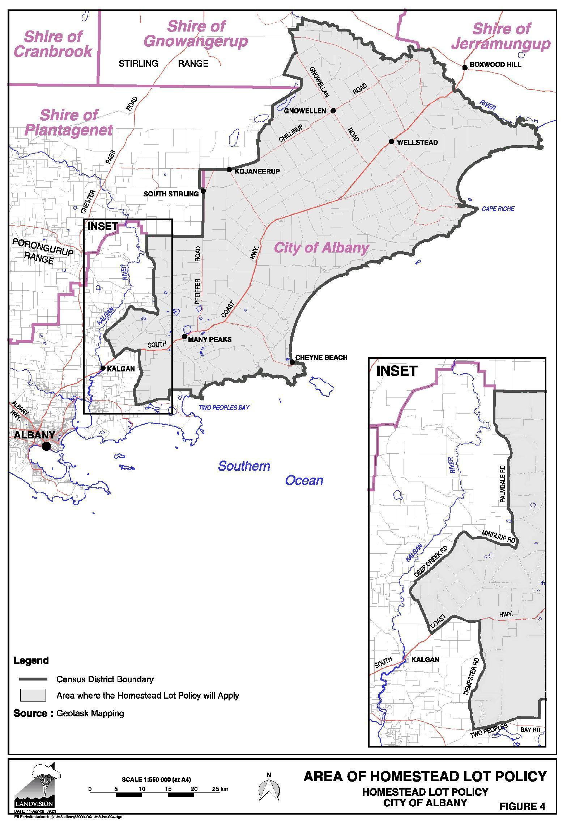

Middleton Beach Activity Centre Precinct Plan
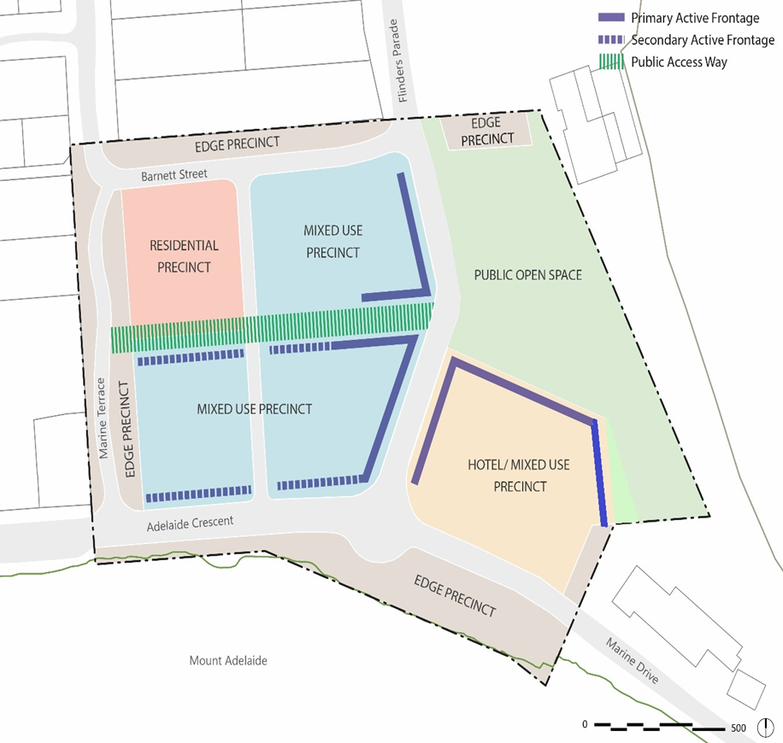

Albany Motorsports Precinct Plan
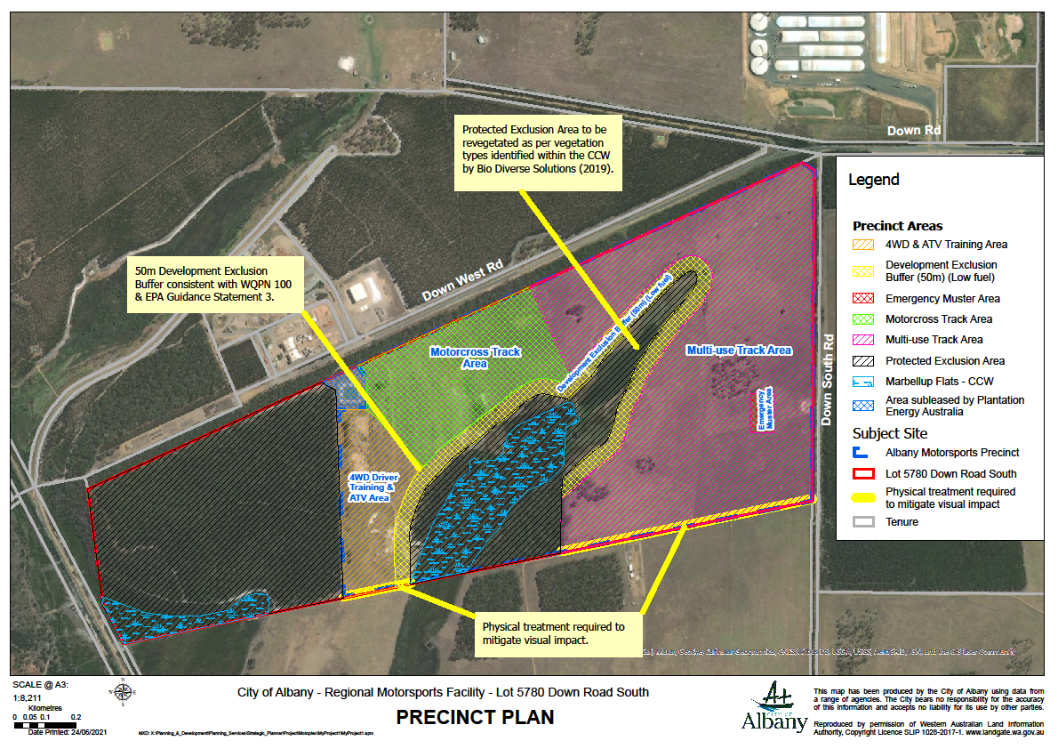

Lot 600-615 La Perouse Rd and Karrakatta Rd, Goode Beach
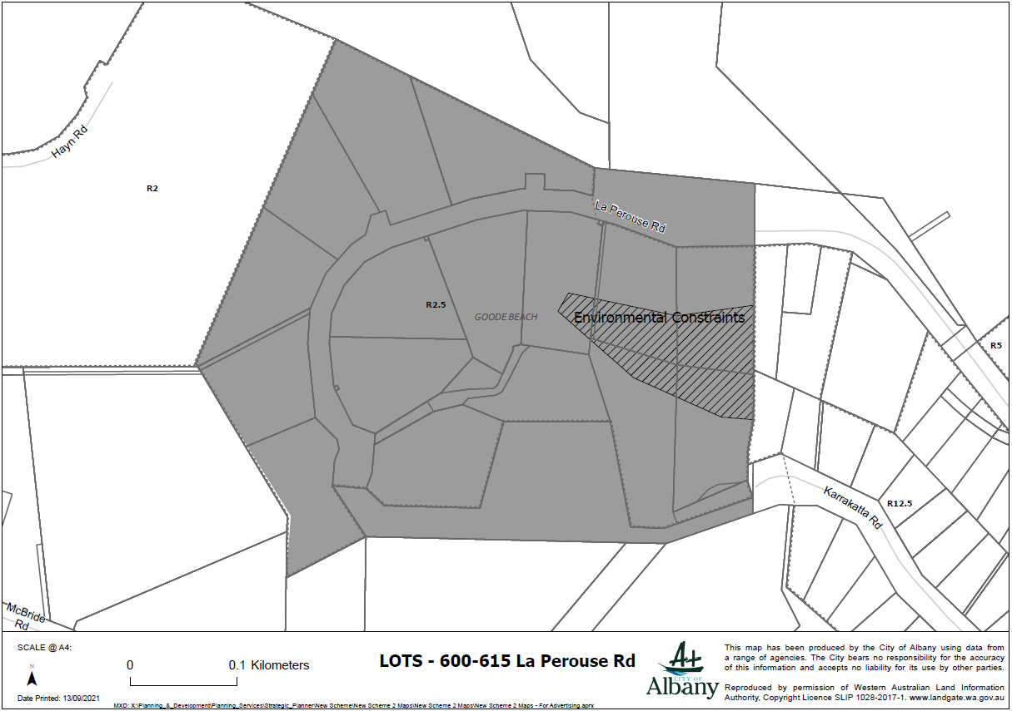

Lots 1-6 Oyster Hts, Lots 50, 905 and 9000, Oyster Hts, Lots 121-131 Maddison Way, Bayonet Head.
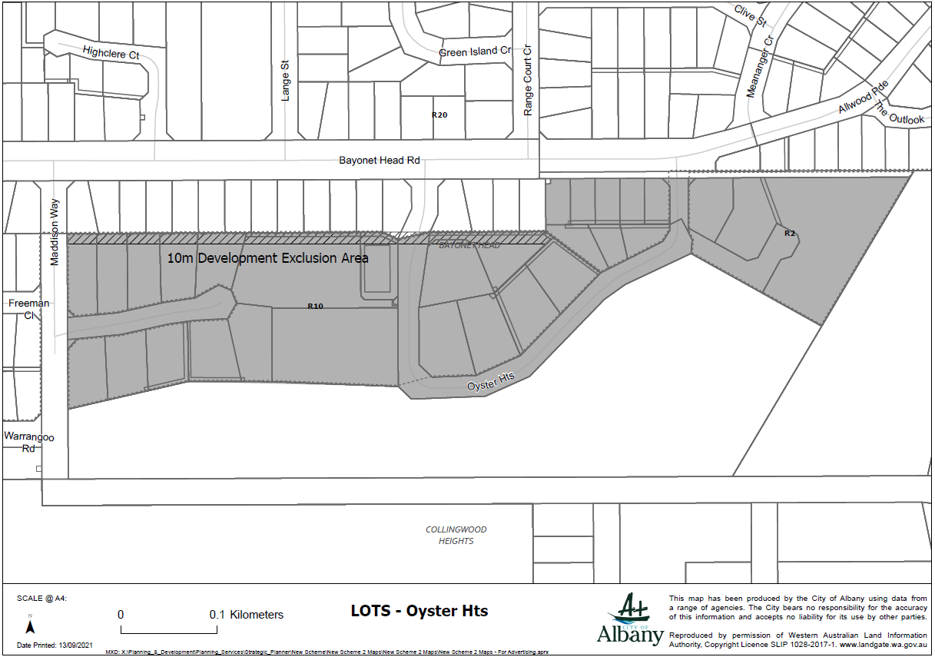

Lots on Endeavour Way, Radiata Drive, Maritime Av and Parmelia Way, McKail
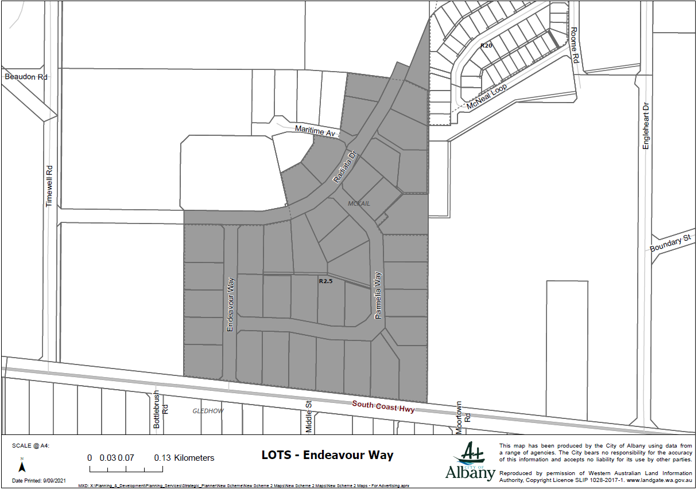

Warrenup Place, Warrenup
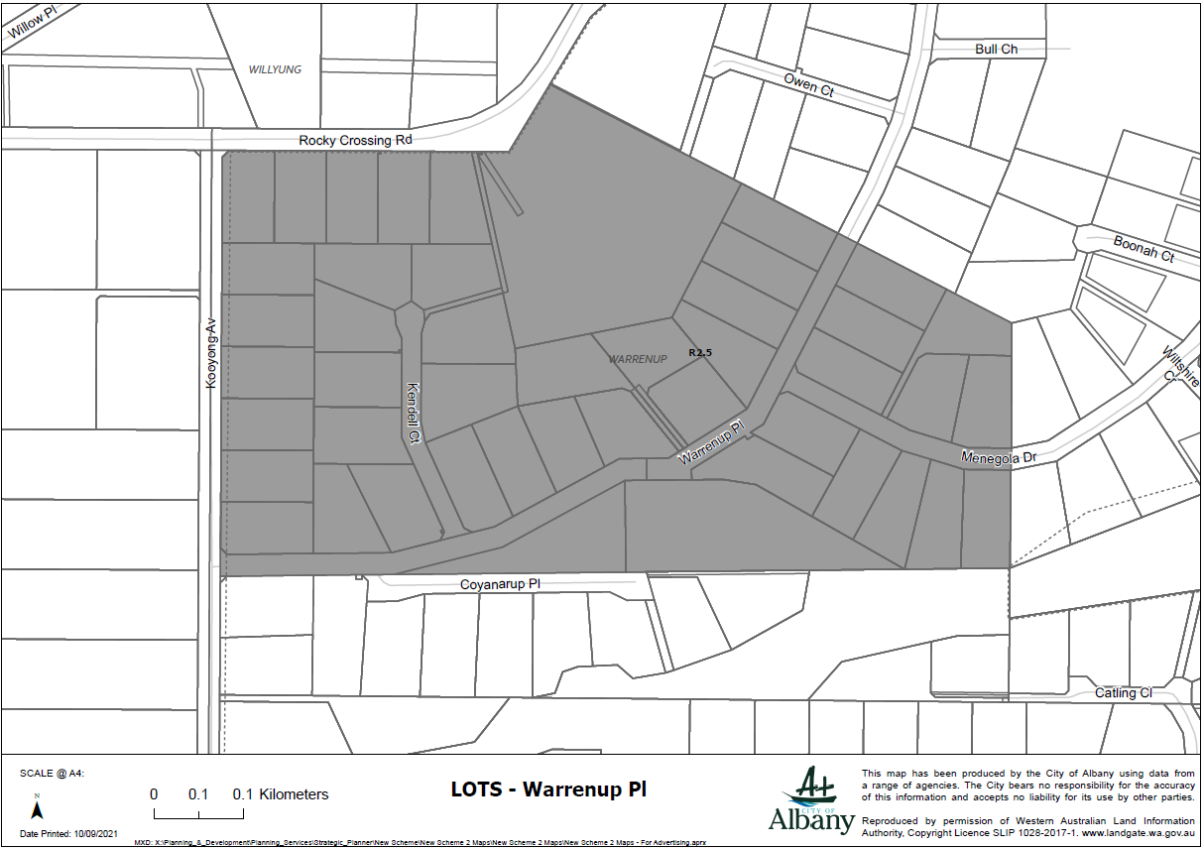

Deloraine Drive, Warrenup
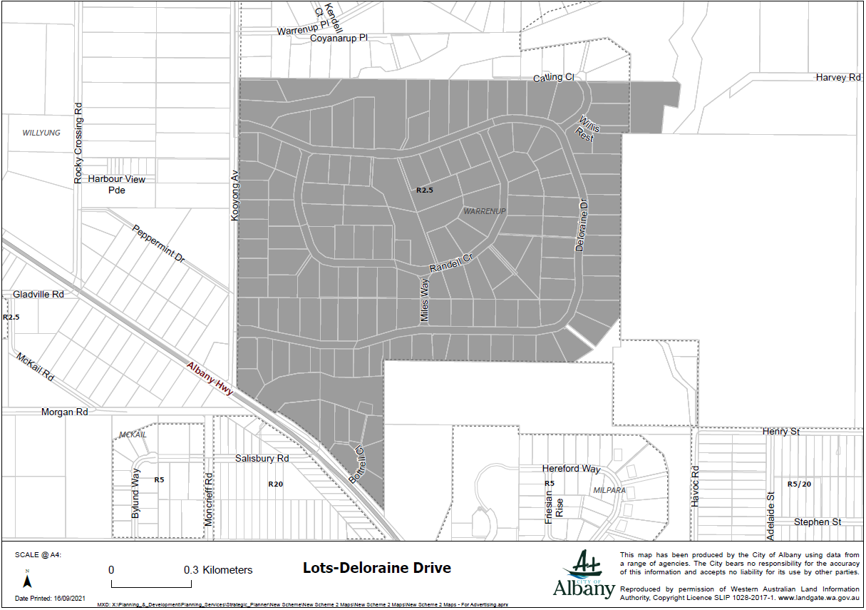

Menegola Drive, Warrenup
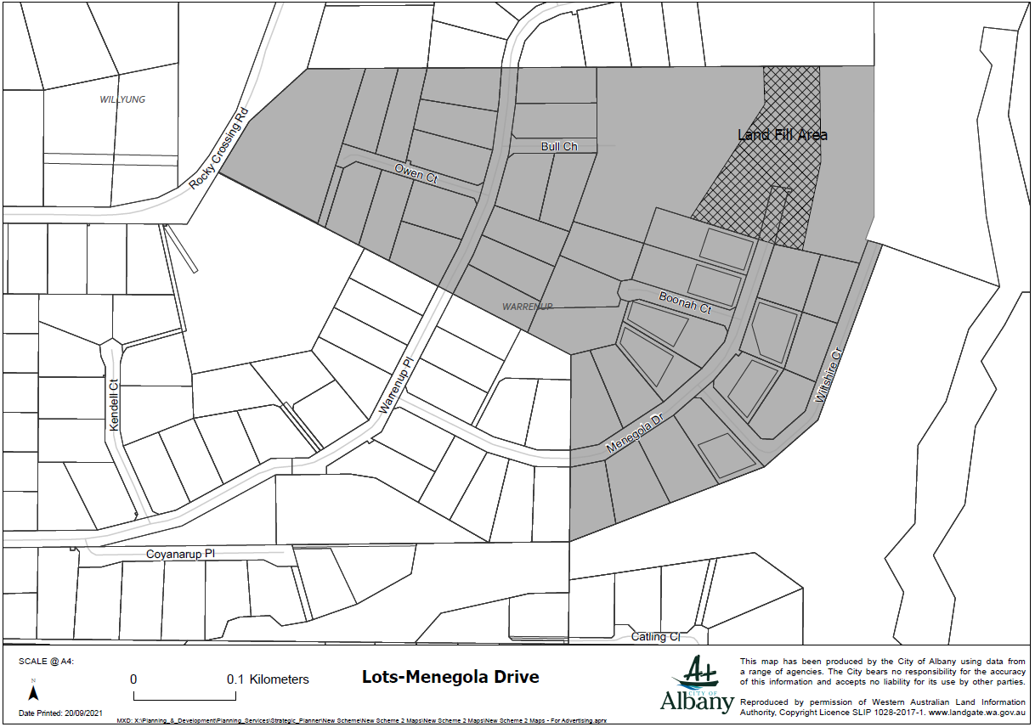

Kemal Court, Warrenup
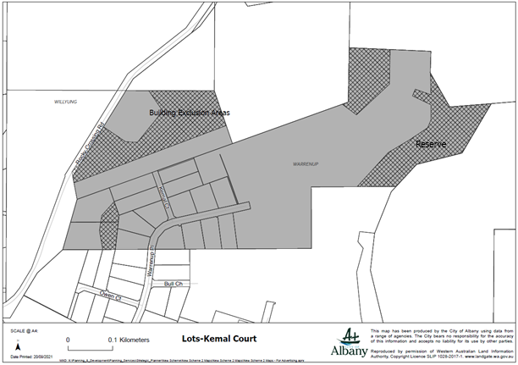

Coyanarup Place, Warrenup
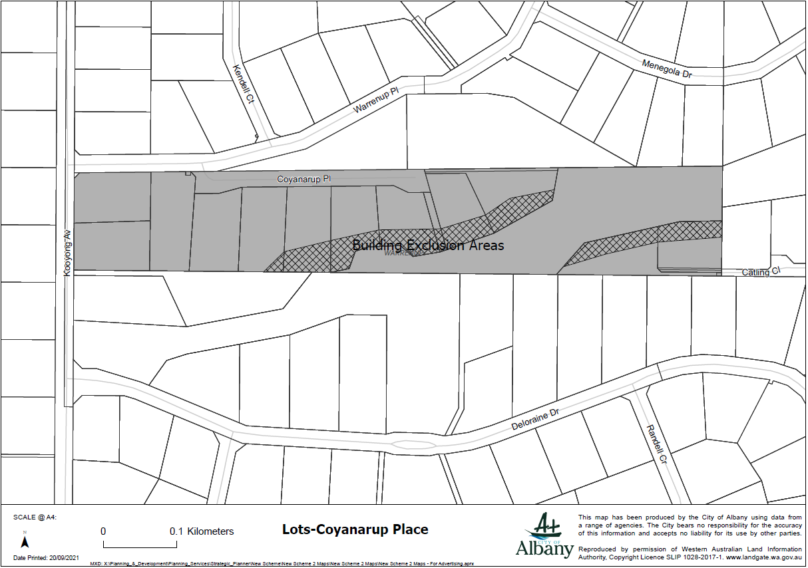

Moortown Road, Gledhow
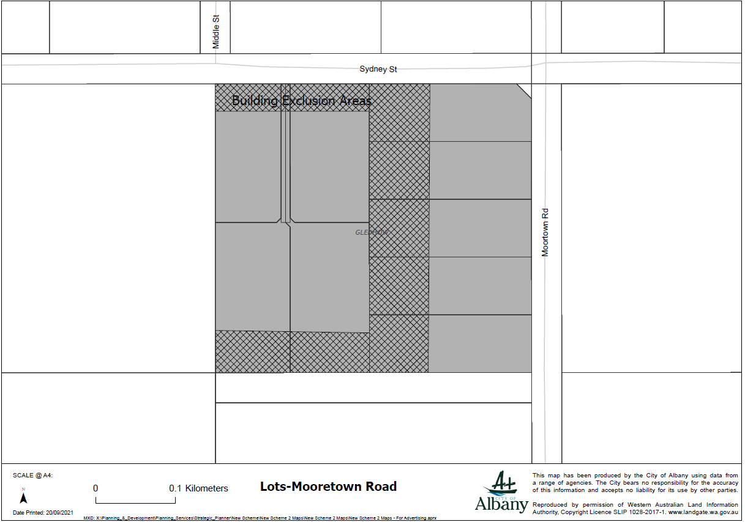

Morilla Road, Lower King
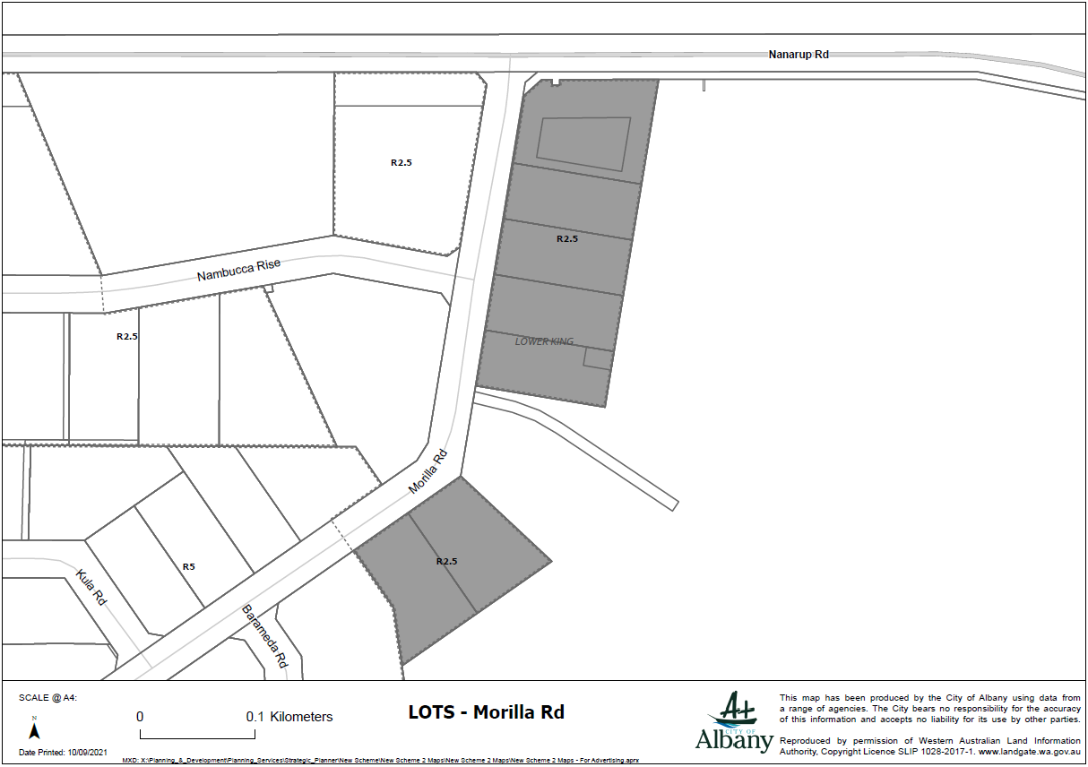

Rufus Street, Milpara
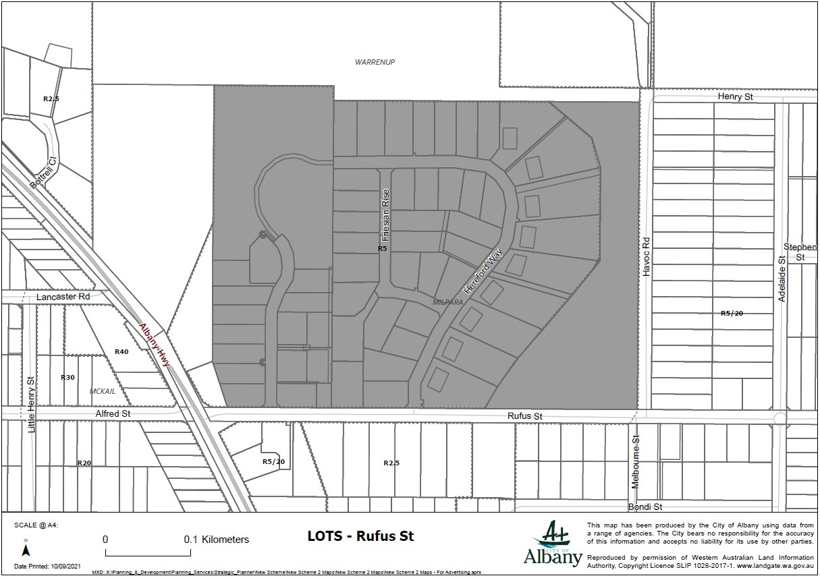

Lots 650-658, La Perouse Court, Goode Beach
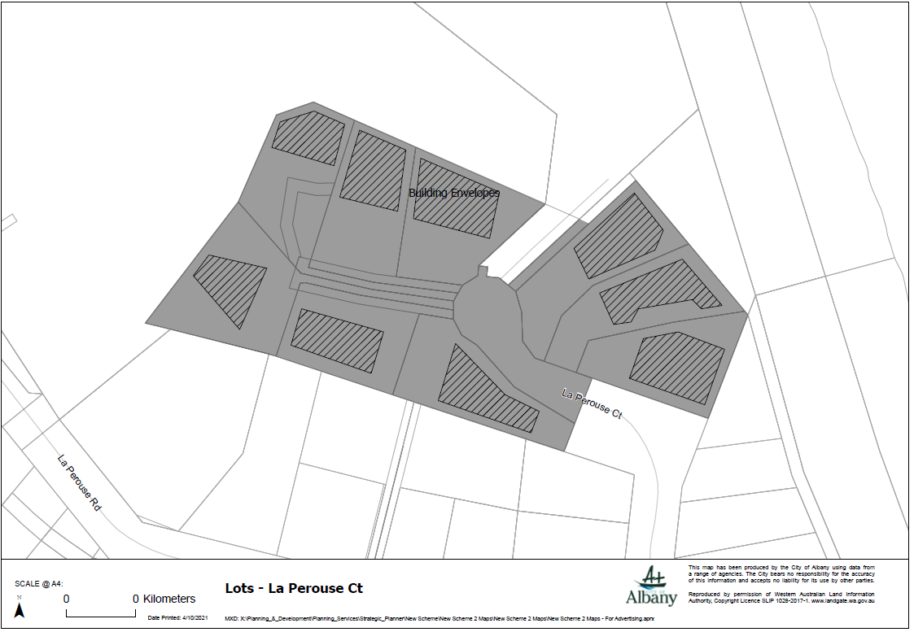

Gladville Road, McKail
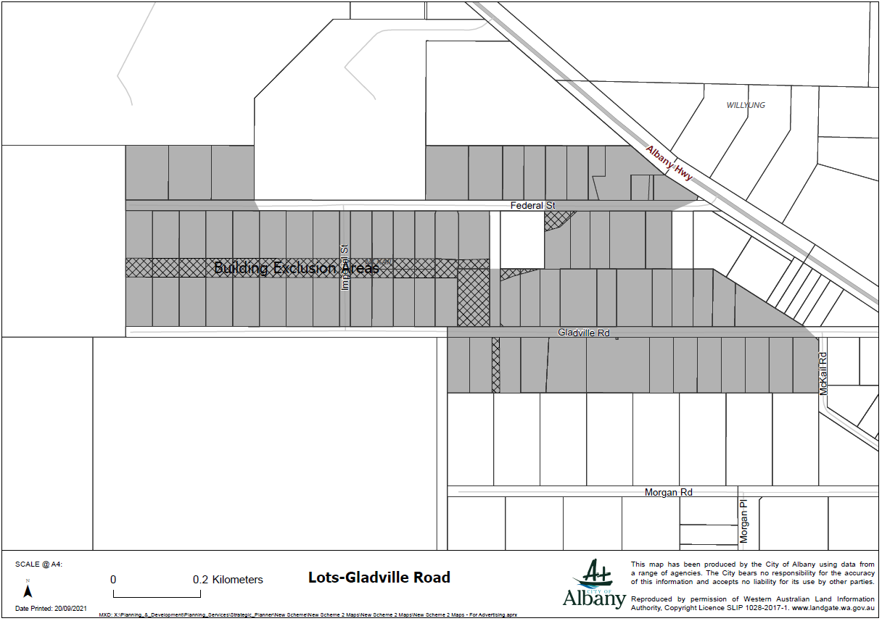

Nanarup/Kula Roads, Lower King
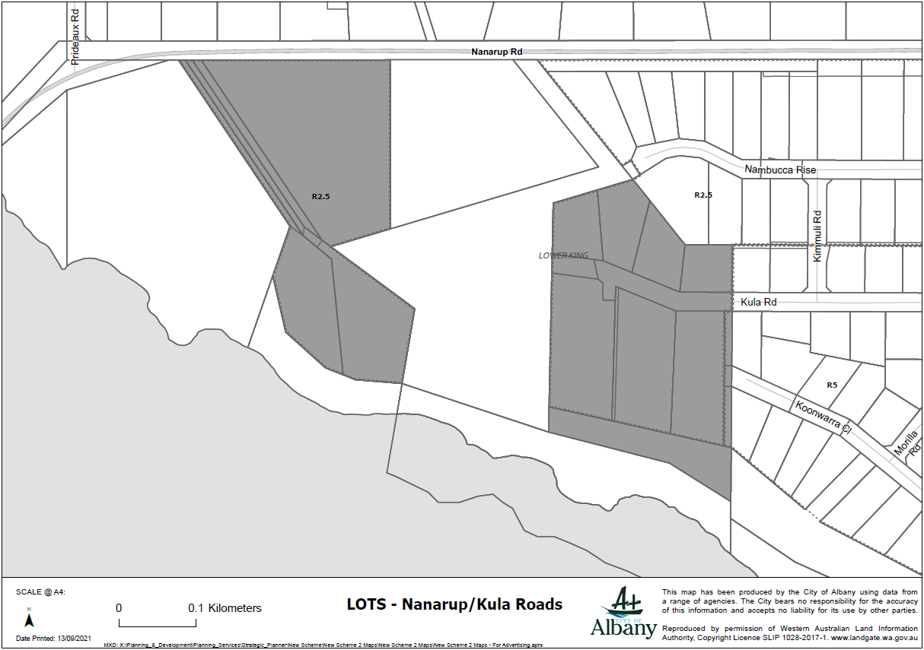

Willyung Road, Willyung
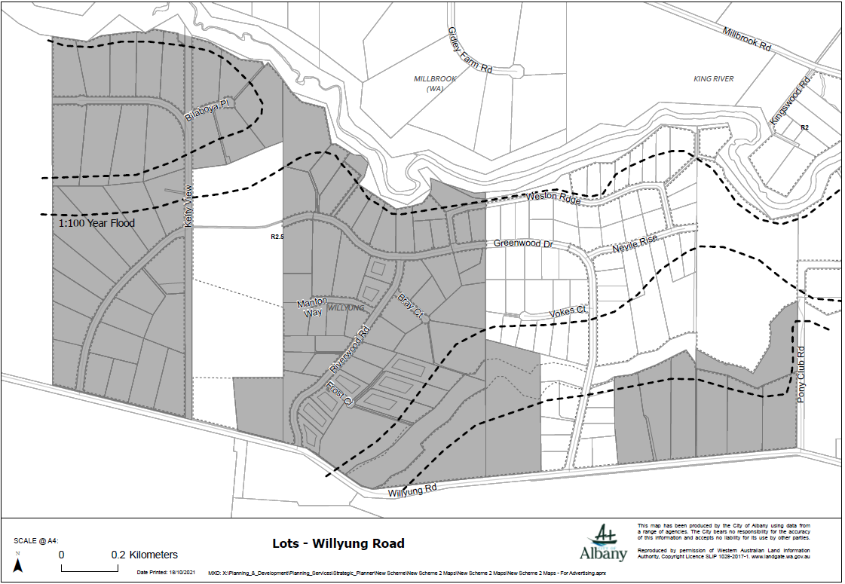

Greenwood Dr, Willyung
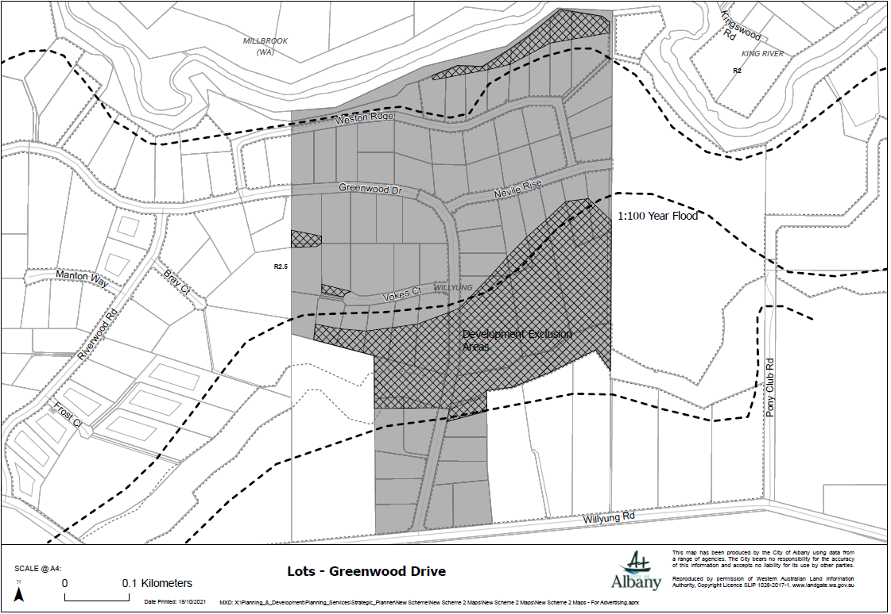

Lots-Pony Club Rd, Willyung
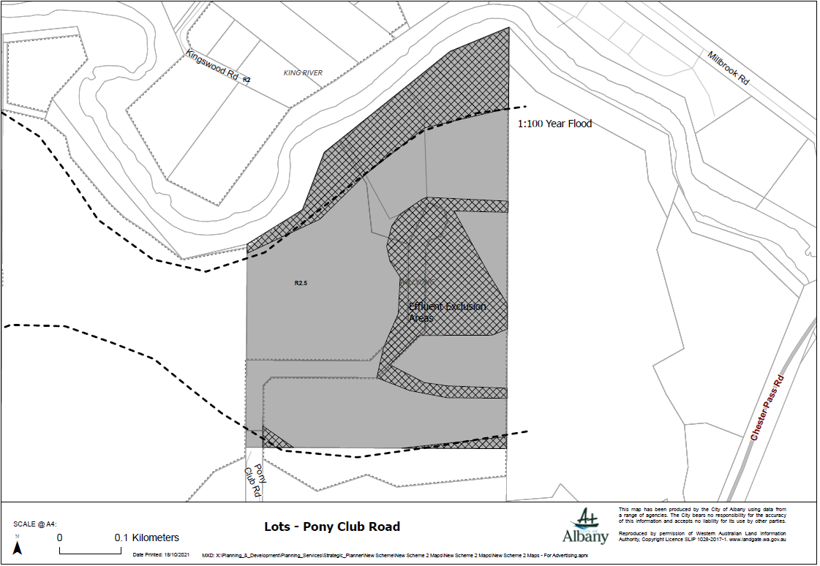

Lots – Nevile Rise, Willyung
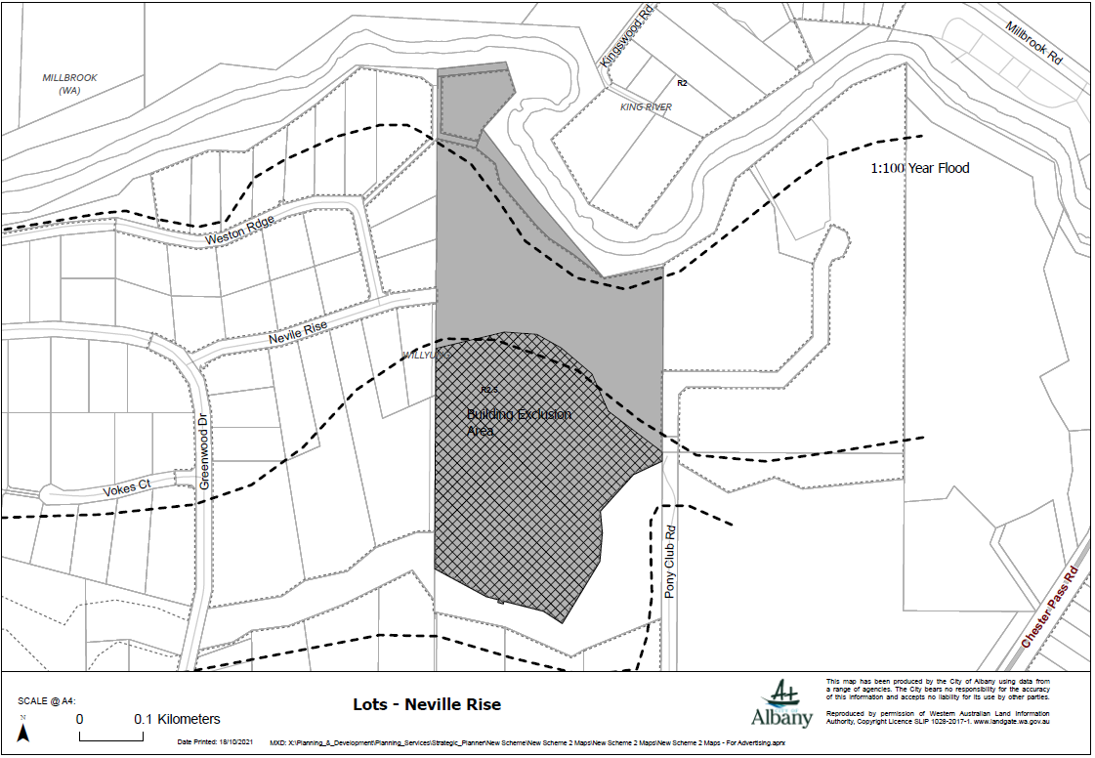

Lots-Kelty View, Willyung
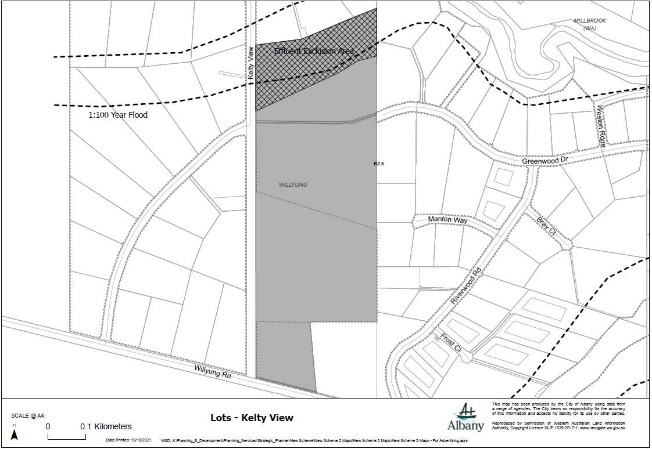

Hayne Road, Goode Beach
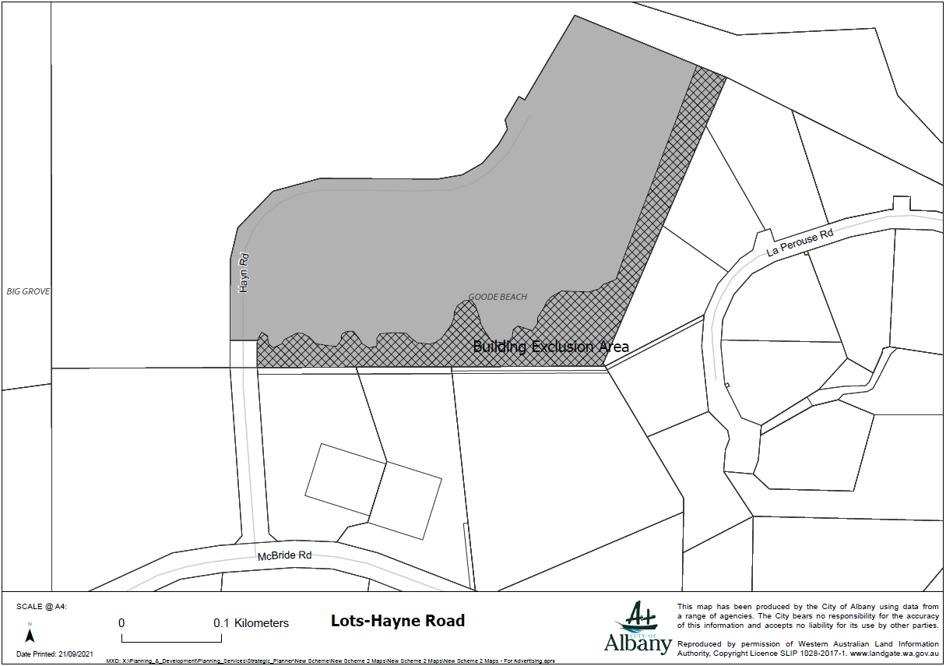

Bylund Way, McKail
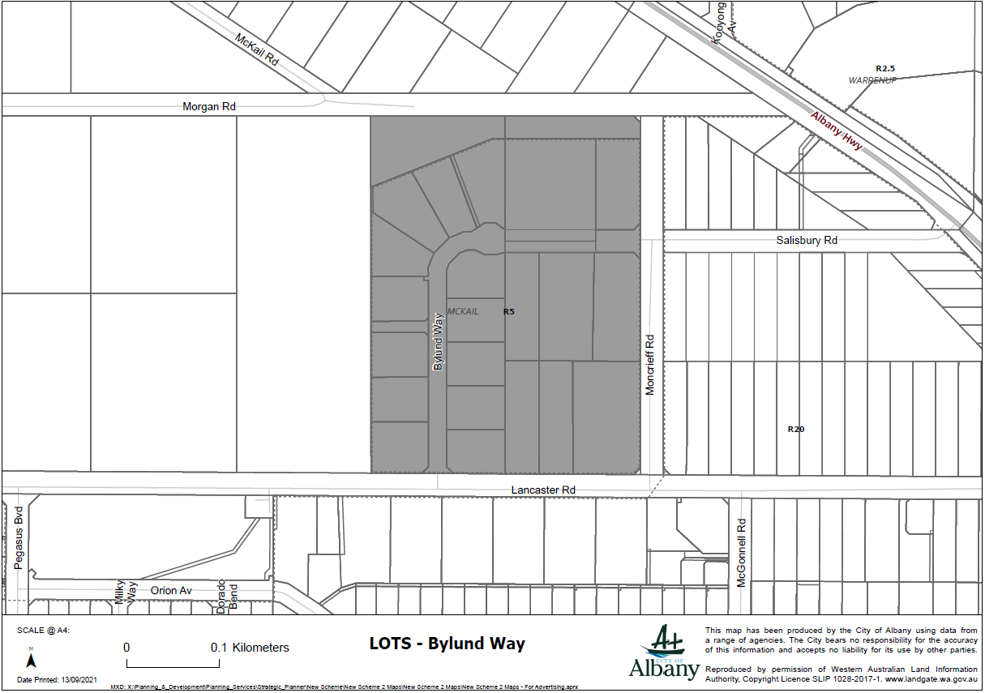

Norwood Road, Lower King
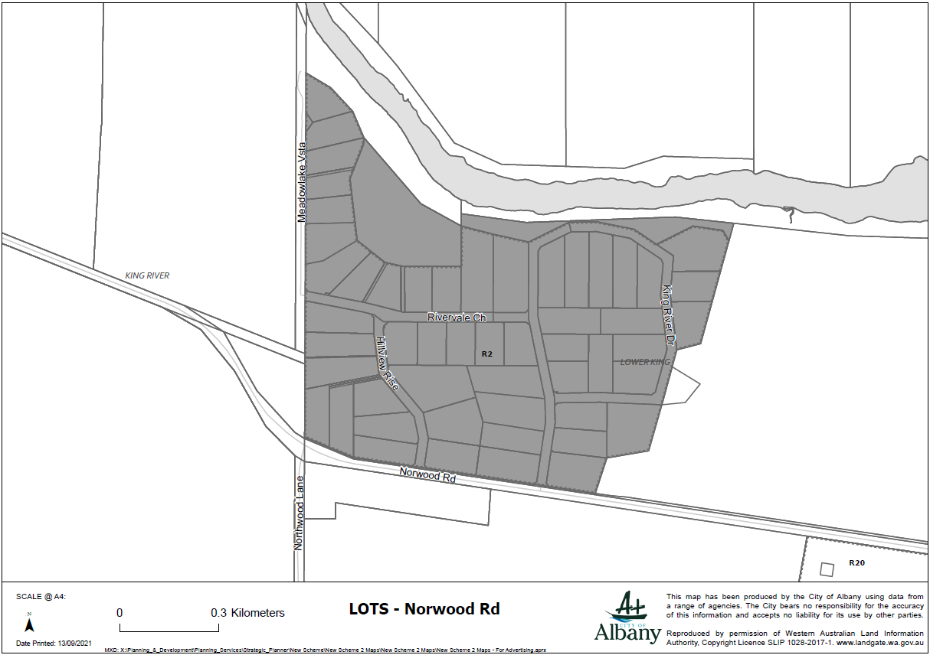

Henry Street, Warrenup
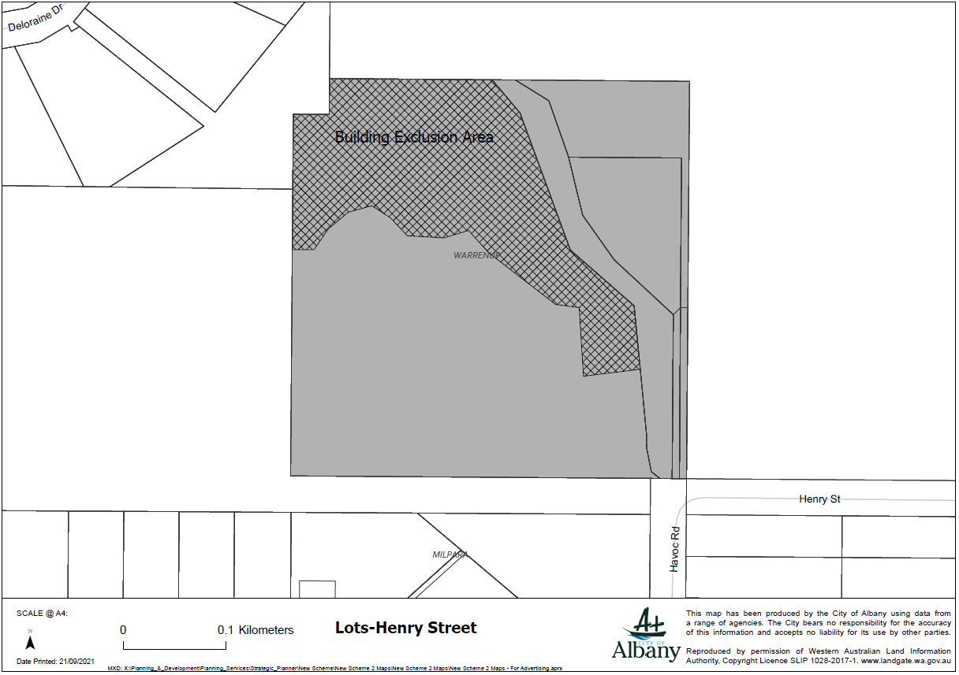

Lot 11 Nanarup Road, Kalgan
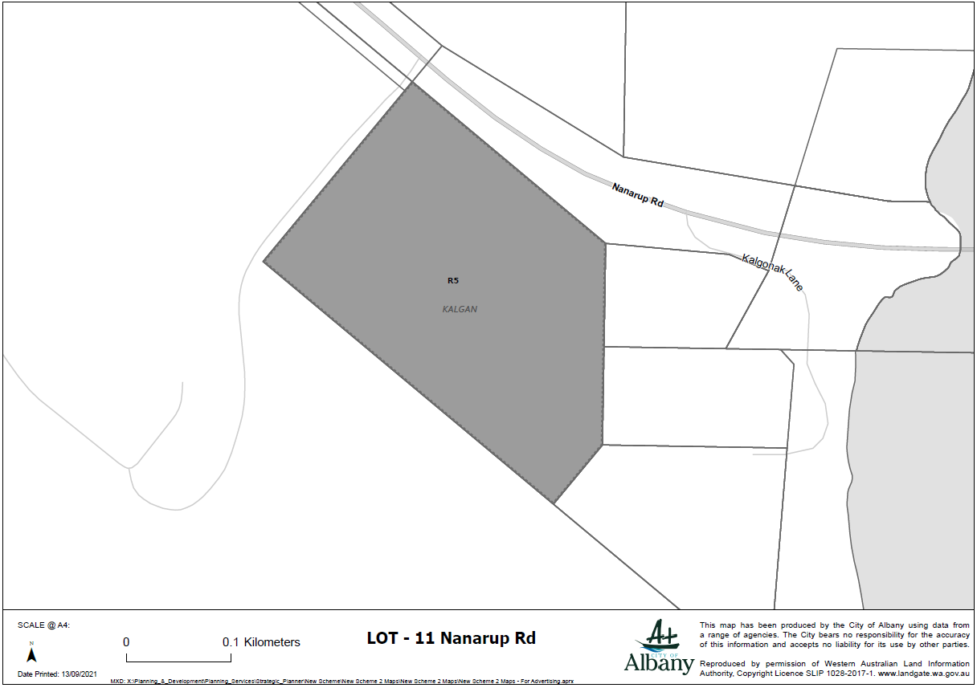

Lots – Kalgonak Lane
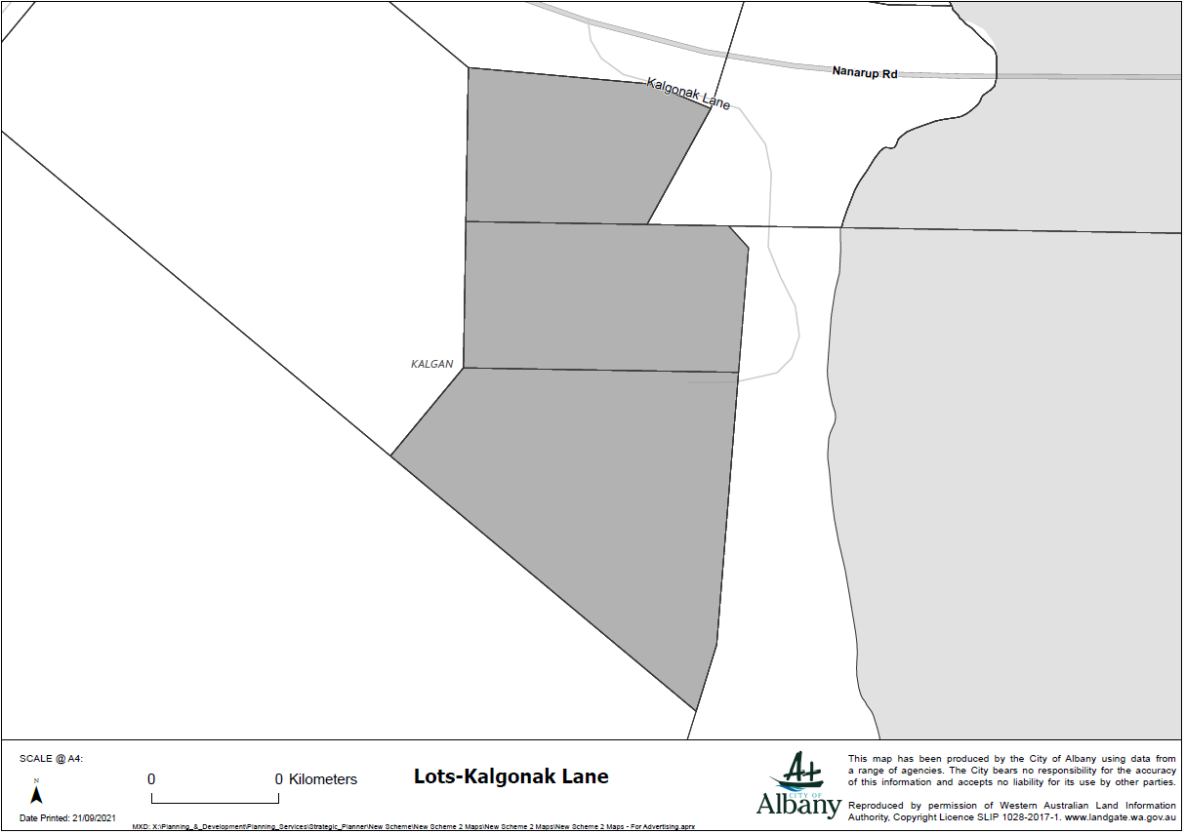

Lots – Sandalwood Road
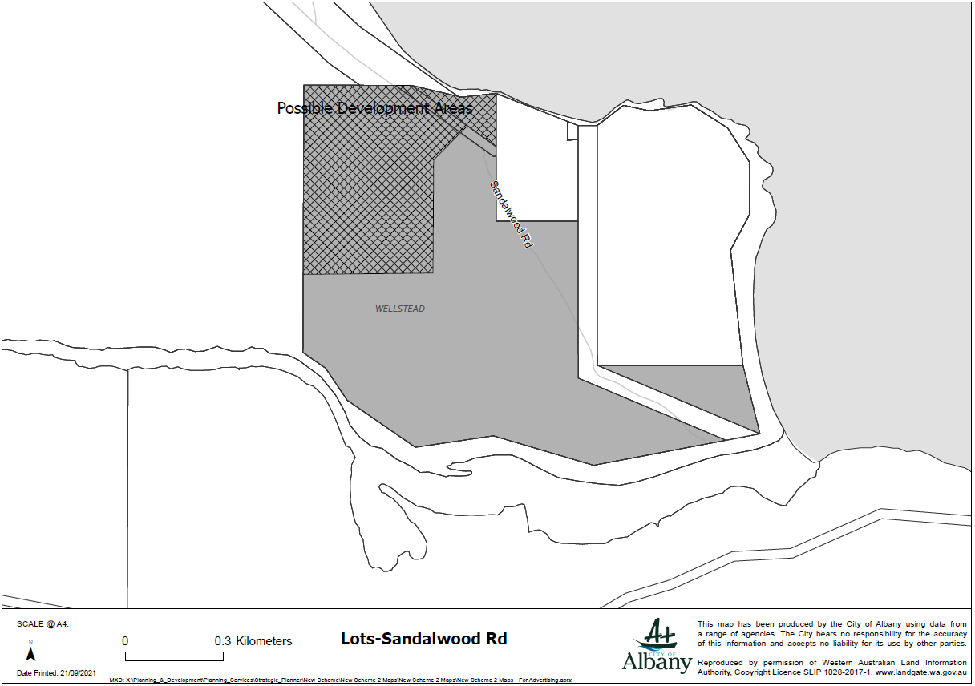

Lots - Hazzard Road, Millbrook
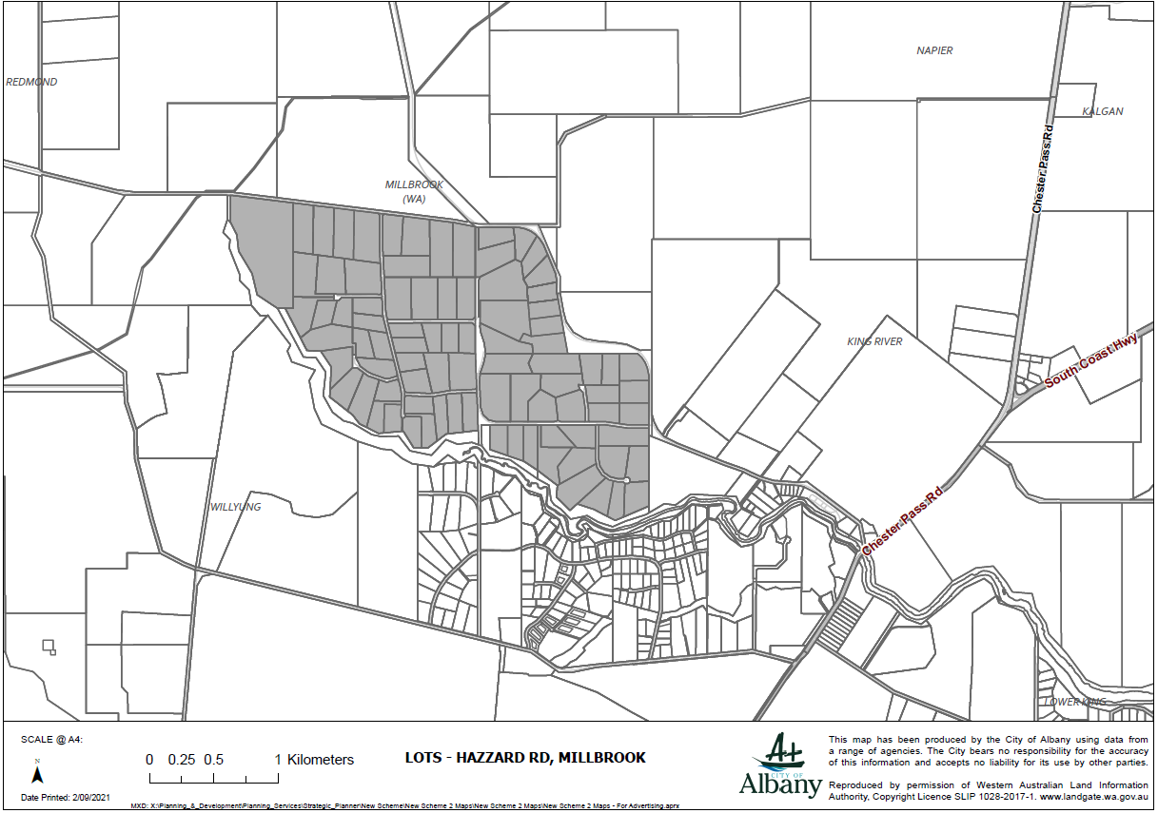

Lots – Mead Rd, Kalgan
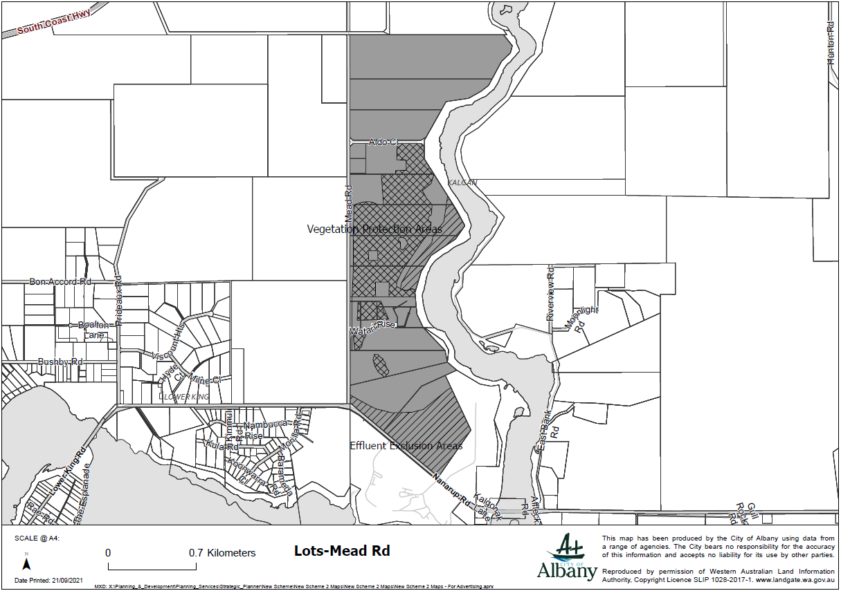

Lots – McBride Road, Goode Beach
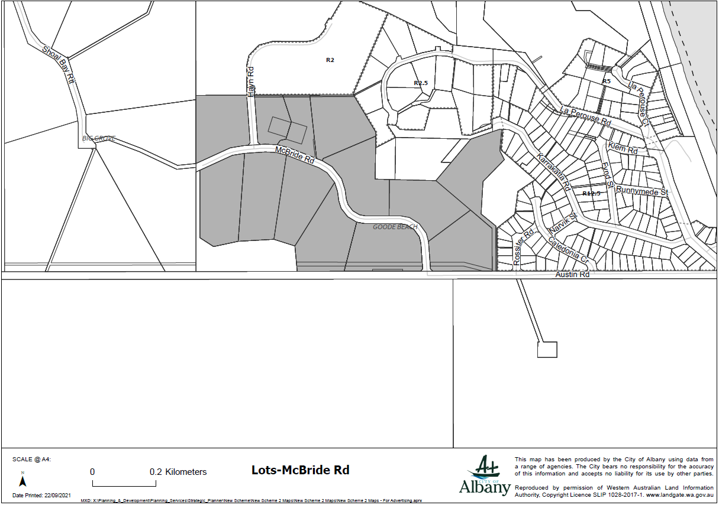

Lots - Gull Rock Road (West), Kalgan
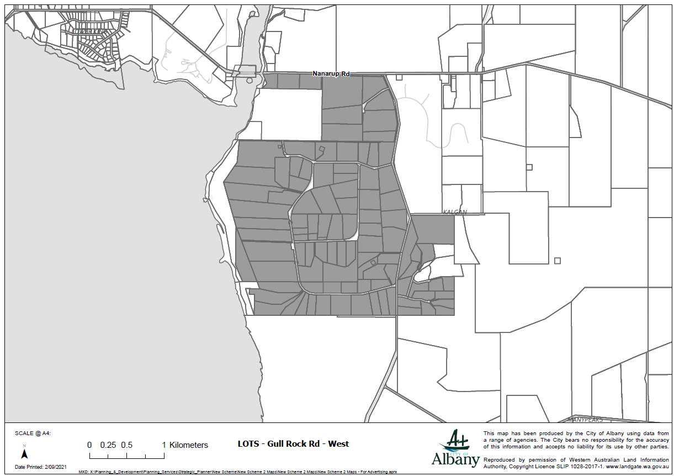

Lots – Valley Pond Hts
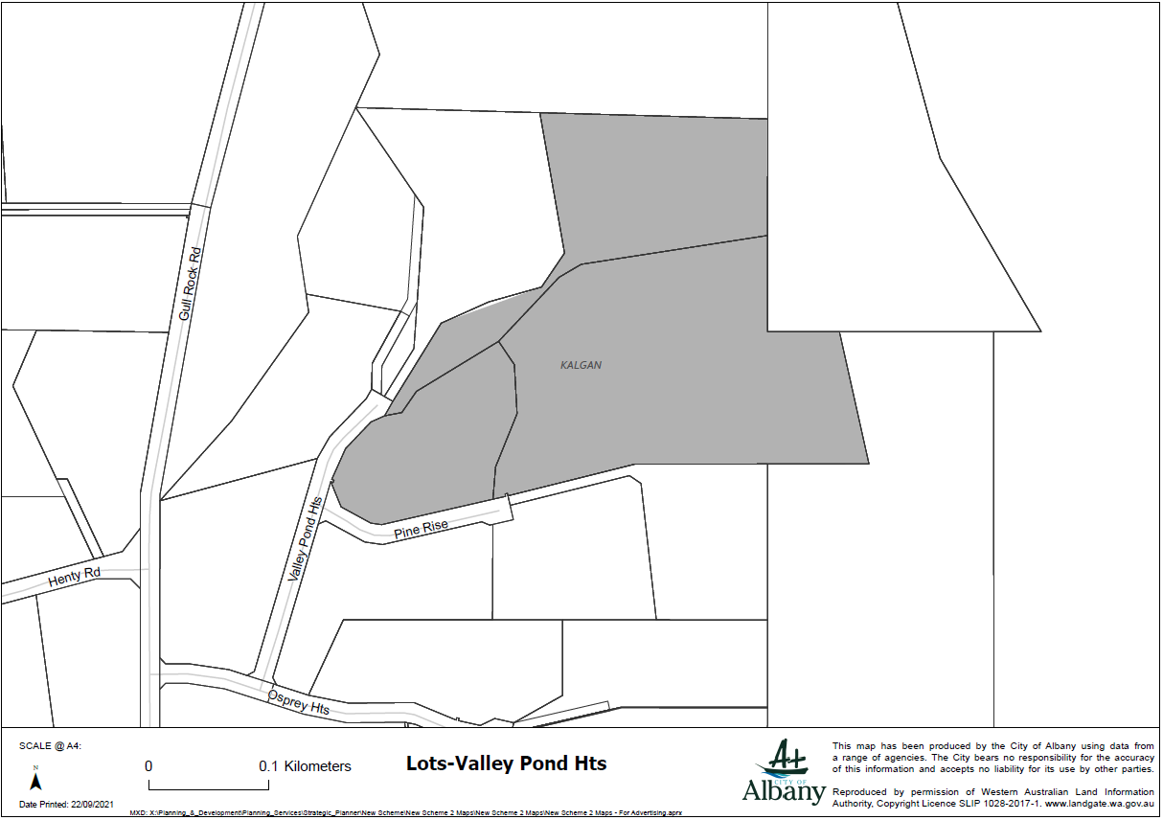

Lots - Gull Rock Road (East), Kalgan
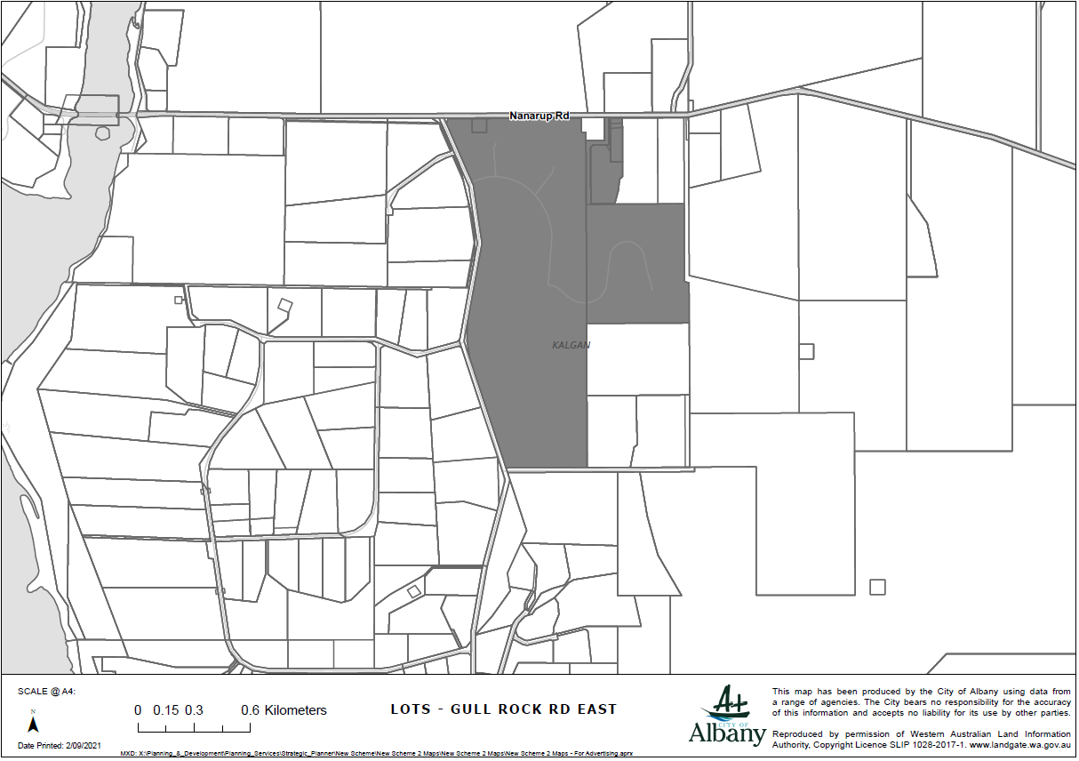

Lots – Shoal Bay Rtt
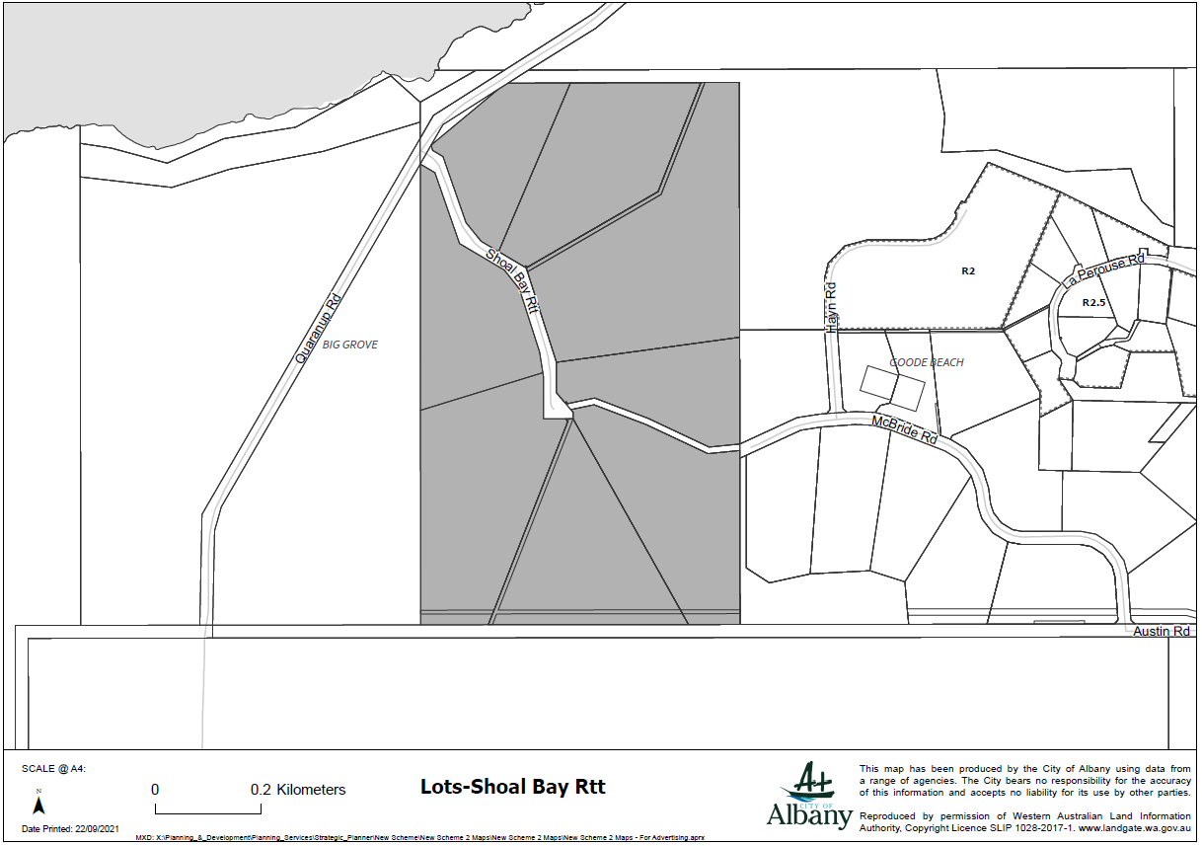

Lots - Rowney Road, Robinson
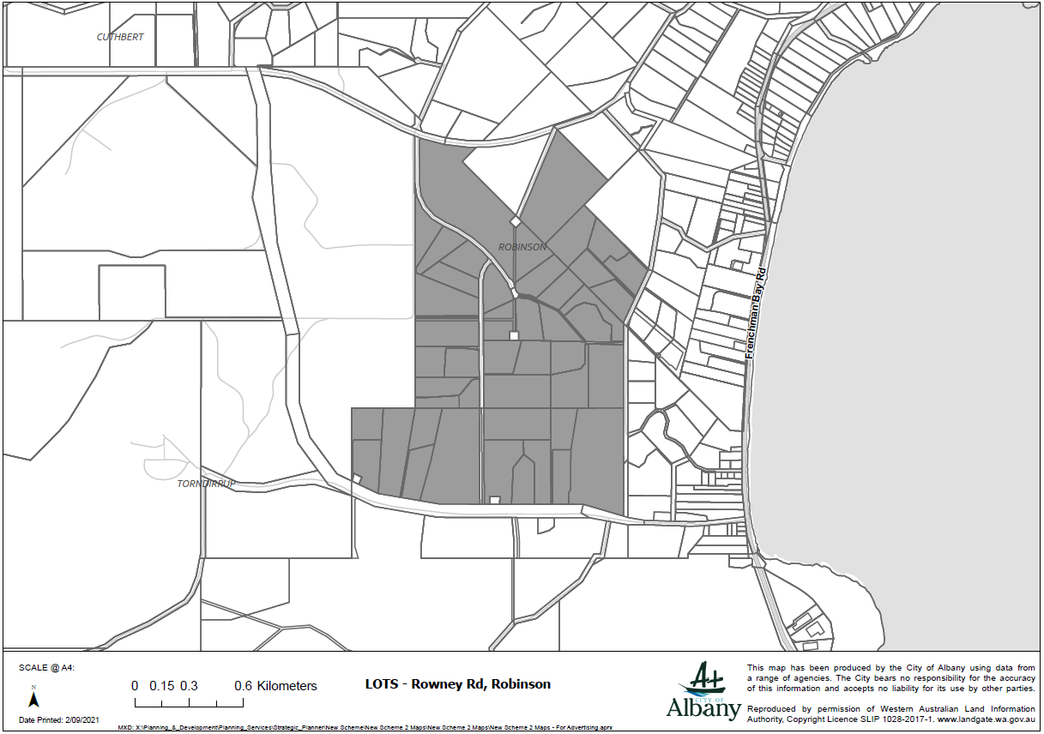

Lots - Viscount Hts, Kalgan
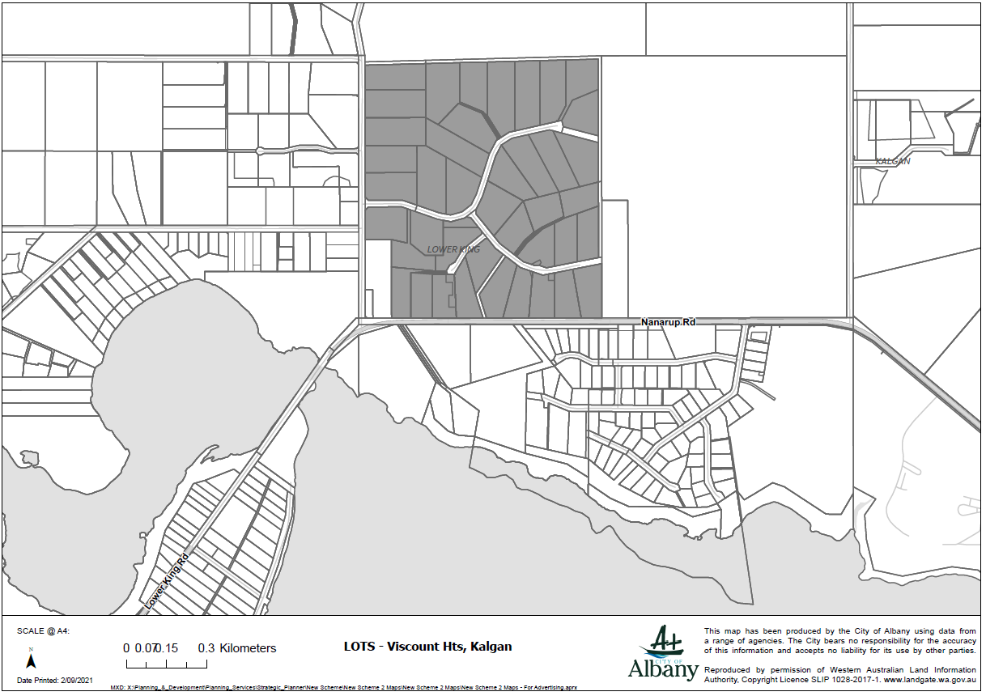

Lots - Pinaster Road, Willyung
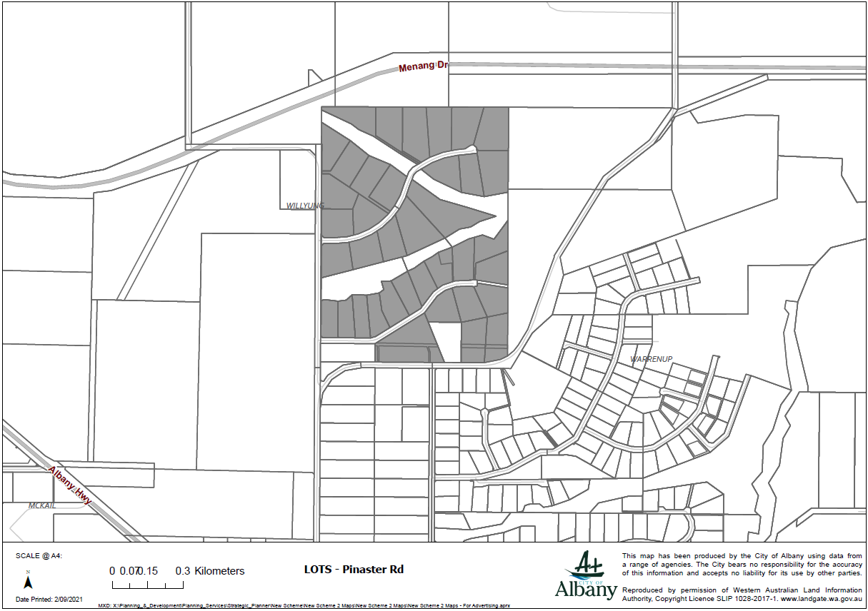

Lots – Peet Rise, Kronkup
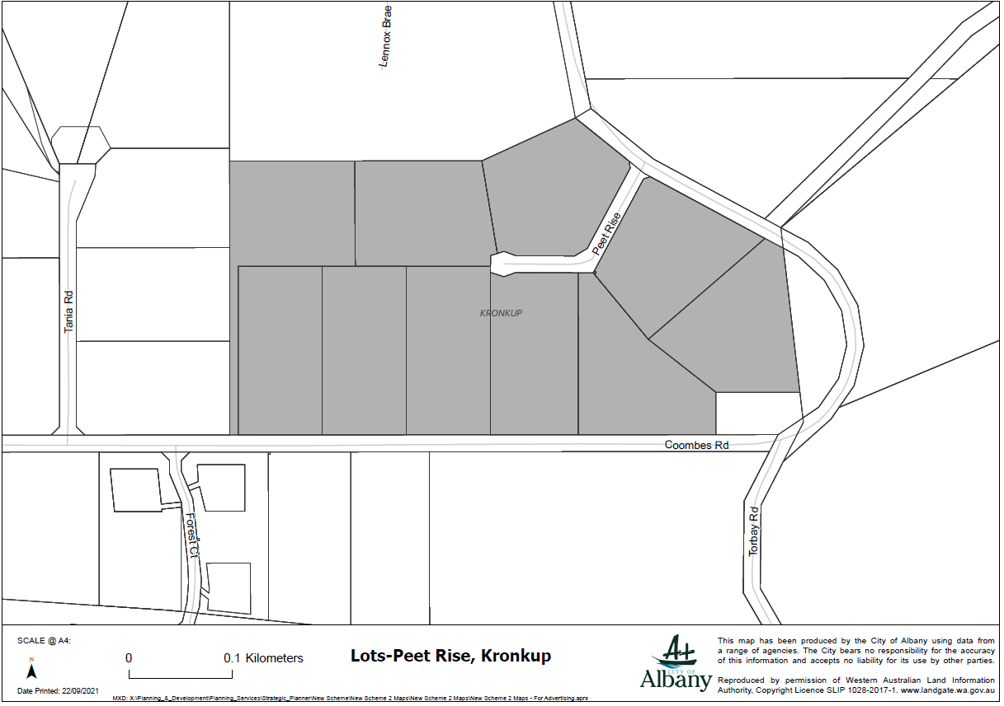

Lots – Forsyth Glde
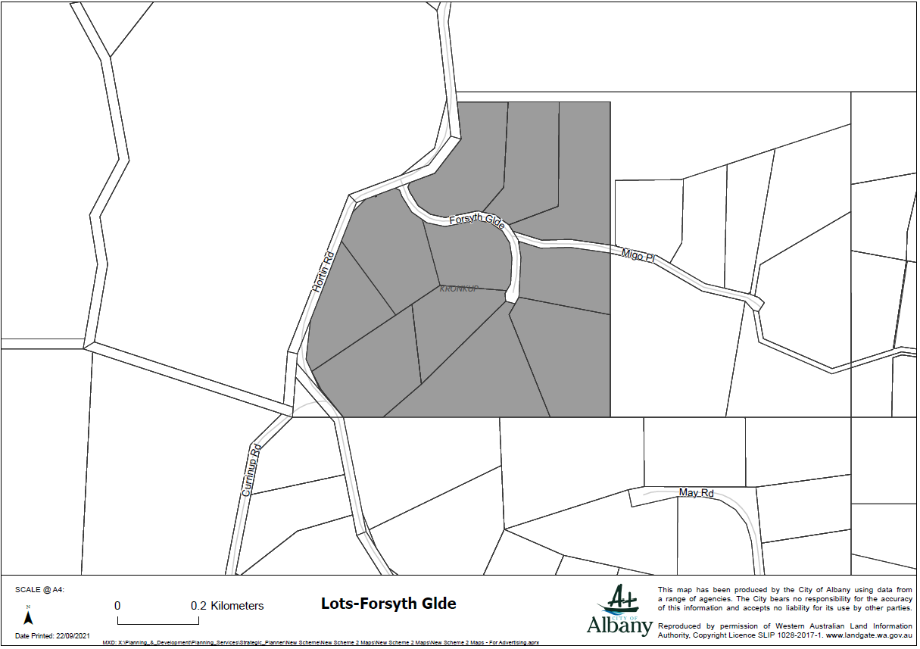

Lots – Robinson Road
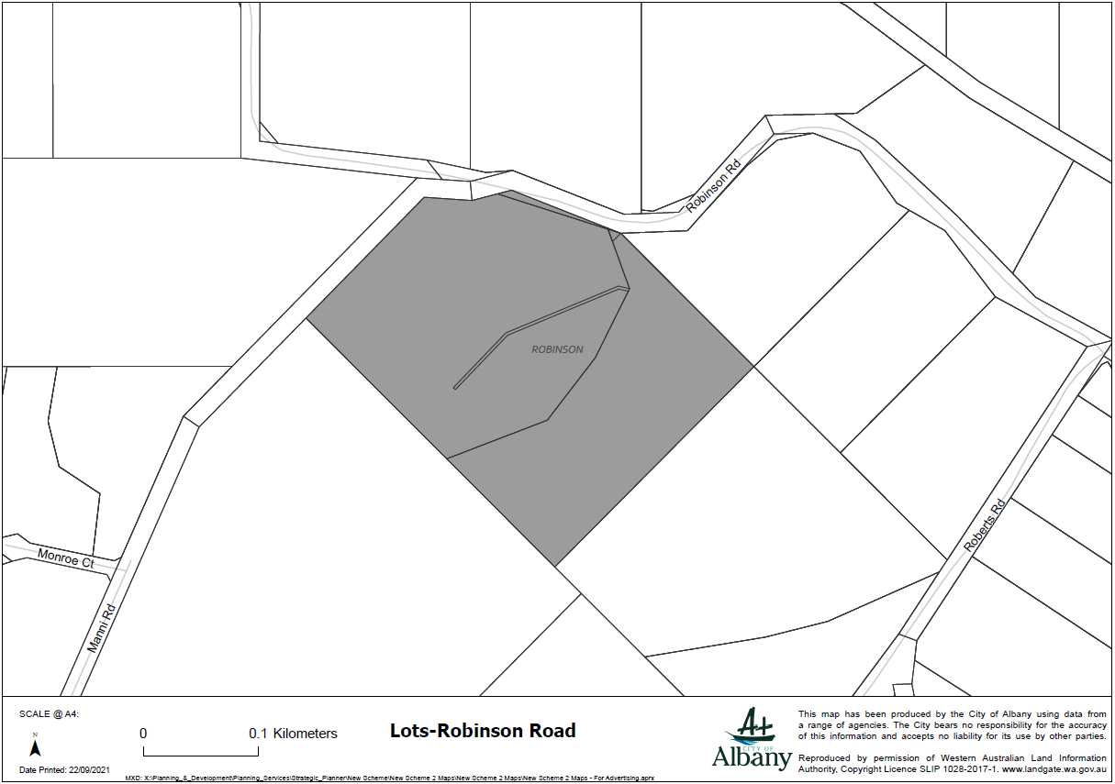

Lots – Pearson Place
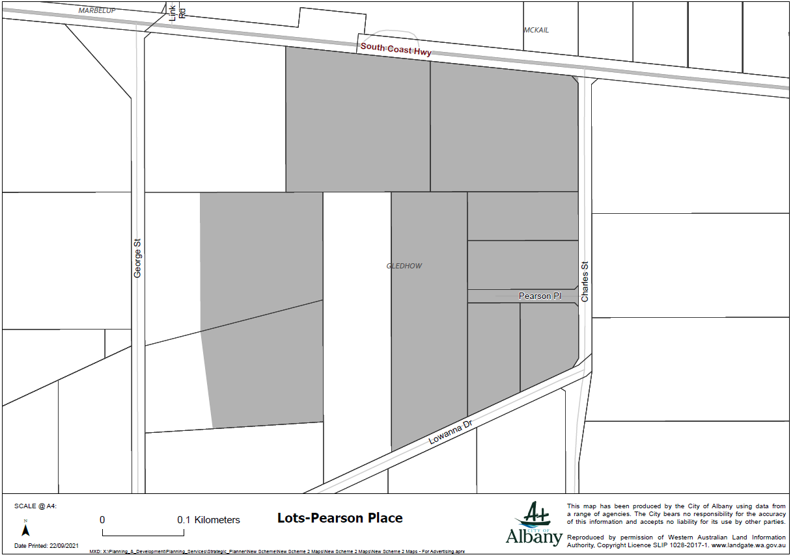

Lots – Greatrex Road
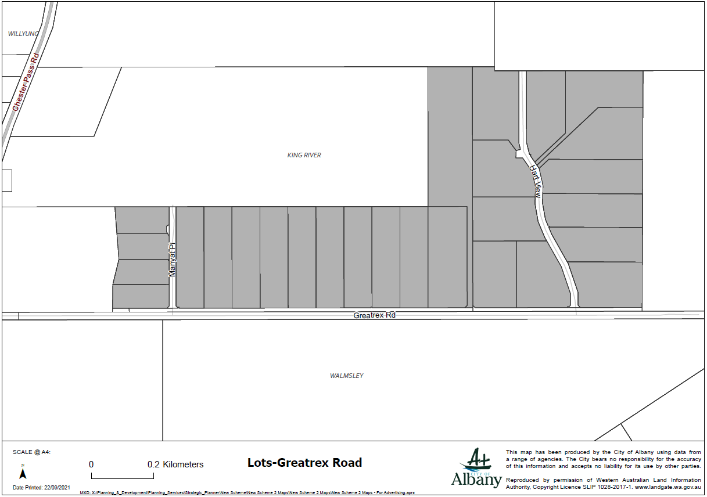

Lots - Bon Accord Road, Lower King
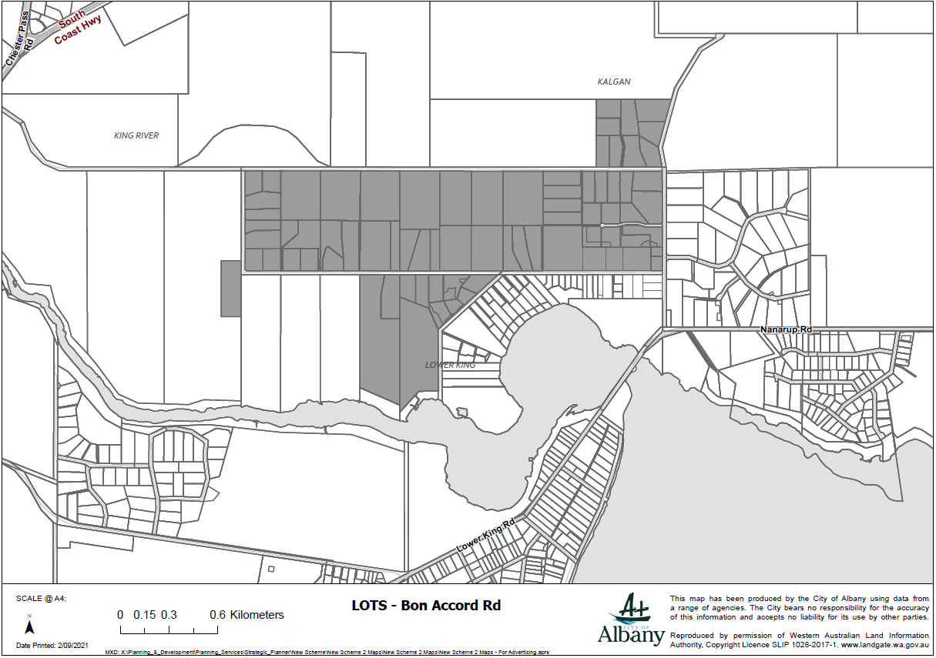

Lots - Lowanna Drive, Marbelup
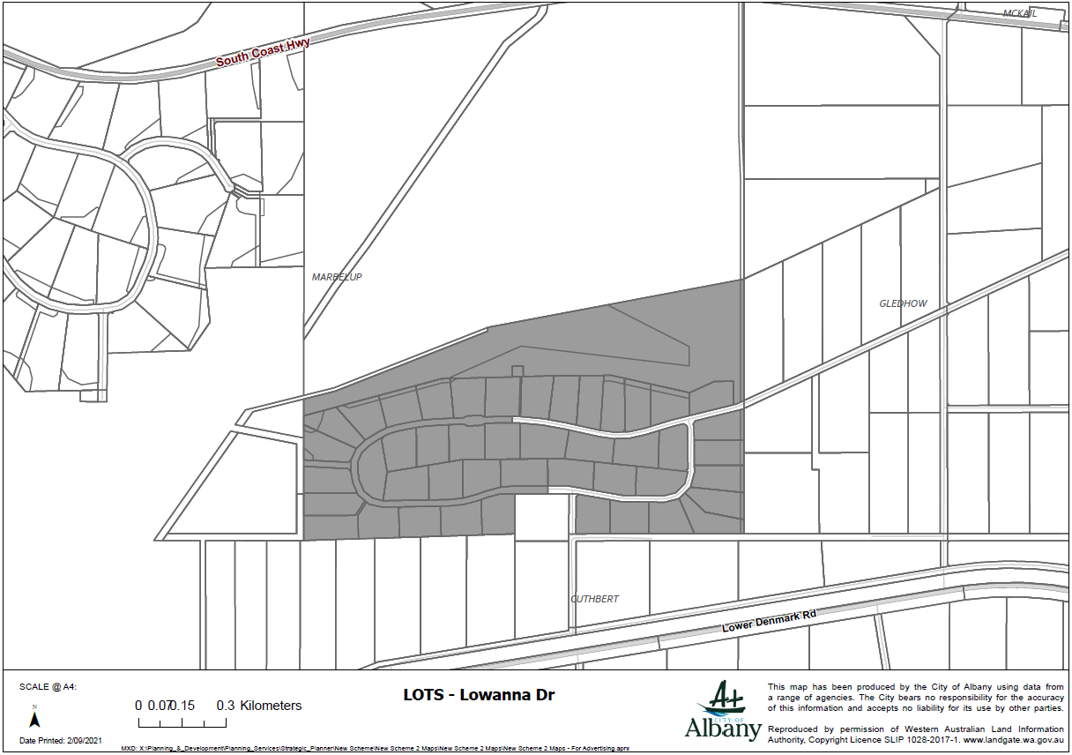

Lots – Lancaster Road
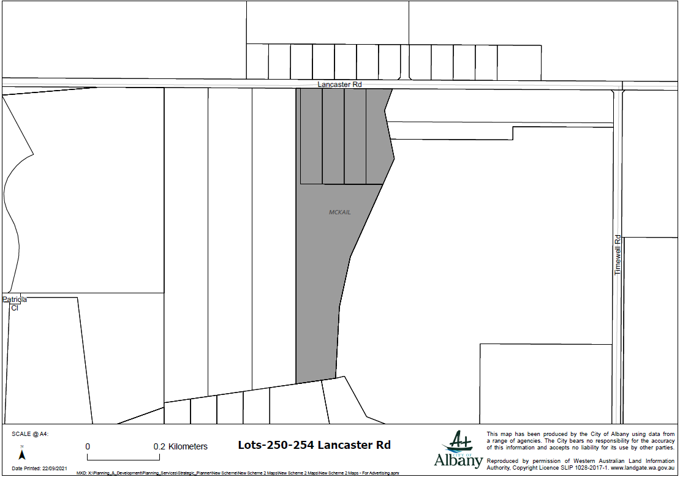

Lots - Link Road/Ajana Drive, Marbelup
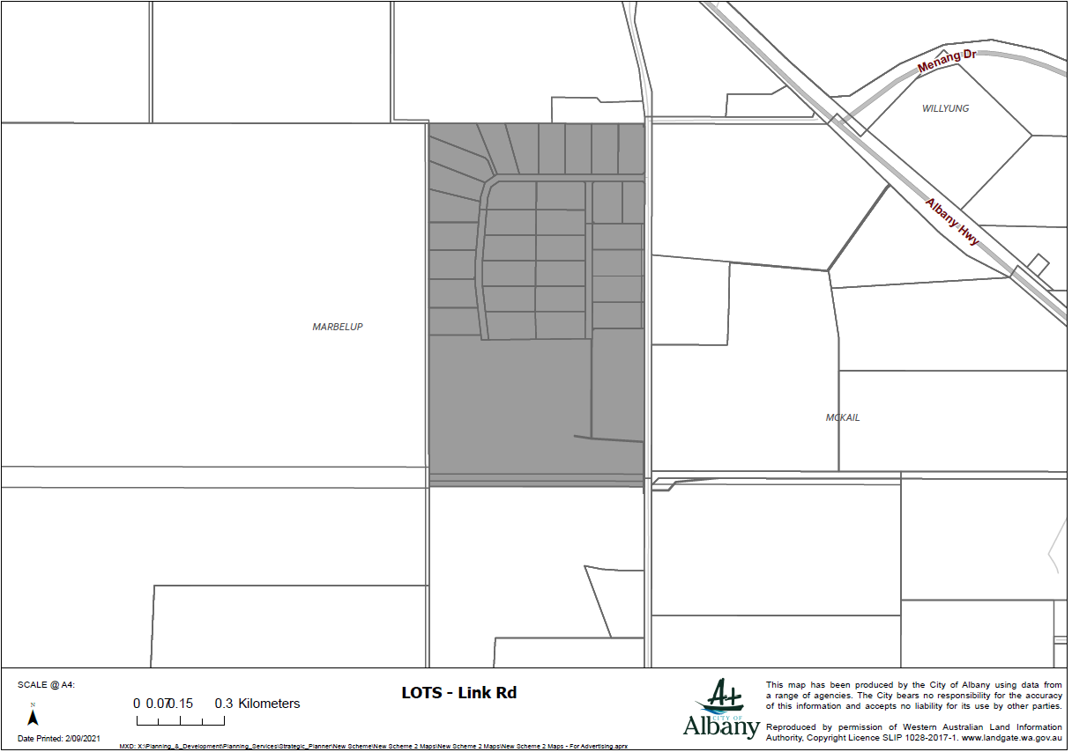

Lots - Laithwood Crt, Marbelup
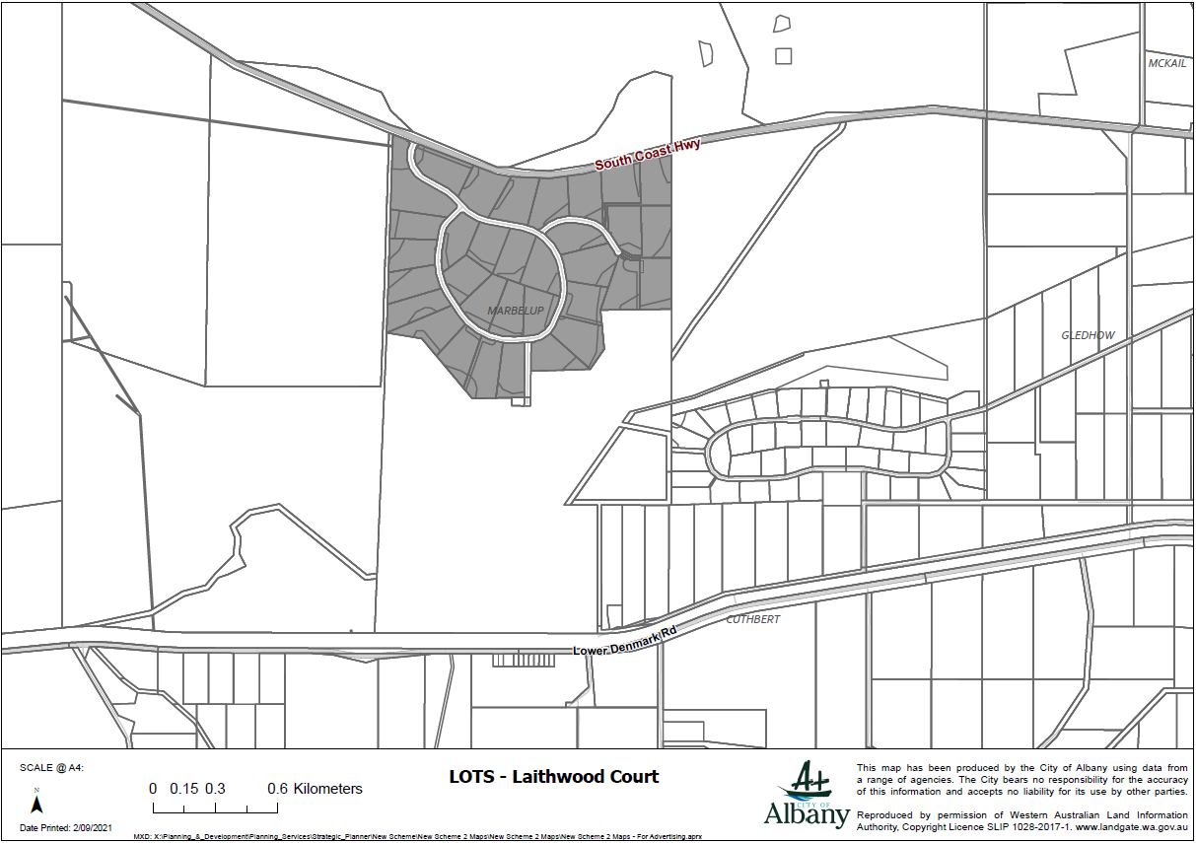

Lots - Manni Road, Robinson
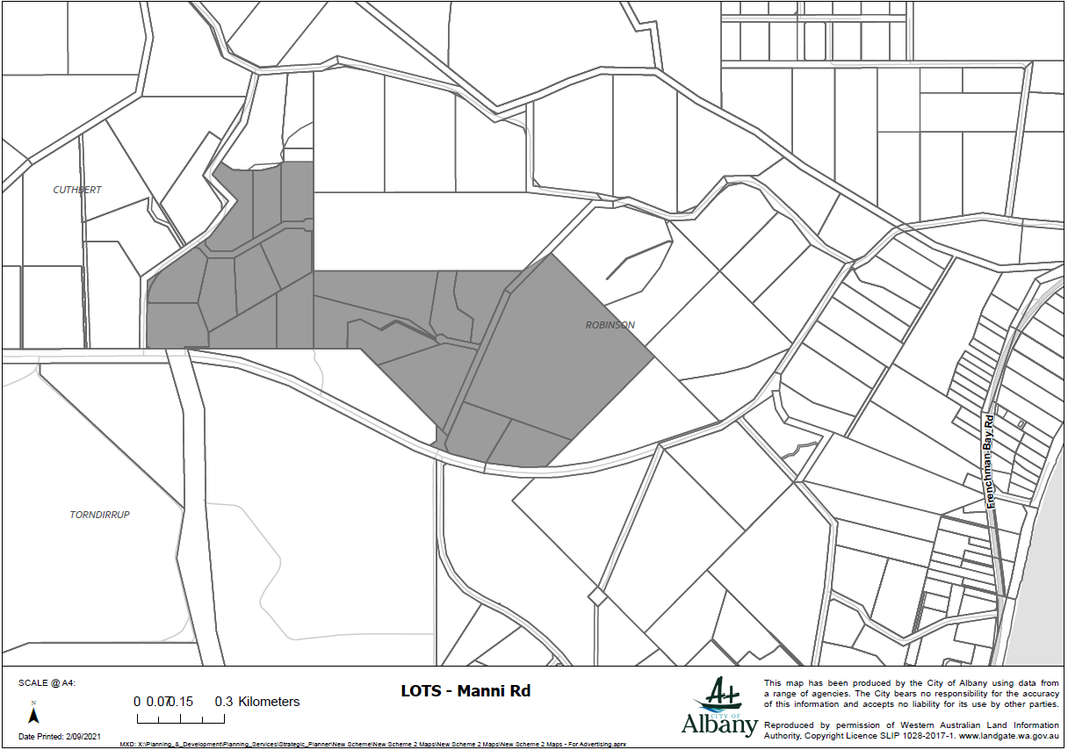

Lots – Racecourse Road
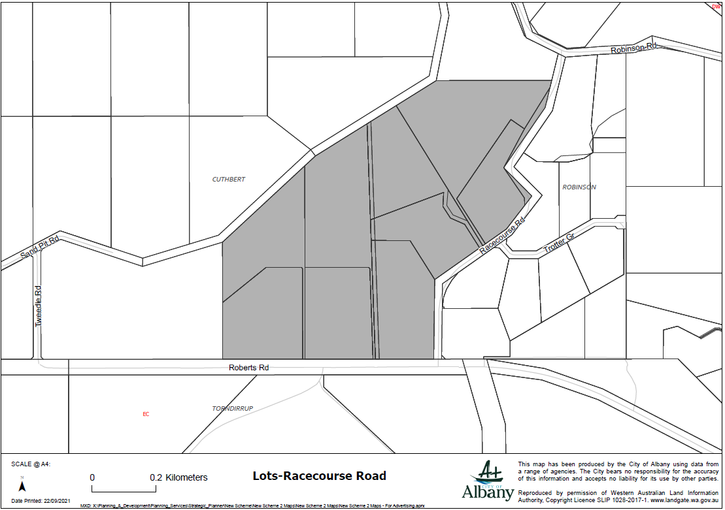

Lots - Migo Place, Kronkup
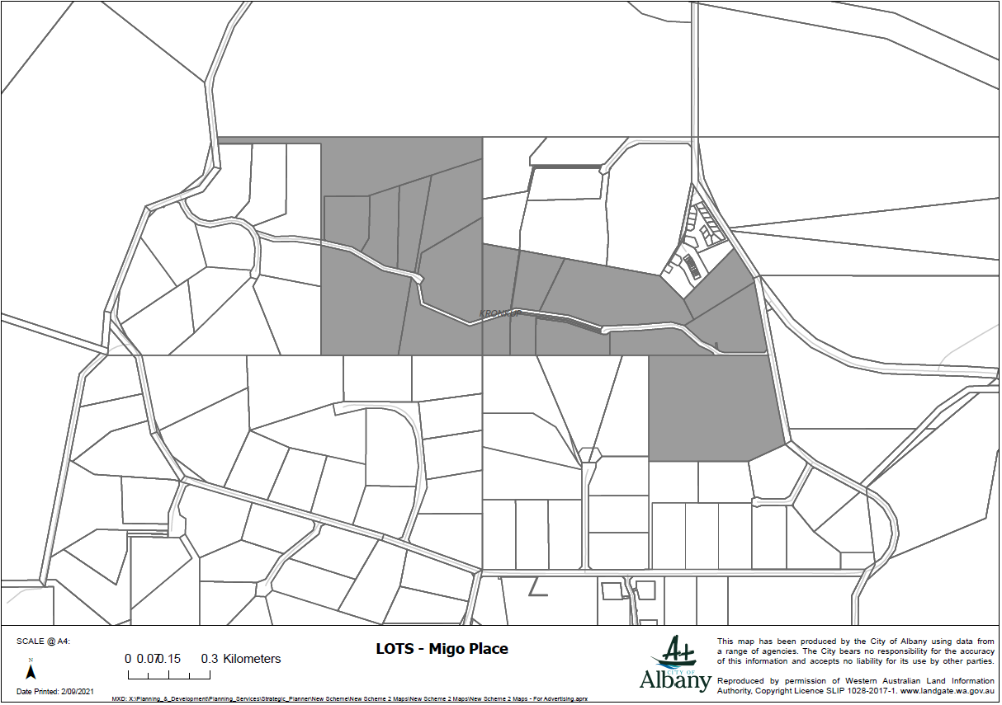

Lots – Koolbardi Court
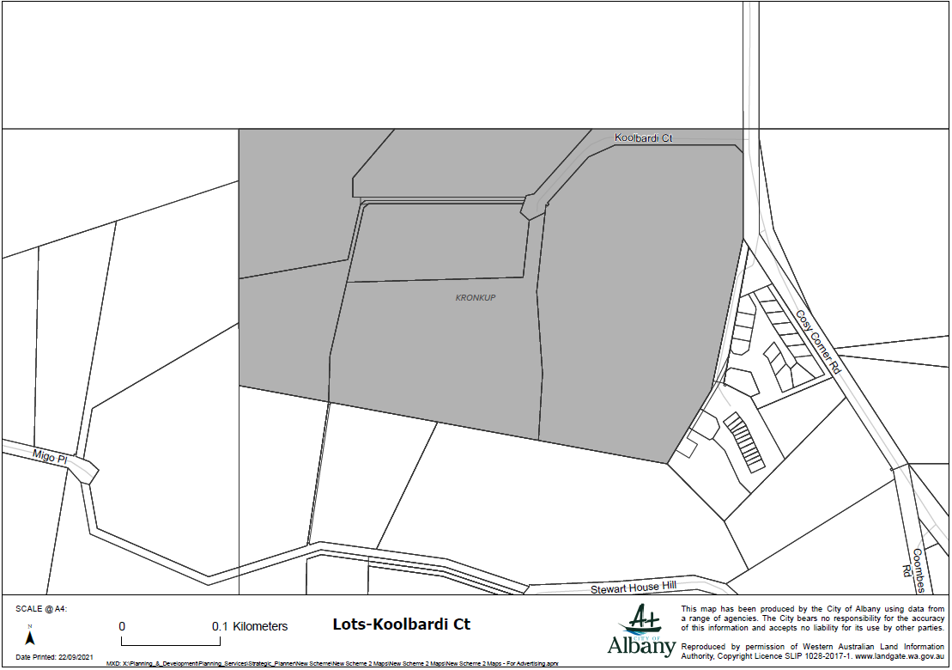

Lots - Forest Court, Kronkup
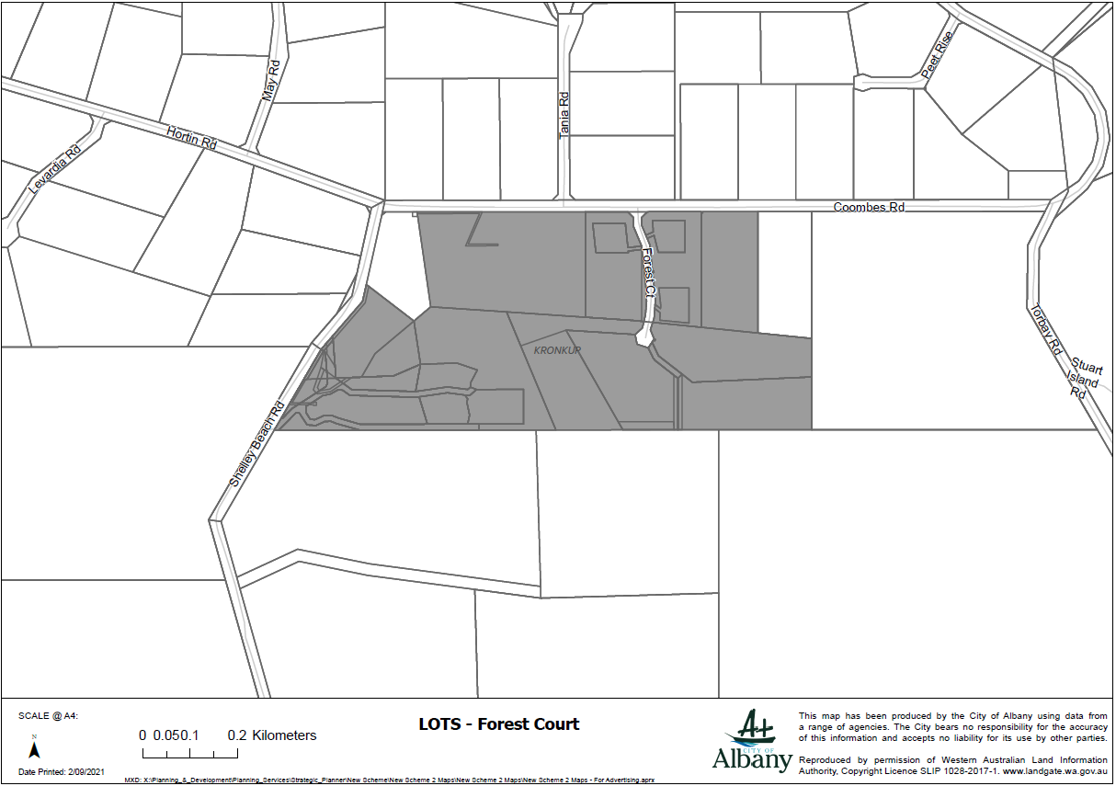

Lots – Bottlebrush Road
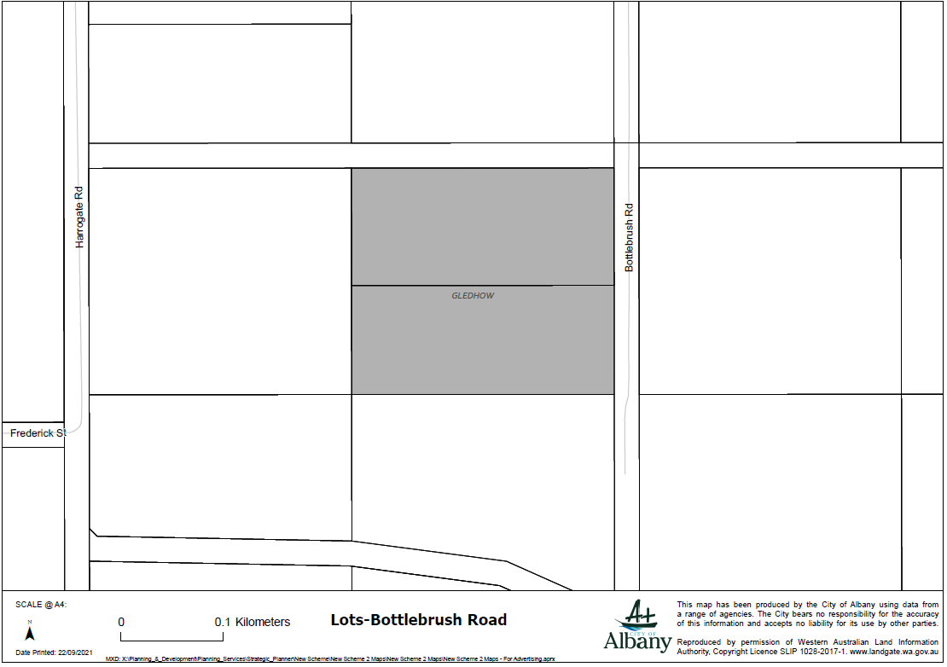

Lot - Henderson Road
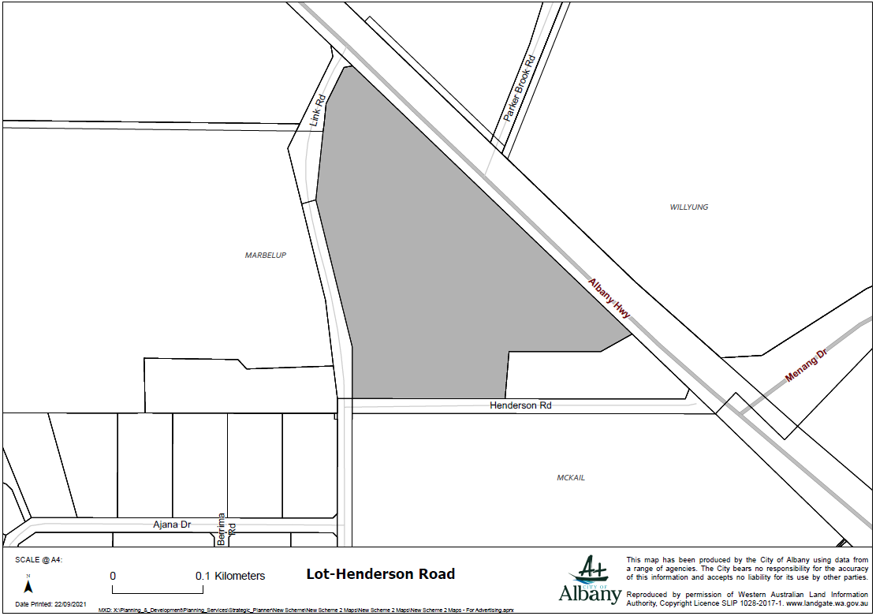

Lot 9000-Lancaster Rd
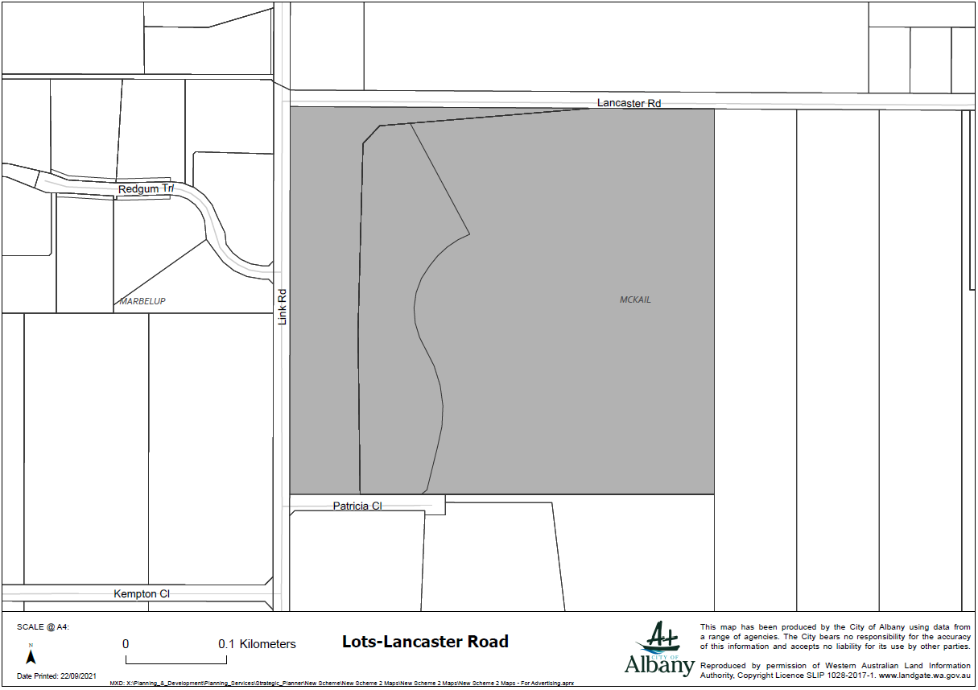

Lots - Link Rd, Marbelup
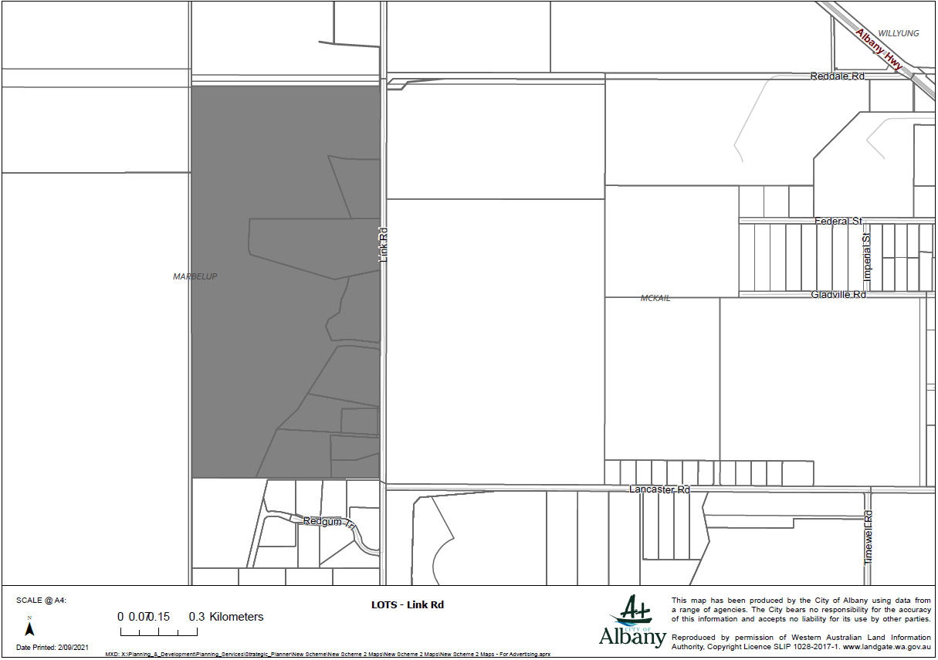

Lots – Redgum Trail
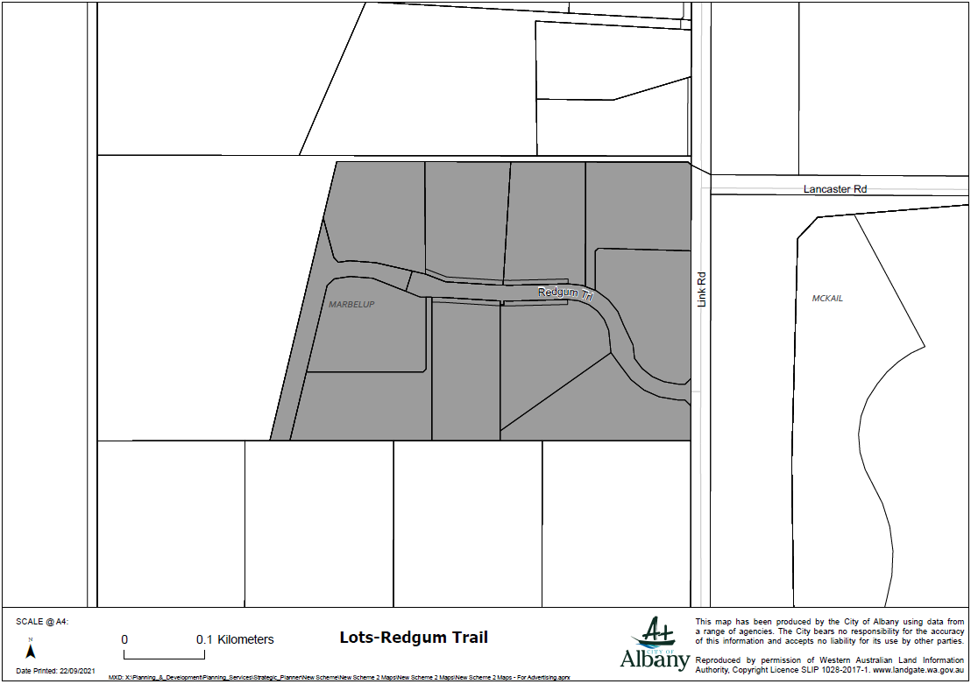

Lots - Shelley Beach Road
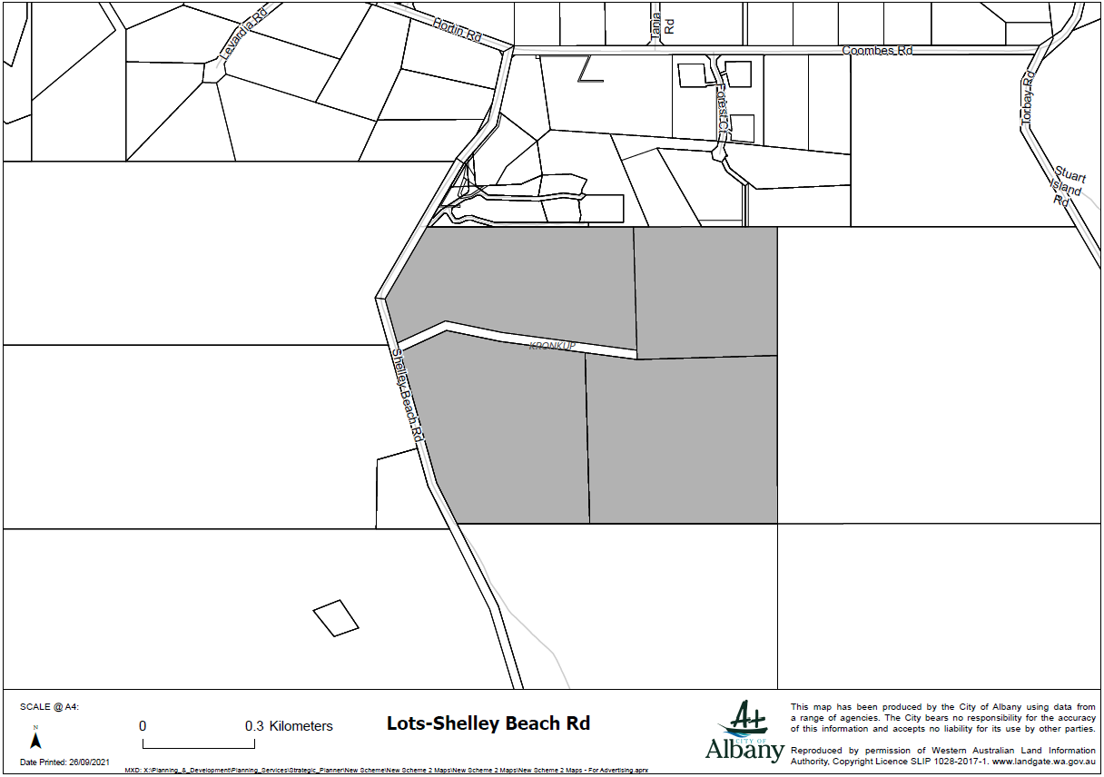

Lot – 202 Sandalwood Road
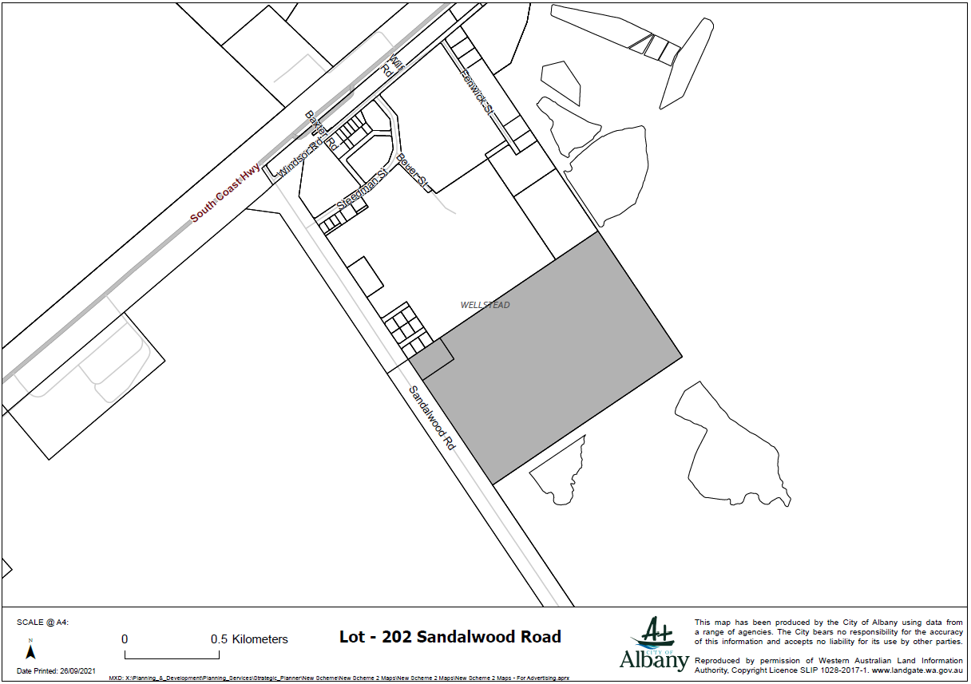

Lots – Home Road
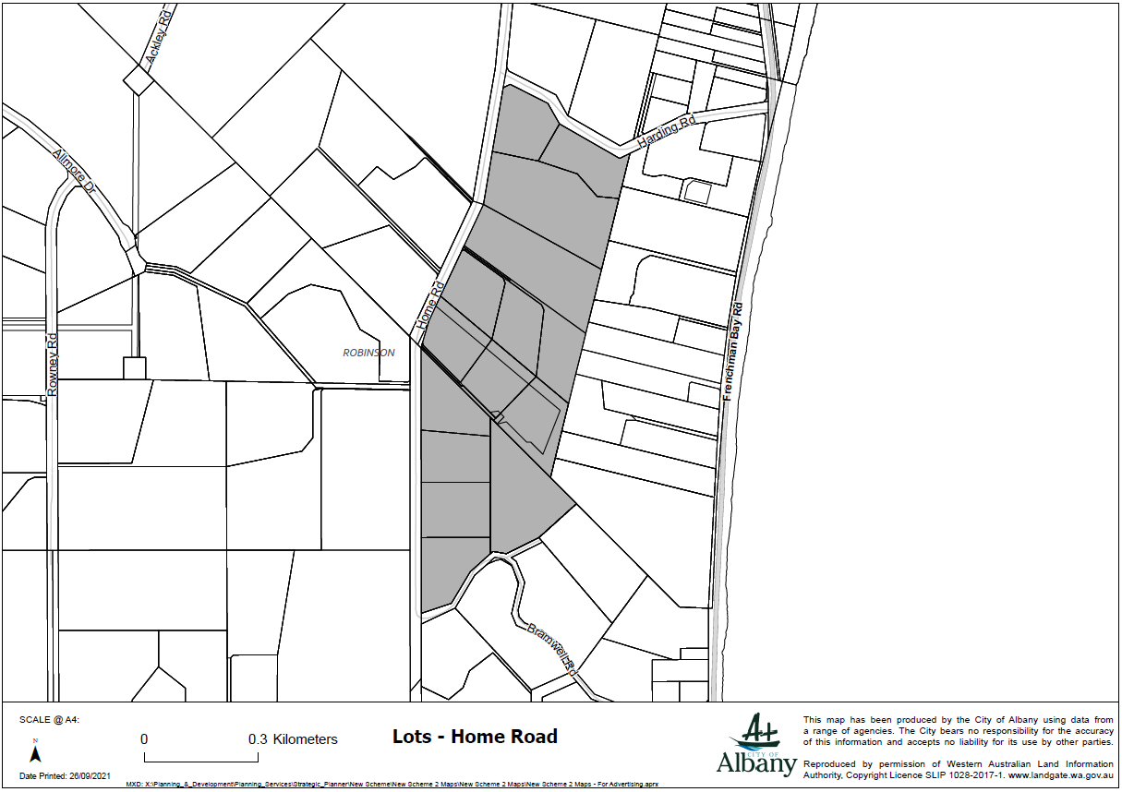

Lots – Beaudon Road
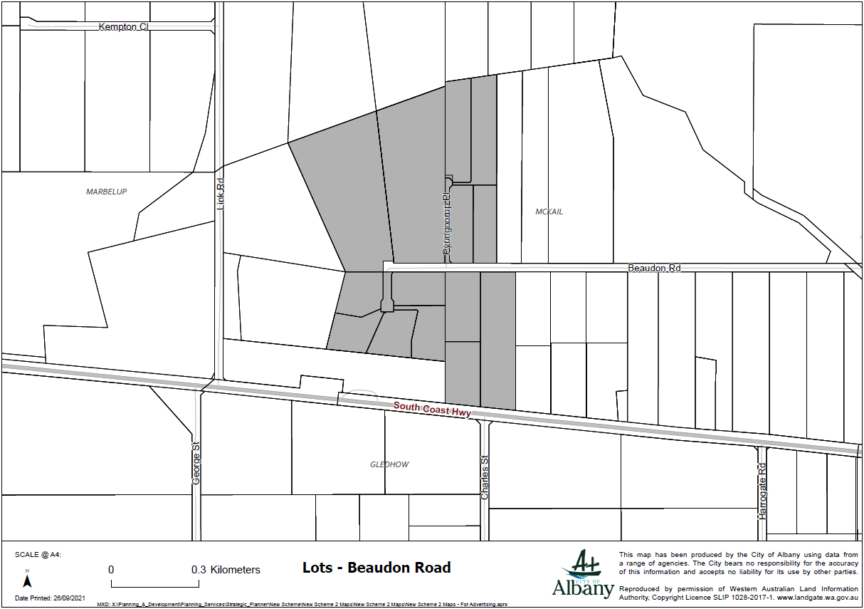

Lot 50 Chester Pass Road
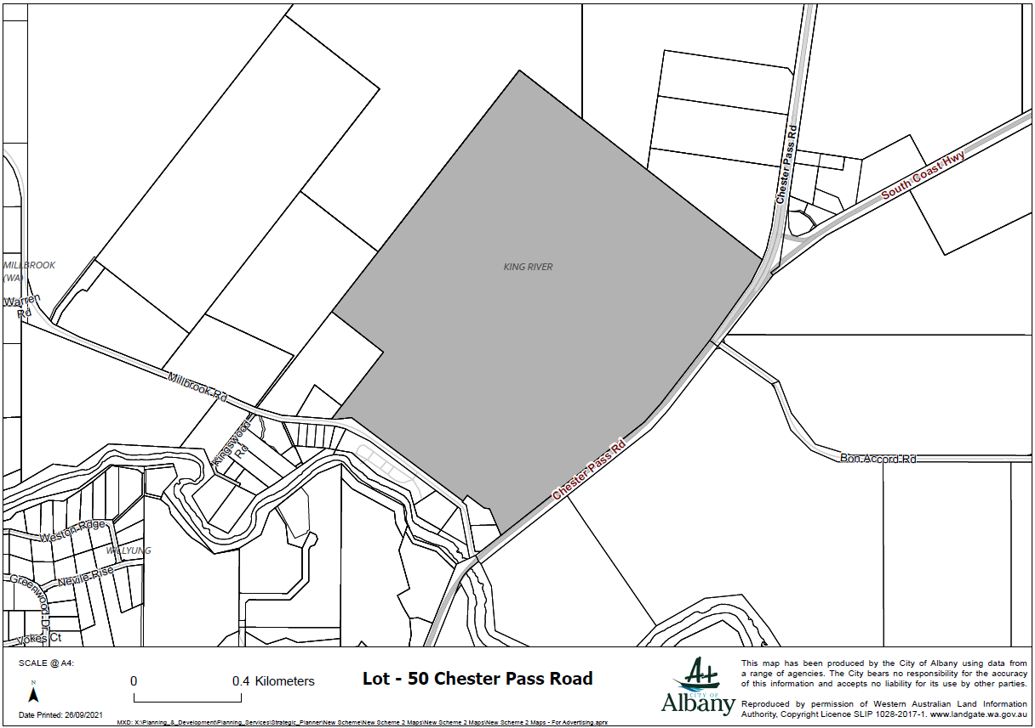

Lots - Symers Street, Little Grove
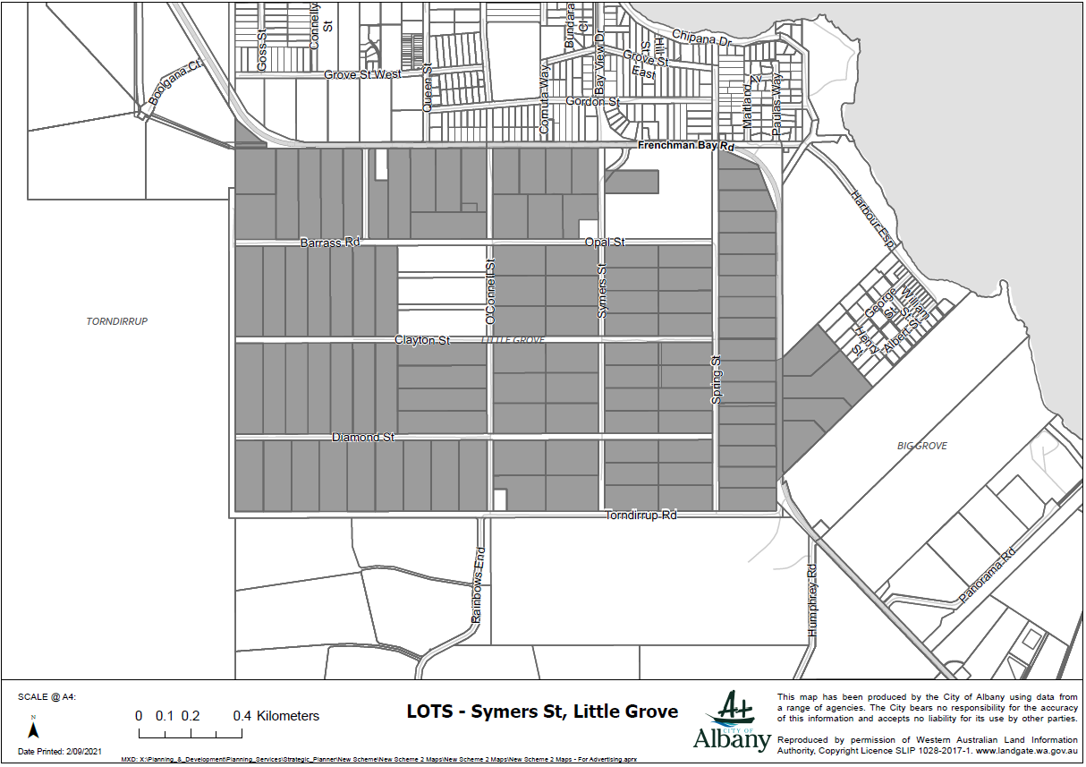

Lot – 114 Frenchman Bay Road
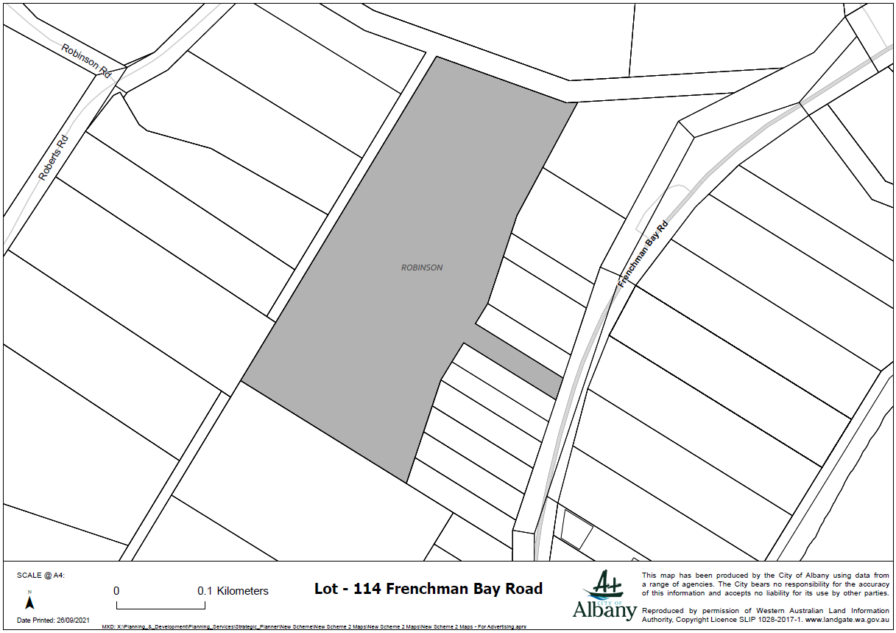

Lots - Hortin Rd, Kronkup
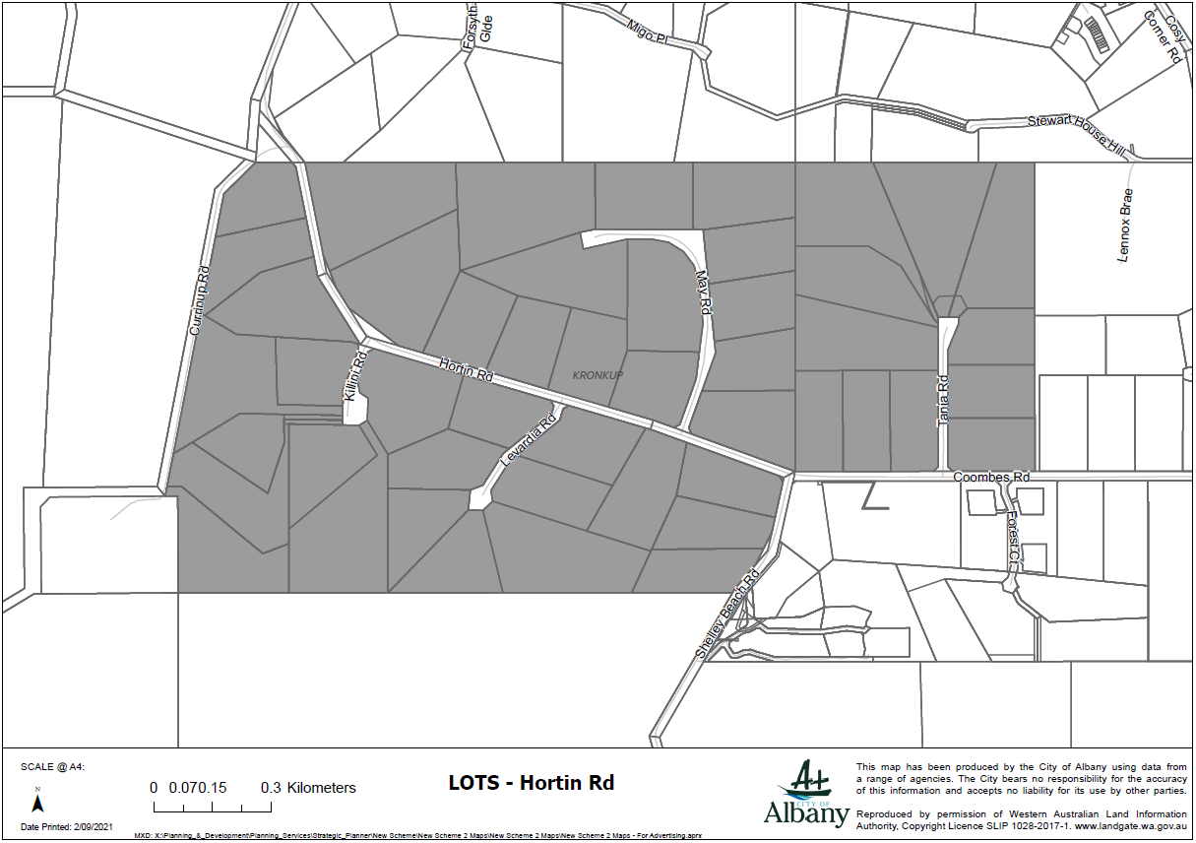

Lots – 1 & 973 Nanarup Road
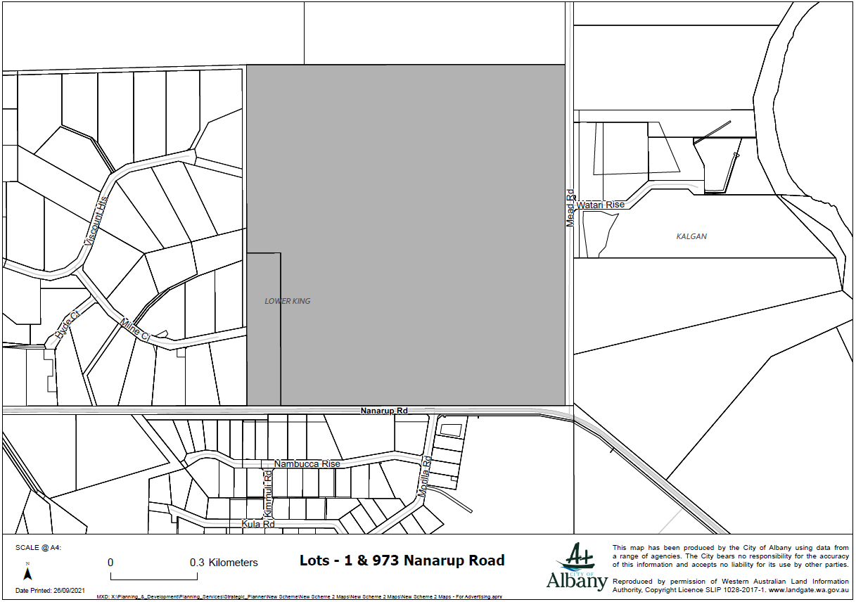

Lot – 2 Gunn Road
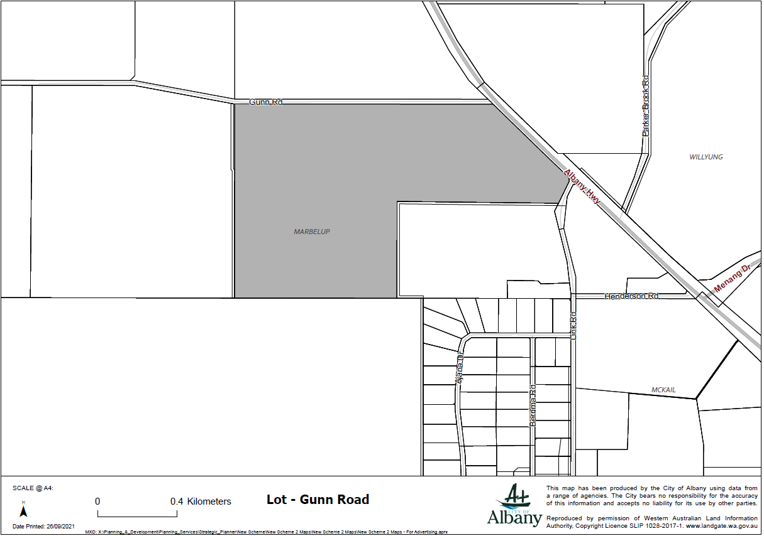

Lots 105-106 Nanarup Road
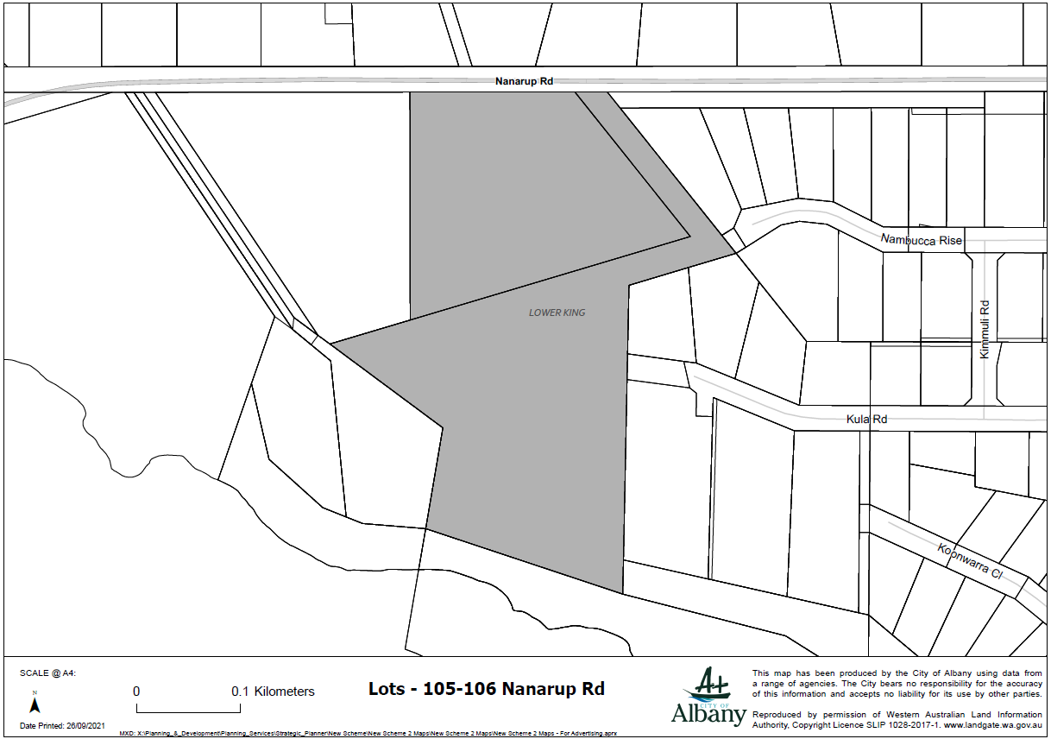

Lots - Eden Rd, Nullaki
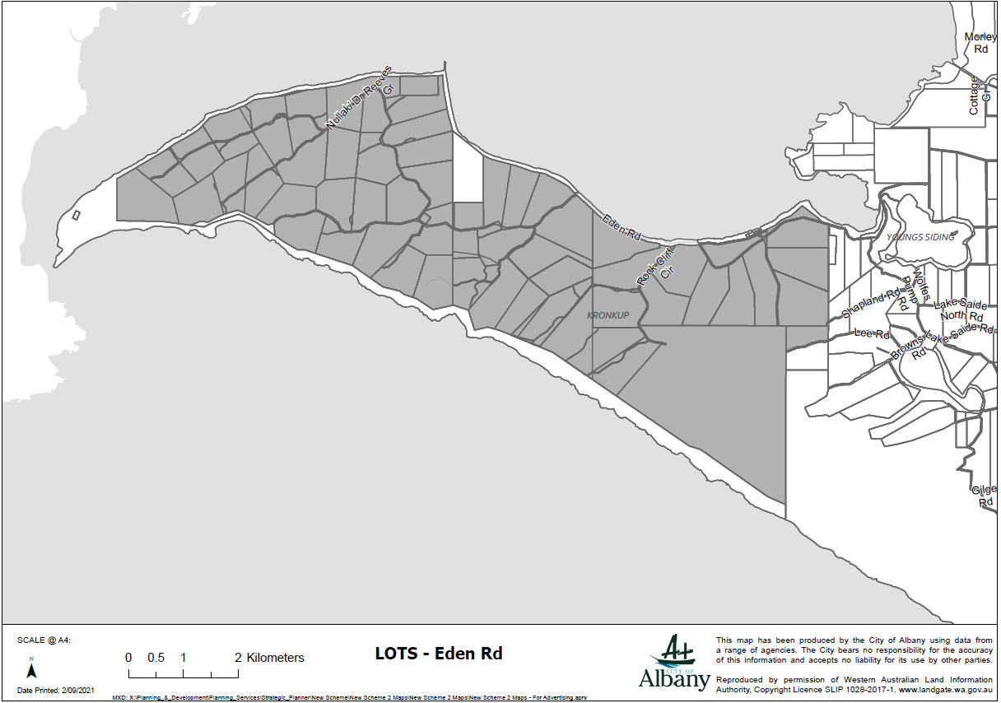

Lots – Rainbows End, Little Grove
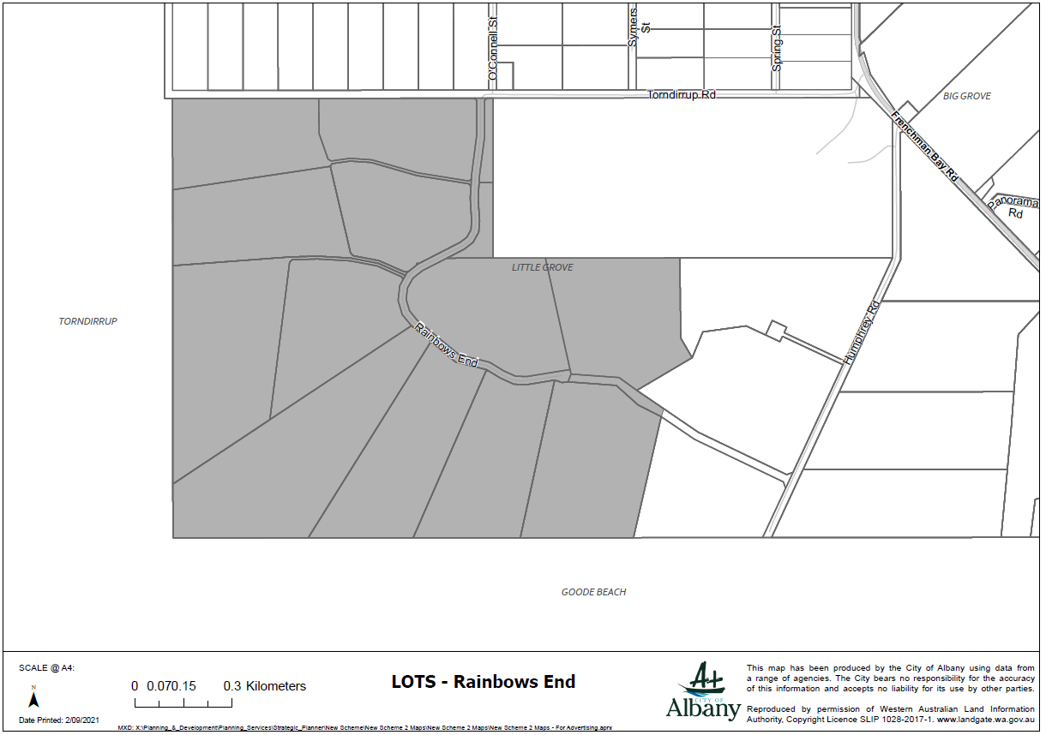

Lots 20-23 Torbay Road
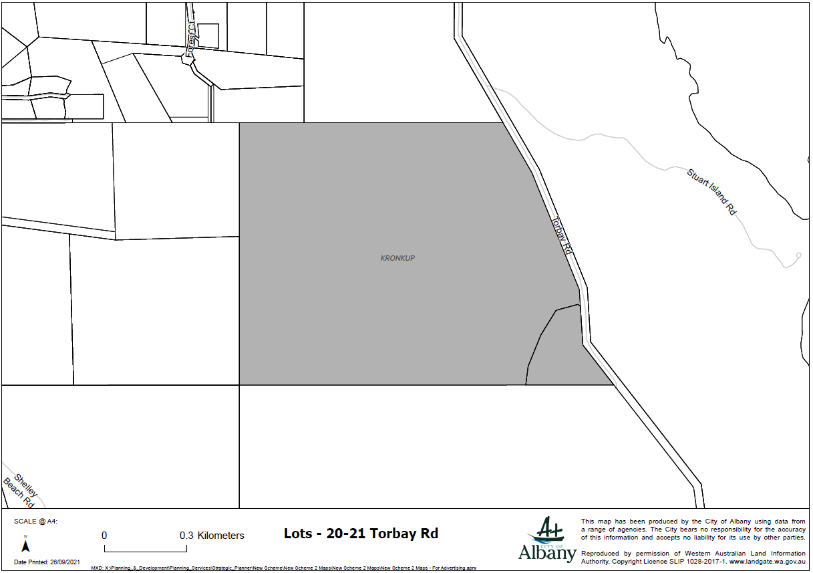

Lot - 10 Chester Pass Road and portion of Lot 521 Mercer Road, Walmsley
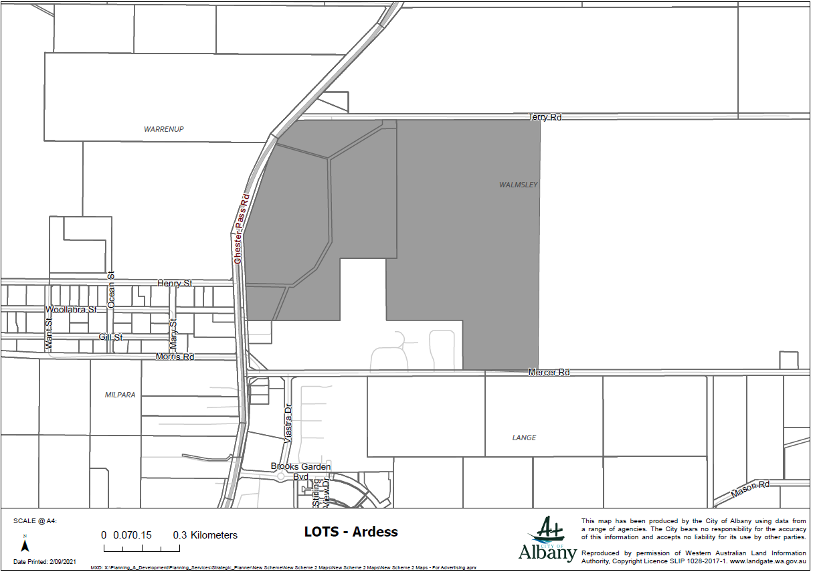

Lots –Chester Pass Road, Pendeen Road, Copal Road and Mallard Road, Willyung
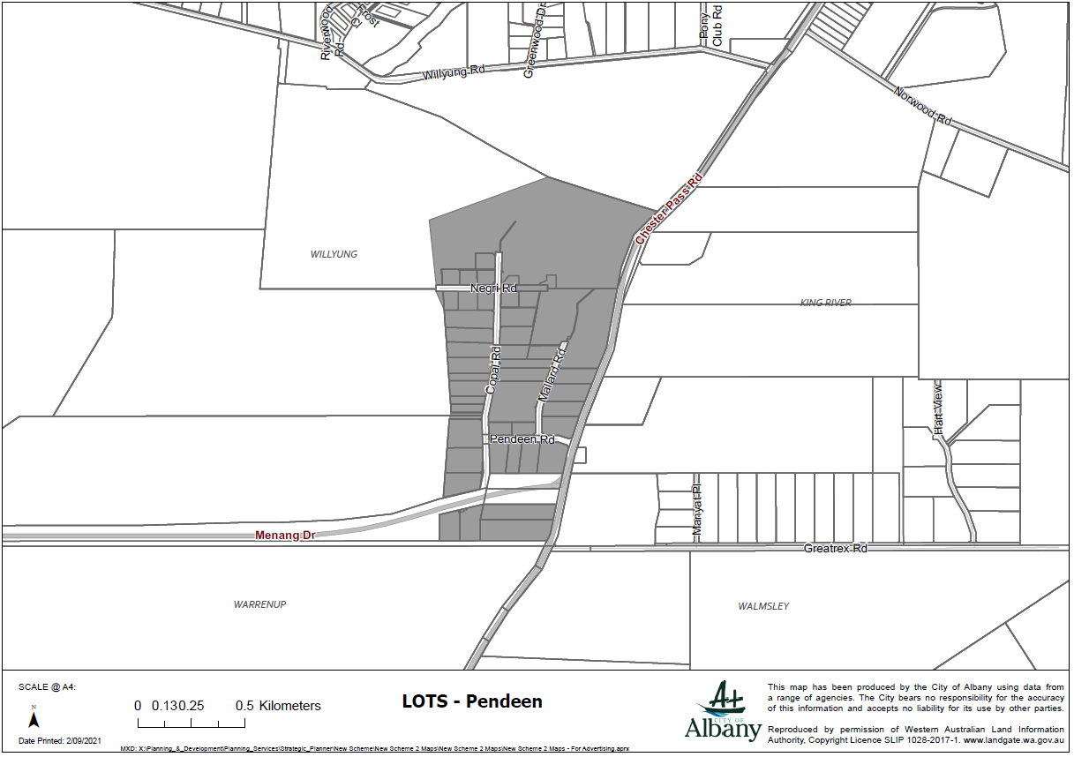

Lots – Cnr. Down Road and Albany Highway, Drome.
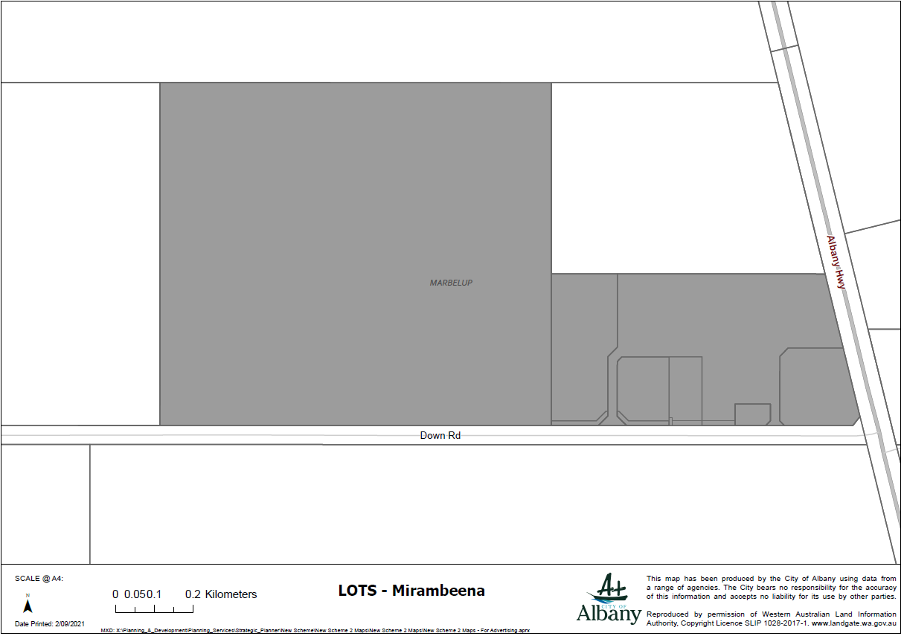

Local Structure Plan & Local Development Plan Areas
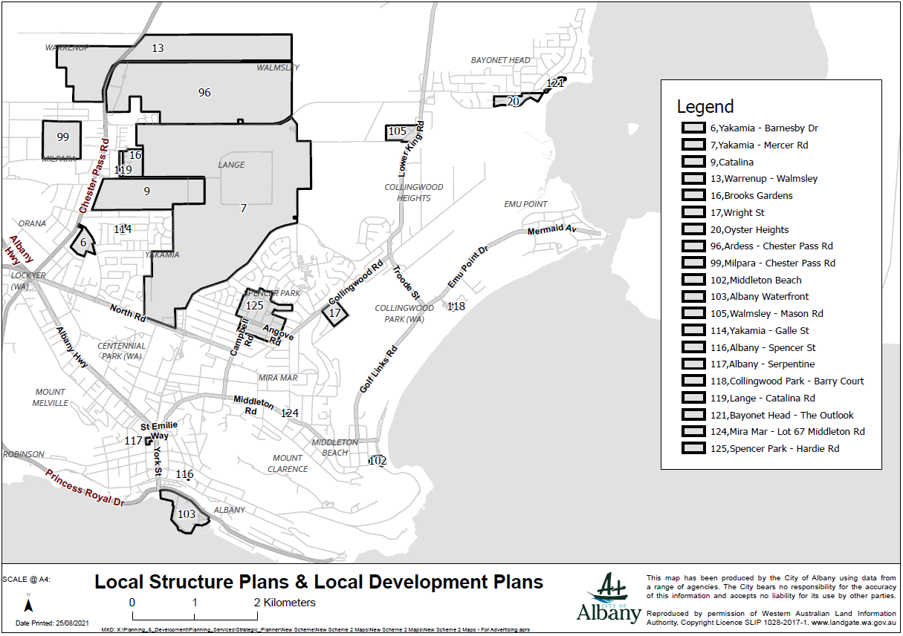

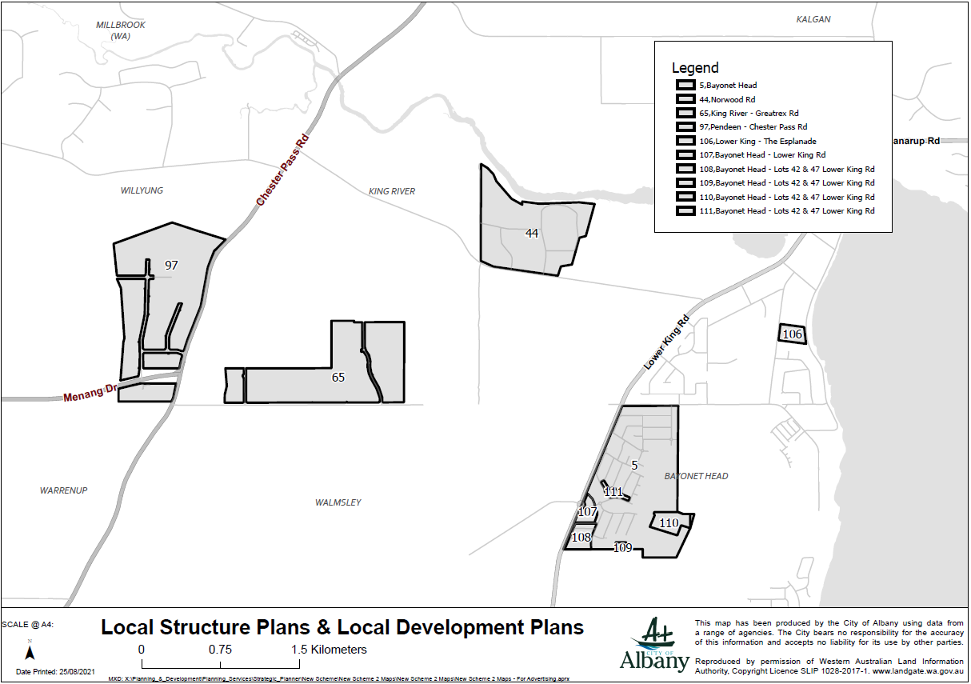

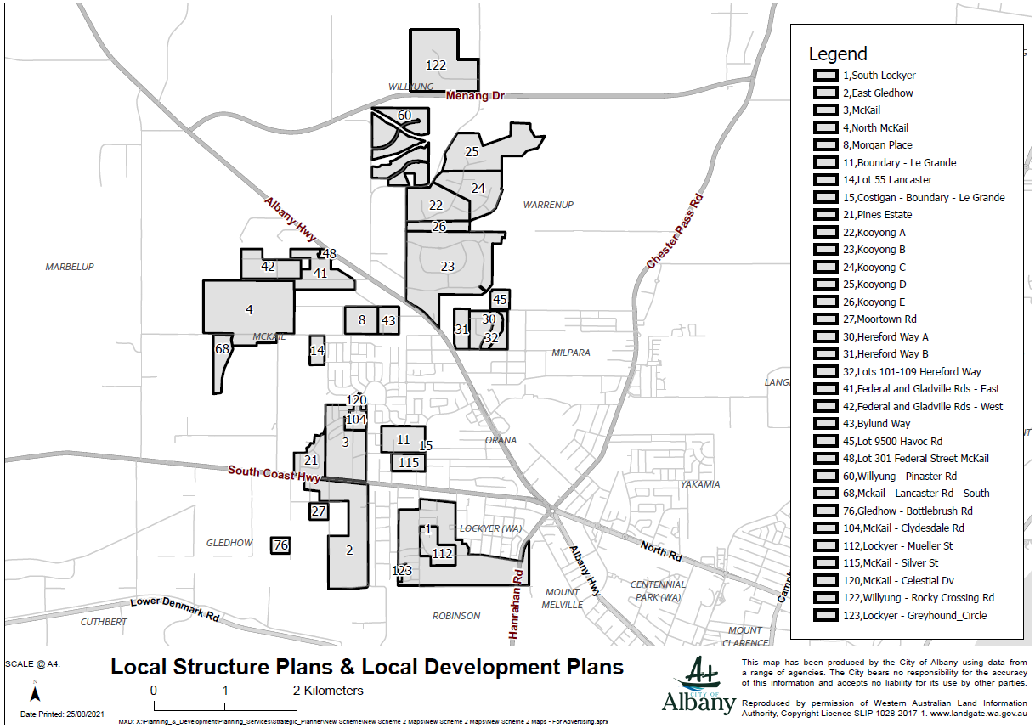
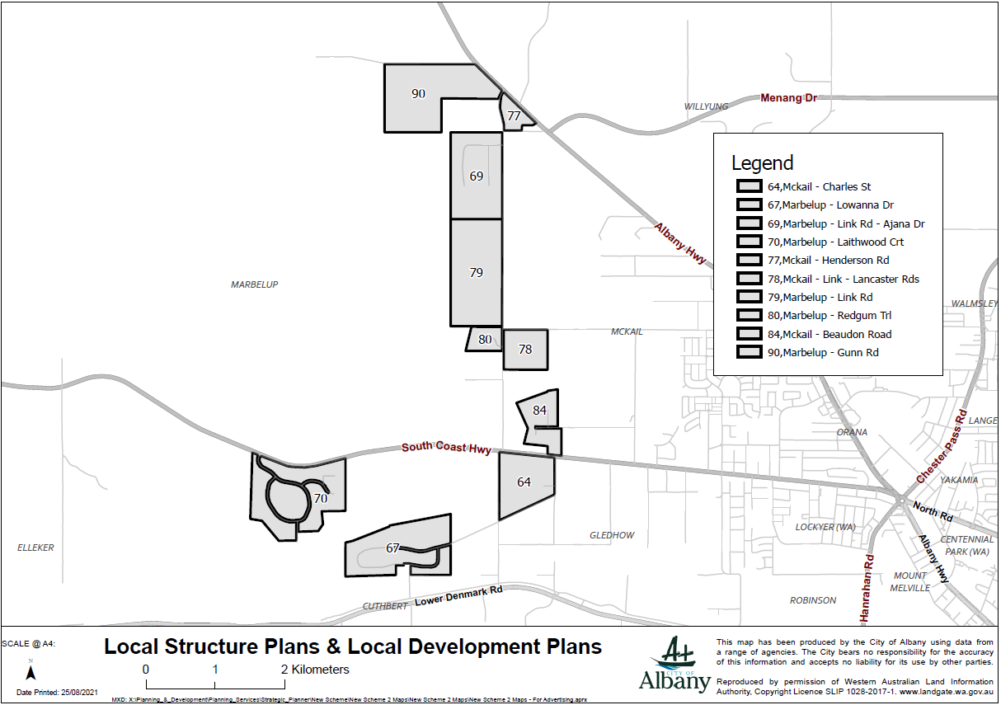

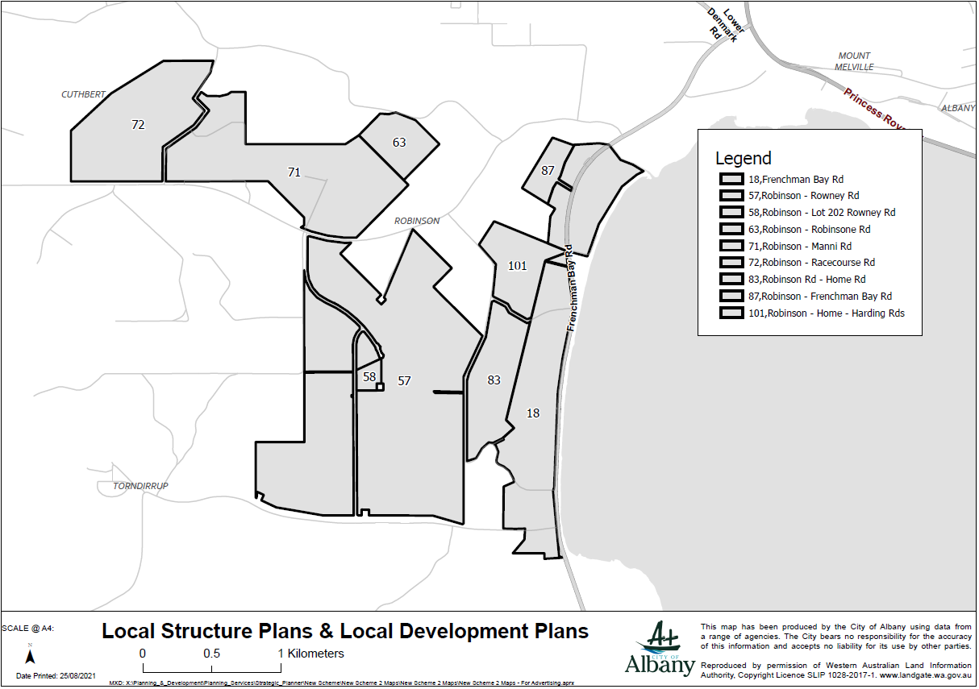
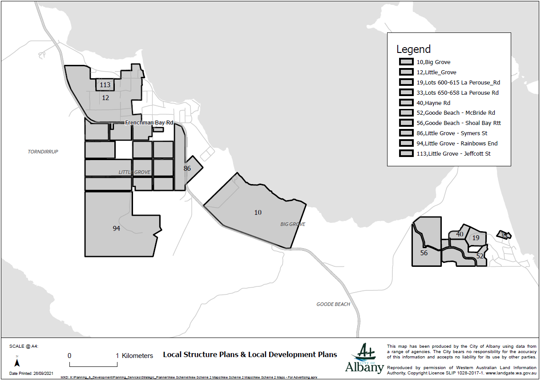
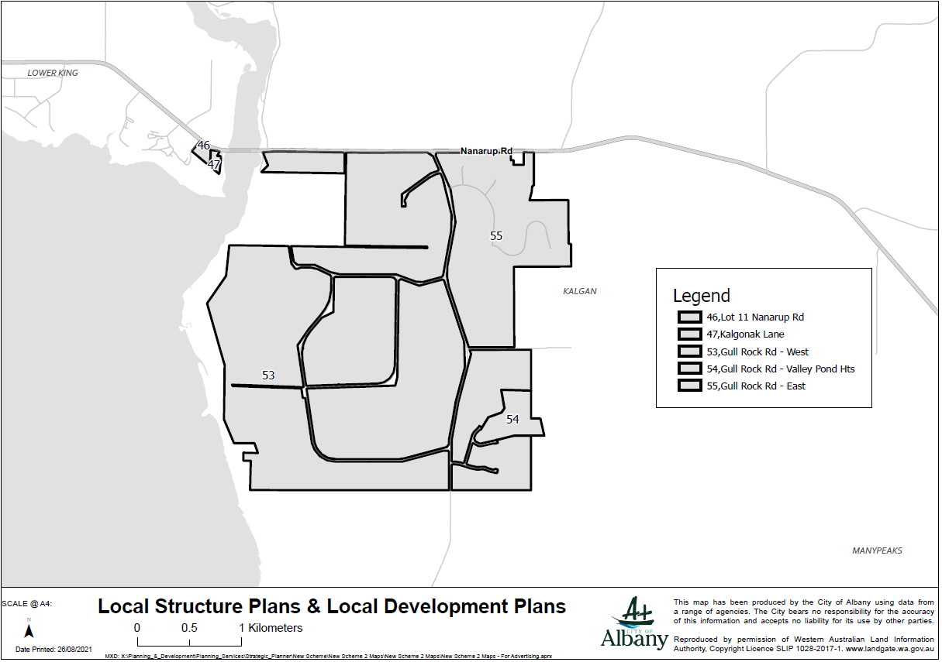
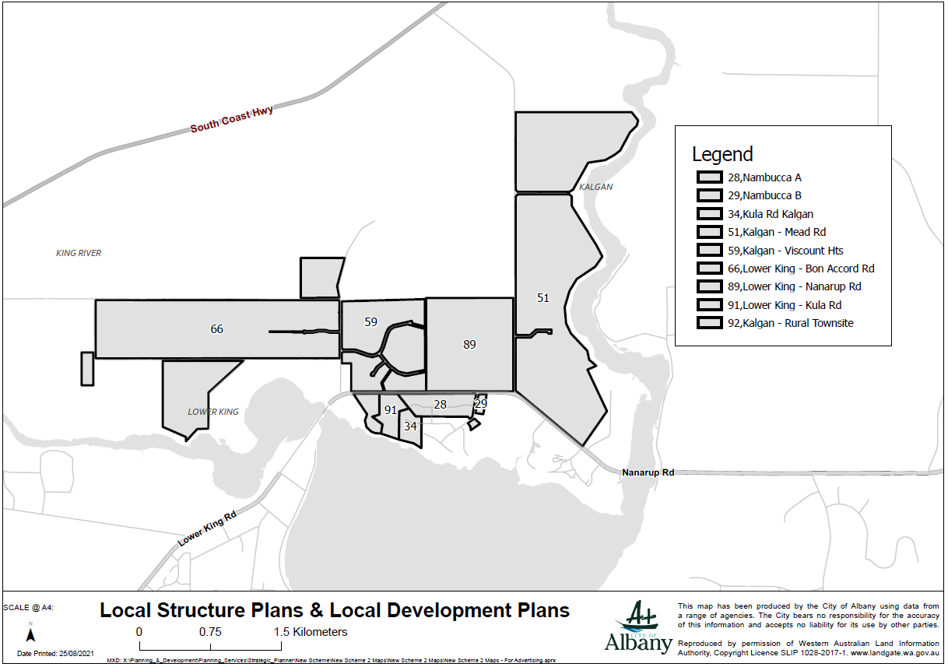
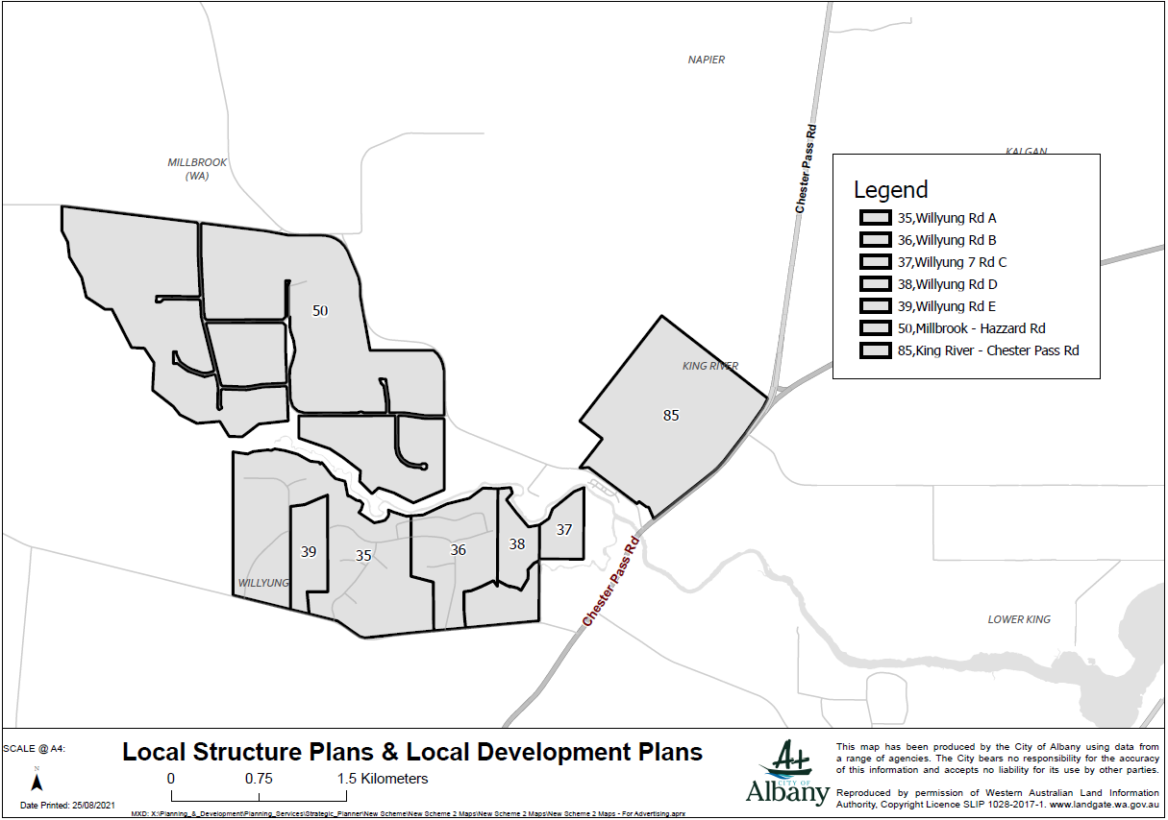
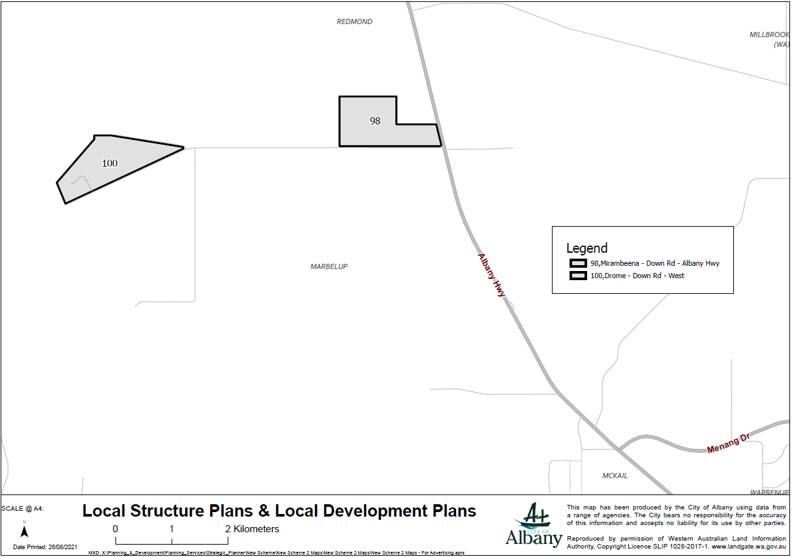
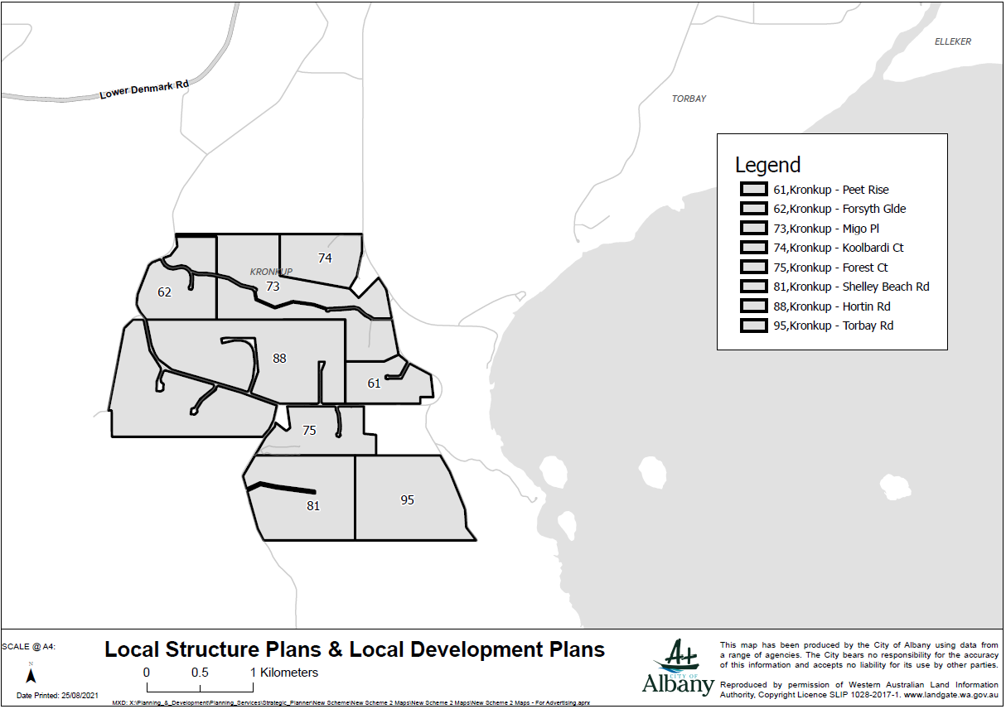
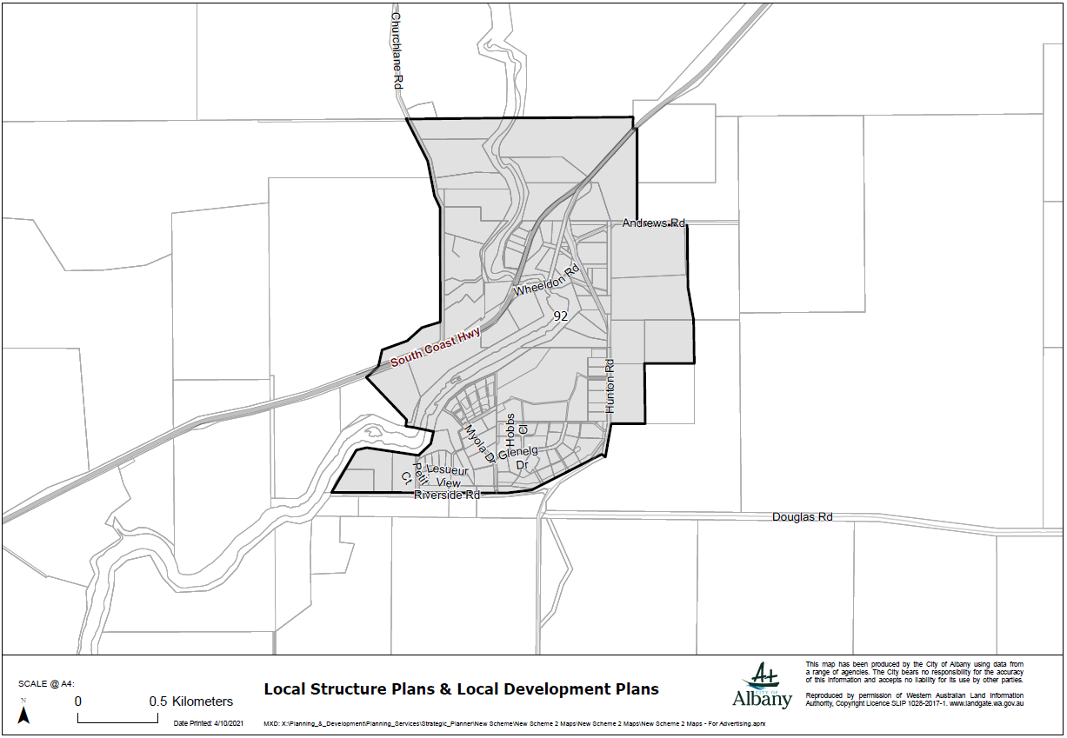
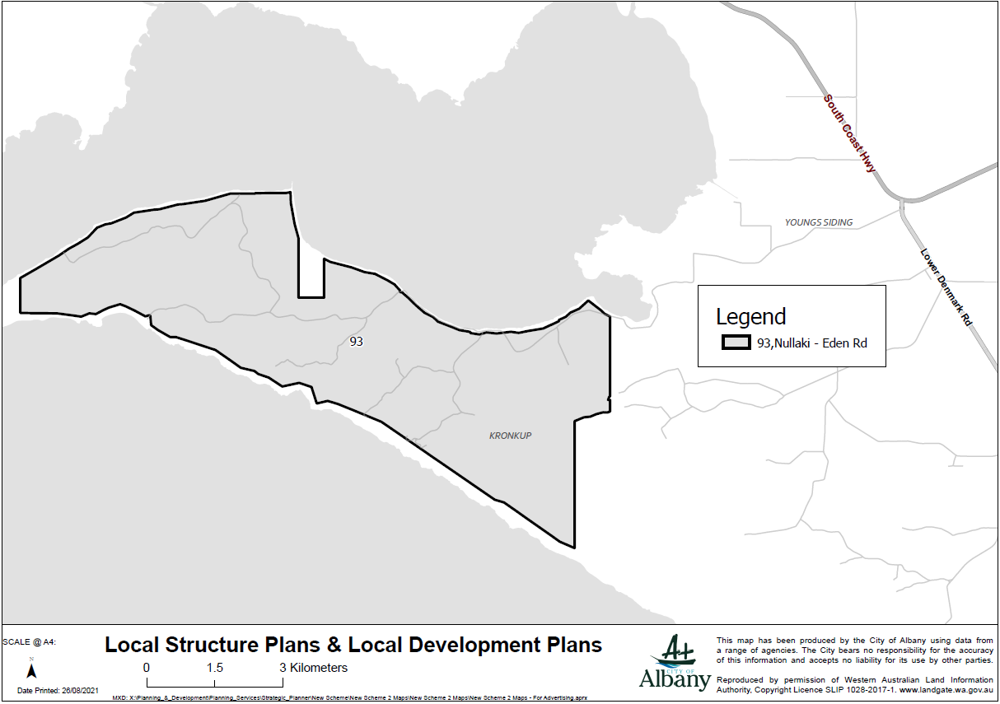
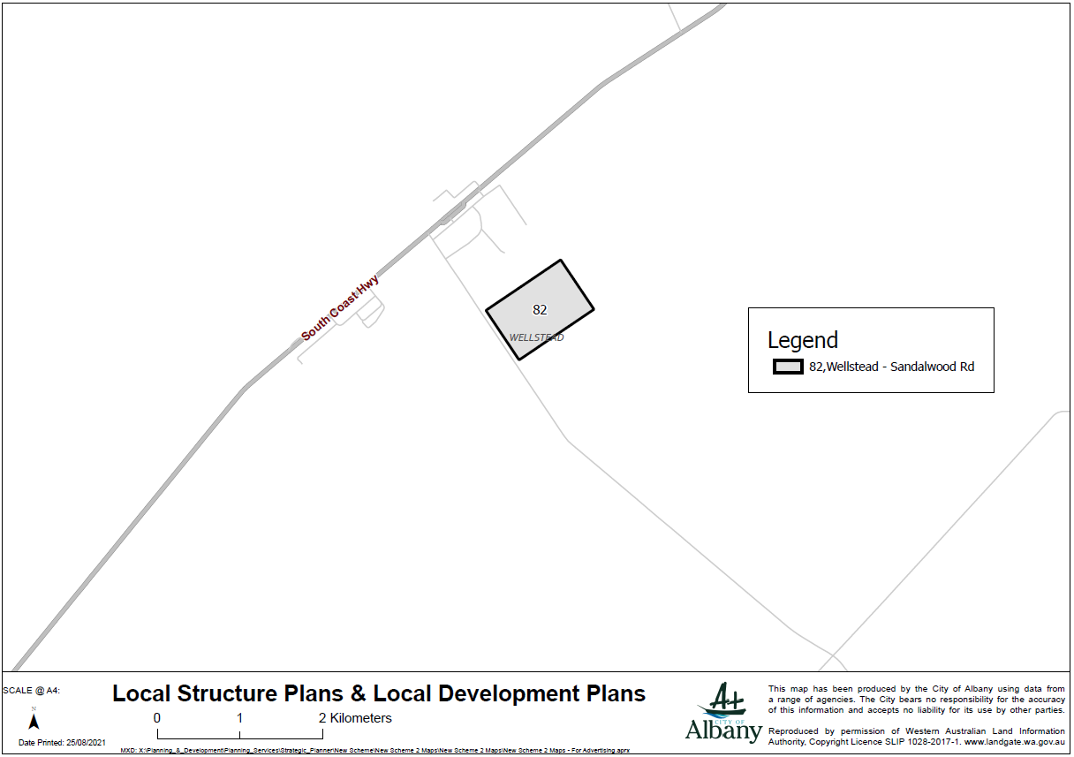
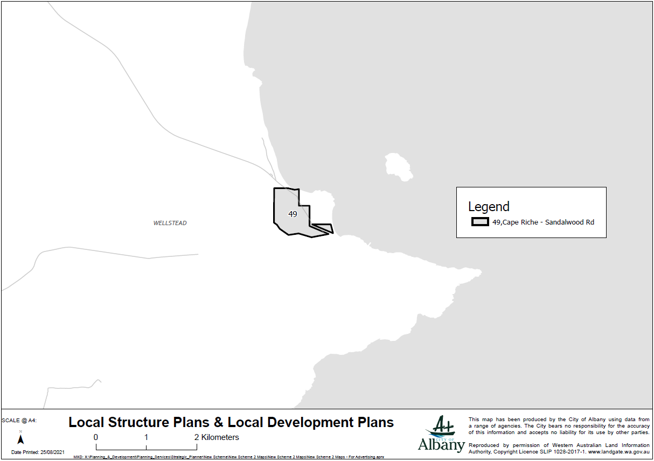

Adoption
ADOPTED by resolution of the City of Albany at the Ordinary local government Meeting held on the 23 November 2021.

Mayor

Chief Executive Officer

Final Approval
ADOPTED for final approval by resolution of the City of Albany at the Ordinary local government Meeting held on the _________________. The Common Seal of the City of Albany was hereunto affixed pursuant to that resolution in the presence of:

Mayor

Chief Executive Officer

Recommended/Submitted for Final Approval

DELEGATED UNDER S.16 OF THE PLANNING
AND DEVELOPMENT ACT 2005
Date__________________________

Final Approval Granted

MINISTER FOR PLANNING

Date___________________________

