  Quick response grants  Guidelines and Application 2024/25 | The City’s Quick Response Grants support a range of small-scale initiatives for local residents, community groups and organisations.  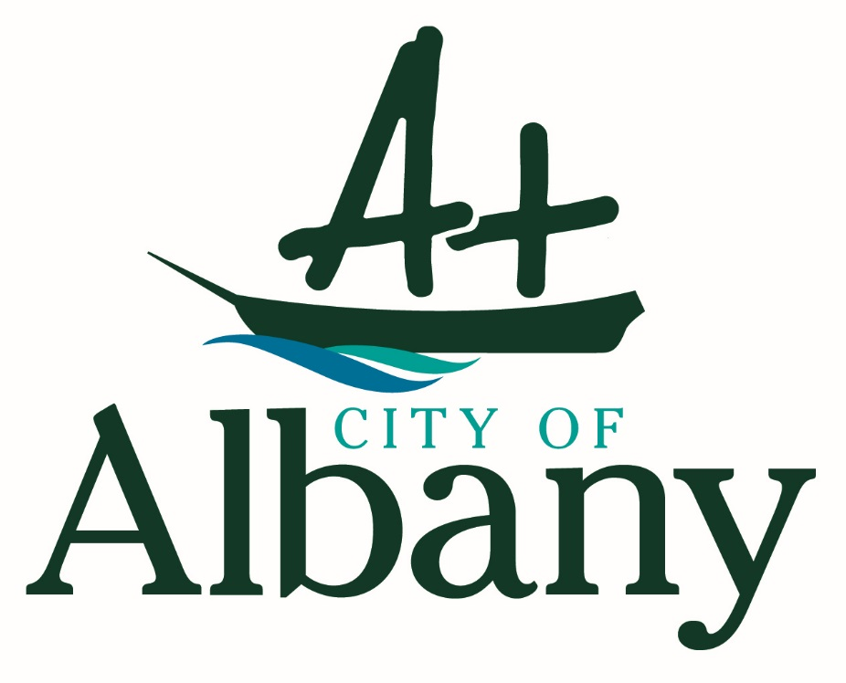

About Quick Response Grants
Quick Response Grants are for small grants of up to $1,000 for proposals that fall outside the City’s annual Community Funding Program. Applications can be made at any time, and applicants will be advised if they are successful within two weeks of their application being submitted.
Applications will be processed on a first-come, first-served basis until the allocation is exhausted.
This program will support small-scale initiatives that take place from 1 August 2024 to 30 June 2025. Applications for NAIDOC Week which falls in July each year will also be considered.
Funding Priorities
Applications must address at least one of the funding priorities to be eligible for assessment:
- Increasing community engagement and participation in local events and in community life, in particular by marginalised or disadvantaged population groups.
- Improving the health and wellbeing of local communities.
- Helping communities shape, understand and celebrate their identity, history and heritage.
What Can I Apply For?
Grants can be used for most aspects of an activity, including:
- Programming costs, including fees for presenters, instructors and performers (including travel costs);
- Production and venue costs, including materials and equipment hire;
- Marketing costs associated with promoting the funded activity;
- Council sponsorship for a one-off event or activity;
- Purchase of materials in order to deliver the activity.
Who Can Apply?
Eligibility
- Quick Response Grants are available to not-for-profit and incorporated community organisations based in the City of Albany, or which have a demonstrated, principal interest in the City.
- Individuals who are residents of the City of Albany and have a sponsoring, incorporated community group prepared to auspice the funds on their behalf and they can demonstrate specific benefits to the Albany community.
- Unincorporated organisations may seek the services of an incorporated body (sponsor) to auspice the activity on their behalf. The sponsor will be required to accept legal and financial responsibility for delivering the activity.

Ineligible Applications
- Individuals to attend sporting, conferences or training (please refer to the City’s Community Leadership Grants for these activities);
- Retrospective or deficit funding;
- Recurrent expenditure such as salaries, wages, electricity, insurance, water, rates and other core organisational operating costs;
- Fees associated with administering the grant funding;
- Equipment purchases;
- Registration days, fundraising projects, prizes and trophies;
- Structural or capital works to facilities, including restoration or conservation works;
- Schools, government or quasi-government agencies.
Handy Tips for a Strong Application

- Answer all questions providing as much detail as possible and consider how your proposed project addresses funding priorities.
- Before submitting your application ensure you have proofread and if possible get a second person to as well, they may notice something you did not.
- Don’t be afraid to ask questions if you are not sure what is required within your application.

Application Assessment
Applications for Community Funding will be assessed by the Community Development Coordinator against the following criteria:
- The application addresses at least one funding priority.
- Demonstrated genuine community need for the activity.
- Demonstrated value for money.
Applicants should answer all questions provided with as much detail as necessary. When completing the application form consider how your proposed activity addresses the criteria above. Letters of support for the proposed activity and indicative quotes for budget items are encouraged.
The Community Relations Manager will approve recommended applicants for funding, with all applicants advised of the outcome of their application within two weeks of receipt by the City where possible.
Approval is at the City’s absolute discretion and subject to available budget.
Conditions of Funding
Successful applicants will be required to sign a funding agreement with the City. Auspicing organisations will enter into a funding agreement with the City on behalf of the individual or unincorporated organisation whose activity they are sponsoring.
Canvassing of elected members will automatically disqualify the application from consideration.
Event Approvals
Applicants who receive funding to host an event must seek the relevant approvals from the City’s Events Team by contacting 6820 3035 or eventsapprovals@albany.wa.gov.au.
ABN and Tax Status
Successful applicants without an ABN must complete a Statement by a Supplier form in order to be funded. Statement by a Supplier forms are available to download from the City website as a PDF or can be obtained from Australia Post.
The City cannot release funds to individuals or organisations without an ABN or signed Statement by a Supplier form.
Applicants must advise of their organisations’ GST status. If registered for the GST individuals or organisations must supply a tax invoice to receive funds.

Application
APPLICANT DETAILS
Organisation’s Name:
Contact Person:
Organisation Postal Address:
This is the address that the City of Albany will send hardcopy documents to i.e. Funding Agreements
Telephone:
Organisation Email:
Is the applicant (tick one box only): | an organisation  individual
(note that individuals must be auspiced by an incorporated organisation. Please complete the auspicing body details below)
ORGANISATION DETAILS
Is your organisation a registered not for profit? (Incorporated or registered charity) (You may be required to supply a copy of your Certificate of Incorporation if your application is successful)
Yes (date of incorporation or charity registration) _________________________
No (please complete the auspicing organisation details below)
If the applicant is an individual, or a non incorporated group, please complete the following section.
Auspicing organisation’s name:
Contact person:
Postal Address:
Phone:
Email:

PROJECT DETAILS
Your Project (Please describe your proposed activity and what the City’s funding will be used for):

Project Start Date:
Project End Date:
How will you determine whether your activity has been successful?

Which of the funding priorities does your project address (Applicants may select more than one priority):
Increasing community engagement and participation in local events and community life, in particular by marginalised or disadvantaged groups
Improving the health and wellbeing of local communities
Helping communities shape, understand and celebrate their identity, history and heritage
Funding Requested:  (excluding GST) |  | Please itemise what you are requesting funding for
Total Project Cost:
(excluding GST)
Which of the following ways are you able to acknowledge the City of Albany’s support for the project?
Acknowledgement of City of Albany support in advertising and media publicity
City of Albany signage while the project is occurring
Verbal acknowledgement during the project
Formal invitations to City of Albany Mayor and/or Councillors to attend project activities, official functions and hospitality opportunities
The Mayor or Councillors to be invited to present the welcome or opening speech at the commencement and/or launch of the project
APPLICANT DECLARATION
I, the undersigned, certify that I have been authorised to submit this application and that the information contained herein or in the attachments is, to the best of my knowledge, true and correct.
Name:
Signature:
Position:
Date:

Please send completed applications to:
City of Albany
Community Development
PO Box 484
Albany WA 6331
Or by email: commdevel@albany.wa.gov.au
Synergy File Reference: CR.SPO.89

