Local Plan for Animal Welfare in Emergencies (PAWE)

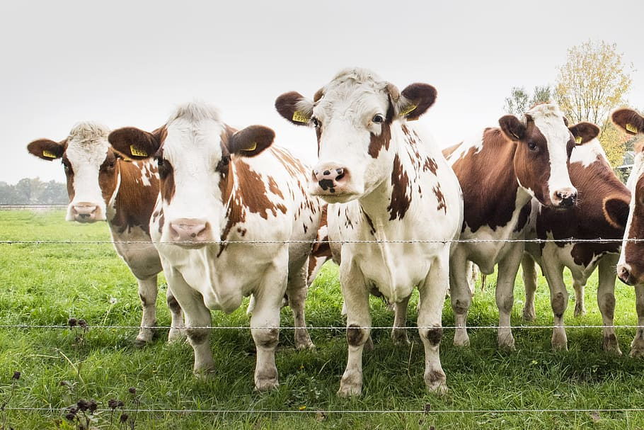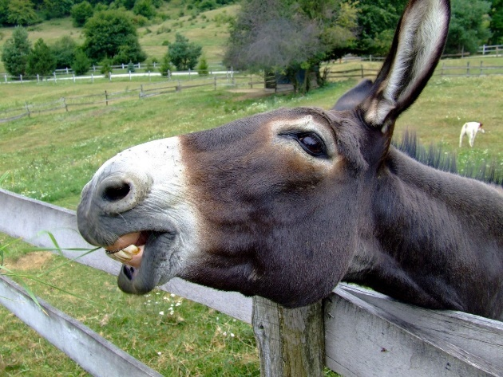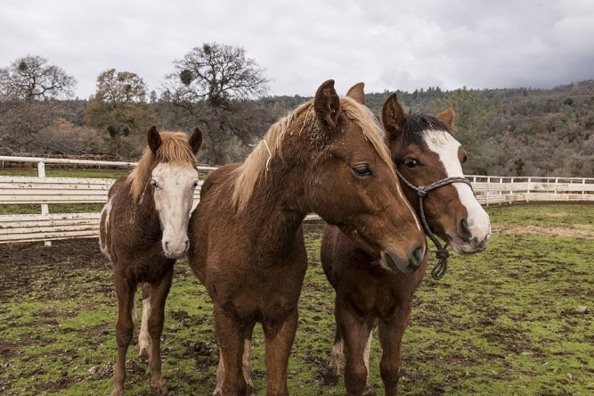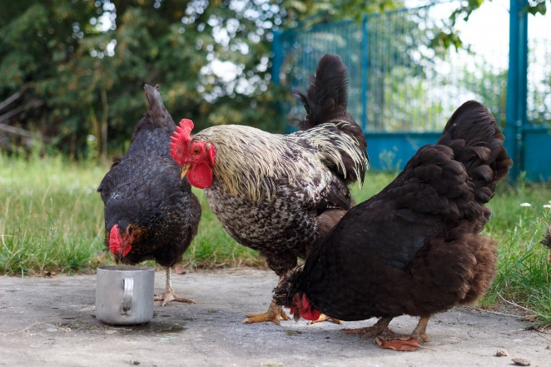
Table of Contents
1 - INTRODUCTION 3
1.1 Associated Documents and Legislation 3
1.2 Objectives 3
1.3 Roles and Responsibilities 3
2.0 Scope and Risk Profile 4
3.0 Costs 4
4.0 Preparedness 4
5.0 Response 5
5.1 General Operations 5
5.2 Activation 6
5.3 Situation and Intelligence 6
5.4 Public Information 6
5.5 Response Activities 7
Animal Welfare Team and Control Centre 7
Equipment 7
Temporary Animal Shelters 7
Welfare Evacuation Centres 7
Transportation and Evacuation Route Options 7
Stray Animals 7
Access to Properties 8
Animal Welfare Assessment, Triage and Treatment 8
Firegrounds 8
Injured Animals 8
Emergency Supplies 9
5.6 Volunteers and Donations 9
5.7 Other Considerations / Challenges 9
Biosecurity 9
Zoonotic Disease 9
5.8 Recovery 9
6.0 Appendices 10

GLOSSARY OF TERMS AND ACRONYMS
DPIRD | Department of Primary Industries and Regional Development
DBCA | Department of Biodiversity and Conservation Attractions
DC | Department of Communities
DFES | Department of Fire and Emergency Services
RSPCA | Royal Society for the Prevention of Cruelty to Animals (WA)
WALGA | Western Australi Local Government Association
LEMC | Local Emergency Management Committee
IC | Incident Controller
ISG | Incident Support Group
IMT | Incident Management Team
HMA | Hazard Management Agency
AWT | local Animal Welfare Team
SSP – AwiE | State Support Plan – Animal Welfare in Emergencies
LEMA | Local Emergency Management Arangements
EEP | local Emergency Evacuation Plan
LRP | Local Recovery Plan
PAWE | local Plan for Animal Welfare in Emergencies
Animals in Perth Zoo or Wildlife Parks | All animals kept in Perth Zoo or establishments licensed by the DBCA
Companion Animal | Any animals other than horses kept primarily for companionship, hobbies, sport or work
Horse | Any horse or equine hybrid (Equus caballus; Equs asinus
Livestock | Has the meaning of ‘Stock’ as defined in regulation 4 of the Biosecurity and Agriculture Management Regulations 2013.
Owner or Carer | The owner of the animal, a person who has actual physical custody or control of the animal, the owner or occupier of the place or vehicle where the animal is or was at the relevant time
Wildlife | An animal that is indigenous to Australia’s land or waters, living without regular human intervention or support and having the meaning of fauna, as defined with the Biodiversity Conservation Act 2016

1 - INTRODUCTION

The connection between people and their animals can be strong and diverse. Emergency events that impact on animals can affect communities on a range of levels. In responding to an emergency, the primary aim is to protect the safety of people.
The human-animal bond can be extremely influential in a person complying with emergency response directions, such as evacuating.
Animals have intrinsic value, and they contribute to human health and wellbeing, they also have economic value and failure to account for animals puts human life at risk.
The owner or carer of an animal is responsible for the welfare of that animal and should include consideration of its welfare in preparedness for, response to and recovery from an emergency. In the event of an emergency the owner of an animal/s should execute their own evacuation plan. , it is not necessary for the owner to contact the HMA to carry out their own evacuation.
The ability of an owner or carer to address animal welfare issues may be hampered or prevented due to the nature of emergency. Encouraging people to take preparedness actions for their animals can have the additional benefit of improving the preparedness for their own safety and resilience.
The plan clarifies roles and responsibilities between the various stakeholders for the delivery of response and recovery activities in relation to animal welfare in emergencies. This plan is used in conjunction with the City of Albany Local Emergency Management Arrangements (LEMA).
The City will work in collaboration with other stakeholders on animal welfare matters arising out of the emergency and shall agree on the distribution of duties, depending on resources available in each instance.
CLASSIFICATION OF ANIMALS

For the purposes of this PAWE, animals have been classified into the following five categories which have been defined in the Glossary of Terms and Acronyms.
- livestock
- horses
- companion animals
- animals in Perth Zoo or wildlife parks
- wildlife.

1.1 Associated Documents and Legislation

- State Support Plan - Animal Welfare in Emergencies (SSP – AwiE) (Dept. of Primary Industries and Regional Development – [DPIRD])
- City of Albany Local Emergency Management Arrangements (LEMA)
- City of Albany Emergency Evacuation Plan (EEP)
- City of Albany Local Recovery Plan (LRP)
- The Emergency Management Act 2005
- The Animal Welfare Act 2002

1.2 Objectives

The Objectives of this Plan are to:
- Define roles and responsibilities for the provision of animal welfare in relation to preparation for, response to, and recovery from emergencies.
- Provide a coordinated approach to the management of animal welfare in emergencies between all stakeholders.
- Provide an alternative refuge for animals until collection by the owners is organised at an appropriate time to both parties.
- Effectively managing the welfare towards animals during an emergency.

1.3 Roles and Responsibilities

The owner or carer is responsible for the welfare of their animals and should consider them when preparing for, responding to, and recovering from an emergency.
Local Government the City of Albany (the City) will provide support as outlined in this Plan. The City will liaise with internal and external stakeholders, businesses and organisations when developing resources and refuges for animal welfare in emergencies.
Western Australia Local Government Association (WALGA) is the representative for member Local Governments on the Committee for Animal Welfare in Emergencies (CAWE) and may be the initial Local Government representative on the Animal Welfare Emergency Group (AWEG) if formed.
Department of Primary Industries and Regional Development (DPIRD) has the role and responsibility for coordinating animal welfare services in emergencies following the activation of the State Support Plan – Animal Welfare in Emergencies (SSP-.AWiE) In an emergency, when the capability of the owner or carer and any local arrangements are no longer sufficient or effective then the SSP-AWiE can be activated. DPIRD will become responsible for coordinating the provision of animal welfare services to support the owner or carer or local arrangements for animals.
Department of Biodiversity, Conservations and Attractions (DBCA) is responsible for advising the owner or carer of wildlife and wildlife parks, on coordinating the provision of animal welfare services to wildlife under their control.

Local Animal Welfare Team (AWT) will form when the plan is activated by the emergency Incident Support Group (ISG) during emergencies.

2.0 Scope and Risk Profile

This plan covers the arrangements for animal welfare in emergencies with the district boundaries of the City of Albany. It is applicable to all hazards except animal and plant biosecurity hazards.
The category of animals located in the district include domestic pets, companion animals, horses, livestock, and wildlife.
There are rural properties involved in livestock on a commercial enterprise scale including sheep and cattle graziers, dairies, free range pork producers, and poultry farmers.
There are also lifestyle properties that have various livestock, and horses for use in racing, harness racing, stock horse events, showjumping and dressage.
There are dog and cat kennels catering for the needs of domestic pets.
There are Aged Care residencies in Albany but are all contained within suburban Albany.
The hazards most likely to effect the District of Albany are bushfires, storm and flood events. Risks associated with these hazards are the displacement of livestock of various kinds and companion animals.

3.0 Costs

The costing arrangements for this plan are addressed under section 3.4 - Financial Arrangements in the City of Albany LEMA.
Any costs and fees incurred relating to animal welfare in emergencies must be recorded using the Animal Emergency Costing Sheet (annexure ?).

4.0 Preparedness

The SSP -AWiE indicates that Local Governments should develop and maintain a local PAWE, and engage with WALGA as their representative on the CAWE.
In addition to maintaining a Local PAWE, Local Governments may consider other preparedness activities in support of community resilience and educating the owner or carer on their responsibility for their animals in emergencies. Communication is a vital component of managing animal welfare in emergencies, communication plans should include animal welfare considerations.
Local Governments may capture preparedness activities as part of general business or within other documents as part of the LEMAs. Local Governments should consider integrating animal welfare considerations when reviewing their Preparedness strategies.
It is the responsibility of owners and carers of animals to properly plan for emergencies in order to keep them safe. The owner or carer is primarily responsible for the welfare of the animal.
The best protection is to be prepared for a range of hazards and threats, such as bushfires or floods, and plan how the person will both respond to and recover from emergency situations.
Having a plan of action that can be implemented when an emergency occurs is the foundation for emergency preparedness.
Animal owners and carers can access a full range of information on emergency plans, emergency kits, preparing their property, evacuation or relocation to safer areas and animal identification through the DPIRD Animal Welfare in Emergencies website.

5.0 Response

The response phase in an emergency will encompass activities by HMA and supporting agency personnel coordinated by an IMT and controlled by the HMA IC.

5.1 General Operations

Weather is a primary indicator of risk and identifier of hazard. For example, Bureau of Meteorology (BoM) upgrade risk rating to Catastrophic ahead of expected extreme heatwaves. The type of hazard is bushfire and the risk is high or extremely high. Activities to undertake leading up to such incident and prior to any formal activation will be:
- Community messaging
- Standby staffing arrangements
- Resource mobilisation / pre positioning
- contacting possible shelters on the Local PAWE Resource List

5.2 Activation

The local PAWE may be activated when an ISG is convened by the HMA or IC in consultation with the HMA during a major incident and is integrated into the Local Emergency Management Arrangements.
Escalation to the State Support PAWE is in accordance with the State Support Plan – Animal Welfare in Emergencies section 3.2 Plan Activation Procedures:
The Controlling Agency or HMA may determine the need to activate the arrangements under the Plan Where:
- Animal welfare is beyond the capacity and capability of the owners or carers, and
- Any local or district arrangements are no longer sufficient or effective, or
- No local or district arrangements exist.
Should the Local Government believe criteria for activation of the SSP – AeiE are met, local government representatives within the ISG or Operation Area Support Group (OASG) should notify the Controlling Agency or HMA of the situation and recommend to activate the SSP - AWiE.
Nothing in the activation phase prevents the AWT from notifying the various resource providers, such as emergency shelters, to be prepared, before the PAWE is activated.

5.3 Situation and Intelligence

Information that needs to be collected to undertake response activities is:
- Type of Hazard
- Hazard size
- Severity of hazard
- Location of hazard
- Predicted duration
- Terrain
- Road infrastructure intact / impassable / alternate road routes.

5.4 Public Information

Release of information to the public will be made available by the Public Information Unit (PIU) through Incident Control in coordination with the Animal Welfare Team.
In relation to wildlife, communication to the community from PIU must be vetted by DPAW before being released to the community.

5.5 Response Activities

Animal Welfare Team and Control Centre
The Animal Welfare Team (AWT) will be comprised of City of Albany Rangers, but may also include other local government rangers, RSPCA officers, veterinarians, State Emergency Services volunteers (SES) and any other individuals formerly acknowledged by the AWT leader to aid in an emergency.
The AWT will work at the Mercer Road complex, unless otherwise directed by the IC, to receive calls, dispatch team members and log resources. The AWT leader will notify the IC of resources in the field.

Equipment
The Animal Welfare Team will have access to:
- 2 x purpose built 4WD vehicle suitable for carrying dogs and small livestock (as at 23/04/2024 ranger team fleet is going through replacement phase and this number is expected to change).
- 2 x 2WD vans suitable for carrying dogs, cats and small livestock.
- 1 x purpose built stock trailer for carrying sheep, goats, pigs and miniature cattle like Dexters.

Temporary Animal Shelters
The resource and contact register identified as Attachment 1 provides a complete list of shelter locations, contact names, type of animals, number of animals and any relevant information from the shelter owner and is in the notes.

Evacuation Centres

In emergencies, the protection of human life remains the priority for the HMA; however, animal welfare is an important consideration due to the intrinsic and economic value animals hold for individuals and the community. While owners and carers are responsible for making decisions regarding their animals, evacuation timing, transport capacity, and available destinations may limit their options. For health and safety reasons, animals are not permitted inside evacuation centres, with the exception of recognised assistance animals. Where it is safe to do so, owners and carers should make every effort to relocate animals to friends, family, or other suitable locations outside the impacted area, and monitor EmergencyWA for current animal welfare information. It is recognised, however, that some evacuees may arrive at evacuation centres with animals. In these circumstances, animals may remain in designated external areas, where available and appropriate. Evacuation centre managers may, in consultation with facility owners, identify and designate suitable external areas for the temporary holding of animals or provide advice on alternative arrangements where available. Owners and carers retain full responsibility for their animals at all times and must remain with them while onsite.

Transportation and Evacuation Route Options
Transportation and Evacuation route options may be developed in conjunction with the Intelligence Unit within the IMT.
Prior to any transportation requests being made to the IMT, the person making the request should see information from the Emergency WA site which will provide information on the safest evacuation direction and routes. This information will be dependent on the warning level (Advice, Watch and Act, or Emergency).

Stray Animals
Managing displaced or stray animals will be performed by the AWT, who will first endeavour to identify the owner or carer responsible for the animal/s and reunite them, transferring responsibility.
If the owner or carer responsible for the animals cannot be identified or contacted, The AWT will assess the situation and if safe to do so will endeavour to confine the animal/s depending on the circumstances. This may be in situ if the infrastructure is available, or the animal/s may be transported to one of the animal welfare shelters.
Displaced or stray animals will not be sheltered within the City’s pound or impound yard in an emergency.

Access to Properties
If road closures are in place people will be prevented from travelling past road blocks and must obey the direction of emergency service personnel staffing the road block.
If there is an active emergency incident in the vicinity of the subject property with emergency service personnel present, permission to access the property will generally be denied.
Any person seeking access to their property must first seek information from the Emergency WA website.
Any person/s wanting to return to their property in the zone of emergency operations for purpose of animal welfare must seek authority from the Hazard Management Agency Incident Control Centre.

Animal Welfare Assessment, Triage and Treatment
If it is beyond the capacity of the owner, the rescue of animals shall be coordinated by the AWT in conjunction with the Incident Management Team. Tasking will be delegated through the Incident Controller or Incident Management Team to the AWT.
The AWT shall:
- Keep a register of animals that need to be evacuated during an emergency where this Plan is activated. Refer to Individual Animal Registration Form (attachment 3 in appendices).
- Secure/confine animals to such an area where it is not likely to injure itself or be injured by other animals.
- Report any apparent injury or illness to a veterinarian, if necessary, for treatment or euthanising as soon as practical. Animals suffering from contagious disease shall be segregated to prevent infection of other animals.
- Ensure arrangements are made for animals to be fed, watered and temporary shelter facilities are cleaned as regularly as practicable.
- Upon release of the animal, record the date and time and identifying details of the owner or person released to including residential address, contact phone numbers and email.

Firegrounds
The AWT will not enter a fireground unless;
- The area has been declared safe by the Hazard Management Agency controlling the emergency.
- The personnel have been trained in basic firefighting (bushfire), have correct Level 1 PPE, clothing, and access to a WAERN radio and approval by the Incident Controller.

Injured Animals
Where an authorised person reasonably believes an animal is suffering so severely that destroying it would be a humane thing to do, may destroy the animal in a humane way. Destruction of the animal shall be undertaken by a Veterinarian, Police Officer or other authorised and qualified person.
An authorised person destroying an animal must notify, if the animal is native fauna, the Dept of Biodiversity, Conservation and Attractions or if otherwise the person in charge of the animal of the destruction and the reason for it, if it is reasonable to do so, before destroying the animal or otherwise, as soon as practicable after destroying the animal.
If the animal/s are on land belonging to another person, the authorised person must have the express consent of the occupier of that land, or some person apparently authorised to act on behalf of the occupier first before using a firearm for the humane destruction of the animal/s.
Authorised Person is a general inspector under the Animal Welfare Act 2002.
Prior to opening an area to the community, it will be coordinated between the Incident Management Team and AWT to ensure that any deceased animals are removed from public sight. All reasonable measures will be taken to notify the owners of non-native animals that are identifiable by way of tag or microchip prior to disposal.
Animals that are not disposed of by lawfully burying on the owner’s land may be disposed of at any of the City of Albany Waste Management facilities that handle deceased animal carcasses.

Emergency Supplies
Where the owner or carer of an animal cannot be found, the City of Albany Pound has a limited supply of food and bedding and can be used for animals in an approved animal evacuation shelter.
Animal food suppliers shall be contacted to obtain additional or specialist food as required with approval from the manager of the AWT.
RSPCA may also be contacted for immediate assistance for food if required.
A list of pet / livestock food suppliers can be found in attachment 1 Animal Welfare Shelter Resource and Contact List in the appendices.

5.6 Volunteers and Donations

The City will activate its Animal Welfare in Emergencies link on The City of Albany emergency management website. In this link, members of the community can volunteer to supply foodstuffs for animal shelters.

5.7 Other Considerations / Challenges

Biosecurity
Should a biosecurity hazard present, DPIRD is the HMA and will be responsible for implementing the State Hazard Plan – Animal and Plant Biosecurity.
Report any biosecurity concerns to DPIRD’s pest and disease information line during business hours on 9368 3080 or, if after normal business hours, the Commonwealth emergency animal disease hotline 1800 675 888.

Zoonotic Disease
If it is suspected an animal is displaying symptoms of a Zoonotic Disease, the animal must be segregated and quarantined.
AWT members must consider and wear the appropriate PPE when there is a risk of contact with a quarantined animal or any animal they suspect is displaying symptoms of a zoonotic disease.
After dealing with the animal PPE must be removed and disposed of safely and appropriate hand hygiene taken.
Report any suspected zoonotic disease to DPIRD’s pest and disease information line during business hours on 9368 3080 or, if after normal business hours, the Commonwealth emergency animal disease hotline 1800 675 888.

5.8 Recovery

Many of the response activities relating to animal welfare will transition into the Recovery phase of the incident response.
Efforts will be made to return responsibility for animal welfare to the owner, however it is acknowledged that there may be challenges that may prohibit an owner or carer from doing this such as restricted access to areas impacted by the emergency, loss of critical services and infrastructure, temporary accommodation options that don’t permit animals.
When releasing information to the public, avoid statements such as “no lives lost” or “no/minimal asset loss” as these types of statements can have significant impact on the mental and physical well-being on those that have lost animals or lost livelihoods relating to animal industries.

6.0 Appendices

Attachment 1 – Animal Welfare Shelter Resource and Contact List
Attachment 1 - Animal Welfare Shelter Resources 2024.xlsx

Attachment 2 – Animal Registration Log
Attachment 2 - Animal Registration Log.docx

Attachment 3 – Individual Animal Registration Form
Attachment 3 individual animal registration.docx

Attachment 4 – Task/Resource Request Form
Attachment 4 - Task_Resource Request Form.docx

